

ConfigTool User Guide

Write by:_________________ Date:_____________

Check by:________________ Date:_____________

Approved by:_____________ Date:_____________

**Comment**

|  |  |
| --- | --- |
|  |  |
| **Date** | **Reversion** | **Modify reason** | **Modify item** | **Author** |
| 2021 | V1.0 | Original version |  | Shujun |
|  |  |  |  |  |
|  |  |  |  |  |
|  |  |  |  |  |
|  |  |  |  |  |
|  |  |  |  |  |
|  |  |  |  |  |
|  |  |  |  |  |
|  |  |  |  |  |
|  |  |  |  |  |

Catalog

1. Purpose …………………………………………………………. 4
2. Use Range……………….………………………………………… 4
3. Document/Tool List………….………………………………… 4
4. Operation…………………..……………………………………… 5
   1. Running …...…………………..........……………5
   2. Connect to DUT……..………………………………7
   3. Modify Parameters of DUT………………………8
5. Notice .………………………………………………….…………13
6. Purpose

This document is used to guide the engineer to modify parameters in DUT of HYN001 and HYN002 project.

1. Use Range

Used for DUT of huiye HYN001 and HYN002

**3**. Document/Tool List

|  |  |  |  |
| --- | --- | --- | --- |
| Num | item | Spec | Qty |
| 1 | PC | Windows XP .Windows 7  RAM 4G | 1 |
| 2 | DUT | HYN001 or HYN002 | 1 |
| 3 | Cable | Uart Cable | 1 |
| 4 | Power Supply | Anglient 66309 | 1 |
|  |  |  |  |
|  |  |  |  |
|  |  |  |  |
|  |  |  |  |

**4**. Operation

4.1 Running ConfigTool

1) Double click  icon to open the tool。

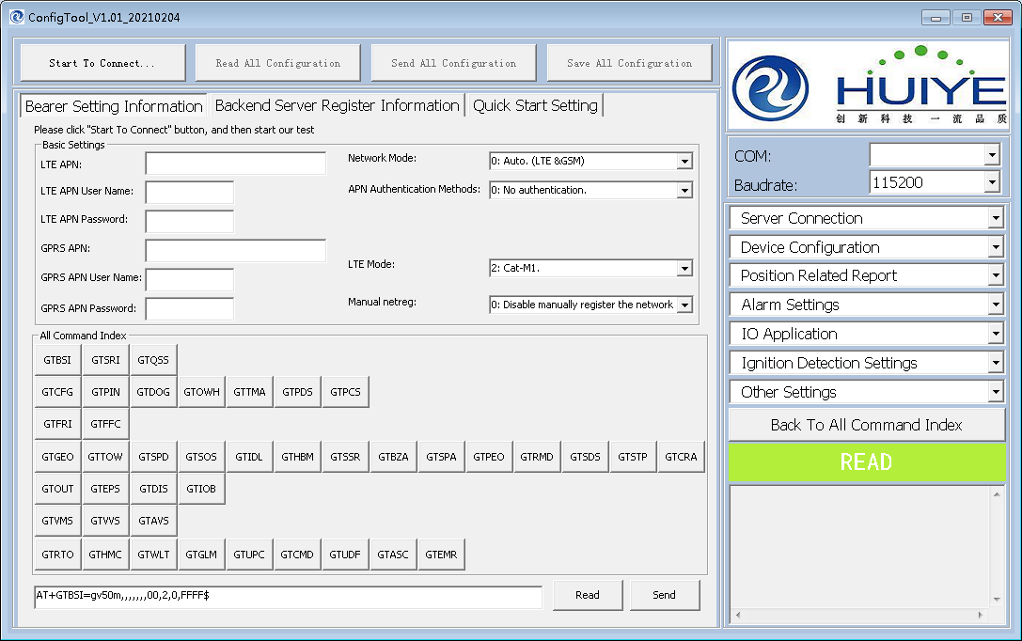

PIC 1

2）Please [Click](http://www.baidu.com/link?url=OV4EUYFKOR9-u4MyQHA3WpNncK6YUd9FxqBCrqmWzfclA1XQWpgdT7AtuOqCXfB4fPedi64m0KRz-itcsbvVMsqpcW99_SpBkVLeAnEdHAG) "COM" [Combox](http://www.baidu.com/link?url=OV4EUYFKOR9-u4MyQHA3WpNncK6YUd9FxqBCrqmWzfclA1XQWpgdT7AtuOqCXfB4fPedi64m0KRz-itcsbvVMsqpcW99_SpBkVLeAnEdHAG) Button, And tool will scan available uart port in your Computer. Please select the right port number connecting to our DUT , otherwise tool will pop up error massage.

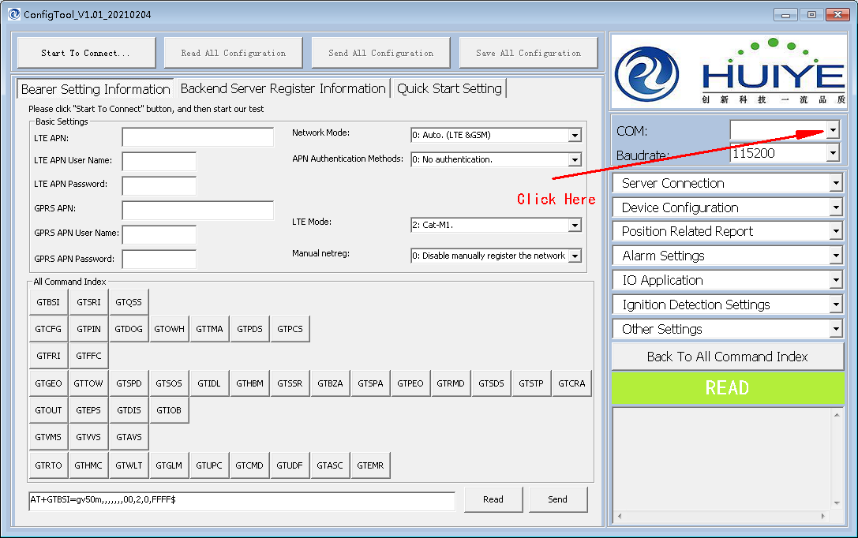

PIC 2

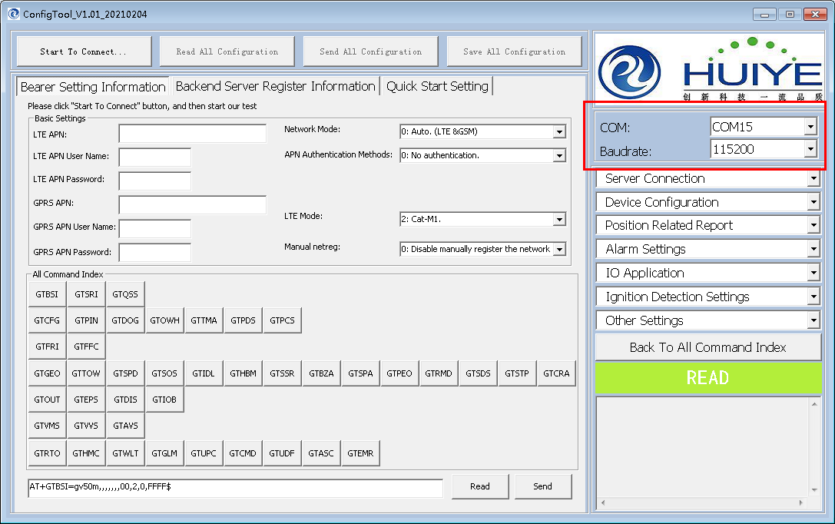

PIC 3

4.2Connect to DUT

Click the Button“Start to Connect..”,tool will try to connect your DUT by Uart COM port, and then wait 3 second, and do next step.

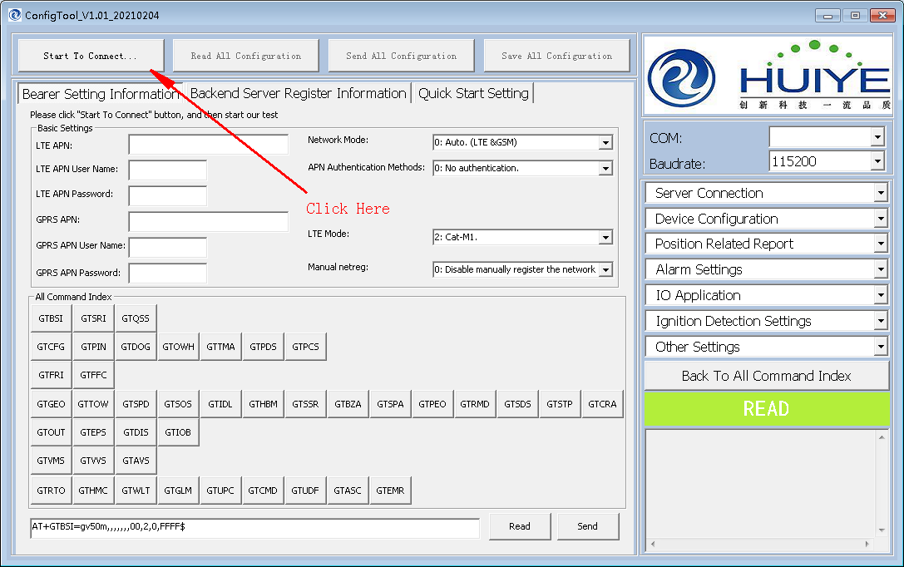

PIC 4

When you see tool pop up message "Please Reboot or Power On!",you need reboot or Power on your DUT right now, as PIC 5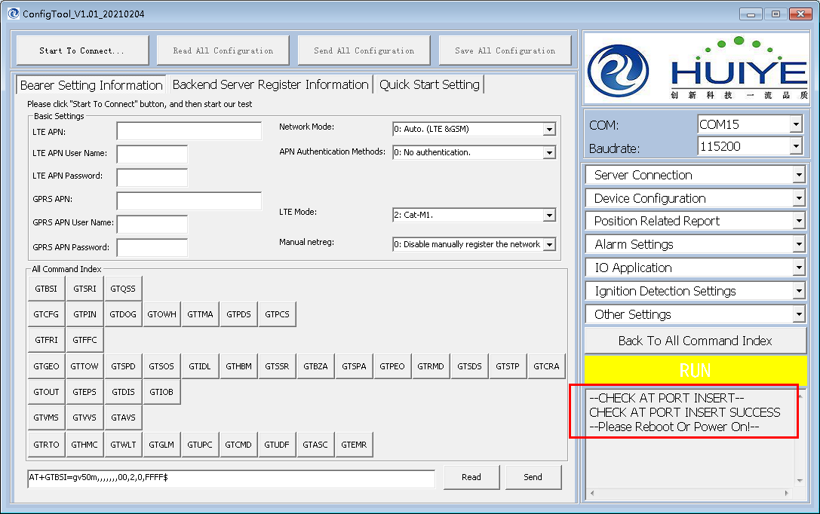

PIC 5

if Okay tool's flag will show PASS, "Start to Connect.." button will get green. as PIC 6

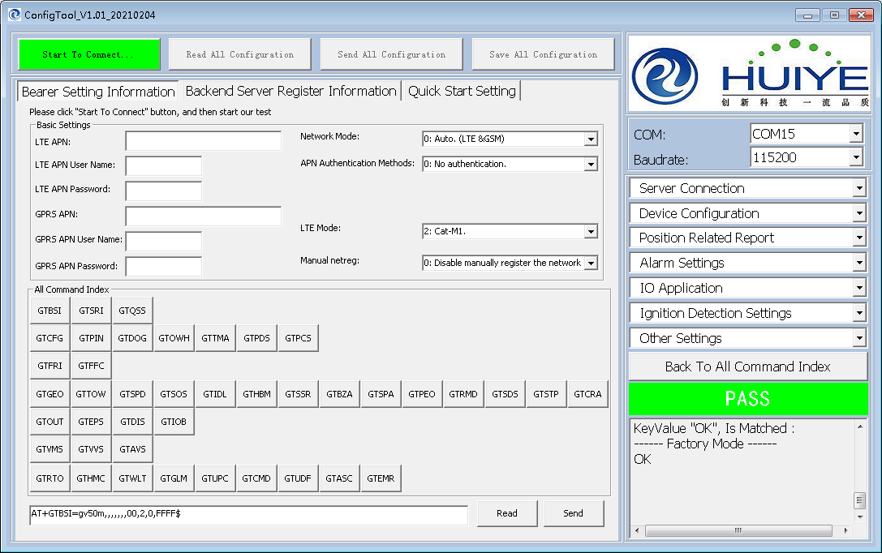

PIC 6

otherwise tool will show fail, as PIC 7.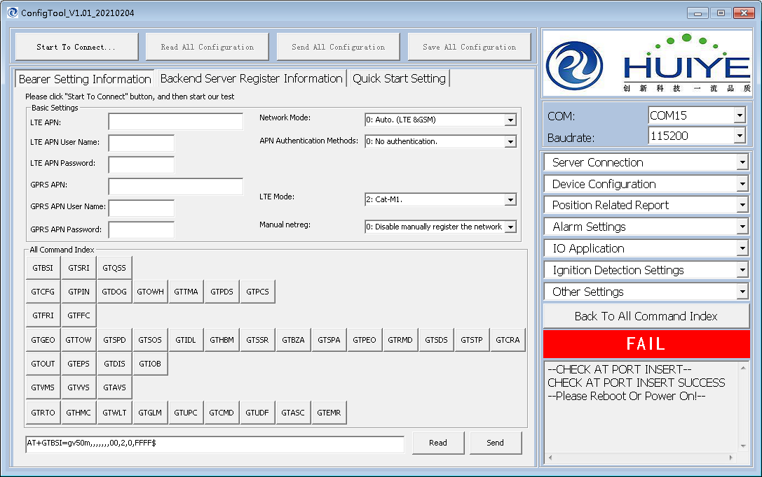

PIC 7

4.3 Modify Parameters of DUT

1）if you want to use "Backend Server Register Information" page to set "Report Mode" to "Force on SMS". as PIC 8, select "Backend Server Register Information" page.

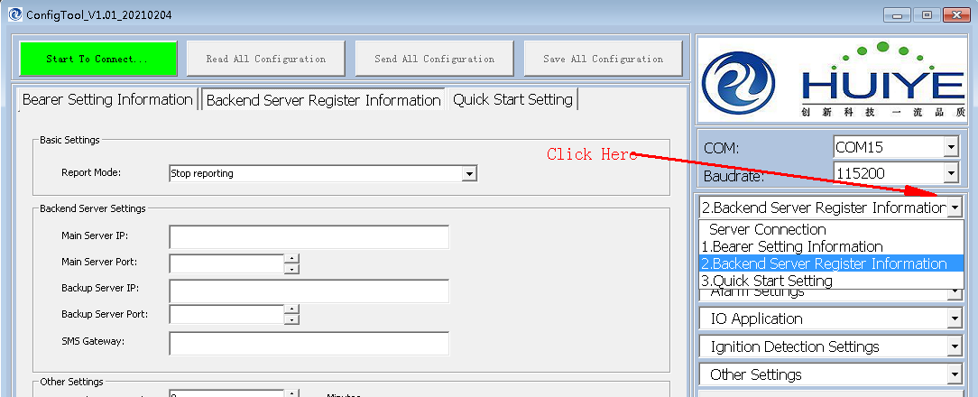

PIC 8

Select basic setting-->Report Mode-->Force on SMS. as PIC 9.

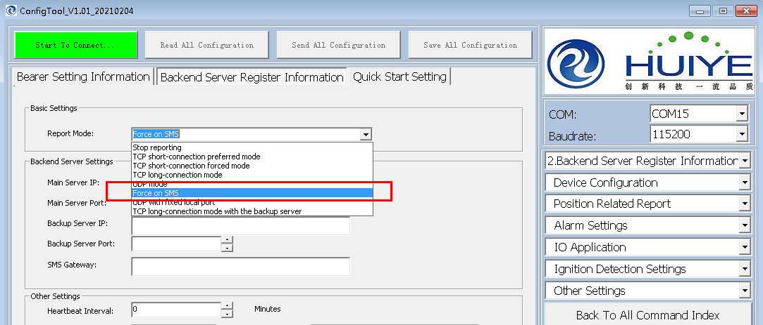

PIC 9

Click "Send" button, tool will send AT command to set "Report Mode" to "Force on SMS"(PIC 10)

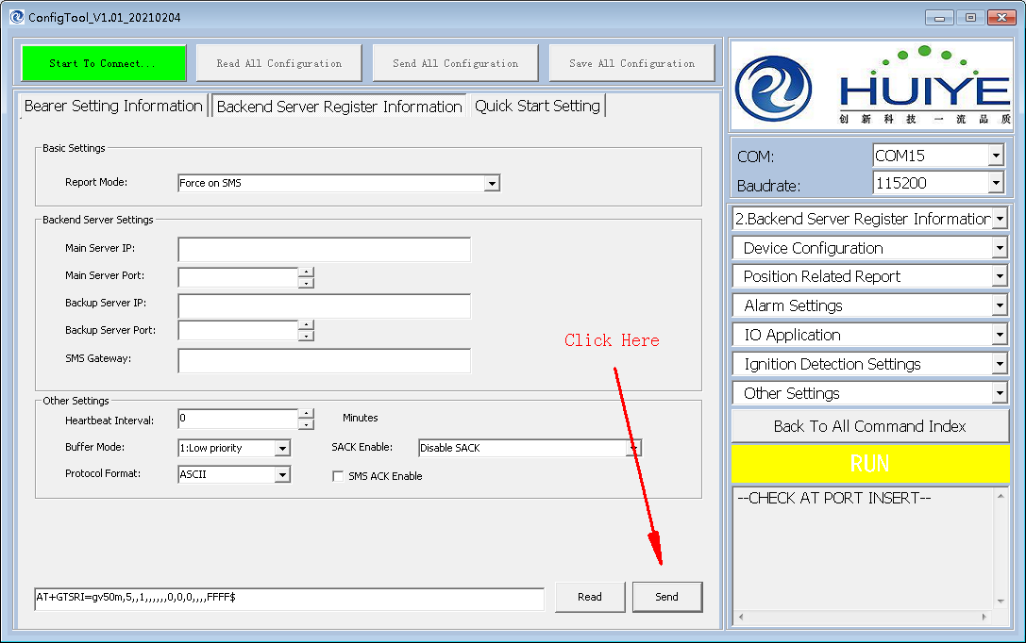

PIC 10

if Okay tool's flag will show PASS, LOG message will show "OK" in log area.(PIC 11)

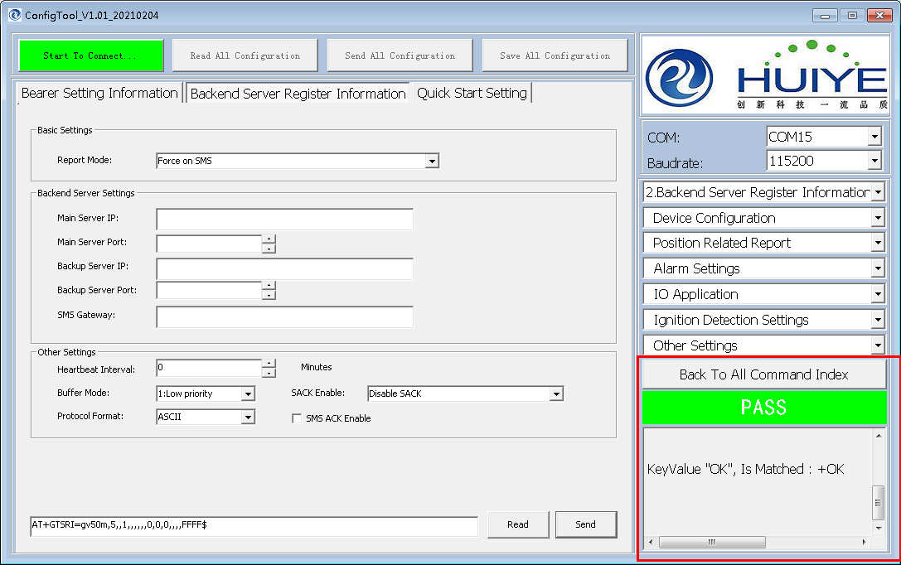

PIC 11

and then please Click "Read" button, tool will send AT command to read "Report Mode" value, you can check if "Report Mode" value is modified your want.( PIC12)

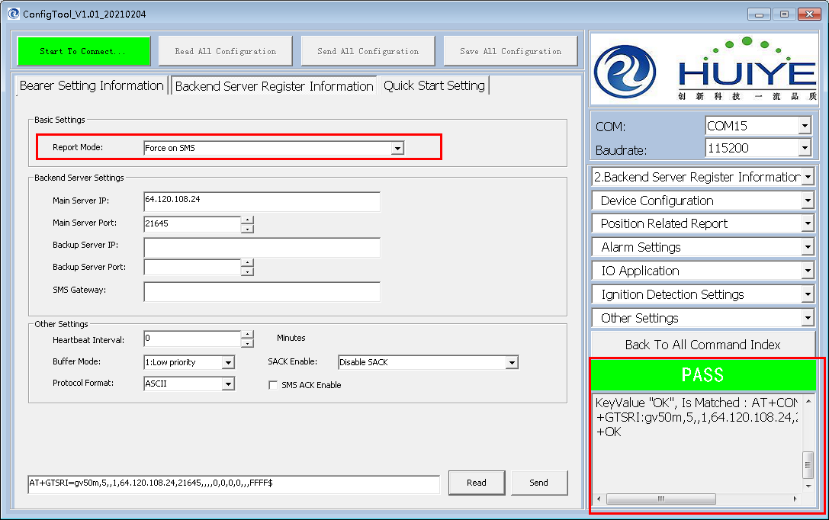

PIC12

5. Notice

"DUT" means Device Under Testing.

other tool distributions as PIC 13

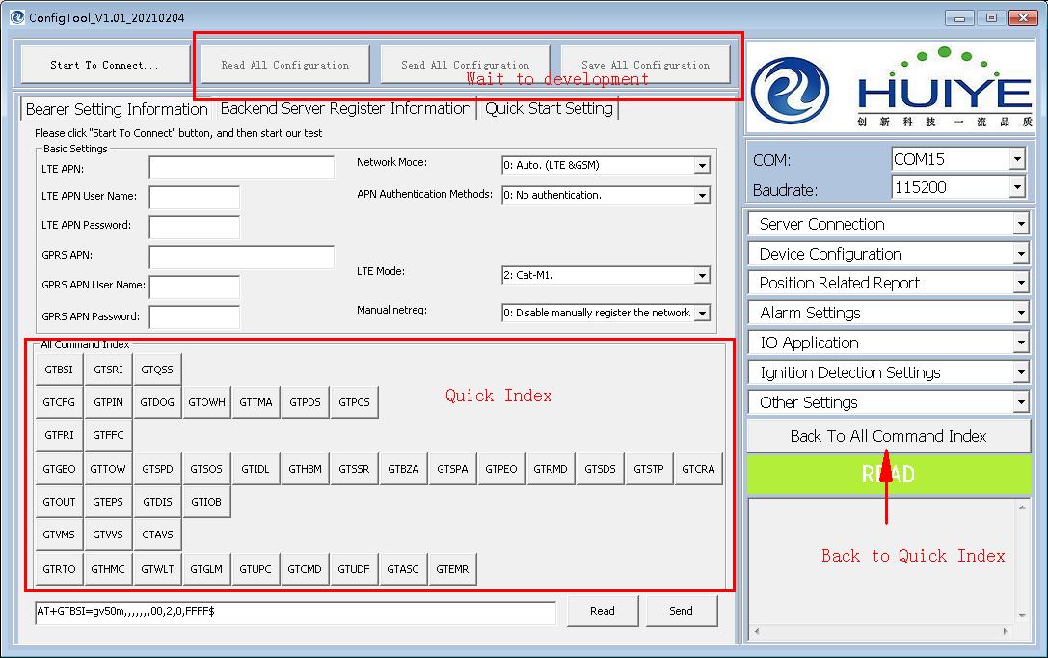

PIC13

How to setup testing station.

Uart Cable connecting in DUT and Computer side (PIC14)

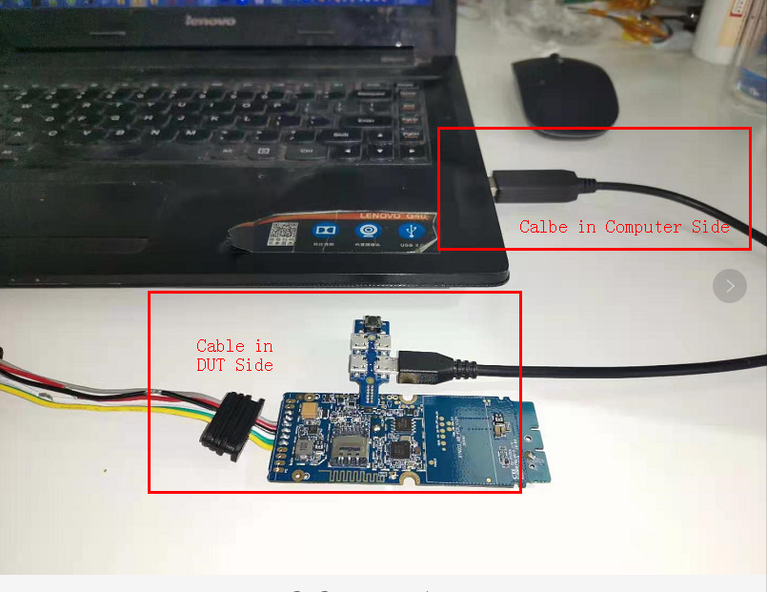

PIC14