**Small-World Minds: How Constrained Stimuli Create the Illusion of Low-Dimensional Social Cognition**

Junsong Lu1*, Chujun Lin1,2

1 Department of Psychology, University of California San Diego, La Jolla, U.S.

2 Department of Psychology, Columbia University, New York, U.S.

**Author Note**

Junsong Lu  <https://orcid.org/0000-0001-6987-6228>

Chujun Lin  https://orcid.org/0000-0002-7605-6508

The authors have no conflict of interest to disclose.

*Corresponding author *E-mail address*: jul140@ucsd.edu

# **Abstract**

A long-standing tradition suggests that social inferences are summarized by a few dimensions (e.g., warmth, competence). However, such findings relied on constrained stimuli (e.g., group labels, static faces). Studies using naturalistic designs instead reveal high dimensionality. We propose a new perspective that reconciles these views: mental representations of social inferences are structured as a growing network with small-world properties. In this structure, nodes (social inferences) are connected with only a few steps from one another, so even limited activation—elicited by constrained stimuli in only a small subset of nodes—propagates broadly across the network, producing covariation that mimics low-dimensional structures. However, these dimensions are not functional but emergent properties of network dynamics under constrained input. We demonstrated how this small-world-minds perspective accounts for classic phenomena—halo effect and psychological dimensions—as artifacts of stimulus limitations. We call for moving beyond low-dimensional paradigms to understand the complexity of social cognition. (150/150)

***Keywords***: person perception, social cognition, network analysis, computational modeling, naturalistic design

# **Introduction**

People have hundreds of different concepts to describe their inferences about other individuals and groups, such as their personality traits, intentions and emotions, and demographic characteristics1–4. How do people represent these concepts in their mind5? Traditionally, answers to this question have been dominated by low-dimensional models6–11, which assume that there are mental shortcuts—only a few core latent dimensions—that simplify the complexity of social inferences. For instance, when participants were asked to infer target individuals’ personality traits based on facial appearances, the variation in these inferences can be captured by only four latent dimensions, “warmth”, “competence”, “femininity”, and “youth”12.

This low-dimensional perspective is supported by two major lines of empirical findings. First, the halo effect, such as the beauty-is-good stereotype, which illustrates that people perceive individuals who look physically attractive to possess other positive qualities as well such as intelligent, healthy, and moral. Stereotypes like this suggest that perceivers compress inferences of an individual into a single broad evaluative dimension13–17. Second, a small number of core psychological dimensions, which are shown to account for a large amount of variance in the wide range of inferences people make about others, from personality traits, emotional states, to group stereotypes4,6–9,12,18.

Despite a long-standing literature supporting the low-dimensional perspective, a growing body of research instead points toward a high-dimensional social cognition19–29. For example, the emotional experiences elicited by naturalistic videos are captured by 27 distinct dimensions25. Our own work analyzing people’s free descriptions of targets in naturalistic videos shows that even 25 latent dimensions are not sufficient to capture the variance in social inferences20.

Why do some studies reveal low-dimensional structures, while others uncover high-dimensionality? We propose that this discrepancy stems from the small-world network properties of social cognition. Specifically, we argue that mental representations of social inferences are structured as a small-world network that grows in a specific way: as people learn more concepts of social inferences, the network expands while preserving many distinct nodes (social inference concepts) and maintaining short paths between them (one social inference can trigger another through a small number of inferences between them). By analogy, social connections between people are structured as a small-world network: as we get to know more people, the network grows with more members, but we can also reach nearly anyone in the network through just a few intermediaries (a friend of a friend).

The small-world mind is inherently high-dimensional; however, when people make inferences based on constrained stimuli, only a small subset of nodes in this high-dimensional network is activated, and these activations propagate broadly across the network due to the short paths between nodes—mimicking activation patterns expected from a low-dimensional structure. Our small-world minds perspective is supported by multiple lines of empirical research and can reconcile the low-vs-high dimensional findings of social cognition.

We illustrate this small-world minds perspective in detail across four sections of this paper. First, we introduce the ongoing debate between the low-dimensional and high-dimensional accounts of social cognition. Second, we propose a small-world network account of social cognition that reconciles this debate. This section outlines the structure of the network and its dynamic interaction with environmental input. We present simulation results in the main text along with detailed mathematical derivations in the supplementary materials. We review evidence from neural and developmental research that supports the small-world network account of social cognition. Third, we apply this small-world minds framework to explain why prior studies have yielded both low-dimensional and high-dimensional findings. Finally, we conclude by advocating for a paradigm shift beyond low-dimensional psychology to better capture the complexity of human social cognition in the real world.

# **The Debate: Low- or High-Dimensional Social Cognition?**

We review evidence supporting both accounts from research conducted over the past 50 years. For the low-dimensional account, we highlight findings including the beauty-is-good stereotype and the small number of core psychological dimensions. For the high-dimensional account, we discuss more recent studies that challenge the validity of the few core psychological dimensions—and, in some cases, questions the latent dimensional structure altogether.

## **Low-Dimensional Social Cognition**

Dion and colleagues in 1972 first demonstrated that people tend to attribute positive qualities (e.g., socially desirable) to physically attractive individuals—an effect known as the beauty-is-good stereotype. In these studies, participants view face images that vary in attractiveness and rate them on multiple traits. Subsequent research, including large-scale meta-analytic reviews in the 1990s, confirmed the robustness and prevalence of this stereotype. Eagjy and colleagues14 showed that this stereotype is more pronounced for interpersonal evaluations (e.g., sociability) and weaker for capability-related evaluations like intelligence and integrity.

These findings has sparked a large body of research investigating why people hold such a stereotype—namely, whether it reflects an objective correlation between attractiveness and positive traits, or whether it arises merely from cognitive heuristics. While meta-analyses reported minimal correlations between ground-truth attractiveness and positive traits16, some anecdotal links were found17,30–33, particularly with objective intelligence and health17,34–37. These links may be explained by the good genes hypothesis, which posits that facial attractiveness may signal genetic fitness, including higher intelligence and better health38.

There is also evidence suggesting that the beauty-is-good stereotype could arise merely from cognitive heuristics without ground-truth. For instance, Zebrowitz and colleagues proposed the overgeneralization hypothesis17,39,40 to explain how people overgeneralize associations that are based on ground-truths (babies are weak) to form associations that are not (baby-faced looking adults are weak). Similarly, people may have overgeneralized the association between attractiveness and certain objective positive traits in a small number of individuals to form mental associations between attractiveness and a much broader range of positive traits for people in general. This mechanism is further supported by recent research showing that the beauty-is-good stereotype is prevalence but the associations between attractiveness and actual traits are weak41–43. Collectively, these findings suggest that mental representations of social inferences are shaped by overly simplified heuristics.

The beauty-is-good stereotype supports a low-dimensional account of social cognition by focusing on a specific subset of social inferences, i.e., positive traits. A second line of research also points to low-dimensionality, but does so by examining a much broader range of traits. This line of search dates back to Asch’s seminal work on impression formation in 194644. By asking participants to make inferences about a person described by a list of traits, Asch found that changing certain traits (e.g., “warm” vs. “cold”) dramatically shaped overall impressions of the person, highlighting the central role of those traits. Reanalyzing these data, Wishner45 showed that a trait’s impact on overall impressions depends on its intercorrelations with other traits. The stronger a trait correlates with others, the greater it influences overall impressions.

Building on this, Rosenberg et al.11 used dimension reduction methods to systematically analyze latent dimensions that drive highly correlated traits, identifying two to three such dimensions (e.g., sociality and intellectual desirability). Subsequent investigations apply such dimension reduction methods to a broader range of trait inferences to search for latent dimensions that determine overall impressions. Some argue that only two dimensions (the Big Two model) are necessary, such as warmth and competence, which recurrently emerge across domains and tasks4,46–50. Others propose a few more dimensions, such as three dimensions—morality, sociability, and competence—for familiar groups and individuals51,52, four dimensions—warmth, competence, femininity, and youthfulness—for facial impressions12, and five dimensions—openness, conscientiousness, extraversion, agreeableness, and neuroticism—for self-presented and peer-perceived personality6.

Despite variations in the number and interpretation of identified dimensions, most studies converge on the finding that a small number of dimensions explain the majority of variance in social inferences53. While these dimensions can be viewed as statistical summaries of social inferences, they are commonly interpreted as psychologically meaningful latent constructs (in particular, dimensions extract using latent factor analysis). The widely replicated Big Two dimensions, warmth and competence, are even proposed to be functional8,54,55, reflecting inferences of others’ intentions and their ability to act on those intentions, which are both crucial for survival4,8. Similar evolutionary interpretations have been proposed for other dimensions, such as attractiveness7,34. Furthermore, these low-dimensional findings are often justified with cognitive constraints: they are thought to offer an efficient way for the mind to simplify and manage complex social environments56,57.

## **High-Dimensional Social Cognition**

Despite the dominance of low-dimensional accounts in the field, recent studies have begun to challenge the idea that a few core dimensions are sufficient to capture the complexity of social inferences. These newer approaches share two key features. First, rather than starting with a small set of predefined dimensions and constructing items to confirm them as in prior research, they use data-driven approaches that are agnostic to the dimensions and rely on diverse items and response formats20,23,58. For instance, Brooks and colleagues22 asked participants to rate 4,659 face images on 48 emotions and mental states, and found 28 facial expression dimensions. Using open-ended responses, Nicolas and colleagues identified 40 distinct dimensions that capture free descriptions of social groups.

Second, rather than using constrained stimuli such as isolated face images or short verbal descriptions as in prior work, these studies employ more naturalistic stimuli ranging from ambient images with contextual backgrounds to dynamic videos that convey richer multisensory information. For example, Cowen and Keltner25 showed participants 2,185 naturalistic video clips that depicted emotionally significant events (e.g., weddings), and identified 27 emotion dimensions that capture emotional experiences from these stimuli. Together, these two approaches suggest that the low-dimensionality doctrine and constrained experimental paradigms in prior research may have precluded a more complete understanding of social cognition. When the assumption of low dimensionality is relaxed and participants are presented with richer, more naturalistic input, we may identify more complex and ecologically valid mental representations.

While the studies discussed above reveal a much larger number of latent dimensions than traditionally assumed, they still operate within the latent dimensional framework. Others suggest that the latent dimensional framework may be insufficient altogether. For example, Connor and colleagues identified 14 dimensions of social attributions using naturalistic face images; yet these 14 dimensions explained only 38% of the variance in participants’ judgments. Similarly, our own work20 showed that even 25 dimensions accounted for less than 15% of the variance in unconstrained social inferences from naturalistic videos.

To address this limitation, we formally compared the latent dimensional framework with an alternative framework—a sparse network model61,62, which does not assume that the associations between social inferences are driven by underlying latent dimensions. We found that the network framework provided a better fit to the data, and we replicated these findings across three world regions (U.S., Europe, Asia) 20. These findings suggest that in naturalistic contexts, mental representations of social inferences may be more accurately captured by non-dimensional, association-based, network representations.

In summary, prior research provides support for both low- and high-dimensional accounts of social cognition. This tension highlights a fundamental gap in our understanding: what kind of mental representations could give rise to such seemingly contradictory findings? We propose a novel framework to address this gap in the next section.

# **A Small-World Network Model of Social Cognition**

## **From Early Network Models to Small-World Thinking**

Cognitive scientists have long viewed the mind as inherently associative and thus have adopted a network approach to investigate mental processing63,64. Early work used networks to model semantic memory. In their seminal study, Collins and Quillian65 proposed that concepts are represented as nodes within a hierarchical tree. While elegant, this model is best suited for hierarchically organized concepts (e.g., animal categories) and does not easily generalize to capture mental representations of other concepts, such as color, faces, or social relationships66,67.

Researchers in sociology and physics provided insights into an alternative network structure that might inform mental representations: the small-world network. In the early 1960s, sociologist de Sola Pool and mathematician Kochen introduced the concept of “small world” in their analysis of social connections68. Their manuscript has been widely circulated and inspired the famous small-world experiment by Milgram69. The central idea, popularized by playwright John Guare as “six degrees of separation,” posits that anyone in a social network can be reached through a few intermediary connections.

Meanwhile, in a separate line of work unknown to sociologists at the time, Erdős and Rényi developed a random graph model70. They showed that when the average number of connections per node in this network increases beyond a certain threshold, a large cluster emerges in which most nodes become interconnected. In this configuration, the maximum distance between any two nodes (the network’s diameter) decreases sharply. Relative to the size of the network (the number of nodes), this diameter becomes so small that nearly any two nodes become connected through only a few steps. This random graph model provides a useful demonstration of how small-world properties can arise once a network becomes sufficiently connected.

While informative, the random graph model assumes that links between nodes are formed randomly (typically following a Poisson degree distribution); whereas, in real-world systems, such as social networks of people, connections are not formed randomly71–73. Instead, they often exhibit a power-law distribution, also known as a scale-free architecture: a few nodes (hubs) have many connections, while most have few. This architecture commonly arises from two generative mechanisms observed in a range of real-world networks (cellular networks, social structures, neural networks, and the Internet)72: growth, whereby networks expand by adding new nodes, and preferential attachment, where new nodes are more likely to connect with already well-connected ones71 (Figure 1). These two mechanisms not only produce scale-free networks but also lead to small-world properties: hubs act as shortcuts that link distant parts of the network, drastically reducing the average path length between any two nodes.

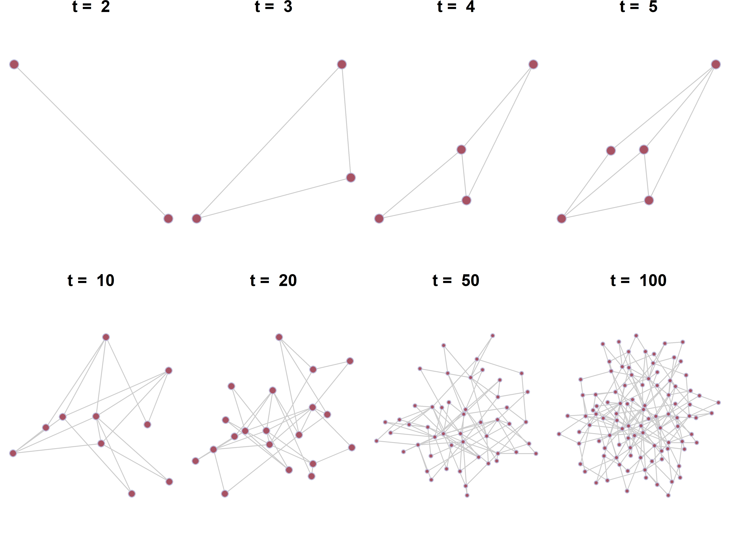

**Figure 1. Evolution of the Barabási-Albert Model.** Simulation of a growing network with 100 nodes, illustrating the two generative mechanisms of the Barabási-Albert Model: growth (at each time step, a new node is added to the network), and preferential attachment (new nodes are more likely to connect to highly connected nodes). Each new node forms two links to existing nodes. Over time (*t* = 2, 3, 4, 5, 10, 20, 50, 100), this generative process produces a scale-free architecture with a few highly connected hubs. These hubs act as shortcuts that drastically reduce the average path length between nodes, giving the network small-world properties.

**Small-World Mind Structure: Growth and Preferential Attachment**

We propose that the same generative mechanisms—growth and preferential attachment—also govern mental representations of social inferences. While the idea that conceptual knowledge in social cognition, such as mental representations of social inferences, may be structured as a network in the mind is not new3,19,74,75, the specific structural characteristics and underlying generative processes of such network remain unclear. Our account fills this gap by arguing that mental representations of social inferences are generated through growth and preferential attachment, giving rise to a network with small-world properties that balance complexity and efficiency.

The first generative mechanism, growth, addresses a fundamental computational challenge: how finite human minds can build increasingly complex social representations while keeping them tractable. This balance between complexity and tractability aligns with Piaget's theory of cognitive development, in which individuals assimilate new information into existing cognitive structures or accommodate it by modifying those structures76. Over time, these processes progressively build richer representations in a way that supports navigating complex social environments.

From an evolutionary perspective, the growth mechanism also offer computational advantages. Even if a representation is adaptive, such as correctly inferring the traits of a potential mate or collaborator, it does not need to be present from birth. Because complex mental representations are computationally costly to maintain, a representation can be acquired later when it becomes relevant. This growth mechanism aligns with the hierarchical sequence of social needs across lifespan77,78. For example, self-protection precedes status seeking, which in turn precedes mate seeking. Thus, concepts related to mating can be acquired later in life (e.g., inferences of family-orientated traits), whereas concepts important for detecting social threat (e.g., inferences of warmth) need to develop earlier.

The second generative mechanism, preferential attachment, characterizes how new information (e.g., new concepts) is incorporated into established mental representations. Intuitively, it follows a “rich-get-richer” pattern, where nodes (concepts) that already have many connections to other nodes are more likely to attract connections to new nodes. Mathematically, it is equivalent to a discrete-time stochastic process called the Chinese restaurant process (CRP), which has been widely used in nonparametric Bayesian models to explain categorization81,82 such as stereotyping83. In stereotype formation, preferential attachment manifests as the tendency to categorize new individuals into more prevalent groups.

Although preferential attachment has not yet been applied to research on social inferences, it offers a clear prediction: new concepts of social inferences (e.g., inferences of family-oriented traits) will tend to be integrated with concepts that are already central to social inferences (e.g., inferences of gender). Importantly, evidence from cognitive modeling supports the broader psychological plausibility of this mechanism84. Resource rational analysis shows that preferential-attachment-like pattern can naturally emerge from a clustering process that minimizes representational complexity85. When complexity is defined as the entropy of cluster assignment distributions, the optimal use of limited cognitive resources favors assigning new items to existing clusters in proportion to their current size—precisely the pattern described by preferential attachment. This suggests that preferential attachment is cognitively efficient and therefore a plausible strategy for organizing mental representations.

Together, growth and preferential attachment provide generative mechanisms through which mental representations of social inferences can develop into small-world networks. This framework is fundamentally distinct from low-dimensional accounts, which posit a small number of fixed, core psychological dimensions underlying social cognition (e.g., warmth, competence) 8,54,79. These dimensions are considered fundamental and universal across lifespan, population, and judgments80. While low-dimensionality may accommodate human cognitive limitations, whether these dimensions accommodate the complex social environment remains debated20. Instead, our framework explains how complex, high-capacity mental representations can remain computationally efficient, not by constraining the system to a few dimensions, but by organizing it into a small-world architecture that supports rapid access to diverse inferences while preserving coherent central inferences.

## **Small-World Mind Dynamics: Spreading Activation and Environmental Inputs**

Having established how a small-world network for mental representations of social inferences can emerge from growth and preferential attachment, we now examine the dynamics that operate within this network. Specifically, we illustrate how information flows through the network and interacts with environmental inputs to produce social inferences.

In network models of cognitive processing, such as semantic memory, a central mechanism is spreading activation, in which activation of one concept spreads to and activates adjacent concepts in the network64. Spreading activation typically has two important characteristics. First, activation propagates recursively: initially activated nodes can receive feedback from related nodes that become activated later86. This recursive property creates dynamic patterns of mutual reinforcement within local regions of the network. Second, activation carries a limited cognitive resource: its signal strength decays over time and distance87,88, eventually returning to baseline resting levels3. Therefore, in a large network with long average path lengths—meaning many steps are required to connect distant nodes—activation can quickly dissipate before reaching distant parts of the network. Small-world networks, on the other hand, keep average path lengths short by linking distant regions through well-connected hubs, allowing activation to reach the entire network efficiently before the signal fades.

While network structure (e.g., large networks with vs without small-world properties) determines how far and how quickly activation can spread, environmental inputs determine where activation begins. For instance, prior work conceptualizing mental representations of social inferences using networks, the dynamic interactive theory3, proposes that nodes (social inferences) differ in terms of their sensitivity to environmental inputs. Specifically, valence-related inferences are more sensitive to visual and auditory inputs resembling emotional expressions, enabling rapid automatic detection of social threat or safety. In contrast, more abstract inferences, such as personality traits, typically require detailed observation of behavior and sustained processing.

The interaction between environmental inputs and spreading activation can be thought of as a two-step process: environmental inputs selectively activate particular nodes in the network, and these activated nodes then transmit activation to their neighbors through recursive spreading. In a small-world network, this means that even activation that begins in a highly localized region—such as a set of valence-related inferences triggered by emotional expressions—can rapidly reach distant part of the network (conceptually unrelated social inferences). As a result, even limited environmental inputs that initially activate only a small number of inferences can influence a wide range of inferences in mental representations with small-world properties.

## **Small-World Mind Plausibility: Neural and Developmental Evidence**

Although no empirical studies have yet directly tested whether mental representations of social inferences are organized in a network with small-world properties, preliminary support for this possibility comes from neural and developmental evidence.

### ***Neural Plausibility: How Social Inferences Mapped onto Biological Neural System***

Our proposed small-world network model of social cognition operates at Marr's algorithmic level: it specifies the rules by which mental representations are organized. However, any algorithmic model must be compatible with the implementation—the neural circuits that realize these representations in the brain. From this perspective, the question is whether known properties of biological neural networks could support a small-world organization of mental representations of social inferences.

There are two plausible neural implementations of the small-world mental representations of social inferences. The first is localist representation, in which each node (i.e., each social inference) corresponds to a single neuron or a very small, dedicated group of neurons. In this implementation, the efficiency of the mental representation network depends directly on the efficiency of the biological neural network. Early studies on the biological neural wiring in the worm C. elegans have found a small-world structure89 at the neuronal level, with similar neuronal-level structure subsequently found in cats, macaque monkeys, and even humans90,91. This suggests that if each social inference were represented by a single neuron (or a small group of neurons), their interconnections could in principle form a small-world network as well.

Although localist representation could, in principle, produce a small-world structure for the mental representations of social inferences, localist representation—each social inference mapped onto a single neuron (or a small group of neurons)—is unlikely to be true. Higher-level mental representations such as those for semantic concepts are found to be scale-free: that is, nodes that represent semantic concepts in a network differ dramatically in the number of connections they have across orders of magnitude67. Higher-level mental representations of social inferences likely share the same scale-free architecture as semantic concepts. Thus, if one social inference maps onto one single neuron (or a small group of neurons), then neurons representing different social inferences should differ dramatically in their connections as well. However, neuroanatomical research shows that biological neurons typically have similar number of connections92. Thus, localist representation is unlikely to be how social inferences are represented in the brain.

Another plausible neural implementation of the small-world mental representations of social inferences is distributed representation. In this implementation, each node (i.e., each social inference) corresponds to a connectivity pattern across many neurons and their collective activation states. This is consistent with a recent theory proposing that social inferences emerge as equilibrium states reached through recurrent processing among thousands of neurons in parallel processing19. This implementation is also supported by empirical neuroimaging studies, which show that the medial prefrontal cortex represents both warmth inferences and competence inferences93. This suggests that the same neural ensembles can encode different social inferences via distinct activation patterns.

Distributed representation is not only neurally plausible but can also accommodate the scale-free properties observed in higher-level mental representations such as semantic concepts and likely social inferences. This implementation only requires that neuron-population-level activation patterns differ among one another in how strongly or frequently they are connected to other neuron-population-level activation patterns. This allows for the emergence of highly connected hubs at the higher mental representation level while keeping individual neurons’ connectivity within biological limits. This property makes distributed representation both neurally plausible and compatible with a small-world organization of mental representations of social inferences.

### ***Developmental Plausibility: Evidence for Growth and Preferential Attachment***

From a developmental perspective, both theoretical considerations and empirical evidence point to mechanisms that could give rise to small-world organization in mental representations of social inferences. Theoretically, the gradual acquisition of social concepts across the lifespan can produce small-world organization through the two generative mechanisms we mentioned earlier: growth and preferential attachment. Growth occurs naturally as people encounter new people and develop new motivations over time, such as acquiring mate-seeking or status-seeking motivations as they get older, and the corresponding social inferences that accompany these motivations. Preferential attachment arises because newly learned concepts—such as inferences about family-oriented traits related to mate-seeking motivations, and inferences about ambitiousness, assertiveness, and dominance related to status-seeking motivations—are more likely to be connected to concepts that are already well-connected—such as social inferences about gender, which is acquired early in life. Because these new connections are added gradually and selectively, the network remains sparse enough to be biologically sustainable while still forming hubs and shortcuts that support efficient information flow. Together, these two generative mechanisms align with developmental trajectories and provide a strong theoretical basis for expecting small-world properties in mental representations of social inferences.

Empirically, two lines of research supports both growth and preferential attachment underlying mental representations of social inferences. First, different social inference concepts are acquired at different times and the representations of them change over lifespan. Age-of-acquisition ratings for over 30,000 English words show that words related to valence are acquired early in development94, such as "nice" (acquired at age 3.95) and "kind" (4.89 years); whereas, words related to more abstract inferences are acquired later in development, such as xx (xx years) and xx (xx years). Developmental changes also appear in how consistently people make social inferences. When judging faces that vary in warmth on warmth related traits (within-concept judgment), agreement between individuals increases with age. This suggest that the “warmth” concept in childhood is not fully developed—children may have a smaller set of warmth-related inferences to draw upon, leading to more individual differences. In contrast, when judging faces that vary in competence on warmth related traits (between-concept judgment)95, adults agree less than children. This suggest that children’s “warmth” concept are less clearly differentiated from “competence” concept than adults, allowing cues for competence to influence warmth judgments. Together, these findings suggest that children’s mental representations for warmth are both less complete (fewer warmth-related nodes) and less specialized (more cross-concept connections) than adults, supporting a growing network account of mental representation of social inferences.

Second, social inference concepts that are acquired earlier in development (e.g., valence-related inferences) also tend to correlate more with other social inference concepts. For instance, valence-related inferences often show stronger and more numerous correlations with other social inferences (i.e., usually showing greater explain variance when they form a factor) than competence-related inferences4,46–50. This pattern even shows up in children’s inferences, where more inferences are strongly correlated with the valence concept than the competence concept. These findings suggest that newly acquired social-inference concepts are connected to earlier-formed, well-connected concepts (forming hubs), supporting the preferential attachment mechanism. Together, these developmental findings support both growth and preferential attachment—generative mechanisms that naturally produce small-world properties in mental representations of social inferences.

# **The Small-World Mind and the Low-Dimensional Illusion**

Having elaborated the small-world network structure, processing dynamics, and its plausibility for organizing mental representations of social inferences, we now demonstrate how this small-world mind account explains previously observed low-dimensional patterns in social cognition. In short, mental representations of social inferences that are organized as a small-world network are inherently high-dimensional, and the low-dimensional findings can be understood as an emergent phenomenon of the network when environmental input is constrained.

We unpack this argument in the next four sections. We first provide formal analysis of the small-world network model, describing how two nodes’ structural connections relate to the correlation between their activations. The demonstrations in the main text are targeted for a broad audience; for those interested in the methodological details, more rigorous mathematical derivations are provided in the supplementary materials. Building on this structural-functional understanding, we then show how the inherently high-dimensional small-world mind can give rise to seemingly low-dimensional observations. We illustrate this with classical social cognitive phenomena, including psychological heuristics such as the beauty-is-good stereotype and seemingly fundamental psychology dimensions such as warmth and competence. Finally, we argue that these examples highlight the need for the field to move beyond low-dimensional “wishful thinking” and engage directly with the reality of a complex, high-dimensional social mind.

**Small-World Network: Structural Connections and Functional Correlations**

Networks generated through growth and preferential attachment mechanisms—that is, scale-free networks—exhibit ultra-small-world properties99. While randomly connected networks can display small-world properties, the presence of hubs in scale-free networks compressed connectivity even further. Specifically, the difference lies in how the average shortest path length between nodes across the whole network (i.e., the average smallest number of steps needed to get from one node to another) increases as the network size (N, the number of nodes) grows. In random networks, this path length increases proportionally to *lnN* (the natural logarithm of N). In scale-free networks, it increases even more slowly—proportionally to *ln(ln N)* (the natural logarithm of the natural logarithm of N). Because *ln(ln N)* grows extremely slowly, even very large scale-free networks maintain remarkably short distances between nodes.

This unusually slow increase in the average shortest path length relative to network size arises from the presence of hubs—a few nodes with exceptionally high connectivity that can link distant network regions in remarkably few steps (Figure 2). These hubs ensure that adding more nodes does not proportionally increase the number of steps needed to connect them. Therefore, the network’s “smallness” is preserved as it grows, allowing seemingly unrelated nodes to rapidly expand their reachable activation space through hub-mediated pathways. Applying this to mental representations of social inferences, it means that in a small-world mind, even conceptually distant inferences can influence one another and reach comparable activation levels despite their conceptual separation.

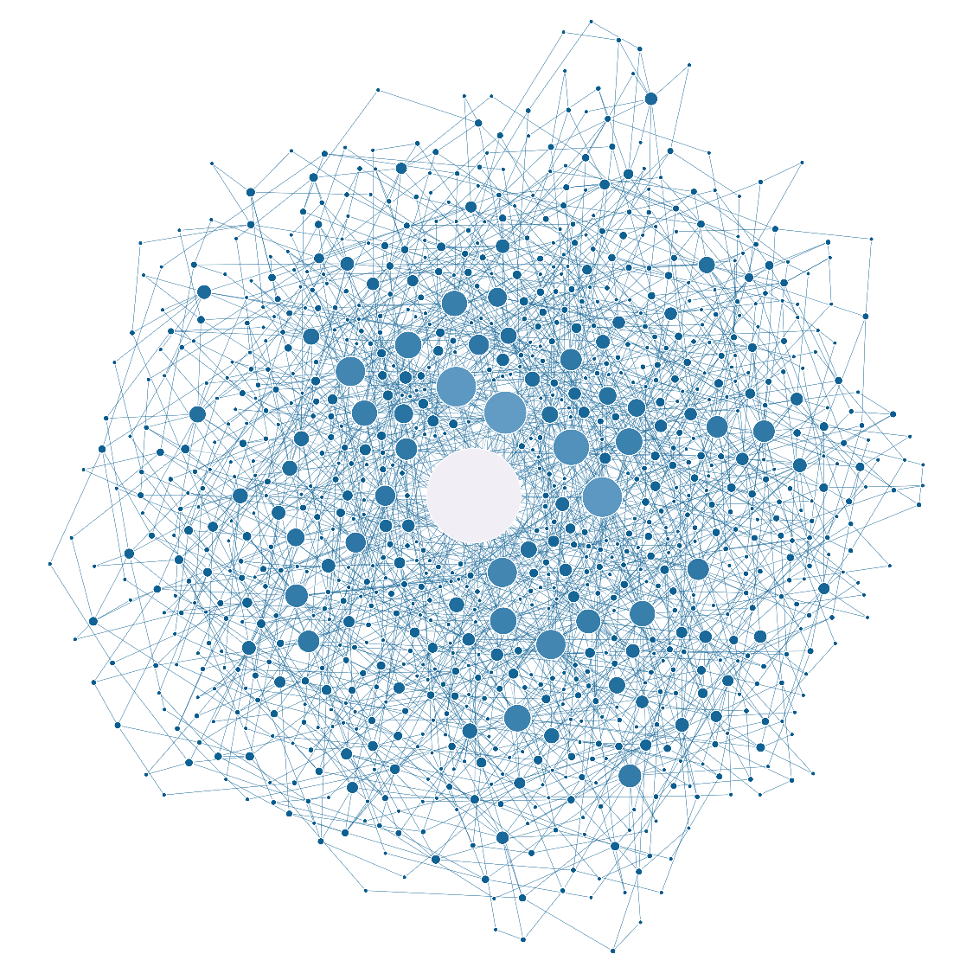

**Figure 2. A Scale-Free Network Generated through Growth and Preferential Attachment.** This network contains 1,000 nodes built through a simulated process. At each time step, a new node is added (i.e., growth) and connected to two existing nodes, with a higher probability of connecting to nodes that already have many links (i.e., preferential attachment). The size and color of each node are proportional to its degree (i.e., the number of connections), with larger nodes and lighter colors indicating higher degrees. The largest grey node in the center represents a hub, which provides shortcuts to connect otherwise distant nodes, helping to maintain short path lengths even as the network grows.

The ultra-small-world property at the global-level described above can be understood more precisely at a micro-level by looking at the shortest path length between two specific nodes—that is, the smallest number of steps needed to connect them. While the shortest path length is a single number, there can be multiple distinct paths of that same length. The number of these equally short paths directly affects how likely it is for the two nodes to be connected at that shortest distance; in large networks, the relationship between the number of paths at a distance and the likelihood of connection at that distance becomes especially direct because the expected count closely approximates the probability. Thus, it is useful to estimate the expected count of paths at a given length *d* between two nodes (i.e., with *d*-1​ intermediate nodes).

The expected count of paths of length *d* is a function of the two nodes’ degrees and (i.e., the number of direct connections each node has). The calculation is based on the configuration model in complex network theory100,101, which is a commonly used starting point for analyzing a complex network (see supplementary materials). In brief, the expected count of paths of length 1 (direct connections) between two nodes is proportional to the product of their degrees: the higher their degrees, the greater the likelihood of a direct connection between them. This logic extends to longer paths: for *d >* 1, the expected count of paths of length *d* still scales with the product of degrees but is amplified exponentially by a factor dependent on the network’s degree distribution (the distribution of the number of connections across all nodes in the network).

Because shorter paths (small *d*) require fewer intermediate nodes, there are fewer constraints on forming them, making such paths more common—especially in networks with hubs that connect to many nodes. This means the expected count, and thus the probability, is typically highest for short path lengths (e.g., *d* = 1 or 2). As a result, even nodes with moderate degrees can have, on average, more than one indirect path of length 2 between them, making it highly likely that they are only two steps apart (Figure 3). In real-world network, the expected number of such paths is often even higher due to assortative mixing102 (nodes connecting to other nodes with similar properties), where high-degree nodes tend to connect preferentially with other high-degree nodes. This further increases the likelihood of short connections, reinforcing the ultra-small-world property.

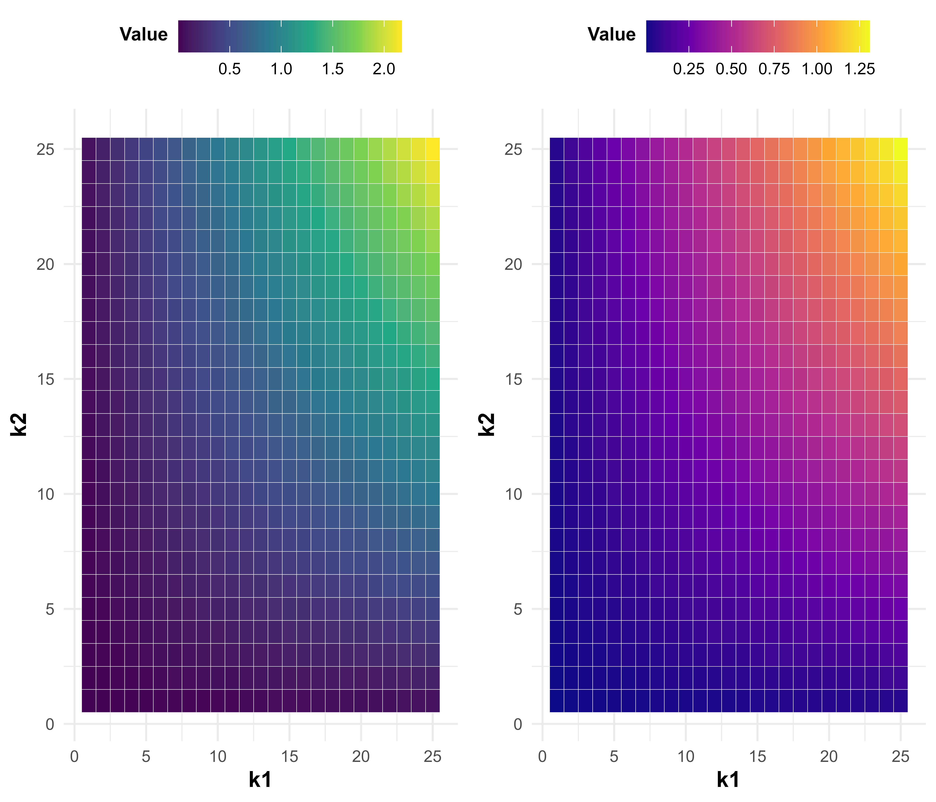

**Figure 3. Expected Count of Paths between Two Nodes of Given Degrees.** Each density map displays the expected number of paths (color) linking two nodes with degrees k1​ (x-axis) and k2 (y-axis)​, calculated based on their degrees and the total number of edges in the network. The left panel is based on a network of 500 nodes with 3 connections added at each time step; the right panel is based on a network of 200 nodes with 2 connections added per step. Warmer colors indicate higher expected count of paths connecting the two nodes. As predicted by the model, nodes with higher degrees are more likely to be connected.

After describing the path length between any two nodes in the network structure, we now turn to how activation spreads between them. When activation spreads through a network with some random noise at each step (i.e., moving from one node to the next)3, the correlation between the activation levels of two nodes depends on the length of the shortest path between them—shorter path lengths produce stronger correlations. In a weighted network (e.g., one representing similarities between different semantic concepts), where each connection has an associated strength (e.g., semantic similarity), these activation correlations are further influenced by the connection weights. In psychological networks, such as mental representations of social inferences, these connection weights may be relatively high due to the limited distinctiveness between different inferences103 (e.g., nice is semantically very similar to kind), leading to strong correlations in activation levels between nodes. As a result, the activation levels of neighboring constructs (i.e., nodes connected by short paths) tend to rise and fall together. This similarity in activation levels increases the correlations across the network—even between nodes that are farther apart—thereby strengthening the high interconnectedness that characterizes small-world networks from a functional perspective.

## **Reinterpreting Beauty-is-Good in the Small-World Mind Framework**

Psychological heuristics such as the beauty-is-good stereotype are typically interpreted as evidence for a low-dimensional mental representation of social inferences. However, an inherently high-dimensional mental representation—the small-world mind—can also explain these phenomena. Specifically, we argue that previously found high correlations between perceived attractiveness and other positive traits are due to the efficient activation spreading in a small-world mind under constrained environmental inputs. This allows activations of input-relevant inferences such as attractiveness to spread to conceptually distinct inferences that occupy distant parts of the network, driving high correlations between them (Figure 4). In this section, we first provide theoretical demonstration of this argument. We then support this argument with empirical findings from our simulation studies.

Consider the commonly reported correlation between perceived attractiveness and perceived intelligence17,42. If these two inferences are closely connected in a small-world network, their short path explains the strong correlation in their activations (e.g., behavioral ratings of these inferences). Indeed, empirically, perceived attractiveness and related inferences like “pretty”, “handsome” often hold a central position in the network due to its early acquisition and high accessibility, giving it a “first-mover” advantage20 (Fig. 4b). Perceived intelligence, shaped by cultural norms and folk theories (e.g., ), is broadly connected to various trait inferences, contributing to its high degree. When constrained stimuli such as cropped-out face images are observed without auditory, semantic, or behavioral information (Fig. 4a), the activation in the network is sparse (i.e., only a few social inferences are activated) and concentrated on accessible nodes like attractiveness (Fig. 4c). The activation of attractiveness is then quickly passed to intelligence without significant decay due to the short paths connecting them in a small-world mind, creating the appearance of high association (Fig. 4d). In such constrained experimental settings where richer, multisensory social cues are missing, abstract social inferences (e.g., intelligence, morality) receive little direct activation from the environmental inputs but eventually obtain efficient activation through their short connections to frequently activated social inferences.

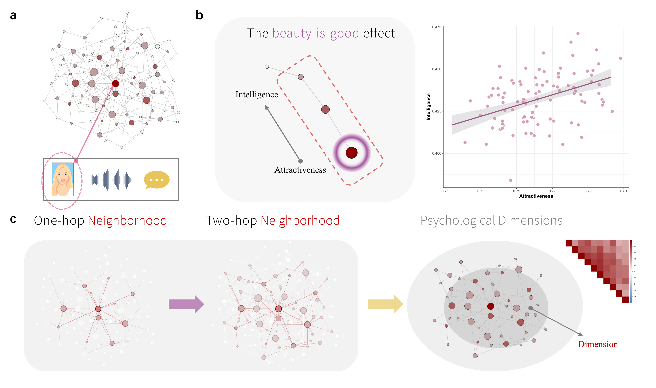

**Figure 4. Beauty-is-Good and Psychological Dimensions in A Small-World Mind.** (a) In typical studies, constrained stimuli, such as isolated face images, are used to elicit social attributions. (b) Empirical evidence from our prior work20 demonstrating that attractiveness-related inferences are often well-connected with other inferences, acting as a hub in the network. (c) The node representing perceived attractiveness is easily activated by environmental inputs, and its activation is rapidly transmitted to neighboring nodes, such as “intelligence.” This activation decays with distance but, due to the small-world property of the network, can quickly reach seemingly unrelated nodes like “intelligence,” producing proportional activation. (d) Our simulation revealed a strong correlation (*r* = 0.50, *p* < .001) between the initially activated node (e.g., attractiveness) and a two-hop neighbor (e.g., intelligence). (e) The initial activation of the central node (dark red) spreads to one-hop neighbors (directly connected nodes), then to two-hop neighbors (nodes that are indirectly connected through one intermediate node). Due to the short paths between nodes in a small-world network, similar activation levels efficiently spread across the entire network. (f) These similar activation patterns lead to high shared covariance across nodes (upper-right heatmap). When applied dimension reduction analyses to the activation levels of the nodes (e.g., behavioral ratings of different social inferences), only a few core psychological dimensions (e.g., one indicated by the central grey region) are needed to explain most of covariance in the activations across nodes.

A key prediction of our argument—that the small-world mind explains the beauty-is-good stereotype—is that this stereotype should weaken or even disappear when richer social information is available and when initial activations conflict. We conducted a simulation study to directly test this prediction. In our simulations, we introduced diverse environmental inputs to the network. We found decreases in the correlations between the activation of attractiveness and other positive inferences, confirming our prediction (Figure 5). For instance, prior research using face-only images often found a correlation between perceived attractiveness and warmth around 0.41104. In our simulations, when naturalistic images that include context such as body posture, movement, clothing, and situational cues are used, the correlation between perceived attractiveness and warmth dropped to 0.12, consistent with a recent empirical research using similarly naturalistic stimuli60. Similarly, using face-only images, prior studies often find a strong correlation between perceived attractiveness and intelligence (*r* = 0.81)42; this association becomes statistically insignificant and approaches zero (*r* = -0.04) in our simulation when more diverse environmental inputs are used, consistent with a recent empirical research examining unconstrained social inferences using dynamic video clips20.

图表

AI 生成的内容可能不正确。

**Figure 5. Simulation Showing the Low-Dimensional Illusion Decreases with Richer Inputs.** (a) When a single constrained stimulus is used—thus, only one or a few nodes are activated—the activations of different nodes quickly reach equilibrium and become similar. Each line represents the activation of a single node across time points. (b) When constrained stimuli are used as environmental input in our simulation, we calculated the correlations between activations across nodes. The correlation heatmap indicates strong overall correlations (brighter red) between all nodes’ activations in the network. In this simulation, only a single latent dimension was identified, and it accounted for 60% of the variance in the nodes’ activations, consistent with the low-dimensional findings in prior research using constrained designs. (c) When more complex environmental inputs (e.g., multisensory social information) are used, activations between nodes become less similar and more unstable. As a result, the correlations between activations weakened, with a single latent factor accounting for only 12% of the variance, consistent with recent studies using naturalistic designs.

## **Reinterpreting Psychological Dimensions in the Small-World Mind Framework**

A similar logic can explain why the inherently high-dimensional mental representation of social inferences in a small-world network can produce the artifact that only a few latent dimensions are needed to account for the variance across most social inferences (Figure 5). Specifically, we argue that these psychological dimensions are not fixed, functional bases that drive social inferences; instead, they are well-connected regions (i.e., communities) in the small-world network, which emerged based on the specific functional dynamics of the activations driven by environmental inputs. In this section, we first describe the methodological and statistical bases of the low-dimensionality found in prior research. We then explain the relations between these dimensions and environmental inputs. Finally, we discuss how this flexible relation between dimensions and environmental inputs is better captured using a network perspective.

Prior studies often used constrained stimuli such as cropped-out face images and only a limited set of pre-selected trait words to investigate the psychological dimensions of social inferences. These practices raised concerns that the identified dimensions may reflect inadequate stimulus sampling50,105,106. Indeed, many studies relied on a priori theories, such as aiming to test the warmth-competence framework, when designing the research (e.g., only selecting trait words that represent these two dimensions). By selecting trait words that are semantically similar to the targeted dimensions, this approach introduces semantic redundancy and inflates inter-trait correlations. However, even when trait words were selected comprehensively without targeted dimensions, a low-dimensional structure often emerges when the stimuli are still constrained (e.g., face images)12,50. However, our own prior work shows that when the constraints on stimuli and trait words are simultaneously relaxed, the evidence for a low-dimensional representation vanishes20. This empirical finding shows that the richness of environmental inputs plays a critical role in eliciting comprehensive social inferences and revealing the mental representation of social inferences.

Statistically speaking, the prerequisite for dimensions to emerge is the high shared variance among measures (e.g., ratings on different social inferences)107,108. This can be evaluated using the Measure of Sampling Adequacy (MSA), which ranges from 0 to 1 and estimates whether a given inference shares sufficient variance with others to justify latent dimensions109. A low MSA value indicates that an inference has unique associations with other inferences that are not easily reducible to the shared variance with other inferences driven by latent dimensions. When the mental representation of social inferences is structured as a small-world network, MSA values become highly dependent on the environmental inputs. When constrained stimuli such as face images are used, only a few facially relevant nodes in the network are activated. These activations then spread efficiently across the entire network through the short paths between nodes in the small-world network, creating the statistical effect that many social inferences’ activations in the network rise and fall together, seemly explainable by just a few dimensions. Thus, high shared variance between social inferences under constrained inputs do not reflect genuine structure of mental representations (i.e., low dimensionality), but rather emergent behavioral characteristics of the network.

Using this network perspective to reinterpret previously found dimensions also informs why the most commonly identified dimensions correspond to readily accessible environmental inputs. For instance, the warmth dimension in the Big-Two model is closely linked to facial expression cues8; the attractiveness dimension in the 3-D model7, and the femininity and youthfulness dimensions in the 4-D model12 are closely linked to facial structural cues. This phenomena can be well explained by the network perspective: environmental inputs activate a few directly relevant nodes, which drive the broader activation pattern throughout the network via their short connections to other nodes62. Thus, the activation patterns across the network are most consistent with the nodes that are directly activated by environmental inputs, giving rise to shared variances in activations (i.e., the “dimensions”) that are directly relevant to the environmental inputs.

When environmental inputs are naturalistic and diverse, the conditional independence assumption of latent dimensions is often violated. This assumption states that, once the variance driven by latent dimensions are accounted for, individual measures should no longer be directly related110–112. This assumption would be violated in naturalistic contexts because, from the small-world mind perspective, not only nodes (inferences) associated with simplified visual inputs are important anchors for activations, other nodes sensitive to auditory, semantic, and behavior information are also activated, introducing more complex activation patterns across the network, allowing unique correlations between specific nodes. In another word, for instance, introducing node activations driven by behavioral information beyond static facial information will largely decrease common variance between nodes’ activations, and thus a small number of dimensions are no longer sufficient to explain the variance across social inferences. This is empirically demonstrated in our prior work.

Formally, from the network perspective, the psychological dimensions previously found are instead communities in the network113. These communities are clusters of nodes (social inferences) that are densely connected, sharing more similar activation patterns than other nodes in the network (Figure 6). Empirical findings from both personality and person perception research have demonstrated the high similarity between traditional dimensions and communities in the network20,62,114. These activation-based communities can vary flexibly depending on the environmental inputs, explaining why dimension-like structures found in prior research vary dramatically depending on the stimuli. Taken together, we argue that psychological dimensions found in prior research are not fixed, functional structures that drives social inferences, but instead emergent structures from the small-world mind.

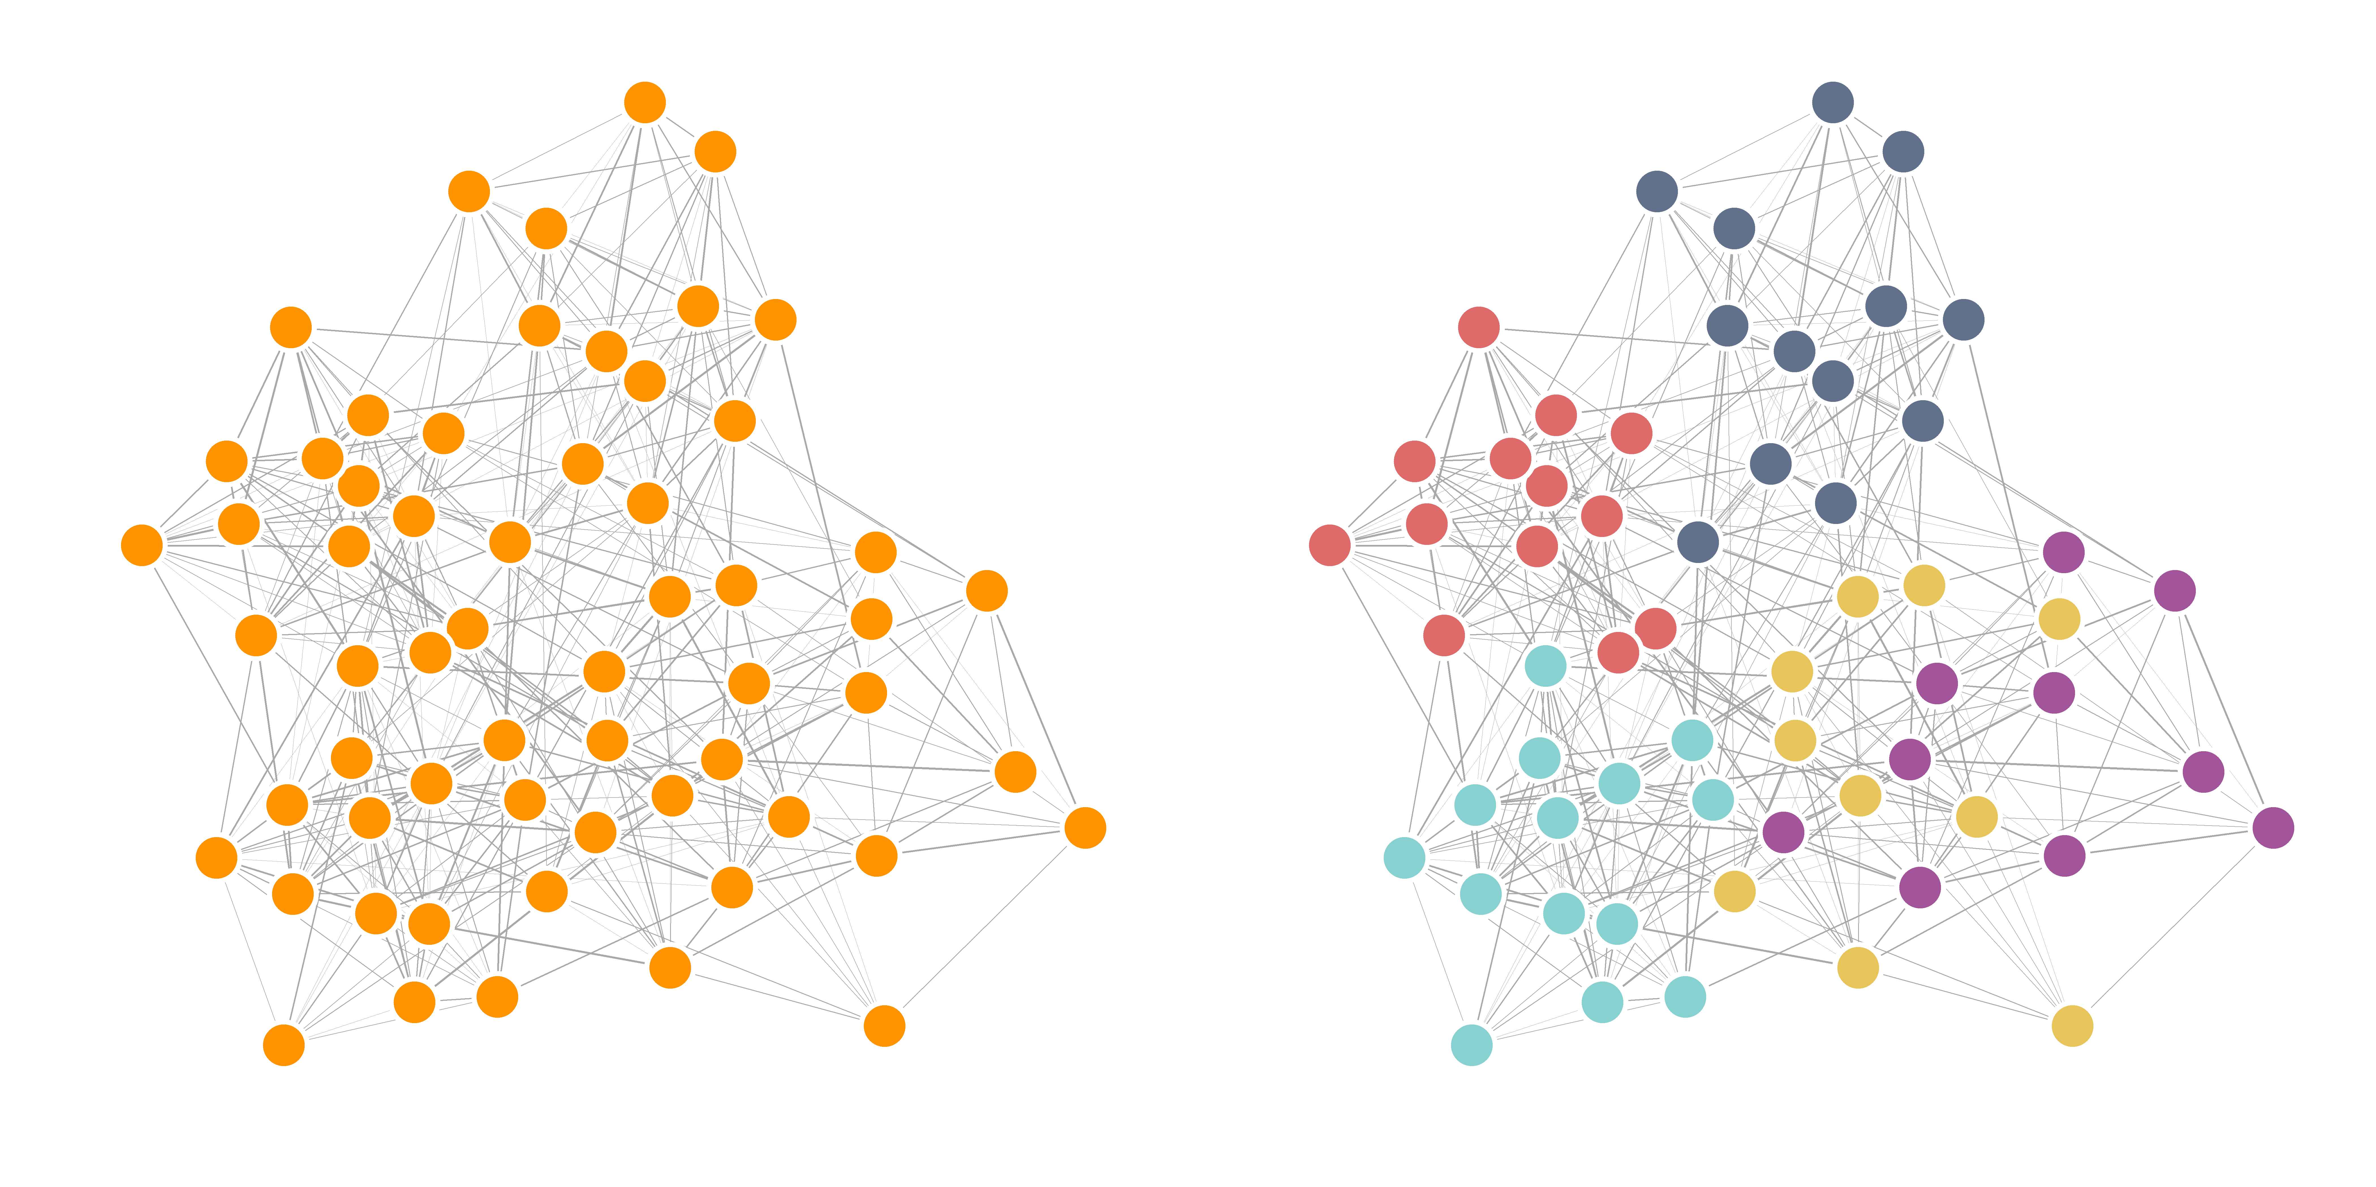

**Figure 6. Psychological Dimensions Are Communities in the Small-World Mind.** Left: A network without communities (densely connected regions) annotated. Right: the same network with communities annotated using colors. Communities are identified using community detection algorithms that focus on network structure between nodes113,115–117. Communities in the small-world mind serve as structural prerequisites for psychological dimensions to be detected when constrained environmental inputs are used. This is because when a node within a community is activated, the activation can efficiently spread to other nodes within the same community, rapidly leading to similar activation patterns and high correlations between measures.

# **Moving Beyond the Low-Dimensional Illusion of Social Cognition**

Taken together, our analyses in the above sections show that the seemingly low-dimensional patterns observed in social cognition are in fact an illusion—arising from the underlying small-world network structure of mental representations of social inferences and its interaction with constrained environmental inputs. Beyond this methodological reason, the persistence of low-dimensional conclusions in the field may reflect deeper cognitive and cultural biases toward simplicity.

Humans have a strong motivation to understand and find meaning in their experiences125. Given the inherent complexity of human psychology, this motivation compels researchers to create mental placeholders that establish feelings of certainty and understanding126—the low-dimensional models serve as good candidates. Beyond these cognitive tendencies, cultural norms in social science research favoring verbal descriptions over mathematical representations when communicating research findings also contribute to the popularity of low-dimensional solutions. Results that are easier to interpret, communicate, remember, and reproduce tend to persist during social transmission; whereas, results that are more difficult to interpret, communicate, or remember are more often criticized and distrusted127. This is consistent with findings showing that transmission of social knowledge (stereotypes) over generations of participants compresses knowledge representations from high- to low-dimensional128. Similar mental compression processes may operate in scientific production and transmission, suggesting that our innate cognitive tendencies may systematically distort the understanding of the dimensionality of psychological spaces, favoring simplified models that are more readily communicated even if they are less accurate.

Moving beyond this low-dimensional “wishful thinking” is key to advancing an ecologically valid understanding of social cognition127. We believe that progress requires two complementary approaches: incorporating the complexity of real-world social interactions into experimental designs, and developing quantitative mental models that make precise predictions about behavior. Specifically, we recommend reconceptualizing experiments as simplified models of real-world interactions rather than artificial manipulations of isolated variables129. Social cognitive processes such as impression formation typically extend beyond a single time slice or glimpses of faces, it will be helpful to incorporate multisensory information and dynamic social interactions in experimental designs. In addition, to better understand cognitive processes, simply manipulating environmental inputs may not be sufficient, as the way cues are integrated and combined can largely influence behavioral outcomes59,123,130. We recommend developing explicit mental representation models that can inform cognitive processes in naturalistic contexts, such as how complex environmental inputs are processed and transformed into the behavioral responses.

In the current paper, for example, we modeled mental representations of social inferences explicitly as small-world networks following growth and preferential attachment mechanisms, and derived correlation patterns of node activations within these networks based on environmental inputs. This approach exemplifies a broader methodological philosophy: mental models functioning as systematic procedures that convert raw environmental inputs into specific behavioral outputs through well-defined mathematical transformations can provide more testable models of mental processes. For instance, we can manipulate a more precisely defined factor in this mental model, and compare the model responses to human behavior to evaluate the model plausibility. Just as a recipe describing how to optimally combine ingredients to produce a dish, models describing psychological processes with precise mathematical functions127,131 may help us better understand cognitive processes in complex, naturalistic contexts.

# **Conclusions**

In this perspective, we propose that mental representations of social inferences are structured as a small-world network generated with growth and preferential attachment. Using mathematical proofs and simulation studies, we showed that this small-world mind framework can reconcile the discrepant findings on the dimensionality of social cognition by producing seemingly low-dimensional behaviors under constrained environmental inputs. Thus, social cognition may be inherently high-dimensional. Future research that leverages more naturalistic designs and precise mathematical models of mental processes will be essential for fully capturing the complexity of social cognition.

**References**

1. Amodio, D. M. A learning and memory account of impression formation and updating. *Nat Rev Psychol* (2025) doi:10.1038/s44159-025-00445-x.

2. Uleman, J. S., Adil Saribay, S. & Gonzalez, C. M. Spontaneous Inferences, Implicit Impressions, and Implicit Theories. *Annu. Rev. Psychol.* **59**, 329–360 (2008).

3. Freeman, J. B. & Ambady, N. A dynamic interactive theory of person construal. *Psychological Review* **118**, 247–279 (2011).

4. Fiske, S. T., Cuddy, A. J. C., Glick, P. & Xu, J. A model of (often mixed) stereotype content: Competence and warmth respectively follow from perceived status and competition. *Journal of Personality and Social Psychology* **82**, 878–902 (2002).

5. Marr, D. *Vision: A Computational Investigation into the Human Representation and Processing of Visual Information*. (MIT press, 1982).

6. Goldberg, L. R. An alternative ‘description of personality’: the big-five factor structure. *J Pers Soc Psychol* **59**, 1216–1229 (1990).

7. Sutherland, C. A. M. *et al.* Social inferences from faces: Ambient images generate a three-dimensional model. *Cognition* **127**, 105–118 (2013).

8. Oosterhof, N. N. & Todorov, A. The functional basis of face evaluation. *Proc. Natl. Acad. Sci. U.S.A.* **105**, 11087–11092 (2008).

9. Ekman, P. & Friesen, W. V. Constants across cultures in the face and emotion. *Journal of Personality and Social Psychology* **17**, 124–9 (1971).

10. Thornton, M. A. & Tamir, D. I. People represent mental states in terms of rationality, social impact, and valence: Validating the 3d Mind Model. *Cortex* **125**, 44–59 (2020).

11. Rosenberg, S., Nelson, C. & Vivekananthan, P. S. A multidimensional approach to the structure of personality impressions. *Journal of Personality and Social Psychology* **9**, 283–294 (1968).

12. Lin, C., Keles, U. & Adolphs, R. Four dimensions characterize attributions from faces using a representative set of English trait words. *Nat Commun* **12**, 5168 (2021).

13. Dion, K. & Walster, E. WHAT IS BEAUTIFUL IS GOOD. *Journal of Personality and Social Psychology* **24**, 285–290 (1972).

14. Eagjy, A. H., Ashmore, R. D. & Makhijani, M. G. What Is Beautiful Is Good, But. . .: A Meta-Anatytic Review of Research on the Physical Attractiveness Stereotype. *Psychological Bulletin* **110**, 109–128 (1991).

15. Feingold, A. Understanding the physical attractiveness literature: Qualitative reviews versus meta-analysis. *Behavioral and Brain Sciences* **40**, e28 (2017).

16. Feingold, A. Good-looking people are not what we think. *Psychological Bulletin* **111**, 304–341 (1992).

17. Zebrowitz, L. A., Hall, J. A., Murphy, N. A. & Rhodes, G. Looking Smart and Looking Good: Facial Cues to Intelligence and their Origins. *Pers Soc Psychol Bull* **28**, 238–249 (2002).

18. Han, Y. & Adolphs, R. A shared structure for emotion experiences from narratives, videos, and everyday life. *iScience* **27**, (2024).

19. Freeman, J. B. & Lin, C. A high-dimensional model of social impressions. *Trends in Cognitive Sciences* S136466132500110X (2025) doi:10.1016/j.tics.2025.04.011.

20. Lu, J. & Lin, C. Network models reveal high-dimensional social inferences in naturalistic settings beyond latent construct models. *Commun Psychol* **3**, (2025).

21. Freeman, J. B., Stolier, R. M. & Brooks, J. A. Dynamic interactive theory as a domain-general account of social perception. in *Advances in Experimental Social Psychology* vol. 61 237–287 (Elsevier, 2020).

22. Brooks, J. A. *et al.* Deep learning reveals what facial expressions mean to people in different cultures. *iScience* **27**, 109175 (2024).

23. Cowen, A. S. *et al.* How emotion is experienced and expressed in multiple cultures: a large-scale experiment across North America, Europe, and Japan. *Front. Psychol.* **15**, 1350631 (2024).

24. Cowen, A. S., Fang, X., Sauter, D. & Keltner, D. What music makes us feel: At least 13 dimensions organize subjective experiences associated with music across different cultures. *Proc. Natl. Acad. Sci. U.S.A.* **117**, 1924–1934 (2020).

25. Cowen, A. S. & Keltner, D. Self-report captures 27 distinct categories of emotion bridged by continuous gradients. *Proc. Natl. Acad. Sci. U.S.A.* **114**, (2017).

26. Cowen, A. S. *et al.* Facial movements have over twenty dimensions of perceived meaning that are only partially captured with traditional methods. Preprint at https://doi.org/10.31234/osf.io/hc93t (2021).

27. Connor, P., Nicolas, G., Antonoplis, S. & Koch, A. Unconstrained Descriptions of Facebook Profile Pictures Support High-Dimensional Models of Impression Formation. *Personality and Social Psychology Bulletin* **0**, 1–17 (2024).

28. Nicolas, G., Uddenberg, S. & Todorov, A. Spontaneous Content of Impressions of Naturalistic Face Photographs. *Social Cognition* **43**, 114–143 (2025).

29. Nicolas, G., Bai, X. & Fiske, S. T. A spontaneous stereotype content model: Taxonomy, properties, and prediction. *Journal of Personality and Social Psychology* **123**, 1243–1263 (2022).

30. Jackson, L. A., Hunter, J. E. & Hodge, C. N. Physical Attractiveness and Intellectual Competence: A Meta-Analytic Review. *Social Psychology Quarterly* **58**, 108–122 (1995).

31. Langlois, J. H. *et al.* Maxims or myths of beauty? A meta-analytic and theoretical review. *Psychological Bulletin* **126**, 390–423 (2000).

32. Kanazawa, S. Intelligence and physical attractiveness. *Intelligence* **39**, 7–14 (2011).

33. Sheehan, C. M. & Hamermesh, D. S. Looks and longevity: Do prettier people live longer? *Social Science & Medicine* **354**, 117076 (2024).

34. Kanazawa, S. Why beautiful people are more intelligent. *Intelligence* **32**, 227–243 (2004).

35. Zebrowitz, L. A., Fellous, J.-M., Mignault, A. & Andreoletti, C. Trait Impressions as Overgeneralized Responses to Adaptively Significant Facial Qualities: Evidence from Connectionist Modeling. *Pers Soc Psychol Rev* **7**, 194–215 (2003).

36. De Jager, S., Coetzee, N. & Coetzee, V. Facial Adiposity, Attractiveness, and Health: A Review. *Front. Psychol.* **9**, 2562 (2018).

37. Weeden, J. & Sabini, J. Physical Attractiveness and Health in Western Societies: A Review. *Psychological Bulletin* **131**, 635–653 (2005).

38. Thornhill, R. & Gangestad, S. W. Human facial beauty: Averageness, symmetry, and parasite resistance. *Human Nature* **4**, 237–269 (1993).

39. Zebrowitz, L. A. & Rhodes, G. Sensitivity to “Bad Genes” and the Anomalous Face Overgeneralization Effect: Cue Validity, Cue Utilization, and Accuracy in Judging Intelligence and Health. *Journal of Nonverbal Behavior* **28**, 167–185 (2004).

40. Zebrowitz, L. A. First Impressions From Faces. *Curr Dir Psychol Sci* **26**, 237–242 (2017).

41. Gulati, A. *et al.* What is beautiful is still good: the attractiveness halo effect in the era of beauty filters. *R. Soc. Open Sci.* **11**, 240882 (2024).

42. Talamas, S. N., Mavor, K. I. & Perrett, D. I. Blinded by Beauty: Attractiveness Bias and Accurate Perceptions of Academic Performance. *PLOS ONE* **11**, e0148284 (2016).

43. Mitchem, D. G. *et al.* No relationship between intelligence and facial attractiveness in a large, genetically informative sample. *Evolution and Human Behavior* **36**, 240–247 (2015).

44. Asch, S. E. Forming impressions of personality. *The journal of abnormal and social psychology* **41**, 258 (1946).

45. Wishner, J. Reanalysis of ‘impressions of personality.’ *Psychological Review* **67**, 96–112 (1960).

46. Liebenow, H. A., Boucher, K. L. & Cassidy, B. S. Trait inferences from the “big two” produce gendered expectations of facial features. *Journal of Experimental Social Psychology* **111**, 104585 (2024).

47. Martin, A. E. & Slepian, M. L. The Primacy of Gender: Gendered Cognition Underlies the Big Two Dimensions of Social Cognition. *Perspect Psychol Sci* **16**, 1143–1158 (2021).

48. Abele, A. E. & Wojciszke, B. Agency and communion from the perspective of self versus others. *Journal of Personality and Social Psychology* **93**, 751–763 (2007).

49. Abele, A. E. & Bruckmüller, S. The bigger one of the “Big Two”? Preferential processing of communal information. *Journal of Experimental Social Psychology* **47**, 935–948 (2011).

50. Jones, A. L., Shiramizu, V. & Jones, B. C. Decoding the language of first impressions: Comparing models of first impressions of faces derived from free‐text descriptions and trait ratings. *British J of Psychology* bjop.12717 (2024) doi:10.1111/bjop.12717.

51. Brambilla, M., Rusconi, P., Sacchi, S. & Cherubini, P. Looking for honesty: The primary role of morality (vs. sociability and competence) in information gathering. *Eur. J. Soc. Psychol.* **41**, 135–143 (2011).

52. Brambilla, M., Sacchi, S., Rusconi, P. & Goodwin, G. P. The primacy of morality in impression development: Theory, research, and future directions. in *Advances in Experimental Social Psychology* vol. 64 187–262 (Elsevier, 2021).

53. Sutherland, C. A. M. & Young, A. W. Understanding trait impressions from faces. *British J of Psychology* **113**, 1056–1078 (2022).

54. Fiske, S. T., Cuddy, A. J. C. & Glick, P. Universal dimensions of social cognition: warmth and competence. *Trends in Cognitive Sciences* **11**, 77–83 (2007).

55. Zebrowitz, L. A. & Montepare, J. M. Social Psychological Face Perception: Why Appearance Matters. *Social and Personality Psychology Compass* **2**, 1497–1517 (2008).

56. Olivola, C. Y. & Todorov, A. Fooled by first impressions? Reexamining the diagnostic value of appearance-based inferences. *Journal of Experimental Social Psychology* **46**, 315–324 (2010).

57. Kahneman, D. A perspective on judgment and choice: Mapping bounded rationality. *American Psychologist* **58**, 697–720 (2003).

58. Stamkou, E., Keltner, D., Corona, R., Aksoy, E. & Cowen, A. S. Emotional palette: a computational mapping of aesthetic experiences evoked by visual art. *Sci Rep* **14**, 19932 (2024).

59. Zaki, J. Cue Integration: A Common Framework for Social Cognition and Physical Perception. *Perspect Psychol Sci* **8**, 296–312 (2013).

60. Zheng, R. & Lin, C. Cues driving trait impressions in naturalistic contexts are sparse. *Preprint at Https://Doi. Org/10.31234/Osf. Io/V39tk* (2024).

61. Epskamp, S., Borsboom, D. & Fried, E. I. Estimating psychological networks and their accuracy: A tutorial paper. *Behav Res* **50**, 195–212 (2018).

62. Cramer, A. O. J. *et al.* Dimensions of Normal Personality as Networks in Search of Equilibrium: You Can’t like Parties if you Don’t like People. *Eur J Pers* **26**, 414–431 (2012).

63. Siew, C. S. Q., Wulff, D. U., Beckage, N. M., Kenett, Y. N. & Meštrović, A. Cognitive Network Science: A Review of Research on Cognition through the Lens of Network Representations, Processes, and Dynamics. *Complexity* **2019**, 1–24 (2019).

64. Collins, A. M. & Loftus, E. F. A spreading-activation theory of semantic processing. *Psychological review* **82**, 407 (1975).

65. Collins, A. M. & Quillian, M. R. Retrieval time from semantic memory. *Journal of verbal learning and verbal behavior* **8**, 240–247 (1969).

66. Kemp, C., Perfors, A. & Tenenbaum, J. B. Learning overhypotheses with hierarchical Bayesian models. *Developmental Science* **10**, 307–321 (2007).

67. Steyvers, M. & Tenenbaum, J. B. The Large‐Scale Structure of Semantic Networks: Statistical Analyses and a Model of Semantic Growth. *Cognitive Science* **29**, 41–78 (2005).

68. de Sola Pool, I. & Kochen, M. Contacts and influence. *Social networks* **1**, 5–51 (1978).

69. Milgram, S. The small world problem. *Psychology today* **2**, 60–67 (1967).

70. On the evolution of random graphs. *The Structure and Dynamics of Networks* **17**, 38–82 (1960).

71. Barabasi, A.-L. & Albert, R. Emergence of Scaling in Random Networks. *Science* **286**, 509–512 (1999).

72. Barabási, A.-L. Scale-Free Networks: A Decade and Beyond. *Science* **325**, 412–413 (2009).

73. Newman, M. *Networks*. (Oxford university press, 2018).

74. Stolier, R. M., Hehman, E. & Freeman, J. B. Trait knowledge forms a common structure across social cognition. *Nat Hum Behav* **4**, 361–371 (2020).

75. Stolier, R. M., Hehman, E. & Freeman, J. B. A Dynamic Structure of Social Trait Space. *Trends in Cognitive Sciences* **22**, 197–200 (2018).

76. Piaget, J. *The Construction of Reality in the Child*. (Routledge, 2013).

77. Neel, R., Kenrick, D. T., White, A. E. & Neuberg, S. L. Individual differences in fundamental social motives. *Journal of Personality and Social Psychology* **110**, 887–907 (2016).

78. Kenrick, D. T., Griskevicius, V., Neuberg, S. L. & Schaller, M. Renovating the Pyramid of Needs: Contemporary Extensions Built Upon Ancient Foundations. *Perspectives on Psychological Science* **5**, 292–314 (2010).

79. Todorov, A., Said, C. P., Engell, A. D. & Oosterhof, N. N. Understanding evaluation of faces on social dimensions. *Trends in Cognitive Sciences* **12**, 455–460 (2008).

80. Olivola, C. Y. & Todorov, A. Elected in 100 milliseconds: Appearance-Based Trait Inferences and Voting. *J Nonverbal Behav* 28 (2010).

81. Aldous, D. J. Exchangeability and related topics. in *Lecture Notes in Mathematics* 1–198 (Springer Berlin Heidelberg, Berlin, Heidelberg, 1985). doi:10.1007/bfb0099421.

82. Gershman, S. J. & Blei, D. M. A tutorial on Bayesian nonparametric models. *Journal of Mathematical Psychology* **56**, 1–12 (2012).

83. Gershman, S. J. & Cikara, M. Structure learning principles of stereotype change. *Psychon Bull Rev* **30**, 1273–1293 (2023).

84. Lieder, F. & Griffiths, T. L. Resource-rational analysis: Understanding human cognition as the optimal use of limited computational resources. *Behav Brain Sci* **43**, e1 (2020).

85. Dasgupta, I. & Griffiths, T. L. Clustering and the efficient use of cognitive resources. *Journal of Mathematical Psychology* **109**, 102675 (2022).

86. Siew, C. S. Q. spreadr: An R package to simulate spreading activation in a network. *Behav Res* **51**, 910–929 (2019).

87. Dell, G. S. A spreading-activation theory of retrieval in sentence production. *Psychological review* **93**, 283 (1986).

88. Anderson, J. R. A spreading activation theory of memory. *Journal of verbal learning and verbal behavior* **22**, 261–295 (1983).

89. Watts, D. J. & Strogatz, S. H. Collective dynamics of ‘small-world’networks. *nature* **393**, 440–442 (1998).

90. Bassett, D. S. & Bullmore, E. Small-World Brain Networks. *Neuroscientist* **12**, 512–523 (2006).

91. Stam, C. J. & Reijneveld, J. C. Graph theoretical analysis of complex networks in the brain. *Nonlinear Biomed Phys* **1**, (2007).

92. Schwartz, J. H., Kandel, E. R., Jessell, T. M., Siegelbaum, S. A. & Hudspeth, A. J. *Principles of Neural Science*. (Elsevier New York, 1991).

93. Van Overwalle, F., Ma, N. & Baetens, K. Nice or nerdy? The neural representation of social and competence traits. *Social Neuroscience* **11**, 567–578 (2016).

94. Kuperman, V., Stadthagen-Gonzalez, H. & Brysbaert, M. Age-of-acquisition ratings for 30,000 English words. *Behav Res* **44**, 978–990 (2012).

95. Cogsdill, E. J., Todorov, A. T., Spelke, E. S. & Banaji, M. R. Inferring Character From Faces: A Developmental Study. *Psychol Sci* **25**, 1132–1139 (2014).

96. Cogsdill, E. J. & Banaji, M. R. Face-trait inferences show robust child–adult agreement: Evidence from three types of faces. *Journal of Experimental Social Psychology* **60**, 150–156 (2015).

97. Jones, B. C. To which world regions does the valence–dominance model of social perception apply? *Nature Human Behaviour* **5**, (2021).

98. Oh, D., Martin, J. D. & Freeman, J. B. Personality Across World Regions Predicts Variability in the Structure of Face Impressions. *Psychol Sci* **33**, 1240–1256 (2022).

99. Cohen, R. & Havlin, S. Scale-Free Networks Are Ultrasmall. *Phys. Rev. Lett.* **90**, 058701 (2003).

100. Bertotti, M. L. & Modanese, G. The configuration model for Barabasi-Albert networks. *Appl Netw Sci* **4**, (2019).

101. Courtney, O. T. & Bianconi, G. Generalized network structures: The configuration model and the canonical ensemble of simplicial complexes. *Phys. Rev. E* **93**, (2016).

102. Newman, M. E. J. Assortative Mixing in Networks. *Phys. Rev. Lett.* **89**, (2002).

103. Bringmann, L. F. *et al.* What do centrality measures measure in psychological networks? *Journal of Abnormal Psychology* **128**, 892–903 (2019).

104. Lan, M. *et al.* Facial attractiveness is more associated with individual warmth than with competence: Behavioral and neural evidence. *Social Neuroscience* **17**, 225–235 (2022).

105. Mondloch, C. J., Twele, A. C. & Thierry, S. M. We need to move beyond rating scales, white faces and adult perceivers: Invited Commentary on Sutherland & Young (2022), understanding trait impressions from faces. *British J of Psychology* **114**, 504–507 (2023).

106. Satchell, L., Jaeger, B., Jones, A. L., Lopez, B. & Schild, C. Beyond reliability in first impressions research: considering validity and the need to “mix it up with folks”. *Social Psychological Bulletin* **18**, 1–21 (2023).

107. Mulaik, S. A. A Brief History of the Philosophical Foundations of Exploratory Factor Analysis. *Multivariate Behavioral Research* **22**, 267–305 (1987).

108. Barrett, P. T. & Kline, P. The observation to variable ratio in factor analysis. *Personality Study & Group Behaviour* **1**, 23–33 (1981).

109. Cerny, B. A. & Kaiser, H. F. A Study Of A Measure Of Sampling Adequacy For Factor-Analytic Correlation Matrices. *Multivariate Behavioral Research* **12**, 43–47 (1977).

110. Kan, K.-J., De Jonge, H., Van Der Maas, H. L. J., Levine, S. Z. & Epskamp, S. How to Compare Psychometric Factor and Network Models. *J. Intell.* **8**, 35 (2020).

111. Van Bork, R. *et al.* Latent Variable Models and Networks: Statistical Equivalence and Testability. *Multivariate Behavioral Research* **56**, 175–198 (2021).

112. Christensen, A. P. & Golino, H. On the equivalency of factor and network loadings. *Behav Res* **53**, 1563–1580 (2021).

113. Fortunato, S. & Hric, D. Community detection in networks: A user guide. *Physics Reports* **659**, 1–44 (2016).

114. Golino, H. F. & Epskamp, S. Exploratory graph analysis: A new approach for estimating the number of dimensions in psychological research. *PLoS ONE* **12**, e0174035 (2017).

115. Christensen, A. P., Garrido, L. E., Guerra-Peña, K. & Golino, H. Comparing community detection algorithms in psychometric networks: A Monte Carlo simulation. *Behav Res* **56**, 1485–1505 (2023).

116. Kritschgau, J. *et al.* Community detection in hypergraphs via mutual information maximization. *Sci Rep* **14**, 6933 (2024).

117. Traag, V. A., Waltman, L. & Van Eck, N. J. From Louvain to Leiden: guaranteeing well-connected communities. *Sci Rep* **9**, 5233 (2019).

118. Lin, C., Bulls, L. S., Tepfer, L. J., Vyas, A. D. & Thornton, M. A. Advancing Naturalistic Affective Science with Deep Learning. *Affec Sci* (2023) doi:10.1007/s42761-023-00215-z.

119. Wang, Y. & Lin, C. Stereotypes at the intersection of perceivers, situations, and identities: analyzing stereotypes from storytelling using natural language processing. (2024).

120. Gendron, M., Roberson, D., Van Der Vyver, J. M. & Barrett, L. F. Perceptions of emotion from facial expressions are not culturally universal: Evidence from a remote culture. *Emotion* **14**, 251–262 (2014).

121. Varela, V. P., Towler, A., Kemp, R. I. & White, D. Looking at faces in the wild. *Scientific Reports* **13**, 783 (2023).

122. Jolly, E. *et al.* *People Are Represented and Remembered through Their Relationships with Others*. https://osf.io/bw9r2 (2023) doi:10.31234/osf.io/bw9r2.

123. Goel, S., Jara-Ettinger, J., Ong, D. C. & Gendron, M. Face and context integration in emotion inference is limited and variable across categories and individuals. *Nat Commun* **15**, 2443 (2024).

124. Malik, M. & Isik, L. Relational visual representations underlie human social interaction recognition. *Nat Commun* **14**, 7317 (2023).

125. Cohen, A. R., Stotland, E. & Wolfe, D. M. An experimental investigation of need for cognition. *The Journal of Abnormal and Social Psychology* **51**, 291 (1955).

126. Strevens, M. The essentialist aspect of naive theories. *Cognition* **74**, 149–175 (2000).

127. Jolly, E. & Chang, L. J. The Flatland Fallacy: Moving Beyond Low–Dimensional Thinking. *Topics in Cognitive Science* **11**, 433–454 (2019).

128. Martin, D. *et al.* The Spontaneous Formation of Stereotypes via Cumulative Cultural Evolution. *Psychol Sci* **25**, 1777–1786 (2014).

129. Smaldino, P. E. *Modeling Social Behavior: Mathematical and Agent-Based Models of Social Dynamics and Cultural Evolution*. (Princeton University Press, Princeton Oxford, 2023).

130. Ma, W. J., Kording, K. P. & Goldreich, D. *Bayesian Models of Perception and Action: An Introduction*. (The MIT Press, 2023).

131. Crockett, M. J. How Formal Models Can Illuminate Mechanisms of Moral Judgment and Decision Making. *Curr Dir Psychol Sci* **25**, 85–90 (2016).