# Platform

Proteus_8.9_SP2 (stm32f103c6)

Keil MDK5

# 1. download STM32F103C6 library (version 3.5.0)

https://www.st.com/content/st_com/en/products/embedded-software/mcu-mpu-embedded-software/stm32-embedded-software/stm32-standard-peripheral-libraries/stsw-stm32054.html

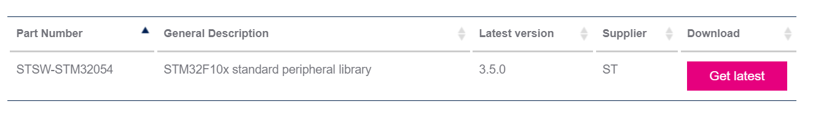

# 2. copy file to project

new BOOT, FreeRTOS, Interrupt, Library, Src directory in project directory. copy file

1. copy to boot directory

STM32F10x_StdPeriph_Lib_V3.5.0\Libraries\CMSIS\CM3\CoreSupport\core_cm3.c

STM32F10x_StdPeriph_Lib_V3.5.0\Libraries\CMSIS\CM3\CoreSupport\core_cm3.h

STM32F10x_StdPeriph_Lib_V3.5.0\Libraries\CMSIS\CM3\DeviceSupport\ST\STM32F10x\startup\arm\startup_stm32f10x_ld.s

2.copy to library directory

STM32F10x_StdPeriph_Lib_V3.5.0\Libraries\STM32F10x_StdPeriph_Driver\

STM32F10x_StdPeriph_Lib_V3.5.0\Libraries\CMSIS\CM3\DeviceSupport\ST\STM32F10x\stm32f10x.h

STM32F10x_StdPeriph_Lib_V3.5.0\Libraries\CMSIS\CM3\DeviceSupport\ST\STM32F10x\system_stm32f10x.c

STM32F10x_StdPeriph_Lib_V3.5.0\Libraries\CMSIS\CM3\DeviceSupport\ST\STM32F10x\system_stm32f10x.h

3.copy to interrupt diectory

STM32F10x_StdPeriph_Lib_V3.5.0\Project\STM32F10x_StdPeriph_Examples\GPIO\IOToggle\stm32f10x_it.c

STM32F10x_StdPeriph_Lib_V3.5.0\Project\STM32F10x_StdPeriph_Examples\GPIO\IOToggle\stm32f10x_it.h

4.copy to src directory

STM32F10x_StdPeriph_Lib_V3.5.0\Project\STM32F10x_StdPeriph_Examples\GPIO\IOToggle\main.c

STM32F10x_StdPeriph_Lib_V3.5.0\Project\STM32F10x_StdPeriph_Examples\GPIO\IOToggle\stm32f10x_conf.h

add file to project

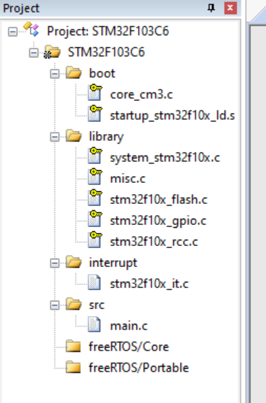

define and config

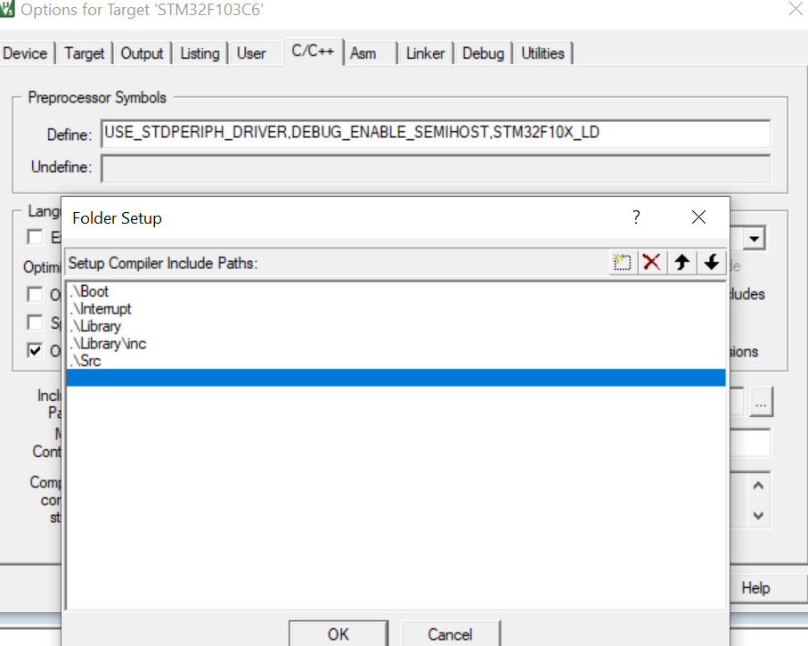

# 3. modify and test

修改Main文件

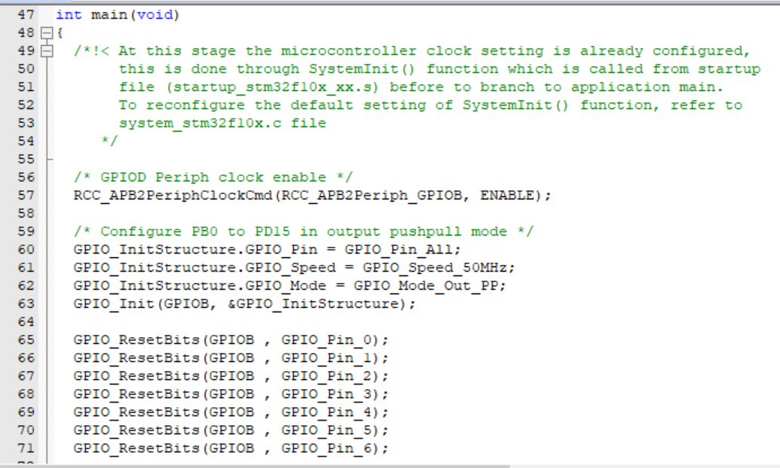

测试结果

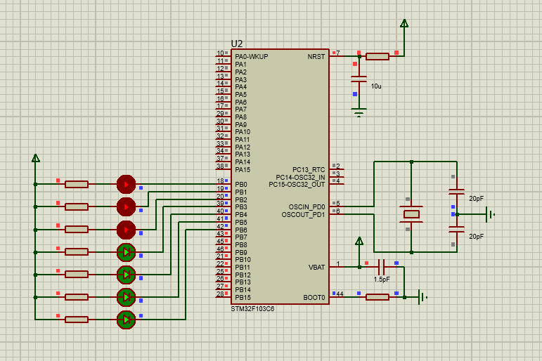

# 4. porting FreeRTOS

1. download freeRTOS

https://www.freertos.org/a00104.html

2. new core, include, portable directory in project directory and porting code

copy flowing code from FreeRTOS to project/FreeRTOS/core

FreeRTOSv202104.00\FreeRTOS\Source\croutine.c

FreeRTOSv202104.00\FreeRTOS\Source\event_groups.c

FreeRTOSv202104.00\FreeRTOS\Source\list.c

FreeRTOSv202104.00\FreeRTOS\Source\queue.c

FreeRTOSv202104.00\FreeRTOS\Source\stream_buffer.c

FreeRTOSv202104.00\FreeRTOS\Source\tasks.c

FreeRTOSv202104.00\FreeRTOS\Source\timers.c

copy include file from FreeRTOS source code to project/FreeRTOS/include

FreeRTOSv202104.00\FreeRTOS\Source\include

copy to project/FreeRTOS/portable

FreeRTOSv202104.00\FreeRTOS\Source\portable\MemMang\

reeRTOSv202104.00\FreeRTOS\Source\portable\RVDS\ARM_CM3\port.c

reeRTOSv202104.00\FreeRTOS\Source\portable\RVDS\ARM_CM3\portmacro.h

FreeRTOSv202104.00\FreeRTOS\Demo\CORTEX_STM32F103_Keil\FreeRTOSConfig.h

add include file directory

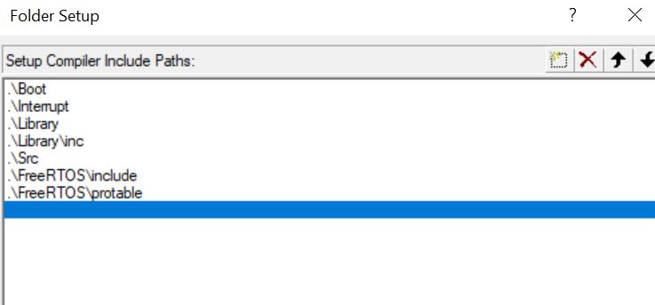

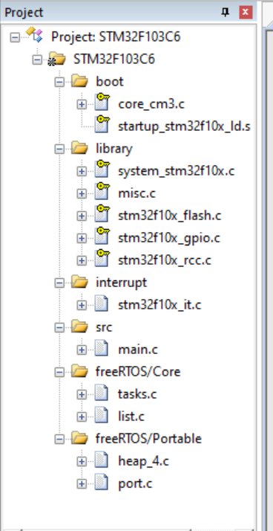

modify code

add include file in main,c

#include "FreeRTOS.h"

#include "task.h"

add in main.c

#define START_TASK_PRIO 1

#define START_STK_SIZE 64

TaskHandle_t StartTask_Handler;

void start_task(void *pvParameters);

#define LED0_TASK_PRIO 2

#define LED0_STK_SIZE 30

TaskHandle_t LED0Task_Handler;

void led0_task(void *pvParameters);

#define LED1_TASK_PRIO 2

#define LED1_STK_SIZE 30

TaskHandle_t LED1Task_Handler;

void led1_task(void *pvParameters);

add in void main() function

xTaskCreate((TaskFunction_t )start_task,

(const char* )"start_task",

(uint16_t )START_STK_SIZE,

(void* )NULL,

(UBaseType_t )START_TASK_PRIO,

(TaskHandle_t* )&StartTask_Handler);

vTaskStartScheduler();

while (1)

{

;

}

add in main.c

void start_task(void *pvParameters)

{

taskENTER_CRITICAL();

xTaskCreate((TaskFunction_t )led0_task,

(const char* )"led0_task",

(uint16_t )LED0_STK_SIZE,

(void* )NULL,

(UBaseType_t )LED0_TASK_PRIO,

(TaskHandle_t* )&LED0Task_Handler);

xTaskCreate((TaskFunction_t )led1_task,

(const char* )"led1_task",

(uint16_t )LED1_STK_SIZE,

(void* )NULL,

(UBaseType_t )LED1_TASK_PRIO,

(TaskHandle_t* )&LED1Task_Handler);

vTaskDelete(StartTask_Handler);

taskEXIT_CRITICAL();

}

void led0_task(void *pvParameters)

{

while(1)

{

GPIO_ResetBits(GPIOB , GPIO_Pin_0);

GPIO_ResetBits(GPIOB , GPIO_Pin_1);

GPIO_ResetBits(GPIOB , GPIO_Pin_2);

vTaskDelay(10);

GPIO_SetBits(GPIOB , GPIO_Pin_0);

GPIO_SetBits(GPIOB , GPIO_Pin_1);

GPIO_SetBits(GPIOB , GPIO_Pin_2);

vTaskDelay(10);

}

}

void led1_task(void *pvParameters)

{

while(1)

{

GPIO_ResetBits(GPIOB , GPIO_Pin_3);

GPIO_ResetBits(GPIOB , GPIO_Pin_4);

GPIO_ResetBits(GPIOB , GPIO_Pin_5);

GPIO_ResetBits(GPIOB , GPIO_Pin_6);

vTaskDelay(10);

GPIO_SetBits(GPIOB , GPIO_Pin_3);

GPIO_SetBits(GPIOB , GPIO_Pin_4);

GPIO_SetBits(GPIOB , GPIO_Pin_5);

GPIO_SetBits(GPIOB , GPIO_Pin_6);

vTaskDelay(20);

}

}

修改FreeRTOSConfig.h

//#define configTOTAL_HEAP_SIZE ( ( size_t ) ( 17 * 1024 ) )

#define configTOTAL_HEAP_SIZE ( ( size_t ) ( 5 * 1024 ) )

#define xPortPendSVHandler PendSV_Handler

#define xPortSysTickHandler SysTick_Handler

#define vPortSVCHandler SVC_Handler

修改stm32f10x_it.c

comment

//void SysTick_Handler(void)

//{

//}

//void PendSV_Handler(void)

//{

//}

//void SVC_Handler(void)

//{

//}

add NVIC_PriorityGroupConfig(NVIC_PriorityGroup_4); in void main()

NVIC_PriorityGroupConfig(NVIC_PriorityGroup_4);