# Platform

Proteus_8.9_SP2 (stm32f103c6)

Keil MDK5

# 1. download STM32F103C6 library (version 3.5.0)

https://www.st.com/content/st_com/en/products/embedded-software/mcu-mpu-embedded-software/stm32-embedded-software/stm32-standard-peripheral-libraries/stsw-stm32054.html

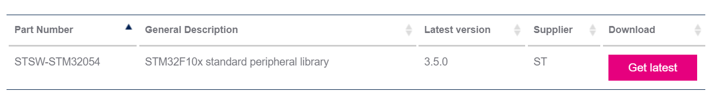

# 2. copy file to project

new BOOT, FreeRTOS, Interrupt, Library, Src directory in project directory. copy file

1. copy to boot directory

STM32F10x_StdPeriph_Lib_V3.5.0\Libraries\CMSIS\CM3\CoreSupport\core_cm3.c

STM32F10x_StdPeriph_Lib_V3.5.0\Libraries\CMSIS\CM3\CoreSupport\core_cm3.h

STM32F10x_StdPeriph_Lib_V3.5.0\Libraries\CMSIS\CM3\DeviceSupport\ST\STM32F10x\startup\arm\startup_stm32f10x_ld.s

2.copy to library directory

STM32F10x_StdPeriph_Lib_V3.5.0\Libraries\STM32F10x_StdPeriph_Driver\

STM32F10x_StdPeriph_Lib_V3.5.0\Libraries\CMSIS\CM3\DeviceSupport\ST\STM32F10x\stm32f10x.h

STM32F10x_StdPeriph_Lib_V3.5.0\Libraries\CMSIS\CM3\DeviceSupport\ST\STM32F10x\system_stm32f10x.c

STM32F10x_StdPeriph_Lib_V3.5.0\Libraries\CMSIS\CM3\DeviceSupport\ST\STM32F10x\system_stm32f10x.h

3.copy to interrupt diectory

STM32F10x_StdPeriph_Lib_V3.5.0\Project\STM32F10x_StdPeriph_Examples\GPIO\IOToggle\stm32f10x_it.c

STM32F10x_StdPeriph_Lib_V3.5.0\Project\STM32F10x_StdPeriph_Examples\GPIO\IOToggle\stm32f10x_it.h

4.copy to src directory

STM32F10x_StdPeriph_Lib_V3.5.0\Project\STM32F10x_StdPeriph_Examples\GPIO\IOToggle\main.c

STM32F10x_StdPeriph_Lib_V3.5.0\Project\STM32F10x_StdPeriph_Examples\GPIO\IOToggle\stm32f10x_conf.h

add file to project

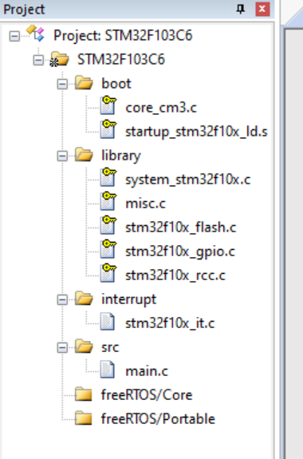

define and config

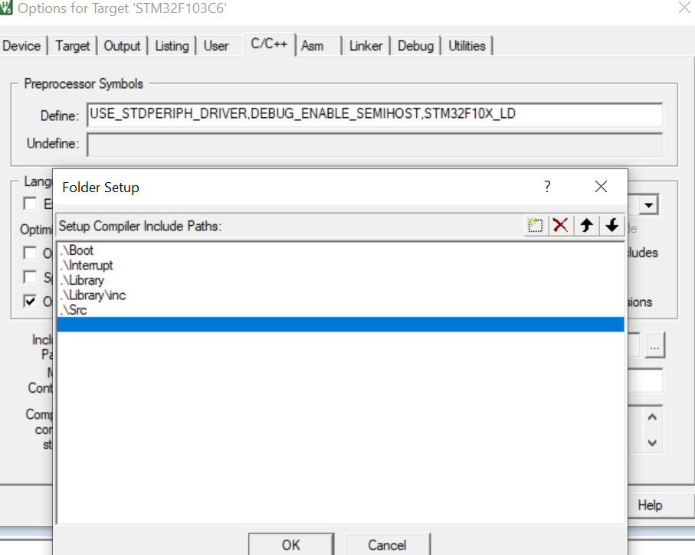

# 3. modify and test

修改Main文件

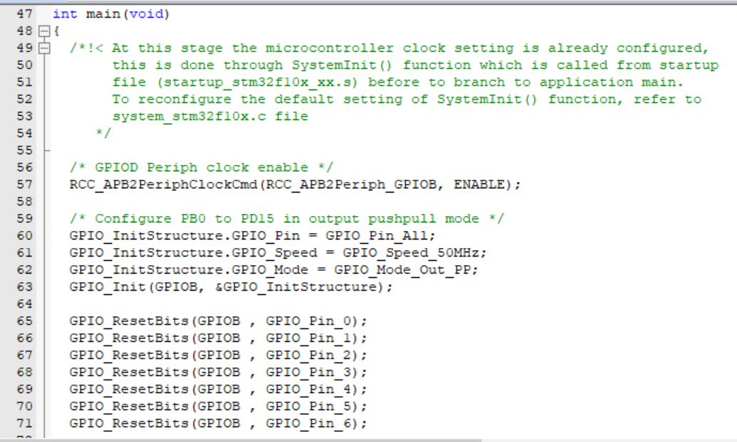

测试结果

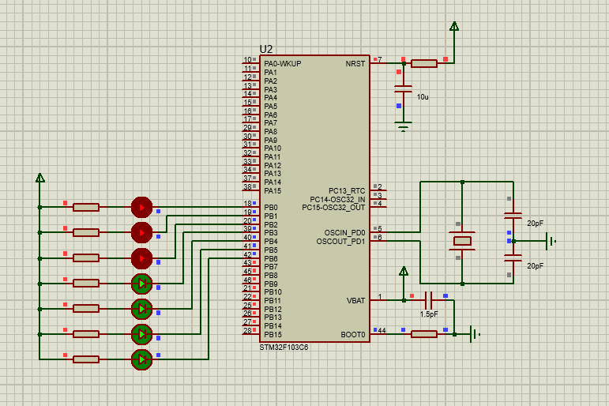

# 4. porting UCOS

1. download UCOS

https://github.com/weston-embedded/uC-OS3

https://github.com/weston-embedded/uC-CPU

https://github.com/weston-embedded/uC-LIB

2. porting uc-lib

uC-LIB-develop\lib_ascii.c

uC-LIB-develop\lib_ascii.h

uC-LIB-develop\lib_def.h

uC-LIB-develop\lib_math.c

uC-LIB-develop\lib_math.h

uC-LIB-develop\lib_mem.c

uC-LIB-develop\lib_mem.h

uC-LIB-develop\lib_str.c

uC-LIB-develop\lib_str.h

uC-LIB-develop\Cfg\Template\lib_cfg.h

3. porting ucos-cpu

uC-CPU-develop\cpu_cache.h

uC-CPU-develop\cpu_core.c

uC-CPU-develop\cpu_core.h

uC-CPU-develop\cpu_def.h

//Cortex-M0 ARM-v6的架构

//Cortex-M3、 Cortex-M4和 Cortex-M7等都是采用的ARM-v7的架构

uC-CPU-develop\ARM-Cortex-M\ARMv7-M\ARM\cpu_a.asm

uC-CPU-develop\ARM-Cortex-M\ARMv7-M\ARM\cpu.h

uC-CPU-develop\ARM-Cortex-M\ARMv7-M\cpu_c.c

uC-CPU-develop\Cfg\Template\cpu_cfg.h

uC-CPU-develop\BSP\Template\bsp_cpu.c

4. porting ucos-source

uC-OS3-develop\Source\os.h

uC-OS3-develop\Source\os_cfg_app.c

uC-OS3-develop\Source\os_core.c

uC-OS3-develop\Source\os_dbg.c

uC-OS3-develop\Source\os_flag.c

uC-OS3-develop\Source\os_mem.c

uC-OS3-develop\Source\os_msg.c

uC-OS3-develop\Source\os_mutex.c

uC-OS3-develop\Source\os_prio.c

uC-OS3-develop\Source\os_q.c

uC-OS3-develop\Source\os_sem.c

uC-OS3-develop\Source\os_stat.c

uC-OS3-develop\Source\os_task.c

uC-OS3-develop\Source\os_tick.c

uC-OS3-develop\Source\os_time.c

uC-OS3-develop\Source\os_tmr.c

uC-OS3-develop\Source\os_trace.h

uC-OS3-develop\Source\os_type.h

uC-OS3-develop\Source\os_var.c

5. porting ucos-portable

uC-OS3-develop\Cfg\Template\os_app_hooks.c

uC-OS3-develop\Cfg\Template\os_app_hooks.h

uC-OS3-develop\Cfg\Template\os_cfg.h

uC-OS3-develop\Cfg\Template\os_cfg_app.h

uC-OS3-develop\Ports\ARM-Cortex-M\ARMv7-M\os_cpu_c.c

uC-OS3-develop\Ports\ARM-Cortex-M\ARMv7-M\ARM\os_cpu_a.asm

uC-OS3-develop\Ports\ARM-Cortex-M\ARMv7-M\ARM\os_cpu.h

uC-OS3-develop\Template\bsp_os_dt.c

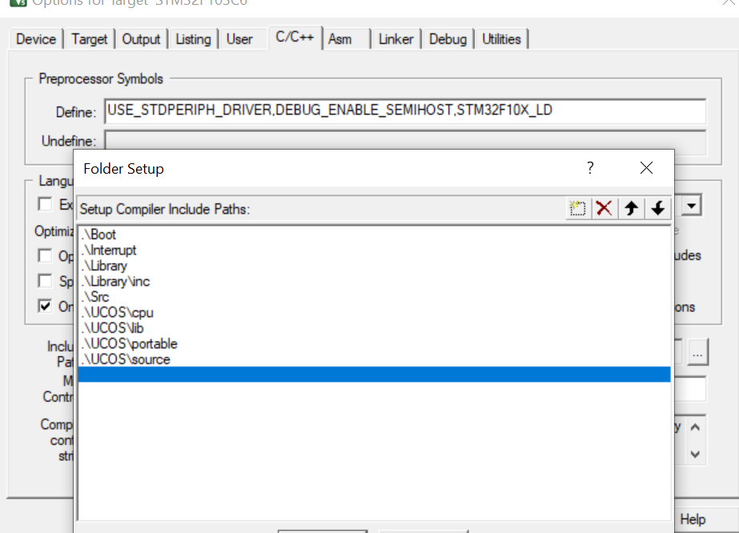

修改os_cpu.c

#include "os.h"

修改 cpu_cfg.h

#if 1

#define CPU_CFG_NVIC_PRIO_BITS 4u

#endif

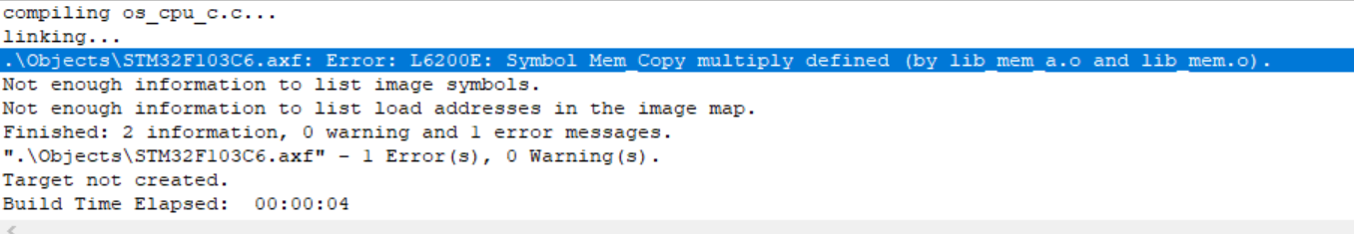

删除lib_mem_a.asm

修改启动文件

将PendSV_Handler 和 SysTick_Handler 替换成 OS_CPU_PendSVHandler 和 OS_CPU_SysTickHandler

;DCD PendSV_Handler ; PendSV Handler

;DCD SysTick_Handler ; SysTick Handler

DCD OS_CPU_PendSVHandler

DCD OS_CPU_SysTickHandler

;PendSV_Handler PROC

; EXPORT PendSV_Handler [WEAK]

OS_CPU_PendSVHandler PROC

EXPORT OS_CPU_PendSVHandler [WEAK]

B .

ENDP

;SysTick_Handler PROC

; EXPORT SysTick_Handler [WEAK]

OS_CPU_SysTickHandler PROC

EXPORT OS_CPU_SysTickHandler [WEAK]

B .

ENDP

UCOS不能同时执行两个任务，

调用OSTimeDlyHMSM(0,0,0,500,OS_OPT_TIME_HMSM_STRICT,&err); LED不闪烁

进入OSTimeDlyHMSM， 发现LED在OSSched() 里不闪烁

进入OSSched(), 发现经过 #if (OS_CFG_TASK_IDLE_EN > 0u) CPU_INT_EN()处，LED不亮

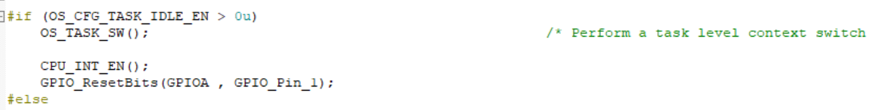

失能OS_CFG_TASK_IDLE_EN后

经过这里

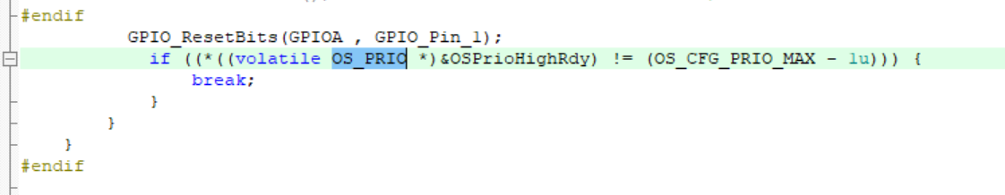

最后发现原因：在OS_IdleTask 写LED 闪烁代码，发现LED闪烁，说明了任务切换的时候，进入了空闲任务

OSTimeDlyHMSM 调用为什么会进入空闲任务？

经查询资料发现：疑似没有初始化SystemTick，在AppTaskStart函数中加上如下内容，再次测试结果

CPU_INT32U cpu_clk_freq;

CPU_INT32U cnts;

cpu_clk_freq = BSP_CPU_ClkFreq(); //获取 CPU 内核时钟频率（SysTick 工作时钟）

cnts = cpu_clk_freq / (CPU_INT32U)OSCfg_TickRate_Hz; //根据用户设定的时钟节拍频率计算 SysTick 定时器的计数值

OS_CPU_SysTickInit(cnts);

原文地址

[(14条消息) uC/OS-III移植后发现程序停在空闲任务出不来_Dlu.的博客-CSDN博客](https://blog.csdn.net/m0_46563076/article/details/104867322)

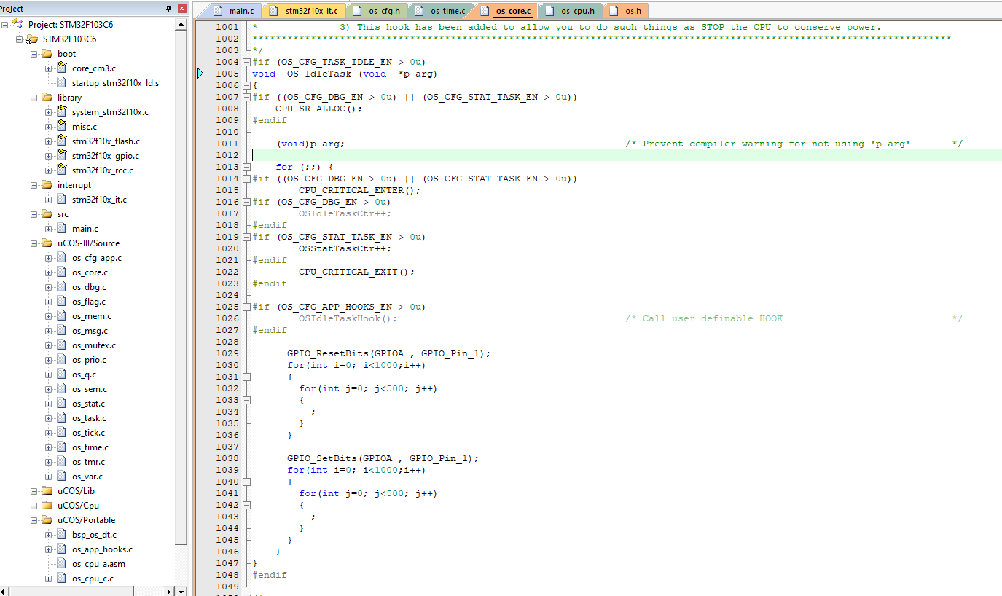

OSSched()任务调度

开始是为task1->切换到task2->切换到IdleTask->systick中断执行中进行任务切换回task1、2

