Project 1: README

Junwen Bu
Build Wizard
- run compile.bat
- run run.bat
Before doing run.bat: After doing run.bat:
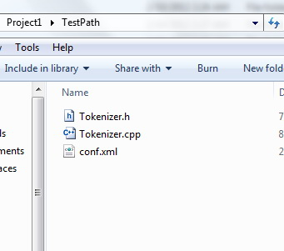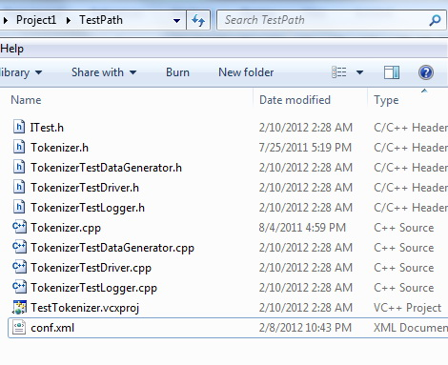

Use Wizard
I copied file folder “TestPath” into “UseWizard” to do Use-Wizard test.
- run runTest.bat to see TestLogger information.

What I did:
Double click ./Project1/UseWizard/TestPath/TestTokenizer.vcxproj

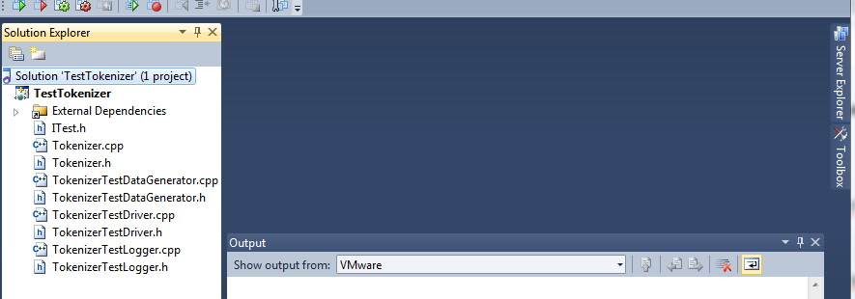

Open TokenizerTestDriver.cpp add code into bool test() function.
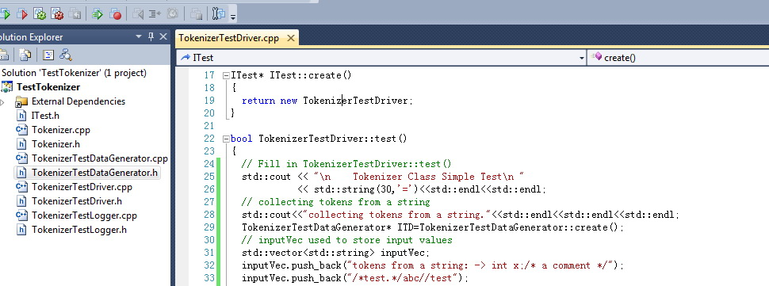
Add new project UseTestTokenizer under ./Project1/UseWizard/TestPath directory; add client.cpp; set StartUp Project; build TestTokenizer to generate TestTokenizer.lib; add TestTokenizer.lib to UseTestTokenizer Project.
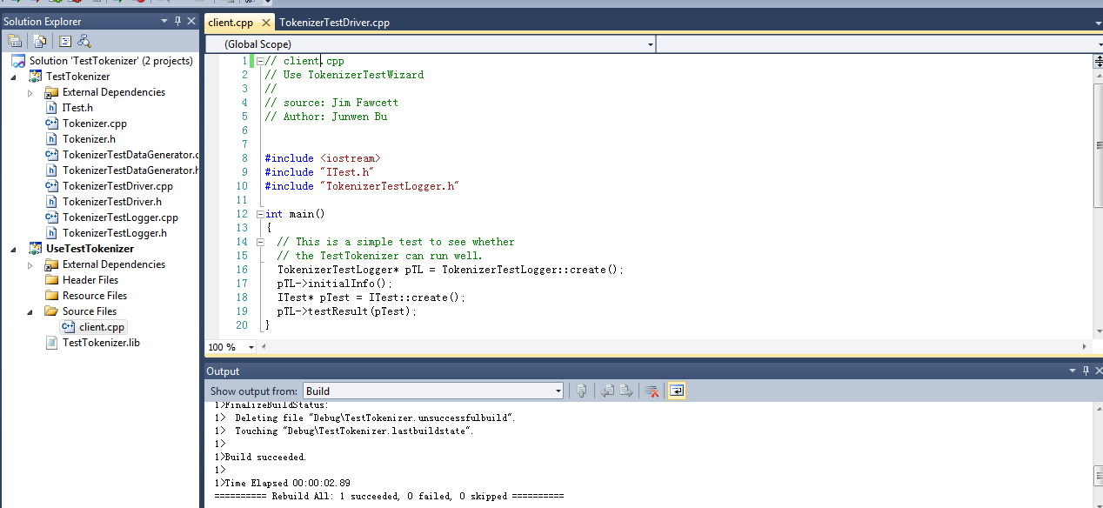
CTRL + F5 Run UseTestTokenizer. Close VS2010.
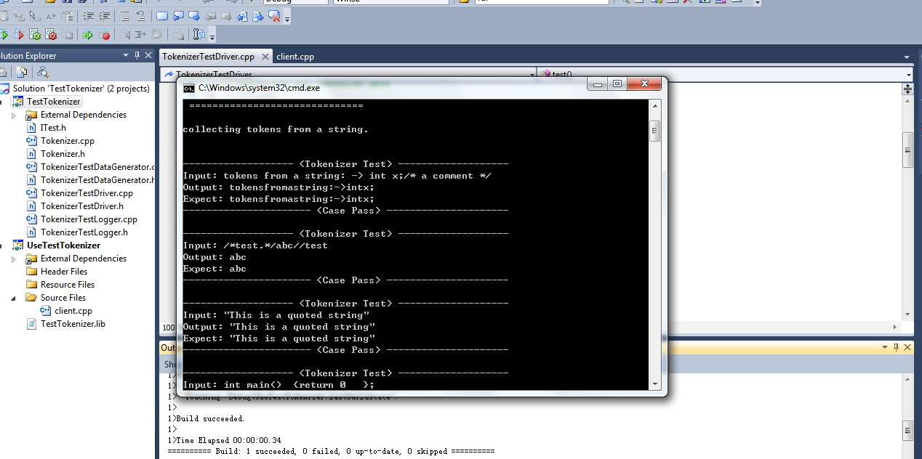
Can also see result of Test Logger by running runTest.bat in ./Project1.

