README

**Junwen Bu**

# GUI Description

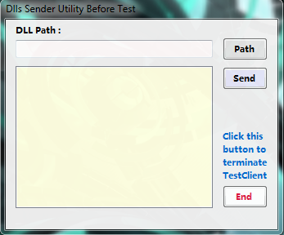

**Dlls Sender Utility Before Test:**

**Path:** select the path of Dll files

**Send:** checking send dll list and send dll files to Test Server

**End:** terminate only TestClient not TestServer

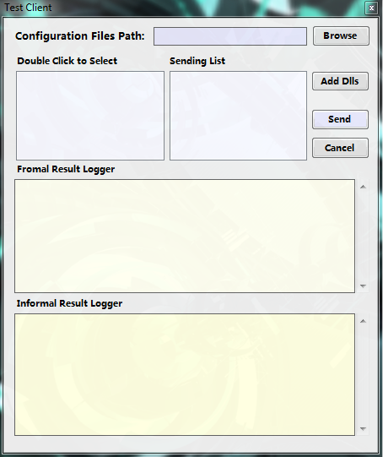

**Test Client:**

**Browse**: browse and set XML files directory

**Send**: check sending list and send Xml files'

info to Test Server

**Cancel**: cancel sending list

**Add Dlls**: show Form which will send dll files

to Test Server

# Compile and Run

## Test Description

**compile.bat** and **run.bat** are in directory: **./Project4/Project4**

In **./Project4/TestCaseFolder** Folder, there are some configuration **xml** files and **dll** files.

Those **xml** files and **dll** files will be sent from **Test Client (Project 4)** to **TestServer (Project 3)**.

Before running there is no dll files in **./Project4/Project3/TestDlls** folder.

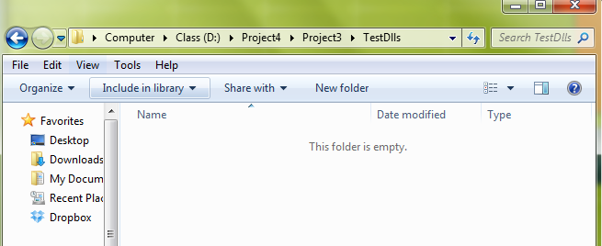

## Run Test

1. run **compile.bat**
2. run **run.bat**

***:run.bat***

***start ..\Debug\Project3.exe***

***start ..\Debug\Project4.exe***

**After execute run.bat:** Click ‘Allow access’

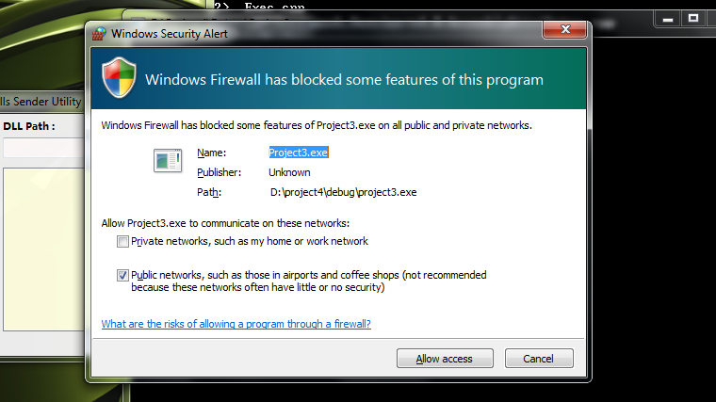

There are two windows:

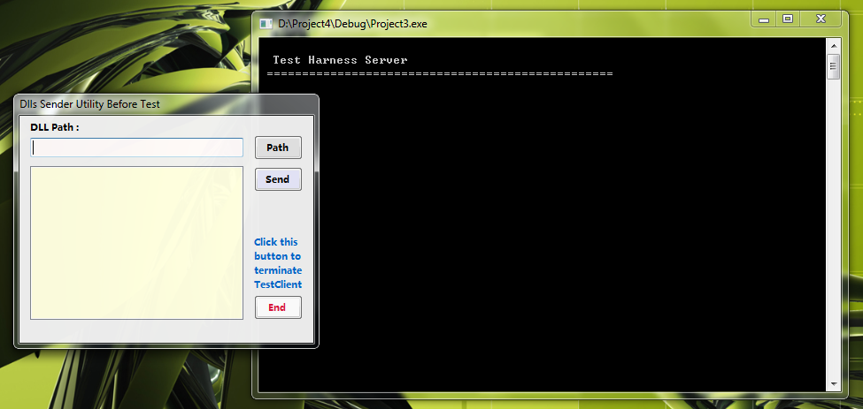

This is a utility to send dll files from the Test Client to Test Server.

Press **‘Path’** Button to Select Dll Path:

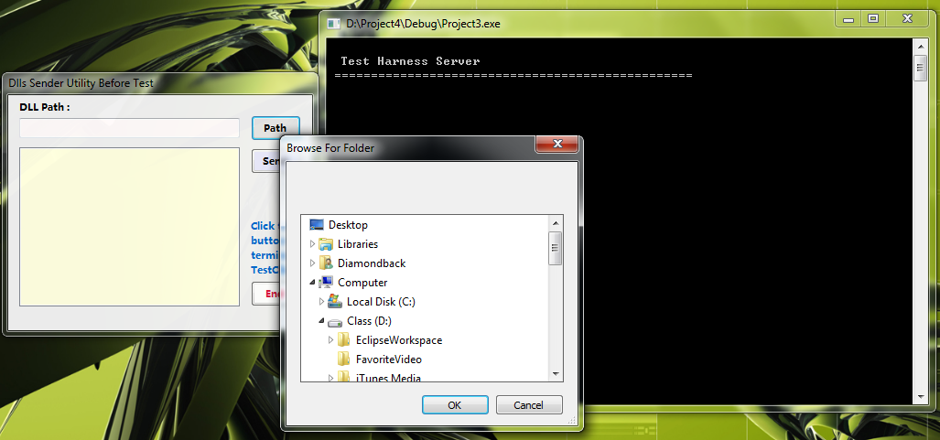

For example, select **./Project4/TestCaseFolder** and click **OK**

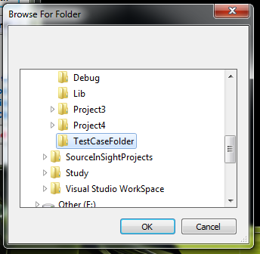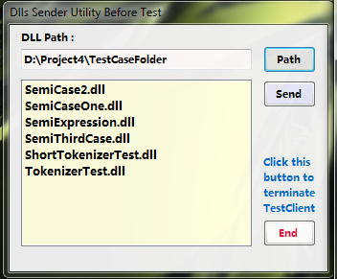

Click **‘Send’** button

A **MessageBox** will be shown. Click **OK** to continue. Click **Allow access.**

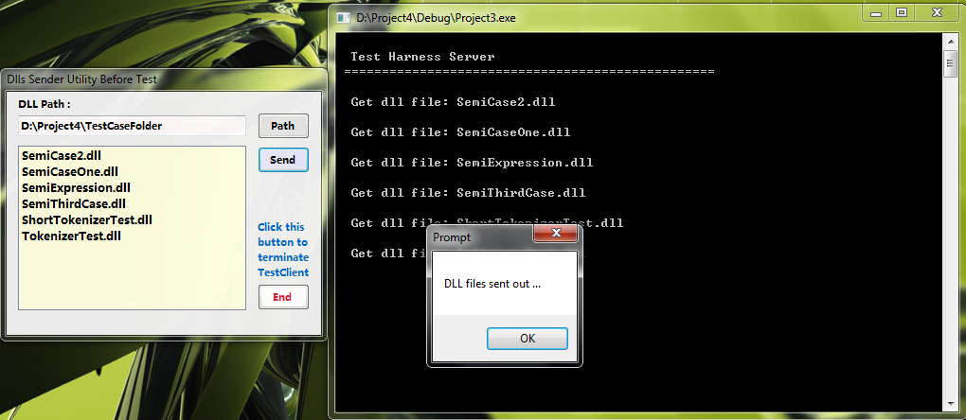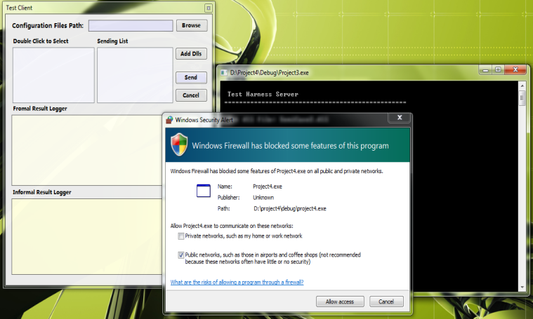

**Dll files** were sent to **./Project4/Project3/TestDlls** folder successfully.

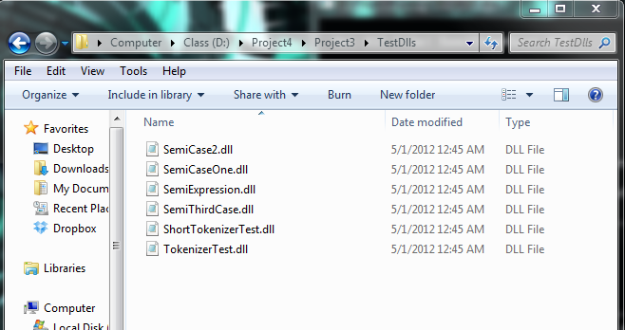

Then click **‘Browse’** button to select Folder of **Xml Configuration files.**  Again, select **TestCaseFolder**.

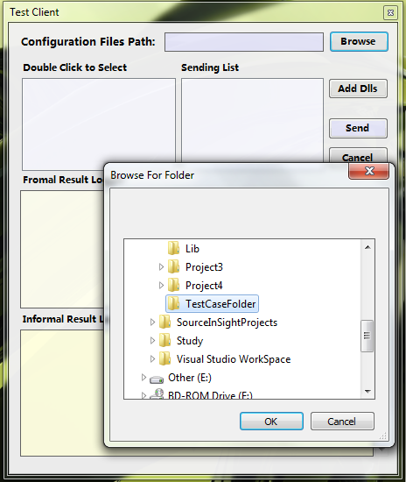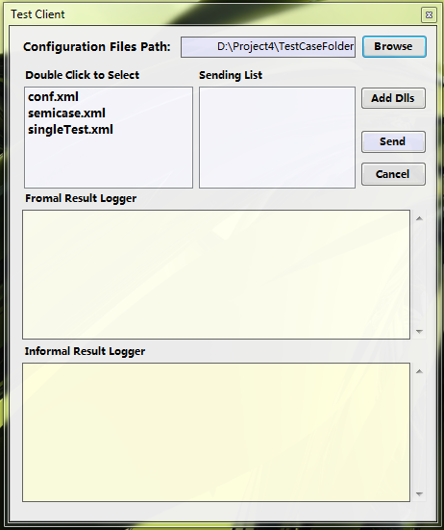

**Double Click Items** in **Left ListBox** to select **xml** configuration files to send**.**

If Sending List not empty and xml files are correct, **test results** will be shown inboth **Client and Server’s Views.**

**Server** only shows **Formal Results. Client** will show both **formal results** and **informal results in two textbox.**

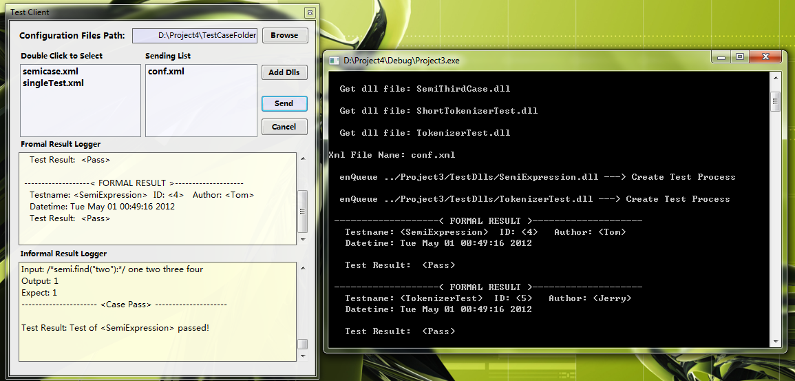

Choose different xml files to do test several times.

If **lacking Dll files,** click **‘add Dlls’** button **to send new dll files** and **<DLL Send Utility>** will show again.

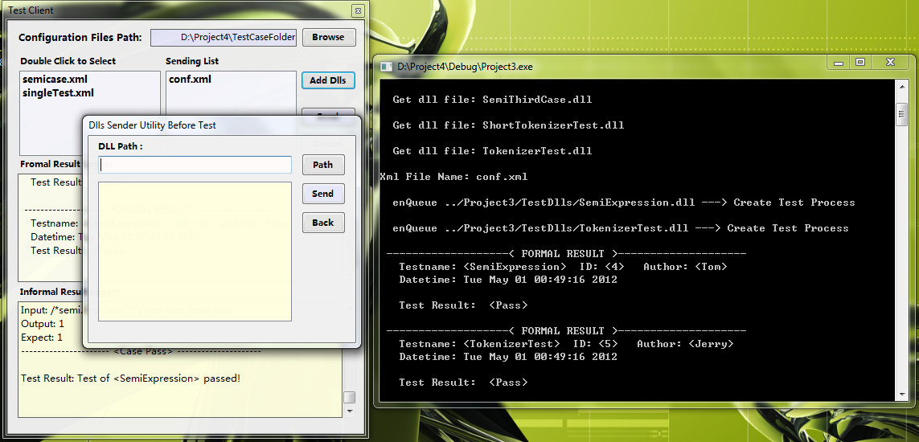

# Others

**Test Client Receiver**

Ip: localhost port: 1354

**Test Server Receiver**

Ip: localhost port: 8088