**Monochrome**

Team CS

GAM150S18KR

Spring 2018

Producer: Chunmook Kim

Lead Designer: Sungmin Moon

Tech Director: Junwoo Seo

Test Manager: Sanghoon Kim

***Table Of Contents***

High Concept……………………………………………………….…… 3

Story………………………………………………………………….…….. 3

Summary………………………………………………….………. 3

Game Mechanics…………………………………………….……….. 4

Color Control………………………………………….………… 4

Platform Rules………………………………………….………. 4

Platform Control.……………………………………………… 4

Summary / Stage Example………………………………... 5

Game Environment………………………………………………….. 6

Game Flow…………………………………………………………….…. 7

Game Controls…………………………………………………………. 7

Component Design………………………………………………….. 8

Visual Design……………………………………………………. 8

Audio Design……………………………………………………. 9

Physics Design…………………………………………………. 10

***High Concept***

Monochrome will be a 2D side-scroll puzzle platformer game, based on usage of color and platform controls.

***Story***

Long time ago, the tribe of white and black were oppressed by other colors, considered “colorless” in others’ view. The three-color tribes, red, blue and green, put a curse upon the road that connected themselves from the colorless tribes. The cursed road absorbed the ones with the same color, and it mainly composed of colorless, giving no chance for colorless tribes to negotiate. After the fall of the colorless tribe, one mysterious figure, having the ability to become black or white with free will, appears in the colorless grave. Seeking for avenge, his journey to other tribes begin, to dye the world into “colorless” once and for all.

The protagonist, with his power to dye others, will be dyeing other tribes’ totems into black or white, weakening the colors and strengthening the “colorless”. The world will start losing its colors, eventually leading to “colorless” state. After dyeing all three of the tribes’ color, the game will reach to an end, depending on what your choices were. Whether you want the world darker than black, or emptier than white. The game will reach to an end by dyeing all three of thentribes’ color. The world will become darker than black or emptier than white by your choice. (빨간색이 수정해야할 부분이고 검은색이 수정한거)

*Summary*

In Monochrome, you play as the protagonist. By controlling the color of the protagonist himself, and controlling the colored platforms. You will be leading him to the tribes and their temples, where the totems of the color lies. You will be the one to choose flow of the story, and based on your choices the game reaches its end based on your choices, the game’s end changes.

***Game Mechanics***

*Color Controls*

The first main mechanic of Monochrome is the color control. White can become any color when painted on, and black can never but black can’t become another color. This applies in our game as well. Player has access to only two colors, black and white, in the beginning, only black and white color in the beginning. and will be the only color they can freely access by themselves. Also those two colors will be the only colors they can freely access by themselves.

At the beginning of every levels, except the tutorial, a new color will be unlocked, and player can change their character’s color into the unlocked color by being soaked by liquid drops while they are in white state. He will lose the ability to become black or white in this state, but they get the ability to emit their current color into a projectile and become white again. White platforms soaked by the projectile will also become the color, Also white platform’s color will turn into whichever projectile’s color that hit the platform, just like how it worked with the player. This becomes a key factor of Monochrome due to the following mechanics.

*Platform Rules*

Simply put; player’s color cannot be the same color as the platform they’re standing on. Player would be absorbed into the platform if so. To avoid this, they get to avoid those situations by switching their color or changing the platform’s color instead.

*Platform Controls*

Platforms with certain colors can be controlled by the player, and appears only after the color is unlocked. By clicking on the platform, they will take the action they are set to do, depending on their colors. Red platforms are destroyed, green platforms rotate clockwise, and blue platforms move left and right when the player takes control. Knowing when and how to utilize the colored platforms will be the key to solving puzzles.

*Summary*

The following is the summary of the power each color has.

Black: Color change immunity. Cannot be changed into other colors by liquid. Black-colored player can switch his color into white.

White: Ability to change into other colors by liquid. The player can switch his color into black.

Red: Red- colored player can emit red color projectile. Red-colored platforms can be destroyed by player’s command.

Green: Green-colored player can emit green color projectile. Green-colored platforms can be rotated by player’s command.

Blue: Blue-colored player can emit blue color projectile. Blue-colored platforms can be moved sideways by player’s command.

This is a simple design example of a level using all colors.

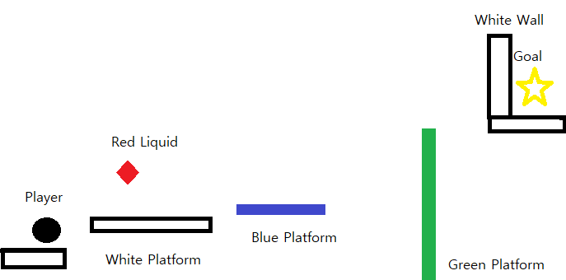

The player will need to absorb the liquid and become red, to destroy the white wall at the end. To destroy the white wall at the end, the player will need to absorb the liquid and become red colored. However, he’ll need to be in white form to absorb the liquid, and turning into white form on a white platform will automatically kill him. So, on the first white platform, he must jump, turn white for an instant, absorb the liquid and land in a red form. land on as a red form.

Then, he will be moving the blue platform sideways, and rotate the green platform to make an angle he needs to reach the goal.

At last, he will emit his red color to paint the wall red and destroy it with his command, opening his way to the goal.

***Game Environment***

*Level Design*

Monochrome is divided into four chapters, and each chapter will have its own theme color. At the start of each chapter, the power of each color is given, and player must utilize the power of each color to reach the end.

*Chapter Themes*

|  |  |  |
| --- | --- | --- |
| Chapter Number | Chapter Themes | New Color(s) Given |
| 1st Chapter(Tutorial) | Colorless Grave | Black / White |
| 2nd Chapter | Azure Waterfall  Temple of Blue | Blue |
| 3rd Chapter | Malachite Forest  Temple of Green | Green |
| 4th Chapter | Crimson Volcano  Temple of Red | Red |

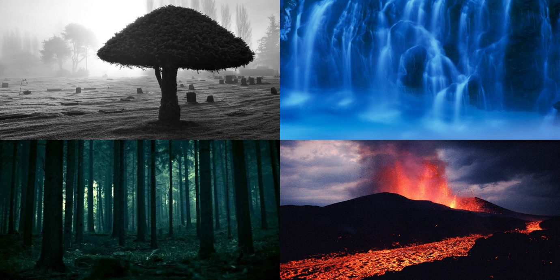

***Game Flow***

Monochrome starts as a simple platformer, in which the player can change its color with freedom, from two colors; black and white. Those levels with only two colors will be a simple tutorial for the players, with explanation of the main system and mechanics. The tutorial will be a simple platformer, with almost no puzzle aspects. Players will only learn how to control correctly, moving, jumping and changing colors between black and white, when with only two colors.

Then, the player will obtain certain new colors by proceeding to a certain level. Each of the colors will have their own power, and this is where the puzzle aspect of Monochrome will shine. All the levels after obtaining colors will be puzzles, and the players must think of each colors’ special abilities and how it will help them in this level. Each level composes of multiple stages, and stages will become longer and harder as the game goes on.

***Game Controls***

Monochrome will have only a few buttons for control. First, as a platformer game, it will have keys for player’s movement, moving left, right, and jump. The keys will be WASD, obvious keys for a keyboard input. Next, there will be a key for players to change their colors, only when the player is black or white. Left clicking in black or white form will change his color into another. Also, there will be keys for the players to control the platforms, depending on their colors. Right clicking on platforms will make the platforms take their actions, depending on their colors. Scroll of the mouse will be used to let the players see the whole view of the stage, which is important in a puzzle. Escape key will be used to pause the game and open the menu.

***Component Design***

*Visual Design*

Background

The background of levels will change, on each level and environment, fitting the main theme and color of the level. Also, there will be different variations of the same background, depending on which color(black/white) the player chose to dye the totems. Animations for the background is highly desirable, but is low on priority.

Animations for level backgrounds

* Rain, thunder (Colorless Grave)
* Waterfall (Azure Waterfall)
* Forest (Malachite Forest)
* Volcano Eruption (Crimson Volcano)
* Animation of Torches (in each Temple of Colors)

Character

Sprites and animation will be done for the protagonist. It will be done in simple artwork, and animations.

Animations for protagonist

* Standing
* Moving
* Jumping
* Emitting the projectile

*Audio Design*

Music

All game music is most likely to be done in piano, or classic themes, fitting the peaceful, chaotic or desperate situations of the game.

Title Screen

With Colorless Grave as its background, the title screen’s theme will be representing the sad theme of Monochrome and background story.

Sound Effects

Sound effects will be used for both the environment and character movement. The environmental sound effects will be used to depict the environment, like the waterfall or the volcano. For character movement, sound effect will be used for character movement, like jumping, running and changing colors.

SFX for environment

* Colorless Grave – Rain, Thunder
* Azure Waterfall – Waterfall
* Malachite Forest – Birds chirping, sound of wind
* Crimson Volcano – Eruption
* Temple of Colors – Torches Burning

SFX for protagonist

* Running
* Jumping
* Changing colors
* Emitting color projectile
* Stage Clear

*Physics Design*

All objects will have collision, and only some of the platforms will be influenced by the gravity. All player movement will be controlled by a certain velocity and gravity. Some platforms will ignore gravity, and when player controls the colored platforms, they will react in a certain calculation given for the color.