How to …

**Solution Development Environment**

1. The solution is built using Visual Studio 2017 CommunityEdition
2. The solution is created as a ASP.NET Core Web Application using Angular 2+
3. Unit Tests are created using .NET Core Unit Test
4. The solution is built using a single project and the Cats list is exposed using WebAPI and it is called from Angular2+
5. The solution uses NewtonSoft.Json Nuget library for mocking the test data

**Solution**

1. The solution contains 2 projects – a web application project and a unit test project
2. The web application project uses Angular2+ as UI Layer and ASP.NET WebAPI as the Service Layer that access the published data
3. The Service Layer access the web service and process data to suite the requirement and serve it using a WebAPI
4. The Angular application consumes the WebAPI to display the data in a web browser.
5. The unit test uses the currently available data to mock the test.

**Screenshots**

On running the application, the home page is opened in a web browser

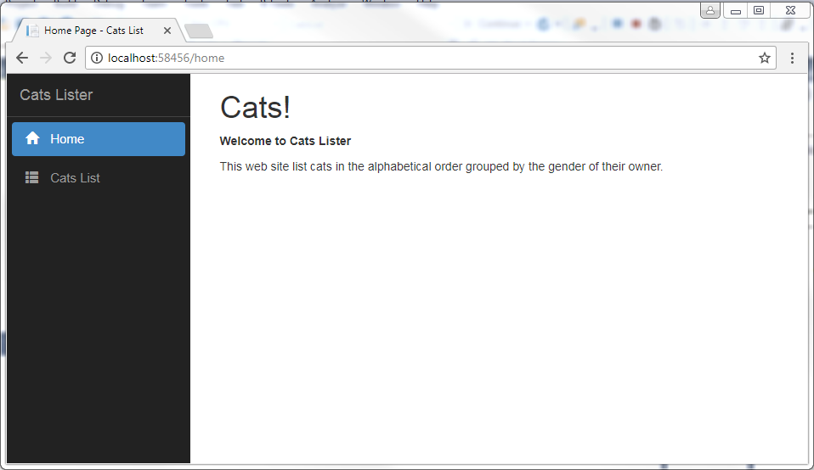

On clicking the Cats List menu at the left hand side, the below screen is displayed with the lists of cats with male and female owners.

