**Introduction**

I choose AISI 1045 as new metal material. Because it is economical and has good overall performance.

As we can see from below, it is much stronger than ABS. However, the problem of using metal is its’ density. The density of 1045 is 7870 and ABS is 1050. So it is around 7 times heavier than before. So we have to reduce the thickness and simplify the structure.

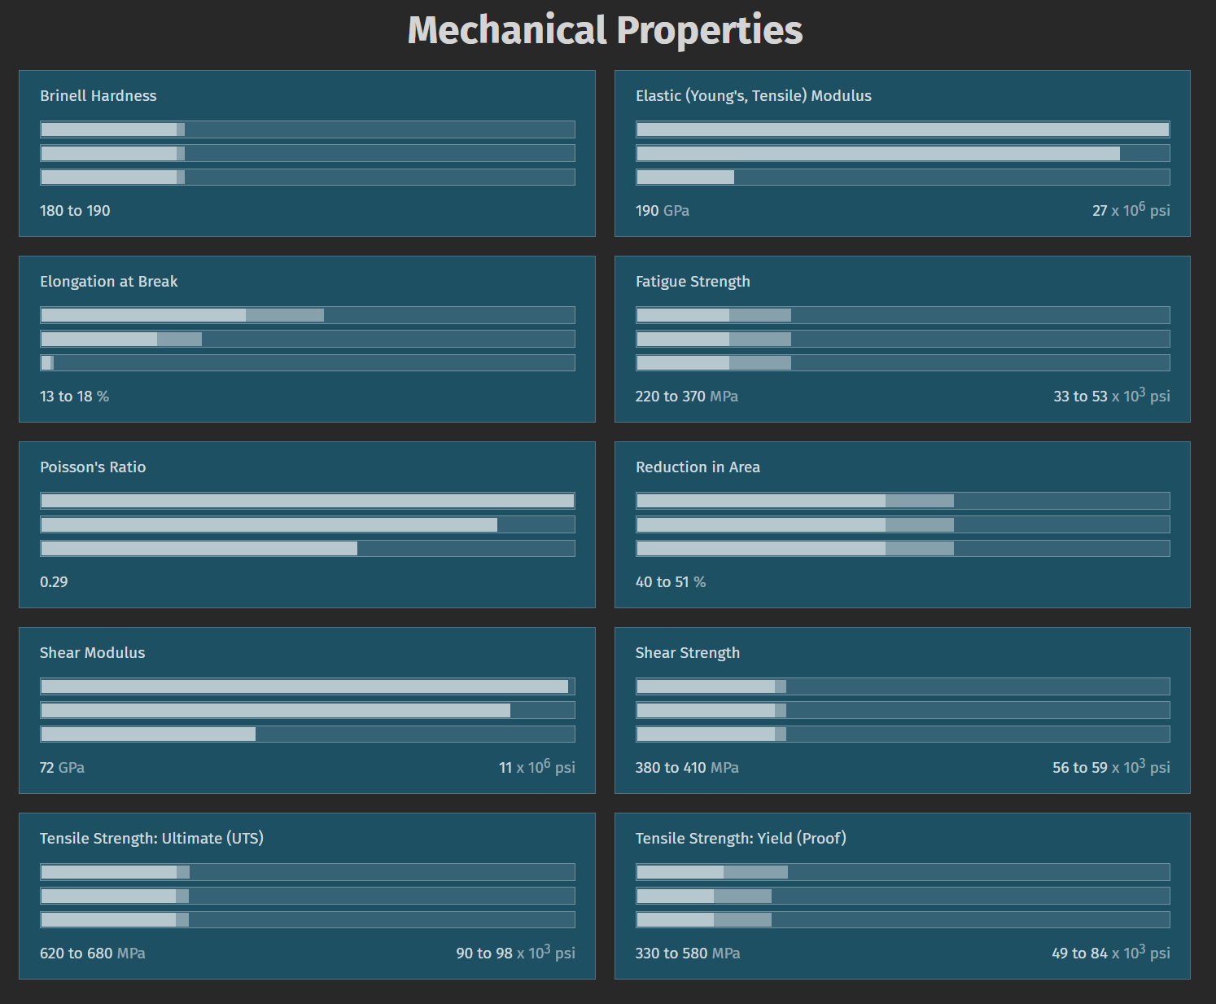

Figure 1 SAE-AISI 1045 (S45C, G10450) Carbon Steel

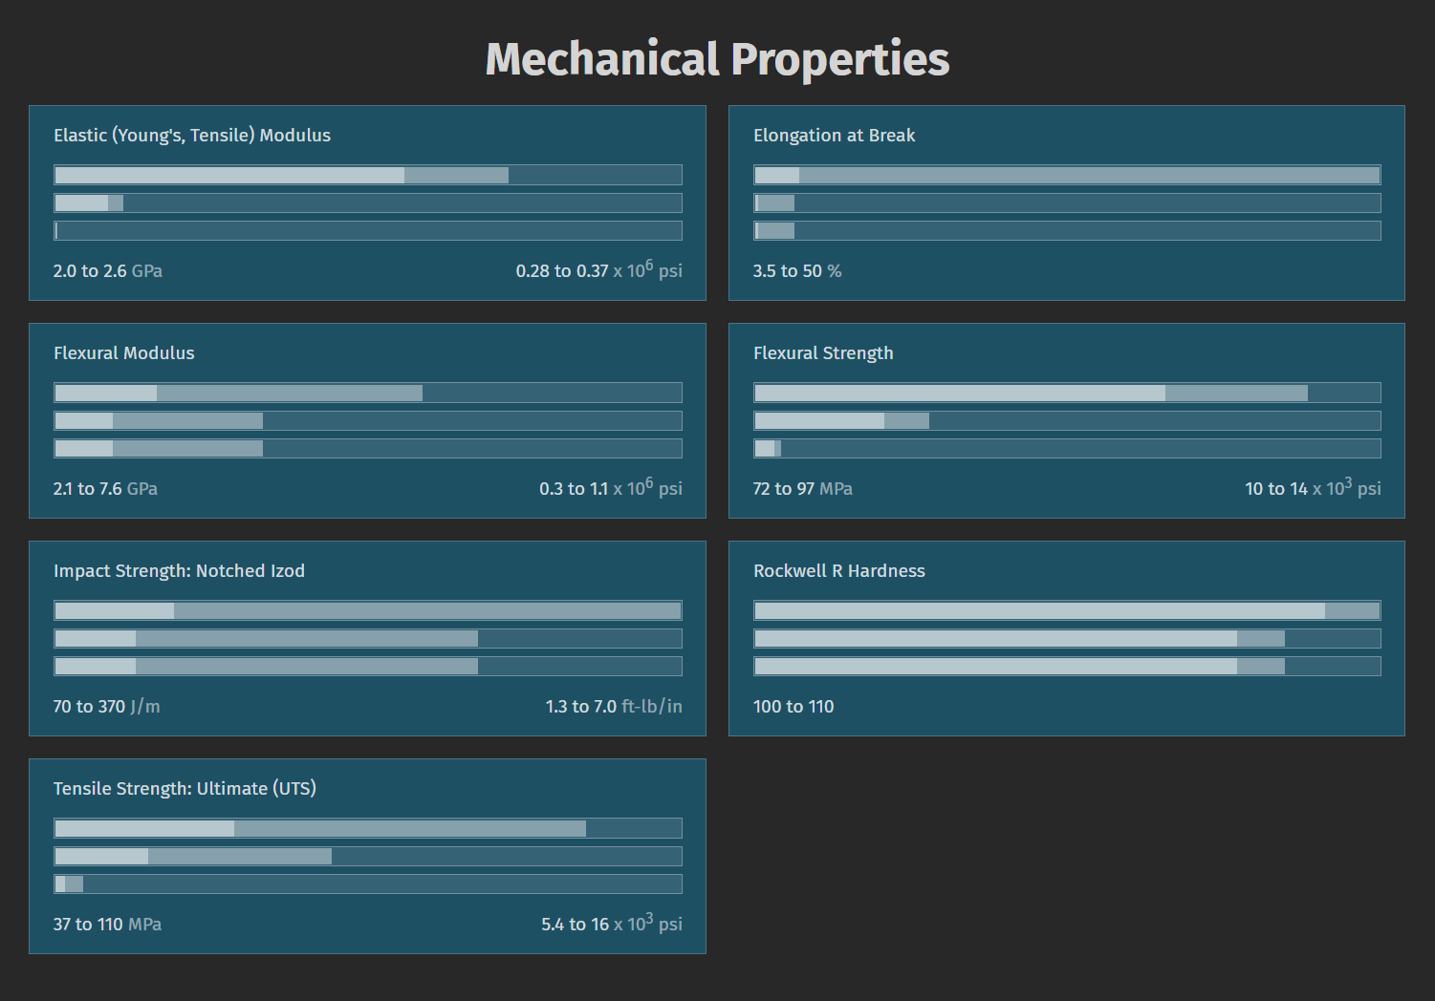

Figure 2 Acrylonitrile Butadiene Styrene (ABS)

Frist of all, I write a matlab script to compute the ideal new structure volume ratio. The original weight is 10.6kg. If we just replace the density of material the new weight would be 33.5kg which is way too heavy. So the equivalent volume shrink ratio I choose is 0.35 for upper body (Consider the ABS chest of upper body actually can be remained.) and 0.5 for lower body. So that the aimed final weight is 18.7kg and weight change ratio is 1.76. After balancing, I decide to use 2 millimeter thick metal sheet instead of 6 millimeter ABS which is the previous parameter. And after remove some structure, I believe it can be lighter than the aimed weight.

**Simplification**

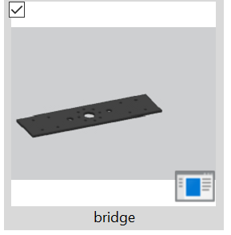 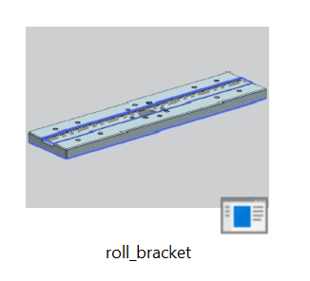

I noticed that there is a designed gap for wire. But by that way it is thick. So I change the gap to hole which the whole structre can be thin and hole is cheap.

There are also other similar changes been made.

I think the foot design need to be explained a little bit.

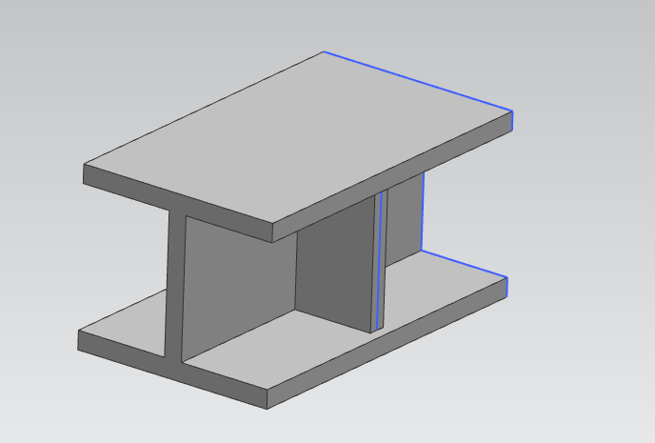

Figure 3 1st foot design concept

I understand the advantage of using structural steel. The first design I considered is use I beam with two fins as shows above. It is very easy and strong but here the issue is structural steel has its own standard with the size of the foot, the thickness is quite large (8 mm) which will make it super heavy.

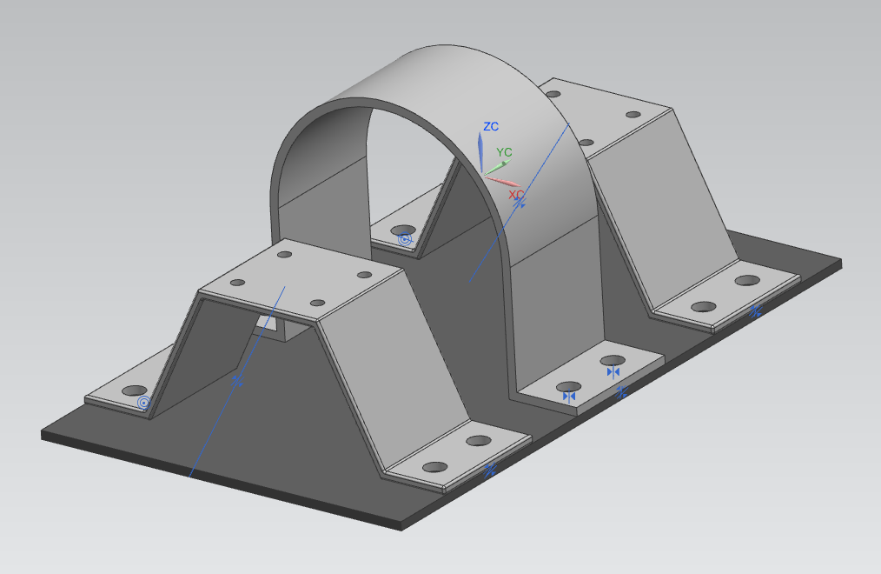

Figure 4 current design

So I decide to design it as this this the center arc is for support the body weight because I it is kind of dangerous to let the ankle bear the whole weight and the beam as well.

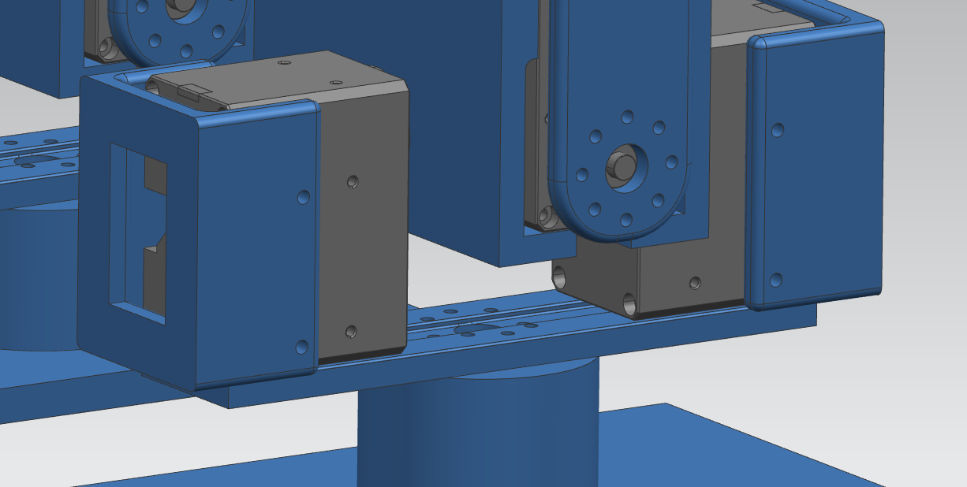

Thank you for your reading!

Welcome for your comments!