Exercise 1: Inheritance Relationship Question 2



i.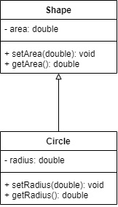

ii: setArea(), setRadius(), getRadius()

iii: area

iv:

a

i: legal

ii: illegal

iii: legal

iv: legal

v: legal

Exercise 1: Inheritance Relationship Question 5

i.

a. width = _w

b. length = _l

ii. extends Rectangle

iii.

a. super(10,15)

b. height = 10

iv. return height * calculateArea();

v. super.display()

vi. Square squarebox = new Square();

vii. squarebox.display();