Page 238 Exercise 1 – Concept

Q1

1. 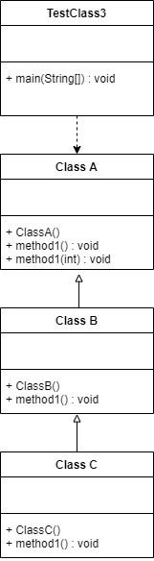
   1. Class C
   2. Class B
   3. Class B
   4. Class C

Q3

* 1. False
  2. True
  3. True
  4. False
  5. True
  6. True
  7. False
  8. No
  9. Yes
  10. Yes
  11. No

Q8

The printMessage method in the parent class (in program 9.15) is declared as final, which its’ child class, ProfNetBallPlayer which also has a printMessage method fails to override the parent’s method.

Amended Program:

//Program 9.15

public class NetBallPlayer{

private int jerseyNumber;

public void printMessage(){ /////notice the method here omit the final keyword

System.out.println("I am a good netball player");

}

}

Q9

A final class cannot be extended (cannot have child class). If we’re intended to extend the Game1 class, it should not be declared with final keyword.

Amended Program:

//Program 9.17

public class Game1{ //// notice the class declaration here omit the final keyword

private int count;

public void printGameRule(){

System.out.println("Count your turn "+ count);

}

}

Page 250 Exercise 2 – Abstract Class

Q1.

1. Illegal
2. Illegal
3. Legal
4. Legal
5. Illegal

Q2.

1. 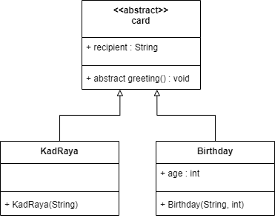
2. 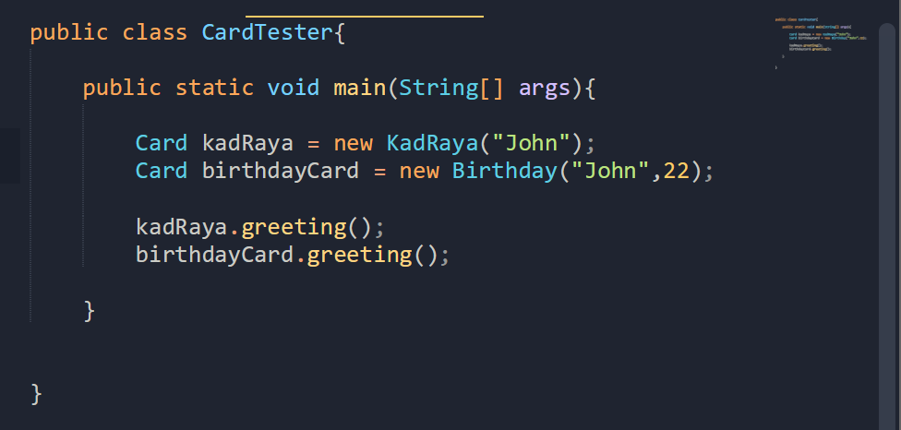
3. 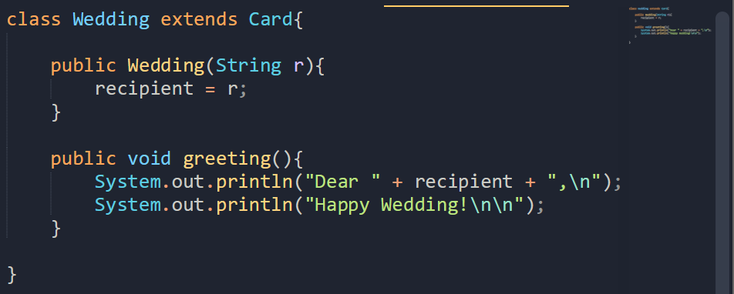  
   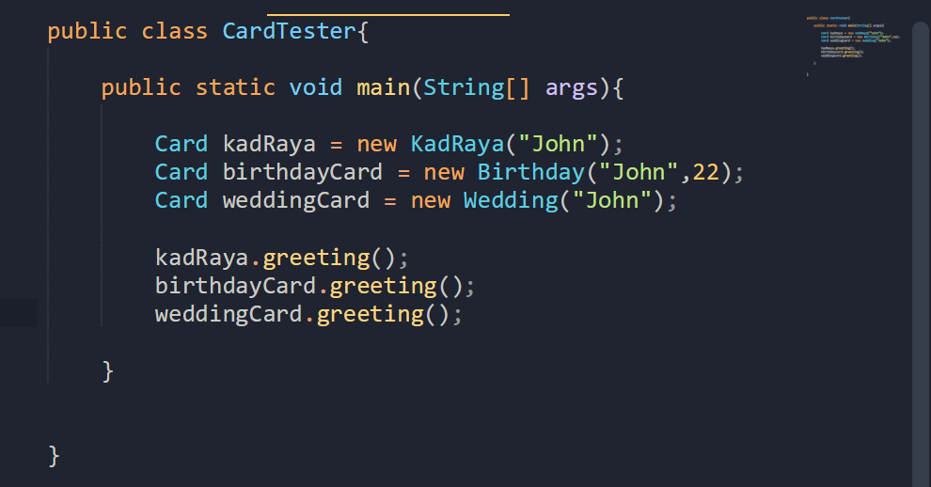
4. 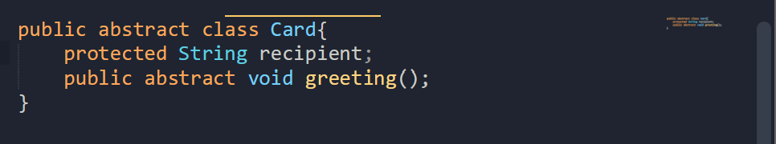  
   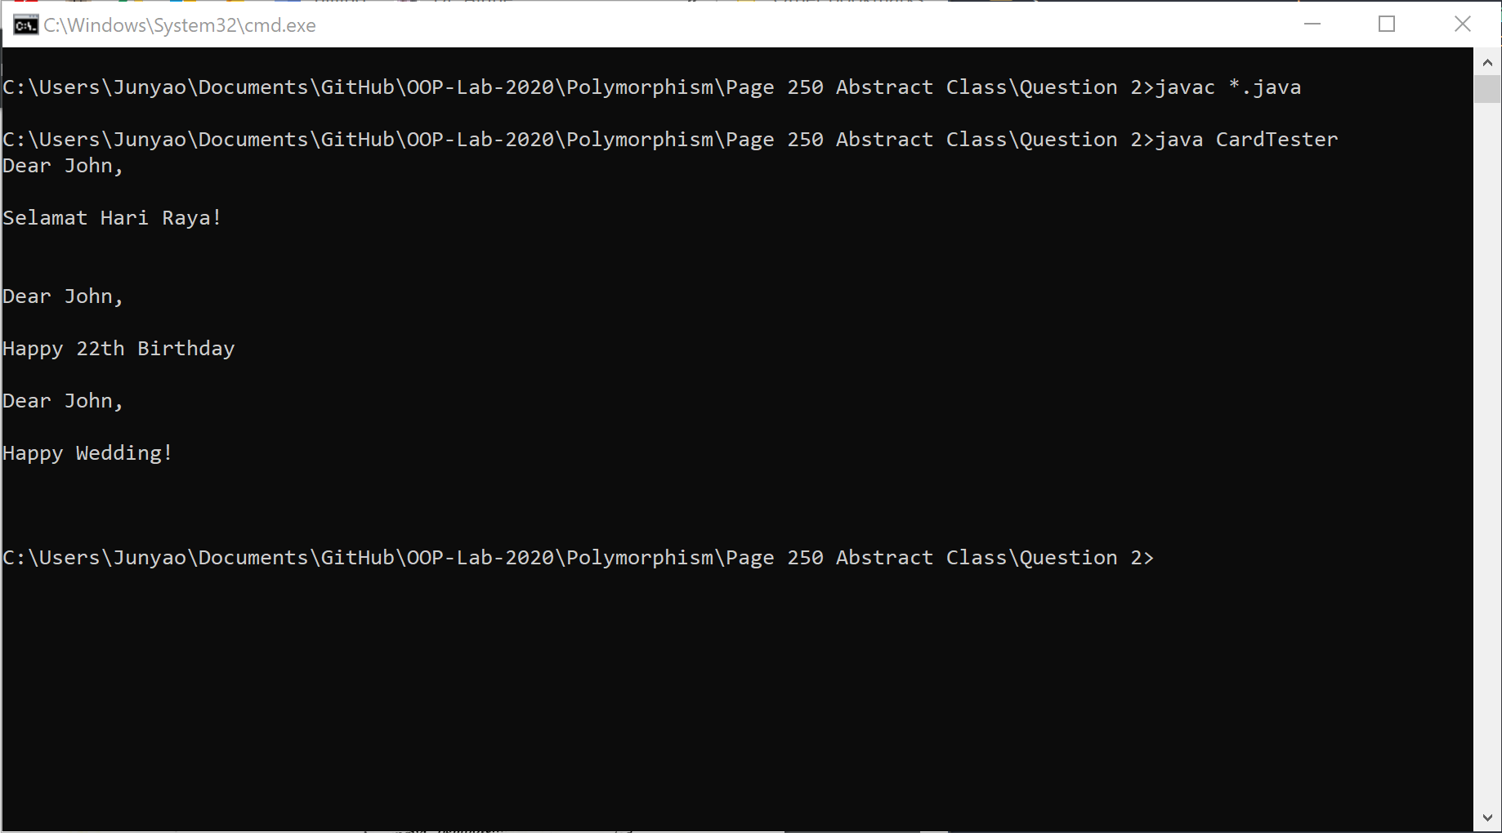
5. 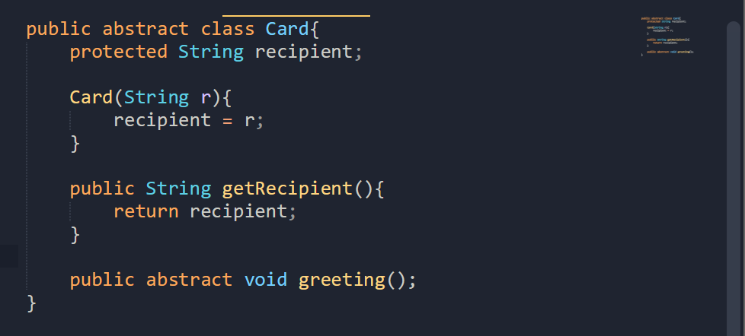  
   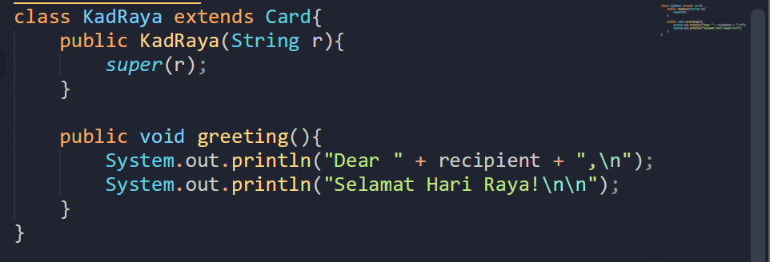  
   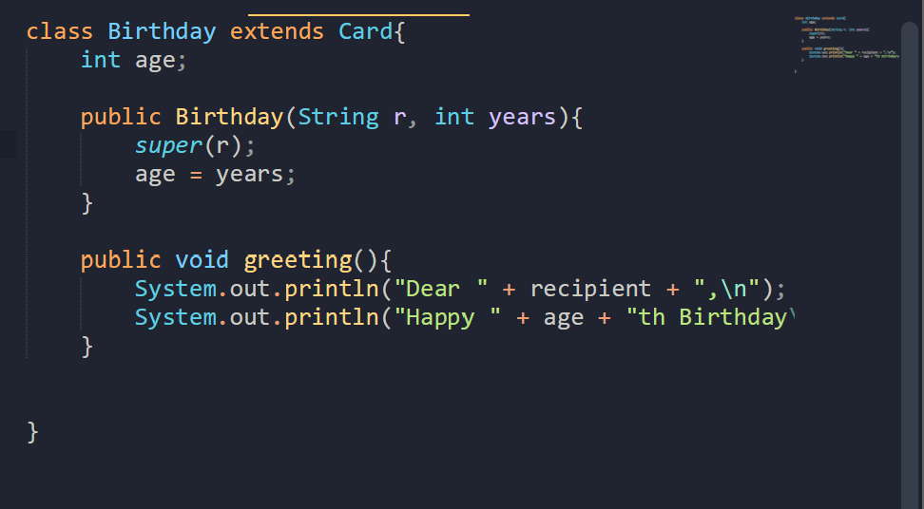  
   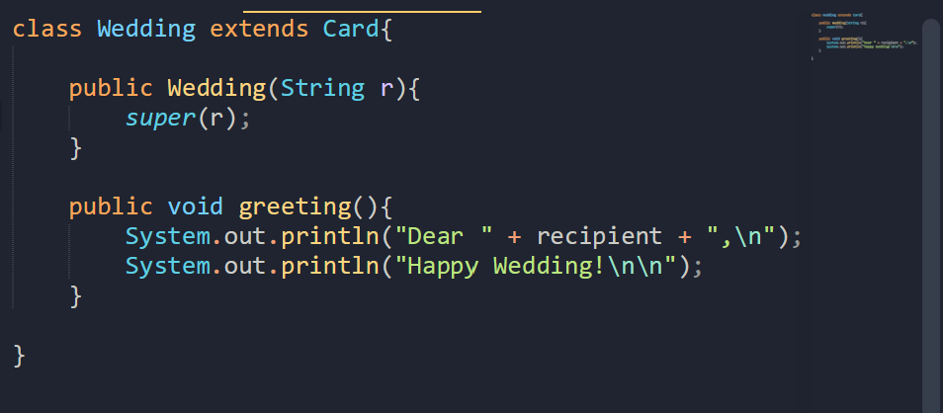  
     
   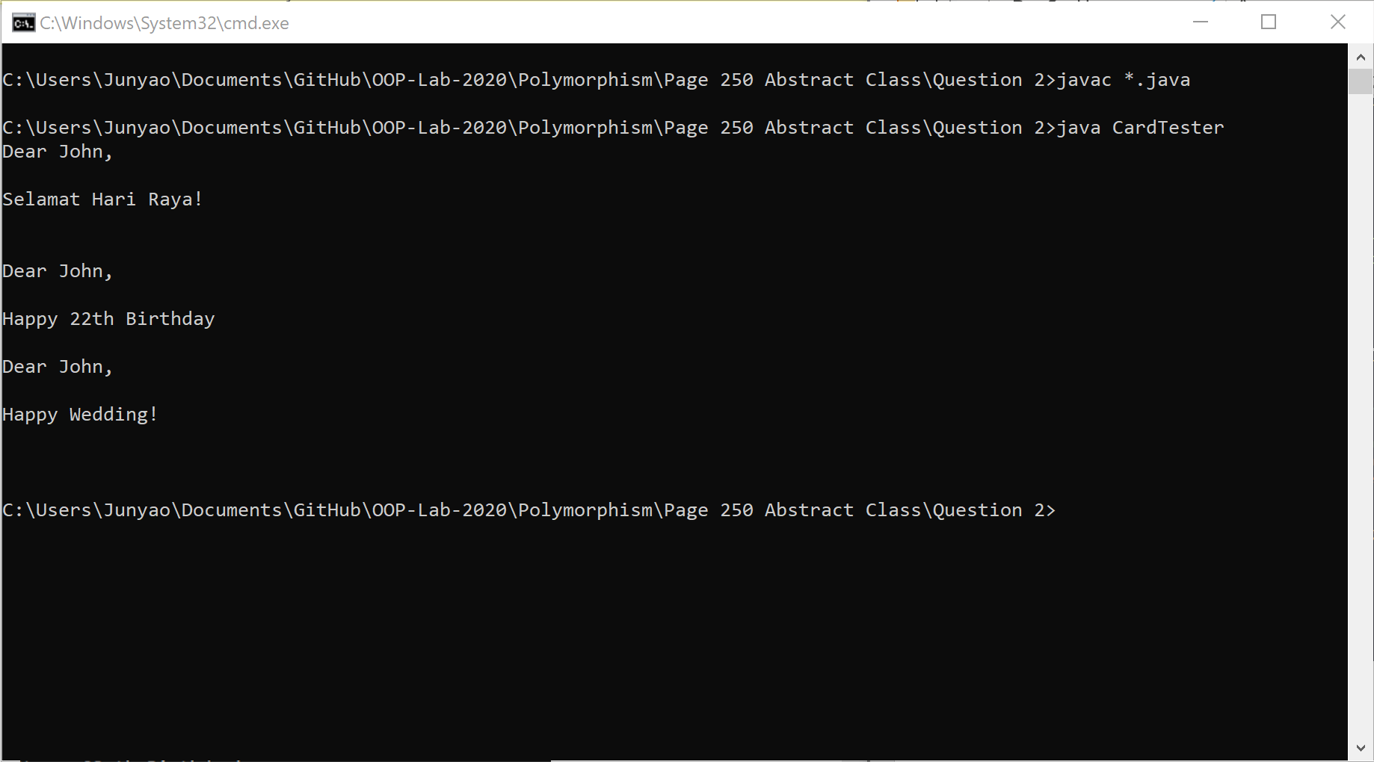

Page 259. Exercise 3 – Interface

Q1.

1. Legal
2. Legal
3. Legal
4. Illegal

Q2

1. 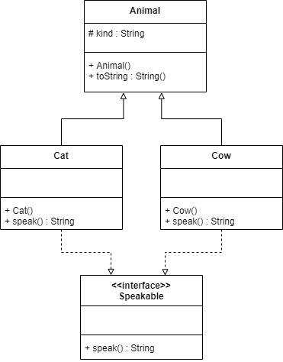
2. 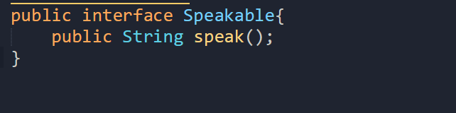  
   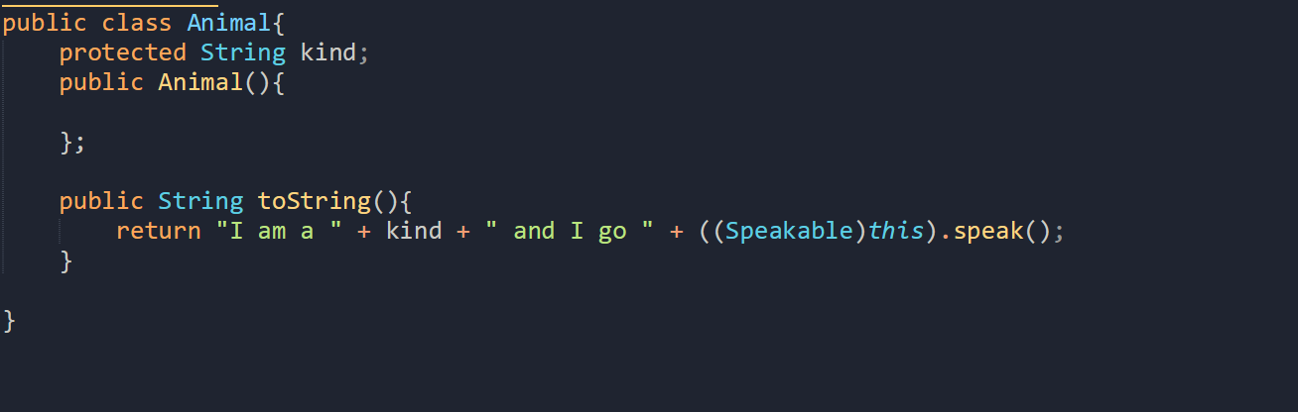  
   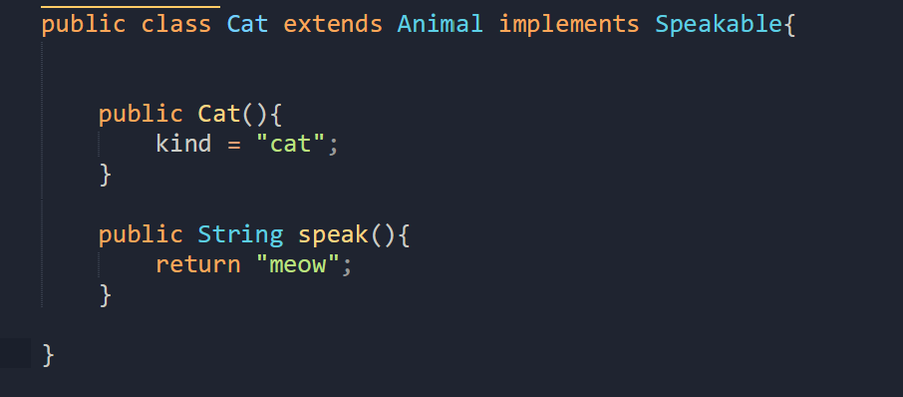  
   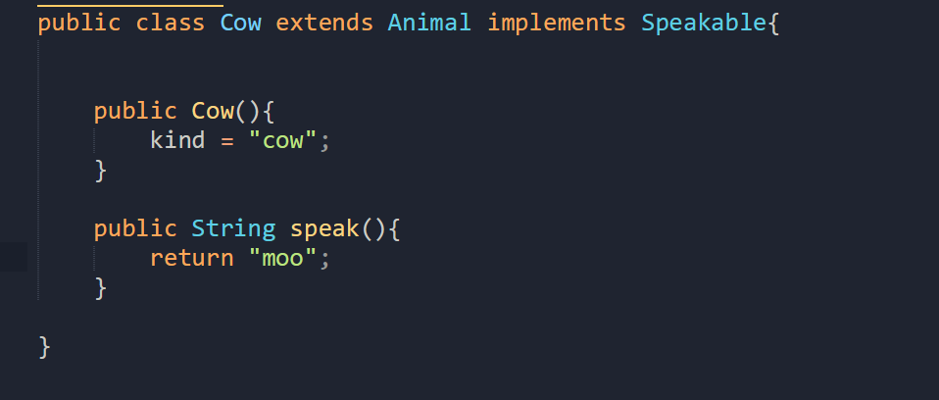  
   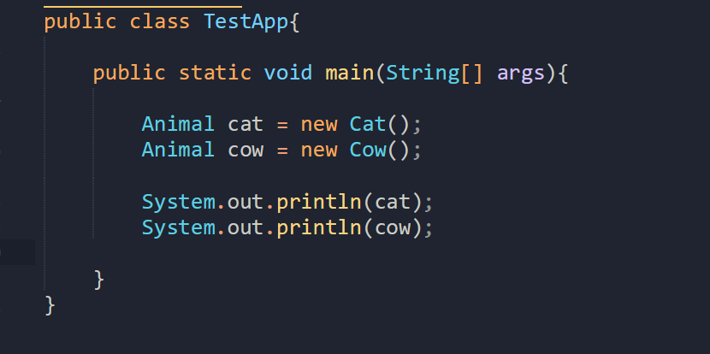  
   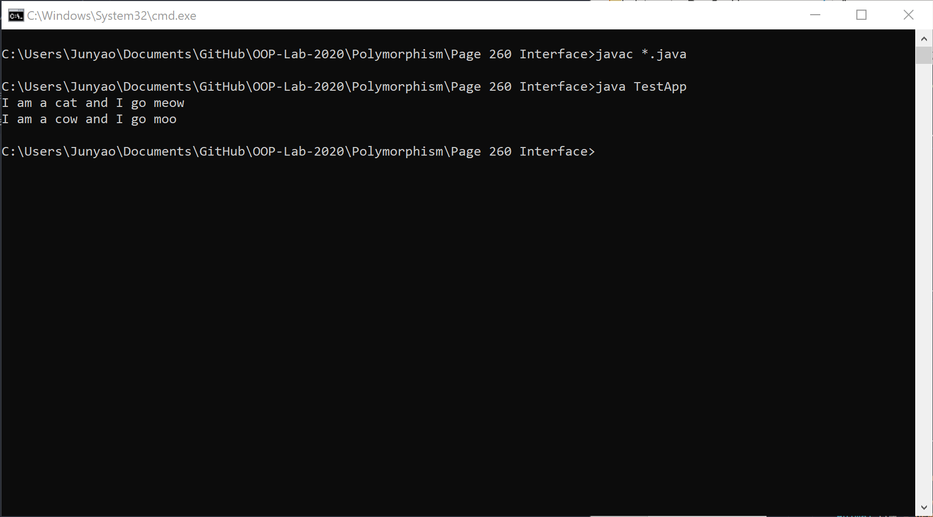  
     
   The Cow and Cat class is a child class of the Animal Class. When passed into the System.out.println, the Cow and Cat class’s overridden toString method is called and return a string to be printed on the console.

Page 263 – Problem Solving

