

███████__██__███___██__█_████_███████

█_____█_██_█_██_██__█__█_█____█_____█

█_███_█______█_███__██____██__█_███_█

█_███_█__███_█__█__██_█__███__█_███_█

█_███_█__█_█__███_███_█_██_██_█_███_█

█_____█_█_█_█_█_███_██__██_█__█_____█

███████_█_█_█_█_█_█_█_█_█_█_█_███████

________█__█_████__█__█_██__█________

____████__█_██_█_█_█___█_██___██___█_

████_█__█_█_██__██__█____███___███_█_

█_█████____██__██████__█_██____██_█_█

██__██_██_███_█_██_█_______█__█___█__

█__█_████_█__█_██____██_______██__███

██████_____██_█________█████__██____█

__█___█_█_█__█__███_____█_█______█_█_

__█_█__█████_█__█______█_█___█_█_█__█

█__██_██__███___███____███_____██_█_█

_██_██__████_█____███____█___█__██__█

___██_██__________█____████____█_██__

_█_███_█_███______████__█__█_█_█___██

___██████___█________█___█__█_████___

█__█____█__█_█____████__█████__█_█__█

_█__█_█___██_____________██_█__███_██

___█_█_█_█_██_██__█_____█___████_█__█

██__█_█_█_███____█_█_██████__██___███

███_██__█_█_█_████____█_██_█_███_█_██

__██_███_█__█_____█_█_██_█___█__█_█__

__█__█_███___██_█_█_██_█__█___██___██

███_███_█_█__█_█_███_█____█_█████████

________██__█_█_█______█_██_█___██___

███████_█___███__██_██_█__█_█_█_█____

█_____█_█__██_███████████___█___█_███

█_███_█_█_█___█_██__█_█___█_█████████

█_███_█__██___██__█_█__████_█___██_██

█_███_█___██_█_██████_█__█__████_█_█_

█_____█__█_██_█____██████_█_█_____█_█

███████__________████_█____█_██_█████

DB 00H,07H,0F3H,38H,0CBH,0DFH,0C0H,00H,00H,04H,16H,0B6H,4AH,10H,40H,00H

DB 00H,05H,0D0H,2EH,61H,97H,40H,00H,00H,05H,0D3H,0A4H,0D3H,97H,40H,00H

DB 00H,05H,0D2H,9DH,0D6H,0D7H,40H,00H,00H,04H,15H,57H,66H,90H,40H,00H

DB 00H,07H,0F5H,55H,55H,5FH,0C0H,00H,00H,00H,04H,0BCH,96H,40H,00H,00H

DB 00H,00H,79H,6AH,8BH,18H,80H,00H,00H,07H,0A5H,66H,43H,8EH,80H,00H

DB 00H,05H,0F0H,0CFH,0CBH,0DH,40H,00H,00H,06H,6DH,0D6H,80H,91H,00H,00H

DB 00H,04H,0BDH,2CH,30H,19H,0C0H,00H,00H,07H,0E0H,0D0H,0FH,98H,40H,00H

DB 00H,01H,15H,27H,05H,02H,80H,00H,00H,01H,4FH,0A4H,0AH,2AH,40H,00H

DB 00H,04H,0D9H,0C7H,0EH,0DH,40H,00H,00H,03H,67H,0A1H,0C2H,26H,40H,00H

DB 00H,00H,0D8H,01H,0FH,0BH,00H,00H,00H,02H,0EBH,81H,0E4H,0A8H,0C0H,00H

DB 00H,00H,0FCH,40H,22H,5EH,00H,00H,00H,04H,84H,0A1H,0E7H,0CAH,40H,00H

DB 00H,02H,51H,80H,03H,4EH,0C0H,00H,00H,00H,0AAH,0D9H,04H,7AH,40H,00H

DB 00H,06H,55H,0C2H,0BFH,31H,0C0H,00H,00H,07H,65H,5EH,16H,0BAH,0C0H,00H

DB 00H,01H,0BAH,41H,5AH,25H,00H,00H,00H,01H,2EH,35H,69H,18H,0C0H,00H

DB 00H,07H,75H,2BH,0A1H,7FH,0C0H,00H,00H,00H,06H,54H,0BH,46H,00H,00H

DB 00H,07H,0F4H,73H,69H,54H,00H,00H,00H,04H,14H,0DFH,0FCH,45H,0C0H,00H

DB 00H,05H,0D5H,16H,51H,7FH,0C0H,00H,00H,05H,0D3H,19H,4FH,46H,0C0H,00H

DB 00H,05H,0D1H,0AFH,0D2H,7AH,80H,00H,00H,04H,12H,0D0H,0FDH,41H,40H,00H

DB 00H,07H,0F0H,03H,0D0H,0B7H,0C0H,00H,00H,00H,00H,00H,00H,00H,00H,00H

02H-7FH

0（30H）... 9（39H） .(2E) /(2F)

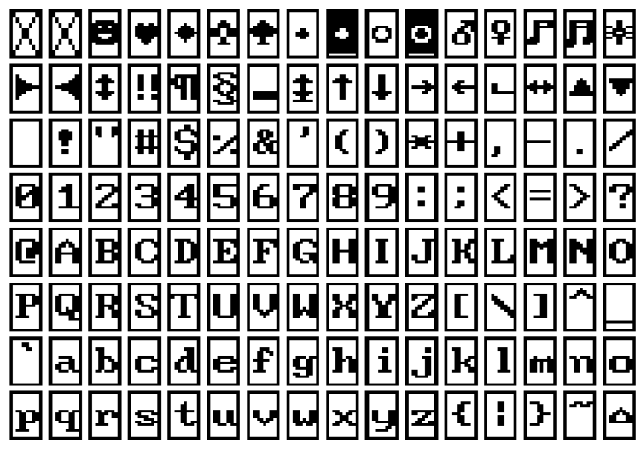

0101 0111

B 11

欢迎乘坐本司出租

司机:胡钧耀

编号:06192081

监督:18986848840

BBB6H D3ADH B3CBH D7F8H B1BEH CBBEH B3F6H D7E2H

CBBEH BBFAH 40H BAFAH BEFBH D2ABH

B1E0H BAC5H 40H 30H 36H 31H 39H 32H 30H 38H 31H

BCE0H B6BDH 40H 31H 38H 39H 38H 36H 38H 34H 38H 38H 34H 30H

起步：6.0元 单价：1.0元/公里

里程：1.3公里

时速：1.2公里/小时

等待：0分0秒

C6F0H B2BDH A3BAH ---- D4AAH A1A0H B5A5H BCDBH A3BAH --- D4AAH 2FH B9ABH C0EFH

C0EFH B3CCH A3BAH ---- B9ABH C0EFH

CAB1H B6C8H A3BAH ---- B9ABH C0EFH 2FH D0A1H BCE4H

B5C8H B4FDH A3BAH ---- B7D6H ---- C3EBH

菜单

* 时间 < 白天 >

格式化

里程01.3km

收益025元

时间 < 夜晚 >

* 格式化

里程 0.0km

收益 000元