From Lung to Brain - Respiration Modulates Neural and Mental Activity
Authors: Josh Goheen^{a,b}, John A.E. Anderson^{b} , Jianfeng Zhang^{c}, Georg Northoffª
The Royal Ottawa Mental Health Centre, The University of Ottawa, Ottawa, Canadaª
Carleton University, Department of Cognitive Science, Canada^{b}
Center for Brain Disorders and Cognitive Sciences, Shenzhen University, Shenzhen, China; School of Psychology, Shenzhen University, Shenzhen, Guangdong, China^{c}

Corresponding Author information:

Josh Goheen – joshgoheen@cmail.carleton.ca
2202A Dunton Tower
1125 Colonel By Drive
Ottawa ON, K1S 5B6, Canada

KEYWORDS: respiration, cognition, emotion, heart rate variability, carbon dioxide
HIGHLIGHTS

- Respiration sustains metabolic activity in all organs, including the brain.
- Respiration affects the neural activity of a widespread variety of regions in the brain
- Respiration modulates different frequency ranges in the brain’s dynamics
- Respiration protocols modulate emotion, cognition and behaviour
- We conclude that respiration may be an integral rhythm of the brain’s neural activity

ABSTRACT
Respiration sustains metabolic activity in all organs, including the brain. Respiration protocols have been developed to manipulate mental states, including their use for therapeutic purposes, e.g., in anxiety disorders. In this systematic review, we discuss evidence that respiration may play a fundamental role in coordinating neural activity, behavior, and emotion. The main findings are: (i) respiration affects the neural activity of a wide variety of regions in the brain; (ii) respiration modulates different frequency ranges in the brain’s dynamics; (iii) different respiration protocols (spontaneous, hyperventilation, slow or resonance respiration) yield different neural and mental effects; (iv) the effects of respiration on the brain are related to concurrent modulation of biochemical (oxygen delivery, pH) and physiological (cerebral blood flow, heart rate variability) variables. We conclude that respiration may be an integral rhythm of the brain’s neural activity. This provides an intimate connection of respiration with neuro-mental features like emotion. A respiratory-neuro-mental connection, in turn, holds the promise for a brain-based therapeutic usage of respiration in mental disorders.
INTRODUCTION
Respiration and brain – Nuisance or neural?
Respiration, being so closely coupled to heart activity and oxygen supply, is key in maintaining metabolic activity in all organs including the brain. Given the increased efficiency of aerobic over anaerobic conditions in cellular energy dynamics, one might predict that the brain should be optimized to maximize its direct coupling with systems that supply its metabolism (S. M. Park & Jung, 2020; Zhang et al., 2020). The brain’s metabolic-energetic coupling to respiration is at odds with how neuroscientists methodologically treat respiration. Respiration-related neural activity is typically considered noise, and entire fields are dedicated to stripping it from brain data, particularly in fMRI (e.g., with global signal regression, independent components analysis, RETROICOR, etc. (Lynch et al., 2020; Power, Lynch, Adeyemo, et al., 2020; Power, Lynch, Dubin, et al., 2020).
While many researchers do not consider respiration beyond stripping it from their datasets, it is possible that elements of the respiratory coupled neural signal are useful, and can inform us about higher cognitive processing, emotion, and behaviour. To test this hypothesis, we conduct an extensive systematic review of combined brain and respiration studies in both functional magnetic resonance imaging (fMRI) and electroencephalography (EEG). In this analysis, we investigate topographic and dynamic effects of respiration on the brain’s neural activity. Moreover, to test the strength of the link between neural and respiratory activity, we investigated the impact of different respiration protocols on biochemical, physiological, neural, and mental activity. Our findings should help uncover if respiration plays an integral role of the brains’ physiology beyond its typical framing as a nuisance variable.
From the rhythms of respiration to brain rhythms
Functional magnetic resonance imaging studies (fMRI) have shown respiration frequency and volume strongly correlates with the Blood Oxygen Level Dependent (BOLD) signal (Birn et al., 2006, 2009; Birn, Murphy, et al., 2008; Birn, Smith, et al., 2008; Keller et al., 2020). In fact, respiration alone has been shown to account for as much as 27% of the variance in the BOLD signal (Power et al., 2017). For this reason, the physiological signals are commonly regressed out of data as noise (for a review see (Birn, 2012). Emerging evidence, however, suggests that fluctuations in the power of spatially distributed slower neuronal oscillations in the frequency range of respiration (0.01 to 0.3Hz; (Critchley et al., 2015)) drive the activity of faster frequencies and even mental features like consciousness and self (Allen et al., 2022; Allen & Williams, 2011; Huang et al., 2016; Northoff, 2017; Northoff et al., 2020a, 2020b).
Like fMRI, EEG can be used to observe respiration-induced modulation of slower neural signals (0.01 to 0.3Hz; (Hinterberger et al., 2019; Karavaev et al., 2018). Because of its greater temporal resolution, EEG can be used to observe respiration-induced modulation of faster frequencies like theta (Sinha et al., 2020), alpha (Kluger et al., 2021), and gamma (Heck et al., 2016). These studies suggest that respiration provides a slow (0.01 to 0.3Hz) intrinsic rhythm which may be coupled with analogous slower neural rhythms in the same frequency range. Thus, respiration may act as a slow-moving envelope carrying and influencing faster frequencies which then manifest as a dynamic mixture of respiratory influenced neural activity.
Respiration and physiology/biochemistry
Mammalian respiration is innately connected with other physiology and biochemistry. For example, respiratory sinus arrhythmia (RSA) is a phase relationship between respiration and heart rate. In humans, upon inhalation, time between heart beats (measured as R-R intervals or RRIs) tend to decrease in length which is indicative of heartbeat acceleration. Conversely, upon exhalation, RRIs tend to increase in length, in other words, the heartbeat will decelerate (Schäfer & Kratky, 2008). Furthermore, prolonged periods of hyperventilation (i.e., more than 30 seconds) tend to increase mean heart rate (HR), lower heart rate variability (HRV), reduce the blood gas partial pressure of carbon dioxide (pCO₂), and decrease cerebral blood flow (Dratcu, 2000; Friedman et al., 2006; Holper et al., 2015; Ide et al., 2003; Pittig et al., 2013; Telles et al., 2011; Tunnell et al., 2021; Wollburg et al., 2011). Conversely, slow respiration tends to lower mean heart rate, increase HRV, raise pCO₂, and increase cerebral blood flow (Chalaye et al., 2009; C.-C. Chang et al., 2014; Critchley et al., 2015; Lin, 2018; Zunhammer et al., 2013).
How do these physiological and biochemical factors influence the impact of respiration on the brain’s neural activity? Given that the physiological and biochemical variables reviewed above express similar spatiotemporal influences on the brain’s neural activity, one might expect that these more fundamental biochemical processes might modulate and mediate respiration. This would provide a first insight into the physiological mechanisms for the coupling of the brain’s neural activity to respiration.
Respiration and mental activity
Neuropsychiatric conditions such as anxiety and panic disorder are often accompanied by irregularities in respiration patterns (for reviews see (Dratcu, 2000; Giardino et al., 2007; Meuret et al., 2005; Sikter et al., 2007). In fact, hyperventilation is a trait which researchers argue is self-perpetuating and responsible for propagating neuropsychiatric disorders such as anxiety. The hyperventilation theory (Ley, 1985) describes that panic patients will often present with chronic hyperventilation. By this account, panic attacks are brought on by cognitive misinterpretations of bodily symptoms such as accelerated heart rate, decreased heart rate variability, dizziness, and tingling in the extremities that often accompany hyperventilation.
In contrast to the hyperventilation theory account, (Klein, 1993) , describe hyperventilation as a subconscious preventive measure the body uses to maintain the partial pressure of carbon dioxide (pCO₂) in the blood below threshold values of peripheral and central chemoreceptors. Klein proposed that over time, chemoreceptors become hypersensitive due to sustained levels of low pCO₂ brought on by chronic hyperventilation. The authors proposed a positive feedback loop where hypersensitive chemoreceptors promote hyperventilation to avoid triggering the body’s asphyxiation alarm which, in turn, leads to more panic and anxiety. Slow respiration has also been reported to mitigate problematic mental activity and accompanying biochemistry/physiology brought on by chronic hyperventilation (Zaccaro et al., 2018). In fact, multi-session slow respiration protocols have been shown to increase overall positive affect (Karavidas et al., 2007; Ma et al., 2017; MacKinnon et al., 2013; Tatschl et al., 2020; X. Wang et al., 2020).
It is worth mentioning that previous work from (Klimesch, 2018) has reported on the potential architecture linking brain and body oscillations. The author argues that large reductions in energy demand drive neural systems to express phase and amplitude coupling with physiological rhythms such as respiration at distinct frequencies. Klimesch claims that as a result, the respiration signal tends to have a set of “preferred” frequencies centered around 0.08, 0.16, and 0.32 Hz. Klimesch hypothesizes that each frequency carries with it distinct neural and mental correlates. This appears to be directly in line with our hypothesis as we suggest there are distinct neural and mental features that are coupled to breathing at, or close to these frequencies such as in the case of slow (~0.1Hz), spontaneous (~0.2Hz) and fast breathing (~0.5Hz).
The synchronization between respiration and slow neural activity is likely key to understanding the brain-physiology relationship. Higher degrees of coupling between respiration and brain activity likely manifest as the inverse of symptoms of panic disorder (e.g., relaxation, greater attention, and more measured thoughts). Slow rhythms thus provide a link and shared feature of respiration, neural, and mental activity serving as their “common currency” (Northoff et al., 2020a, 2020b). We, therefore, include in our review studies using different respiration protocols including slow and fast ones in order to show their impact on both neural and mental activity. By establishing a “common currency”, between respiration, brain, and mind, we hope to provide a novel theoretical framework that serves to inspire future research in this area and provide a springboard for possible therapeutic interventions in neuropsychiatric disorders such as anxiety.
Overview of steps
We included studies that reported the partial pressure of carbon dioxide (pCO₂; via capnography), fMRI, EEG, electrocardiogram (ECG), and subjective questionnaires to piece together the neuronal and mental effects of respiration including their mediating physiological and biochemical variables. We hypothesized that; 1) respiration will affect neural activity in terms of topography and dynamics throughout widespread regions and all frequencies; 2) given the fact that the spontaneous frequency ranges between physiology (heart, pCO₂) and respiration overlap, we also expect there to be overlap in the topography and dynamics of neural signals influenced by these processes; 3) Given the existing evidence of respiratory mechanisms that affect pCO₂ and HRV, we predict hyperventilation to provoke panic or anxiety, and conversely, we predict slow respiration to promote emotional well-being and relaxation.
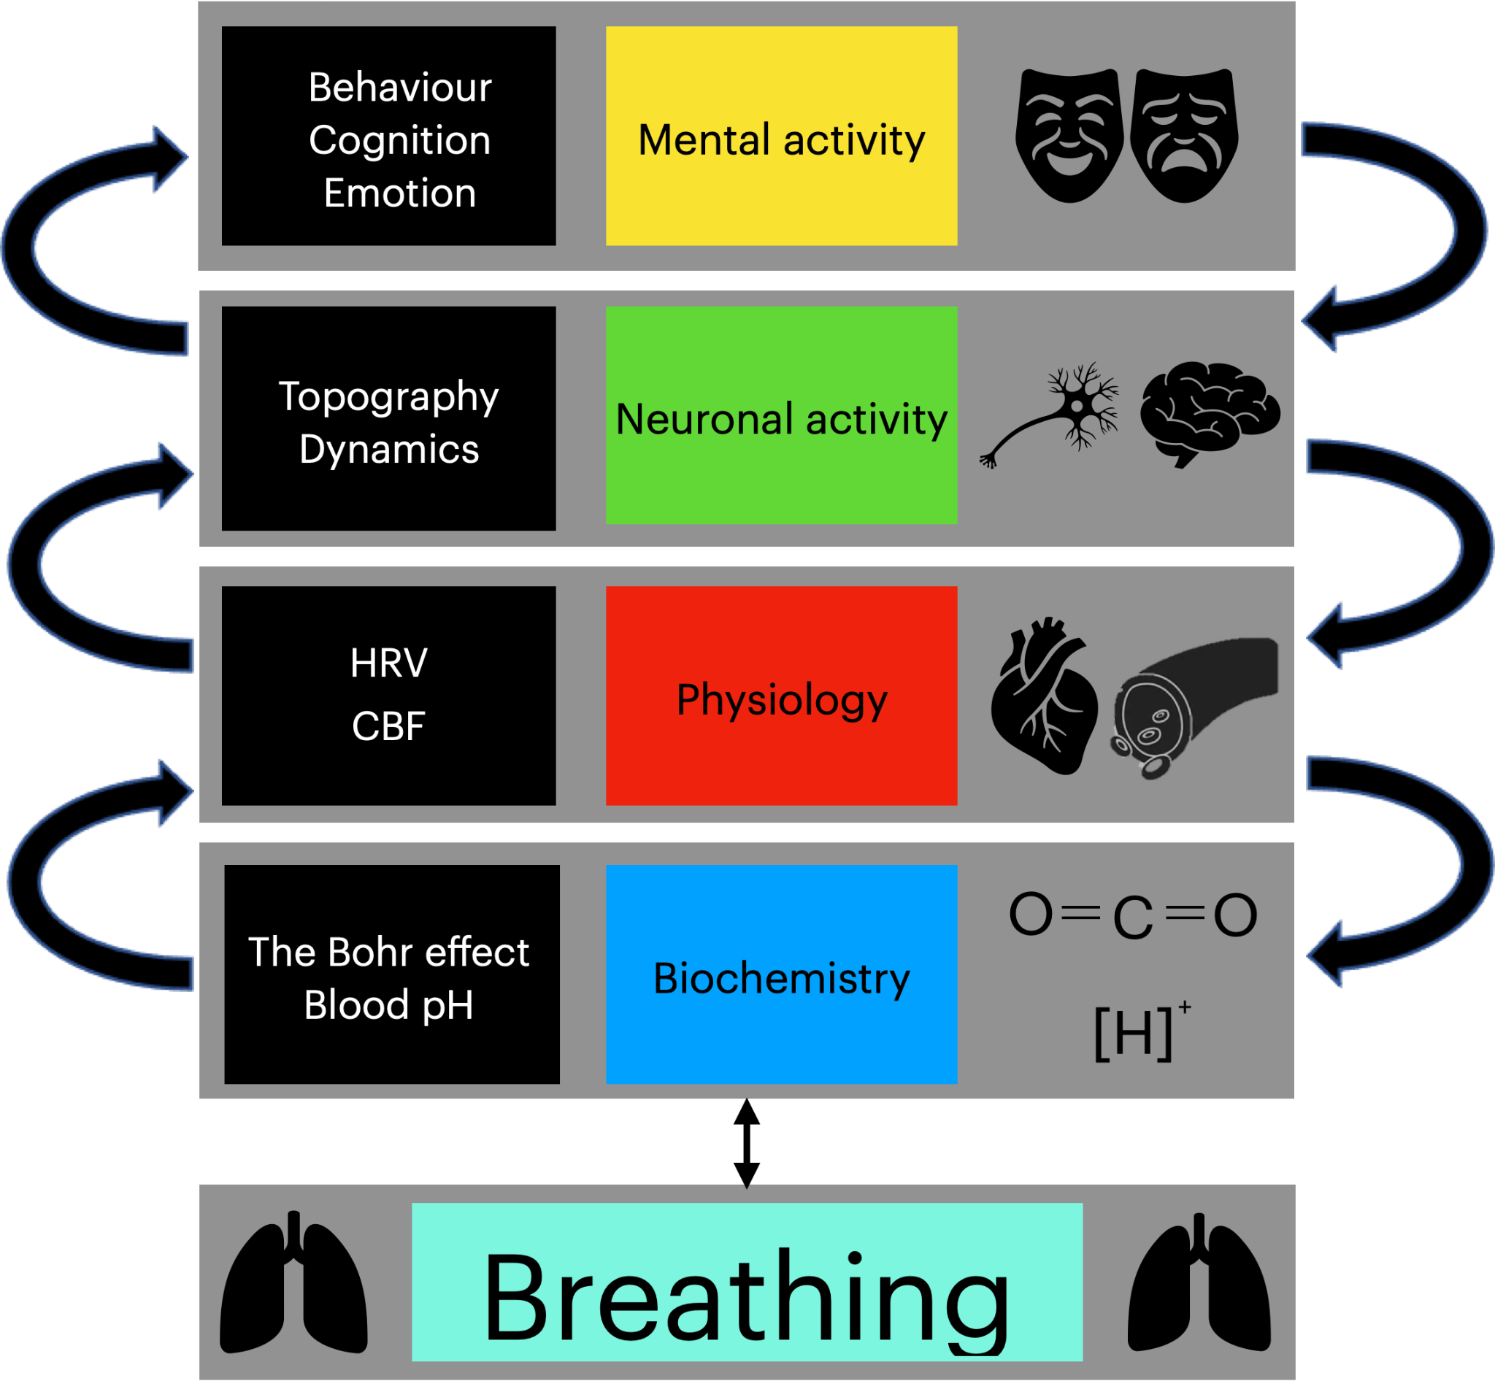
Figure 1. The figure illustrates the theoretical framework of the coupling from respiration to mental features through biochemical (blood pH, Bohr effect), physiological (heart rate variability/HRV, cerebral blood flow/CBF), and neuronal (topography, dynamic) variables.
MATERIALS & METHODS
Article Search
We followed the recommendations of the PRISMA statement (Liberati et al., 2009); design and flow of the PRISMA can be seen in Figure 2). This review focused on the evaluation of research articles obtained from a survey conducted by the primary author in August 2021. The search included terms such as "Respiration", "end tidal carbon dioxide, "Heart rate", and "heart rate variability" (HRV) in combination with "electrocardiogram" (ECG), "electroencephalogram" (EEG), and "functional magnetic resonance imaging" (fMRI). To ensure that this study captured recent literature, results were restricted to studies published between 2000 and 2021.
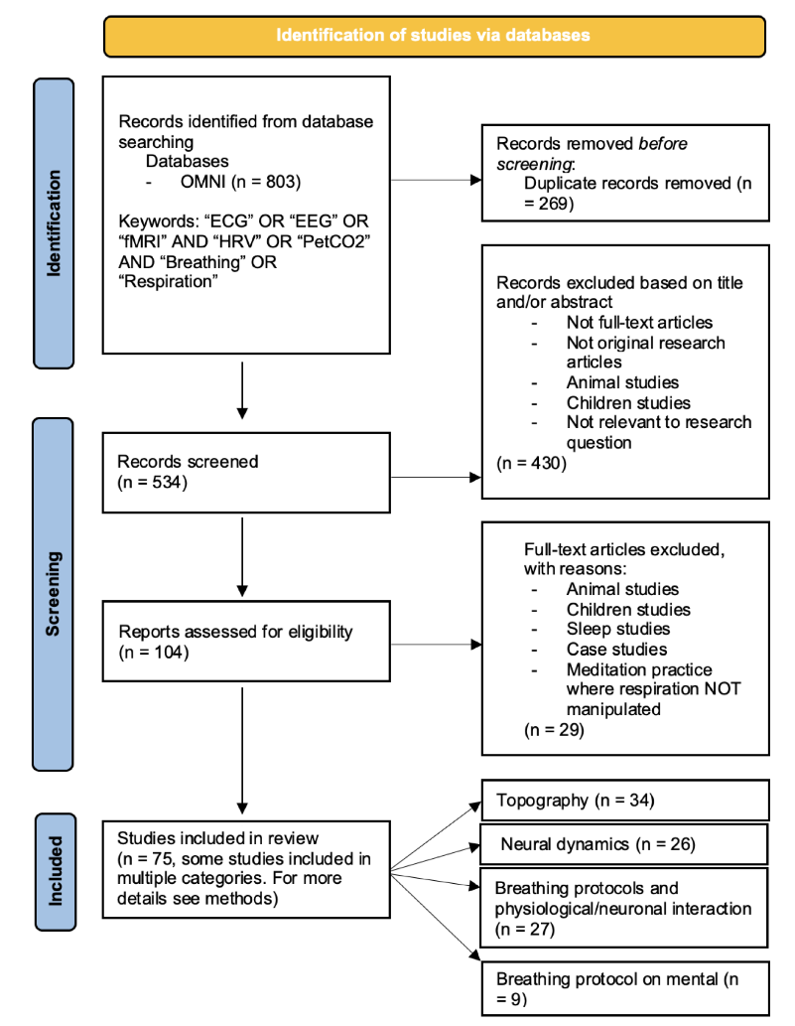
Figure 2. PRISMA scheme. Representation of reviewal process for studies included in survey.
Articles were evaluated for inclusion if they included human subjects, were full text original research articles, and evaluated respiration’s inherent relationships with heart activity, neuronal activity, carbon dioxide levels or mental activity. Articles were excluded if they focused on animals, children (<18 years of age), sleep or were case studies. Articles were also excluded if they investigated a meditation practice where slow respiration or hyperventilation were not a primary measured outcome. Twenty-nine articles met these criteria and were not included in the review.
Our initial search captured relatively few studies focusing on the mental implications of the respiration protocols, particularity hyperventilation. As a result, a secondary search was conducted using the online collaborative database OMNI (https://ocul.on.ca/omni/). Identification, review, and article inclusion was conducted by the first author in January 2022. The intention of this search was to investigate respiratory pathology of anxiety/panic disorders in hopes of linking it to the information compiled in this review. Search algorithms comprised the terms "Anxiety" and "panic disorder" used in combination with "Hyperventilation". To ensure this search captured recent literature, studies were limited to the years between 2000-2021. This search yielded 8 full-text research articles.
Organization of the review
As articles were reviewed, they were placed in the following categories: 1) Topography (spatial relationships), 2) Neuronal Dynamics (temporal relationships), 3) Respiration protocols and physiological or neuronal interactions, and 4) Respiration protocols and mental interactions. Further details on references of individual studies as well as which studies were included in categories 1-4 can be found in supplementary tables 2-5, respectively. Topographical results included fMRI studies investigating regions associated with respiration, heart activity and pCO₂ fluctuations. ECG, EEG, and fMRI studies which investigated global and regional frequencies associated with respiration, heart activity and CO₂ fluctuations contributed to the Neuronal Dynamics category. Studies that investigated the effects of respiration protocols fell into two categories. The first included studies that investigated the physiological and neuronal interactions of respiration protocols. The second included studies that investigated the impact of respiration protocols on the mental level, that is, on mood and cognition.
The search yielded 75 unique relevant studies. Some studies reported multiple measures (e.g., EEG, fMRI, ECG, pCO₂, questionnaires etc…) and were included in multiple categories. Each section yielded 34, 26, 27, and 9 studies, respectively. Collectively, these studies attempted to investigate the significant physiological, neuronal, and mental variance correlated to fluctuations in respiration, heart activity and pCO₂
RESULTS
Topography
Regions modulated by respiration
This review compiled 16 studies that collectively attempted to describe the topographical relationships of respiration in the brain under spontaneous conditions. Regions most associated with respiration include frontal (MPFC, LPFC, OFPFC, SFG), temporal (STG), parietal (SSC, PMC), occipital (OC, SMG), midline (ACC, MCC, PCC/precuneus, cuneus) insular (aINS, mINS, pINS), and cerebellar regions. Subcortical regions (thalamus, caudate, putamen) also appear to be influenced by respiration. More details on the number of studies and references pertaining to each region can be found in Figure 3a and supplementary table 6, respectively.

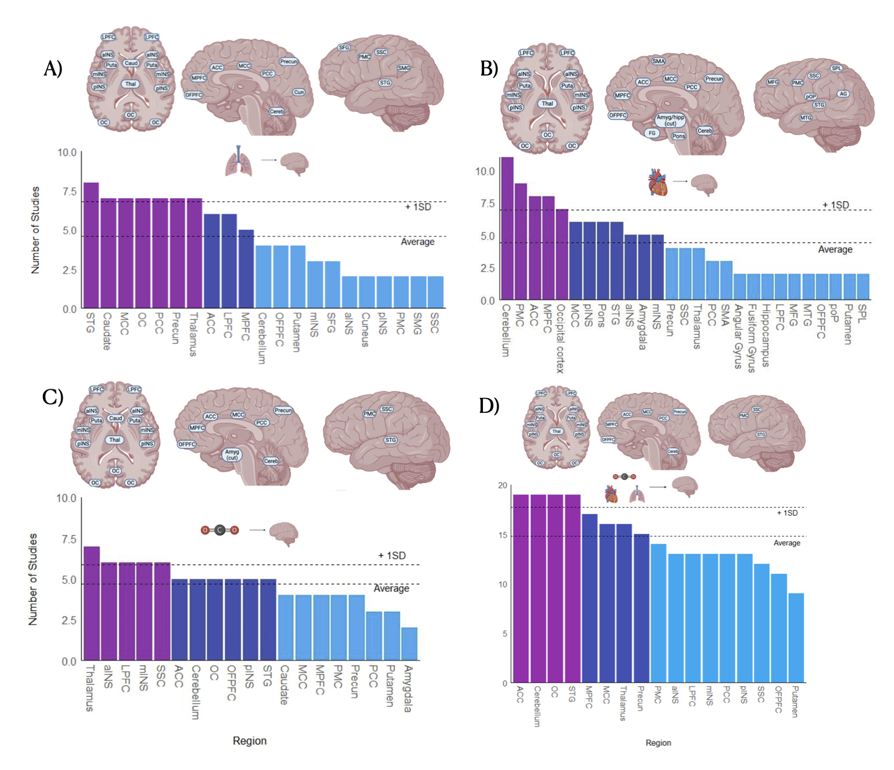
Figure 3. A) Regions that have been shown to covary in activity with factors of respiration. B) Regions that have been shown to covary in activity with factors of heart activity. C) Regions that have been shown to covary in activity with levels of carbon dioxide. D) Summary of regions that have been shown to covary with all three respiration, heart activity, and carbon dioxide. Abbreviations: PCC = posterior cingulate cortex, MCC= middle cingulate cortex, ACC= anterior cingulate cortex, STG= superior temporal gyrus, SSC= somatosensory cortex, SMG = supra marginal gyrus, SMA= Supplementary motor area, DLPFC = Dorsolateral prefrontal cortex , VLPFC = ventrolateral prefrontal cortex, OFPFC = orbitofrontal prefrontal cortex, PMC = primary motor cortex, SFG = superior frontal gyrus, MFG = middle frontal gyrus, DMPFC = dorsomedial prefrontal cortex, SPL = Superior parietal lobule, aINS = anterior insula, mINS = middle insula, pINS = posterior insula, Caud = caudate, Thal = thalamus, LPFC = lateral prefrontal cortex, Cereb = cerebellum, amyg = amygdala, hipp = hippocampus FG = Fusiform gyrus, pOP = parietal operculum, AG = angular gyrus

Regions modulated by heart activity
This review compiled 19 studies that collectively described the topographical relationships of heart activity under spontaneous conditions. Heart activity is most associated with activity in frontal (OFPFC, MPFC, LPFC, MFG), temporal (STG, MTG, FG), parietal (PMC, SSC, SPL, pOP, SMA) occipital (OC, AG), midline (ACC, MCC, PCC, precuneus), insular (aINS, mINS, pINS), and cerebellar regions. Subcortical (thalamus, putamen, amygdala) and brainstem (pons) regions were also shown to be influenced by heart activity. More details on the number of studies and references pertaining to each region can be found in Figure 3b and supplementary table 8, respectively.
Regions modulated by CO₂
This review compiled 10 studies that collectively attempted to describe the topographical relationships of pCO₂ under spontaneous conditions. Regions that are most associated with fluctuations in pCO₂ include frontal (OFPFC, MPFC, LPFC), temporal (STG), parietal (PMC, SSC), occipital (SMG, OC), mindline (ACC, MCC, PCC, precuneus), insular (aINS, mINS, pINS), and cerebellar regions. Activity within subcortical regions (thalamus, putamen, caudate) also appear to fluctuate in activity with pCO₂ levels. More details on the number of studies and references pertaining to each region can be found in Figure 3c and supplementary table 7, respectively.
Regions associated with physiological overlap
This review compiled 45 studies (34 unique studies, 11 studies reported multiple measures) that collectively described the topographical relationships of all physiology described in this review under spontaneous conditions. Regions associated with overlap of the described physiology include frontal (OFPFC, MPFC, LPFC), temporal (STG), parietal (PMC, SSC), occipital (OC), midline (ACC, MCC, PCC, precuneus), insular (aINS, mINS, pINS), and cerebellar regions. In addition, subcortical regions included the thalamus and the putamen. More details on the number of studies and references pertaining to each region can be found in figure 3d and supplementary table 9, respectively.

Dynamics
Frequencies modulated by respiration
We compiled 11 studies that collectively attempted to describe the dynamical relationship of respiration in the brain under spontaneous conditions. Respiration appears to be coupled to infraslow (IS, 0.01-0.1Hz), slow cortical potential (SCP, 0.1-1Hz), delta (1-4Hz), theta (4-8Hz), alpha (8-12Hz), beta (12-30Hz), and gamma (30+Hz) frequencies. The extent of this coupling varied by region. In the frontal lobe, respiration was shown to be coupled to all frequencies. In the insular lobe, respiration was shown to be coupled to IS, SCP, alpha, and gamma frequencies. In the parietal and occipital lobes, respiration appears to be coupled to IS, SCP, delta, theta, alpha and beta frequencies. In the temporal lobe, respiration was shown to be coupled to IS, SCP, delta, theta, alpha and gamma frequencies. In the anterior cingulate cortex, respiration was shown to be coupled to IS, SCP and alpha frequencies. In the middle and posterior cingulate cortices, respiration was shown to be coupled to IS and SCP frequencies. In the precuneus, respiration was shown to be coupled to IS and alpha frequencies. Respiration was also shown to modulate activity in subcortical regions. In the thalamus, respiration was shown to be coupled with IS and alpha frequencies. Finally, In the amygdala and the hippocampus, respiration was shown to be coupled to SCP and gamma frequencies. More details on the number of studies and references pertaining to each region can be found in figure 4a and supplementary table 10, respectively.

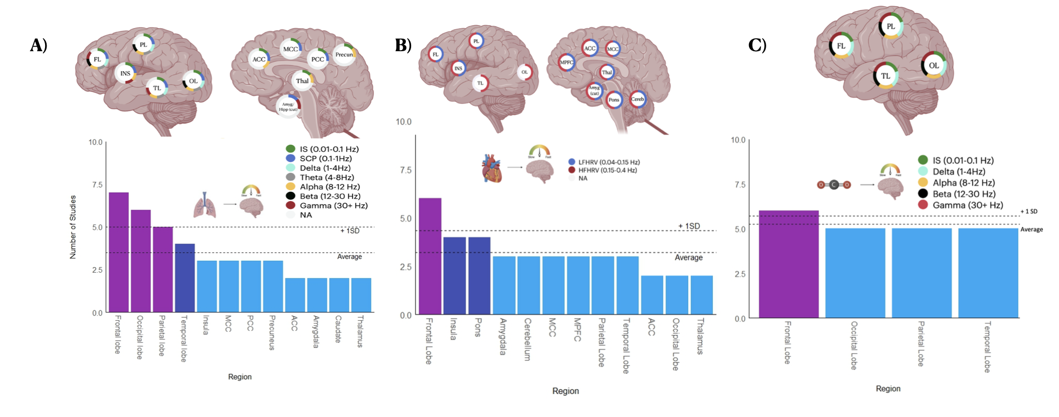
Figure 4. A) Neural dynamics linked to respiration. B) Neural dynamics linked to cardiac activity. C) Neural dynamics linked to carbon dioxide. Structures shown in left lateral view are bilateral. Abbreviations: FL = frontal lobe, PL = parietal lobe, INS = insula, TL = temporal lobe, OL = occipital lobe, ACC = anterior cingulate cortex, MCC = middle cingulate cortex, PCC = posterior cingulate cortex, Precun = precuneus, Thal = thalamus, Amyg = amygdala, hipp = hippocampus, Cereb = cerebellum, MPFC = medial prefrontal cortex, OC = occipital cortex, LFHRV = low frequency heart rate variability, HFHRV = high frequency heart rate variability, IS = infraslow, SCP = slow cortical potentials
Frequencies modulated by heart activity
In order to investigate the dynamical relationships of heart activity we compiled 11 studies that collectively attempted to describe the relationships of low-frequency heart rate variability (LFHRV, 0.04-0.15 Hz) and high-frequency heart rate variability (HFHRV, 0.15-0.4 Hz) under spontaneous conditions.
LFHRV
LFHRV appears to be coupled to activity within frontal, parietal, and insular lobes. In addition, LFHRV appears to be coupled with activity within midline regions (MPFC, MCC), subcortical (thalamus, amygdala), and brainstem (pons) regions. More details on the number of studies and references pertaining to each region can be found in figure 4b and supplementary table 11, respectively.

HFHRV
HFHRV appears to be coupled to activity within the frontal, parietal, occipital, temporal and insular lobes. In addition, HFHRV appears to be coupled to activity within the cerebellum, midline (MPFC, ACC, MCC), subcortical (thalamus, amygdala), and brainstem (pons) regions. More details on the number of studies and references pertaining to each region can be found in figure 4b and supplementary table 11, respectively.
Frequencies modulated by CO₂
We compiled 6 studies that collectively attempted to describe the dynamical relationships of fluctuations in the partial pressure of carbon dioxide (pCO₂) under spontaneous conditions. According to the studies included in this review, pCO₂ appears to be coupled to IS, delta, alpha, beta, and gamma activity. These coupling patterns were consistent throughout frontal, parietal, temporal, and occipital lobes. More details on the number of studies and references pertaining to each frequency/region can be found in figure 4c and supplementary table 12, respectively.
Respiration protocols and dynamical & physiological interactions
Slow respiration - Resonance respiration
We compiled 27 studies that collectively attempted to describe the physiological and dynamical changes induced by resonance respiration. Overall, it appears that resonance respiration causes significant increases in LFHRV, slight increases pCO₂ levels and an overall shift towards slower neuronal frequencies. According to these data, within the frontal lobe there appears to be increased infraslow (IS) coherence, increased slow cortical potential (SCP) power, higher levels of inter and intra hemispheric theta coherence, increased theta power, increased alpha power increased alpha/high beta ratio, and decreased beta power during resonance respiration compared to spontaneous conditions. Within the temporal lobe there appears to be increased IS coherence, increased SCP power, increased interhemispheric alpha asymmetry, and increased alpha/high beta ratio during resonance respiration compared to spontaneous conditions. In the occipital lobe, there appears to be increased SCP power, increased inter and intra hemispheric theta coherence, increased theta power, increased alpha power, and decreased beta power during resonance respiration compared to spontaneous conditions. Within the parietal lobe, there appears to be increased IS coherence, increased SCP power, increased theta power, increased alpha/high beta ratio, increased alpha power, and decreased beta power during resonance respiration compared to spontaneous conditions. Within the cingulate cortex, there appears to be increased activation and increased alpha power during resonance respiration compared to spontaneous conditions. Globally, there appears to be increased IS coherence, increased SCP power, increased delta power, increased alpha power, and increased left brain activation during resonance respiration. Visual representation of the physiological and neuronal changes induced by resonance respiration can be found in figure 5b. More details on the main findings of individual references used to construct this figure can be found in supplementary table 5.
Fast respiration - Hyperventilation
We compiled 5 studies that collectively attempted to describe the neuronal dynamic changes induced by hyperventilation. In contrast to resonance respiration, it appears that hyperventilation elicits a decrease in HRV, decreased pCO₂, and increases in faster frequencies. Within the frontal lobe it appears that there is increased theta power, and increased beta power during hyperventilation compared to spontaneous conditions. Within the occipital and parietal lobes, it appears that there is increased theta power, and increased alpha power during hyperventilation compared to spontaneous conditions. Globally, there appears to be an increase in theta power compared to spontaneous conditions.
This study captured a relatively small number of papers pertaining to the physiological and dynamical changes induced by hyperventilation. By consequence, these data should be used as an indication of what might occur, but more research is necessary to understand the full scope of the physiological and dynamical implications of hyperventilation. A visual representation of the changes induced by hyperventilation can be found in figure 5c. More details on the main findings from individual references used to construct this figure can be found in supplementary table 5.
Respiration protocols – Impact on mental activity
Our search captured 9 studies that collectively attempted to describe the effects that respiration protocols have on mental activity. Four of these studies investigated the effects of resonance respiration protocols (~0.1Hz) on perceived anxiety/stress levels (Karavidas et al., 2007; Ma et al., 2017; MacKinnon et al., 2013; X. Wang et al., 2020). A common theme among all these studies was an overall decrease in symptoms of negative affect after their respective intervention periods. Two studies investigated the effects of hyperventilation protocols (~0.5Hz) on mental activity (Chandra et al., 2017; Peterson et al., 2017). Overall, these studies reported increased levels of perceived anxiety and stress during fast respiration, however, participants scored lower on overall perceived anxiety/stress after several weeks of interventions.
Three studies only included spontaneous protocols (Harrison et al., 2021; Lischke et al., 2020; Zamoscik et al., 2018). One study investigated interoceptive awareness of respiration and found that decreasing its capacity was correlated with increased levels of activity within the anterior insula and increased levels of anxiety (Harrison et al., 2021). Another study described a positive association between HRV and heartbeat detection (Lischke et al., 2020). This study described that decreases in heartbeat detection was linked with increased levels of perceived stress and anxiety. The third study looked at patients in remission of major depressive disorder (Zamoscik et al., 2018). In this study, patients were found to have increased respiration rates and PCC/parahippocampal gyrus activity compared to healthy controls. In addition, this study found patients to experience increased respiration pause variability compared to healthy controls which was correlated to symptom severity. Further information on the main findings of individual studies can be found in supplementary table 5.
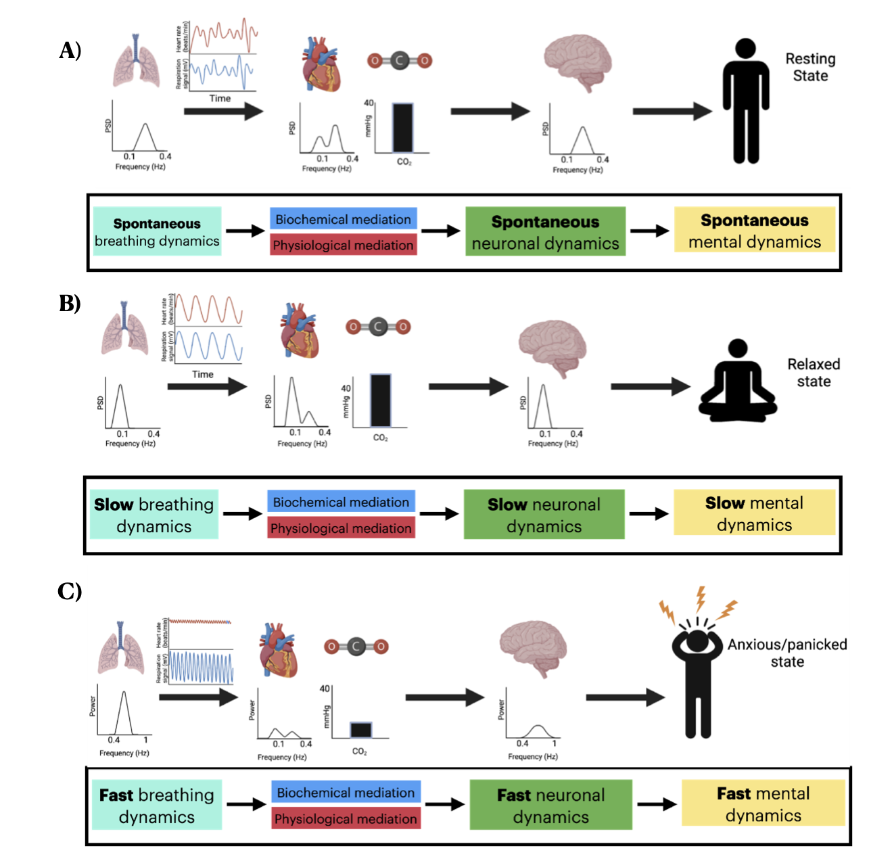
Figure 5. A) Schematic representation of physiology, neuronal, and mental activity during A) spontaneous respiration B) resonance respiration and C) hyperventilation.

Secondary search for articles on respiration and anxiety
Our secondary search yielded a total of 8 studies that investigated the respiratory pathology of anxiety and panic disorder patients. Patients in these studies commonly present with chronic hyperventilation (Dratcu, 2000; Friedman et al., 2006; Meuret et al., 2005; Meuret & Ritz, 2010; Pittig et al., 2013; Sikter et al., 2007; Tunnell et al., 2021; Wollburg et al., 2011), hypocapnia (low pCO₂; (Dratcu, 2000; Friedman et al., 2006; Meuret et al., 2005; Meuret & Ritz, 2010), and lower levels of HF HRV (Pittig et al., 2013) compared to healthy controls. Researchers suggest that patients tend to experience more significant feelings of discomfort, negative affect and dyspnea at lower pCO₂ threshold values and with smaller increases in pCO₂ compared to healthy controls. As a result, patients tend to hyperventilate as a protective mechanism to keep pCO₂ levels below chemosensory threshold values. Chronic hypocapnia leads to hypersensitive peripheral and central chemoreceptors which tend to manifest as a self-perpetuating mechanism for hyperventilation, panic and anxiety (Dratcu, 2000; Meuret et al., 2005; Meuret & Ritz, 2010; Sikter et al., 2007). Other theories represented in this literature (Ley, 1985) suggest that the cognitive misinterpretation of hyperventilation and accompanying bodily symptoms themselves (rather than hypersensitive chemoreception) are responsible for the propagation of anxiety and panic. This assumes that patients tend to disproportionately evaluate feelings of dyspnea, elevated heart rate, and low HRV as deadly. This may lead patients to experience increased levels of anxiety and panic (Dratcu, 2000; Meuret et al., 2005; Meuret & Ritz, 2010; Sikter et al., 2007). Further information on the main findings of individual studies can be found in supplementary table 14.
DISCUSSION
Form lung to brain I - Respiration and topography
We first observed the involvement of widespread regions in the brain associated with respiration. Rather than implicating specific regions or networks, respiration seems to impact both medial and lateral cortical regions as well as the anterior and posterior cortex including higher- and lower-order regions. The global role of respiration in the brain signal hinges on physiological and biochemical processes. We show significant topographical overlap between respiration, heart activity, and CO₂ fluctuations. Regions associated with this overlap include frontal (OFPFC, MPFC, LPFC), temporal (STG), parietal (PMC, SSC), occipital (OC), midline (ACC, MCC, PCC, precuneus), insular (aINS, mINS, pINS), and cerebellar regions. In addition, subcortical regions included the thalamus and the putamen (for individual references see supplementary table 9). Interestingly, many of these regions have been implicated in important networks responsible for the sense of self and cognition such as the default mode and salience networks (Lucherini Angeletti et al., 2021; Melnychuk et al., 2018; Northoff & Bermpohl, 2004). This, albeit indirectly, provides evidence for possible connection of respiratory activity with neuro-mental functions like self and consciousness; that is further supported by the differential neuro-mental impact of different slow-fast respiration protocols.
We believe that this global topographic involvement is, at least in part, mediated by the biochemical and physiological dynamics inherently linked to respiration. For example, CO₂ has been shown to fluctuate with the respiration cycle and has shown to be a potent vasodilator (Birn et al., 2006, 2009; Birn, Murphy, et al., 2008; Birn, Smith, et al., 2008; Van den Aardweg & Karemaker, 2002; Wise et al., 2004). This dilatory property of CO₂ facilitates modulations in cerebral blood flow. In fact, there have been studies utilizing transcranial Doppler ultrasound that show as much as a 5% modulation in blood flow per 1 mmHg change in pCO₂ (Ide et al., 2003). That considered, one would expect the BOLD signal to be most affected by the respiration cycle in regions of high blood supply, which is exactly what we present in this review.
From lung to brain II - Respiration and dynamics
It is becoming well established that respiration entrains oscillations at the same frequency as the respiration rate in several regions, at least in the rodent brain (Heck et al., 2016; Ito et al., 2014; Tort et al., 2018). Moreover, these studies particularly implicate the theta and gamma band in frontal regions phase locked to respiration (Heck et al., 2016; Ito et al., 2014; Tort et al., 2018). Researchers suggest the respiration rhythm in rodents, like humans, is propagated and modulated via a central pattern generator (pre-Botzinger complex) buried deep within the brainstem (Allen et al., 2022; Feldman et al., 2003; Yang et al., 2020).
In mammals, activity within the pre-Botzinger complex is particularly sensitive to changes in blood acidity (pH) levels (for details on the relationship between respiration and pH see the box provided). Central chemoreceptors act in a negative feedback loop with respiratory and cardiac centers to modulate heart and respiration rate accordingly (Feldman et al., 2003; Yang et al., 2020). Given there is a fundamental connection between respiration and central brain activity, global frequency involvement of respiration should not come as a surprise.
In line with other works, our review confirms the involvement of multiple frequencies in the coupling of respiratory and neural activity (for a review see (Mather & Thayer, 2018; Noble & Hochman, 2019; Zaccaro et al., 2018). Support for the involvement of slower frequencies (0.01 to 0.3Hz) comes (indirectly) from fMRI where infraslow fluctuations in respiratory volume (0.01 to 0.05Hz; RVT; ((Birn, 2012; Birn et al., 2006) or frequency (0.1-0.3 Hz; (Keller et al., 2020) modulate neural activity in that frequency range. This is important as the infraslow frequency range of fMRI (0.01 to 0.1Hz) corresponds to the frequency range of respiration (including its variability; 0.01 to 0.3Hz).
From lung to mind - Respiration and mental activity
Although neuroimaging techniques such as fMRI are used in many studies, about 2% of all examinations have to be aborted due to abnormally high state anxiety related to the scanner (Munn et al., 2016). It has been demonstrated that increased state anxiety carries abnormal coherent behaviour of breathing and cardiac oscillations. In fact, negative RSA (nRSA) refers to the condition where increased state anxiety induces a complete reversal of the phasic relationship between respiration and cardiac activity where heart rate slows down during inhalation, and speeds up during exhalation (Pfurtscheller et al., 2019; Rassler et al., 2018).
Chronic mental conditions such as anxiety and panic disorder are often accompanied by abnormalities in respiration patterns (Meuret et al., 2018). Patients often have faster respiration rates, higher mean heart rates, diminished HRV amplitudes, and lower levels of baseline pCO₂ (for reviews see (Dratcu, 2000; Giardino et al., 2007; Meuret et al., 2005; Meuret & Ritz, 2010; Sikter et al., 2007). Over time, diminished levels of pCO₂ lower the threshold value of chemoreceptors to trigger the body's intrinsic asphyxiation alarm. With lower threshold values, slight increases in pCO₂ may trigger feelings of dyspnea, discomfort, anxiety and panic (Klein, 1993). Interestingly, respiration is an autonomic process that can be somatically modulated. In fact, studies investigating slow respiration techniques have shown it to increase HRV amplitudes, raise pCO₂, and promote feelings of positive affect (Karavidas et al., 2007; Ma et al., 2017; MacKinnon et al., 2013; Meuret et al., 2018).
Our findings provide a direct link between respiratory, neural, and mental activity. The impact of different respiration protocols on neural dynamics and topography as well as on mental features like emotions suggest a mechanistic link. We propose the topography and slow-fast dynamics shared by respiratory, physiological, neural, and mental activity act as their (common currency” ; (Northoff et al., 2020a, 2020b). This is illustrated in figure 5 where we draw connections from respiration dynamics to neural and mental dynamics mediated by the dynamics of physiological and biochemical variables related to respiration. Beyond opening novel understanding of the body-brain-mind relationship, this can serve as the basis for the brain-based mechanistic development of novel forms of respiration-based therapeutic intervention in mental disorders like anxiety disorders.
LIMITATIONS AND FUTURE DIRECTIONS
A major limitation to consider is in some instances, sample sizes were small and methodologies between studies varied significantly. Thus, we acknowledge a certain degree of generalizability may be lacking from this work. Additionally, although this manuscript clearly brings forth clinical implications, at the time of the writing of this manuscript, there appears to be a lack of large scale clinical data on this matter. Although we bring forth some of the existing clinical research in our analysis, more work is needed to establish a clear neuro-respiratory mechanism into mental activity. The future is bright, however. We are hopeful that recent increases in interest for non pharmacological interventions for individuals suffering from mental illness and other cognitive disorders may bring much needed funding into the field so that these data can be acquired.
Future research should focus on refining existing paradigms, such as developing more precise methodology for collecting and analyzing respiration entrained neuronal data. Large amounts of high quality neuro-respiratory data may allow researchers to flesh out the mechanistic link between respiration, neuronal activity and behaviour. Additionally, large scale, longitudinal clinical trials should be conducted to assess the efficacy of deliberate breathing protocols in treatment of neuro-cognitive disorders in at-risk populations (i.e., advanced aging, anxiety, depression, etc…). Further, this “big data” approach should focus on the dynamics of neuro-respiratory covariance and how these interactions impact behaviour and mental health.
CONCLUSION
Respiration is a fundamental activity of life as it provides the necessary metabolic ingredients for all organs of our body including the brain. Does respiration contribute useful information to the neural signal rather than just "noise"? Our review suggests this is indeed the case.
We show that respiration affects a widespread set of regions throughout the brain as well as a range of frequencies ranging from slow (0.01 to 0.3Hz) to faster (1-80Hz) ones. Our review furthermore demonstrates that physiological (heart rate variability) and biochemical (carbon dioxide) variables induce similar neural changes in the brain in both its topography and dynamics. These physiological and biochemical variables likely mediate the coupling of respiratory and neural activity thus providing their direct link. Addressing our initial question, these findings strongly suggest that respiration is not a mere nuisance variable but an integral component of the brain’s neuro-mental activity which is mediated by various physiological and biochemical variables.
Our review also shows differential neural and even mental effects of slow and fast respiration protocols. The respiratory-neural connection seems to have particularly strong effects on emotions: slow respiration protocols like resonance respiration exert a relaxing and calming effect while faster respiration tends to induce anxiety states. These observations suggest that slow-fast dynamics may be shared by respiratory, physiological, neural and mental activity thus providing a mechanistic (or better yet dynamic) link as their “common currency” (Northoff et al., 2020a, 2020b). We therefore propose that an individual's respiration rhythm serves a fundamental, intrinsic role that modulates the topography and dynamics of the whole brain. Going beyond respiration-brain coupling, this opens the door for usage of respiration as therapeutic techniques in mental disorders like anxiety disorders and others.
CONFLICT OF INTEREST
The authors declare that there is no conflict of interest regarding the publication of this article.

ACKNOWLEDGEMENTS
Figures were created using images from biorender (biorender.com)

REFERENCES
Allen, M., Varga, S., & Heck, D. H. (2022). Respiratory rhythms of the predictive mind. Psychological Review. https://doi.org/10.1037/rev0000391
Allen, M., & Williams, G. (2011). Consciousness, plasticity, and connectomics: the role of intersubjectivity in human cognition. Frontiers in Psychology, 2, 20.
Bates, M. E., Lesnewich, L. M., Uhouse, S. G., Gohel, S., & Buckman, J. F. (2019). Resonance-Paced Breathing Alters Neural Response to Visual Cues: Proof-of-Concept for a Neuroscience-Informed Adjunct to Addiction Treatments. Frontiers in Psychiatry / Frontiers Research Foundation, 10(PG - 624-624), 624.
Birn, R. M. (2012). The role of physiological noise in resting-state functional connectivity. NeuroImage, 62(2), 864–870.
Birn, R. M., Diamond, J. B., Smith, M. A., & Bandettini, P. A. (2006). Separating respiratory-variation-related fluctuations from neuronal-activity-related fluctuations in fMRI. NeuroImage, 31(4), 1536–1548.
Birn, R. M., Murphy, K., & Bandettini, P. A. (2008). The effect of respiration variations on independent component analysis results of resting state functional connectivity. Human Brain Mapping, 29(7), 740–750.
Birn, R. M., Murphy, K., Handwerker, D. A., & Bandettini, P. A. (2009). fMRI in the presence of task-correlated breathing variations. NeuroImage, 47(3), 1092–1104.
Birn, R. M., Smith, M. A., Jones, T. B., & Bandettini, P. A. (2008). The respiration response function: the temporal dynamics of fMRI signal fluctuations related to changes in respiration. NeuroImage, 40(2), 644–654.
Bright, M. G., Bulte, D. P., Jezzard, P., & Duyn, J. H. (2009). Characterization of regional heterogeneity in cerebrovascular reactivity dynamics using novel hypocapnia task and BOLD fMRI. NeuroImage, 48(1), 166–175.
Chalaye, P., Goffaux, P., Lafrenaye, S., & Marchand, S. (2009). Respiratory effects on experimental heat pain and cardiac activity. Pain Medicine , 10(8), 1334–1340.
Chan, A. S., Cheung, M.-C., Sze, S. L., Leung, W. W.-M., & Shi, D. (2011). Shaolin dan tian breathing fosters relaxed and attentive mind: a randomized controlled neuro-electrophysiological study. Evidence-Based Complementary and Alternative Medicine: eCAM, 2011(PG - 180704-11), 180704.
Chandra, S., Sharma, G., Sharma, M., Jha, D., & Mittal, A. P. (2017). Workload regulation by Sudarshan Kriya: an EEG and ECG perspective. Brain Informatics, 4(1), 13–25.
Chang, C.-C., Hsu, H.-Y., & Hsiao, T.-C. (2014). The interpretation of very high frequency band of instantaneous pulse rate variability during paced respiration. Biomedical Engineering Online, 13(1 PG - 46-46), 46.
Chang, C., Cunningham, J. P., & Glover, G. H. (2009). Influence of heart rate on the BOLD signal: the cardiac response function. NeuroImage, 44(3), 857–869.
Chang, C., Metzger, C. D., Glover, G. H., Duyn, J. H., Heinze, H.-J., & Walter, M. (2013). Association between heart rate variability and fluctuations in resting-state functional connectivity. NeuroImage, 68(PG - 93-104), 93–104.
Cheng, K. S., Han, R. P. S., & Lee, P. F. (2018). Neurophysiological study on the effect of various short durations of deep breathing: A randomized controlled trial. Respiratory Physiology & Neurobiology, 249(PG - 23-31), 23–31.
Critchley, H. D., Corfield, D. R., Chandler, M. P., Mathias, C. J., & Dolan, R. J. (2000). Cerebral correlates of autonomic cardiovascular arousal: a functional neuroimaging investigation in humans. The Journal of Physiology, 523 Pt 1(Pt 1), 259–270.
Critchley, H. D., Mathias, C. J., Josephs, O., O’Doherty, J., Zanini, S., Dewar, B.-K., Cipolotti, L., Shallice, T., & Dolan, R. J. (2003). Human cingulate cortex and autonomic control: converging neuroimaging and clinical evidence. Brain: A Journal of Neurology, 126(Pt 10), 2139–2152.
Critchley, H. D., Nicotra, A., Chiesa, P. A., Nagai, Y., Gray, M. A., Minati, L., & Bernardi, L. (2015). Slow breathing and hypoxic challenge: cardiorespiratory consequences and their central neural substrates. PloS One, 10(5), e0127082.
Dratcu, L. (2000). Panic, hyperventilation and perpetuation of anxiety. Progress in Neuro-Psychopharmacology & Biological Psychiatry, 24(7), 1069–1089.
Driver, I. D., Whittaker, J. R., Bright, M. G., Muthukumaraswamy, S. D., & Murphy, K. (2016). Arterial CO2 Fluctuations Modulate Neuronal Rhythmicity: Implications for MEG and fMRI Studies of Resting-State Networks. The Journal of Neuroscience: The Official Journal of the Society for Neuroscience, 36(33), 8541–8550.
Falahpour, M., Refai, H., & Bodurka, J. (2013). Subject specific BOLD fMRI respiratory and cardiac response functions obtained from global signal. NeuroImage, 72(PG - 252-264), 252–264.
Faull, O. K., Cox, P. J., & Pattinson, K. T. S. (2018). Cortical processing of breathing perceptions in the athletic brain. NeuroImage, 179(PG - 92-101), 92–101.
Feldman, J. L., Mitchell, G. S., & Nattie, E. E. (2003). Breathing: rhythmicity, plasticity, chemosensitivity. Annual Review of Neuroscience, 26, 239–266.
Friedman, S. D., Mathis, C. M., Hayes, C., Renshaw, P., & Dager, S. R. (2006). Brain pH response to hyperventilation in panic disorder: preliminary evidence for altered acid-base regulation. The American Journal of Psychiatry, 163(4), 710–715.
Giardino, N. D., Friedman, S. D., & Dager, S. R. (2007). Anxiety, respiration, and cerebral blood flow: implications for functional brain imaging. Comprehensive Psychiatry, 48(2), 103–112.
Glover, G. H., Li, T. Q., & Ress, D. (2000). Image-based method for retrospective correction of physiological motion effects in fMRI: RETROICOR. Magnetic Resonance in Medicine: Official Journal of the Society of Magnetic Resonance in Medicine / Society of Magnetic Resonance in Medicine, 44(1), 162–167.
Golestani, A. M., Chang, C., Kwinta, J. B., Khatamian, Y. B., & Jean Chen, J. (2015). Mapping the end-tidal CO2 response function in the resting-state BOLD fMRI signal: spatial specificity, test-retest reliability and effect of fMRI sampling rate. NeuroImage, 104(PG - 266-277), 266–277.
Golestani, A. M., Kwinta, J. B., Khatamian, Y. B., & Chen, J. J. (2017). The Effect of Low-Frequency Physiological Correction on the Reproducibility and Specificity of Resting-State fMRI Metrics: Functional Connectivity, ALFF, and ReHo. Frontiers in Neuroscience, 11(PG - 546-546), 546.
Golestani, A. M., Wei, L. L., & Chen, J. J. (2016). Quantitative mapping of cerebrovascular reactivity using resting-state BOLD fMRI: Validation in healthy adults. NeuroImage, 138(PG - 147-163), 147–163.
Harrison, O. K., Köchli, L., Marino, S., Luechinger, R., Hennel, F., Brand, K., Hess, A. J., Frässle, S., Iglesias, S., Vinckier, F., Petzschner, F. H., Harrison, S. J., & Stephan, K. E. (2021). Interoception of breathing and its relationship with anxiety. Neuron, 109(24), 4080–4093.e8.
Heck, D. H., McAfee, S. S., Liu, Y., Babajani-Feremi, A., Rezaie, R., Freeman, W. J., Wheless, J. W., Papanicolaou, A. C., Ruszinkó, M., Sokolov, Y., & Kozma, R. (2016). Breathing as a Fundamental Rhythm of Brain Function. Frontiers in Neural Circuits, 10(January), 115.
Herrero, J. L., Khuvis, S., Yeagle, E., Cerf, M., & Mehta, A. D. (2018). Breathing above the brain stem: volitional control and attentional modulation in humans. Journal of Neurophysiology, 119(1), 145–159.
Hess, A., Yu, L., Klein, I., De Mazancourt, M., Jebrak, G., Mal, H., Brugière, O., Fournier, M., Courbage, M., Dauriat, G., Schouman-Clayes, E., Clerici, C., & Mangin, L. (2013). Neural mechanisms underlying breathing complexity. PloS One, 8(10), e75740.
Hinterberger, T., Walter, N., Doliwa, C., & Loew, T. (2019). The brain’s resonance with breathing-decelerated breathing synchronizes heart rate and slow cortical potentials. Journal of Breath Research, 13(4), 046003.
Holper, L., Scholkmann, F., & Seifritz, E. (2015). Time-frequency dynamics of the sum of intra- and extracerebral hemodynamic functional connectivity during resting-state and respiratory challenges assessed by multimodal functional near-infrared spectroscopy. NeuroImage, 120(PG - 481-492), 481–492.
Huang, Z., Obara, N., Davis, H. H., 4th, Pokorny, J., & Northoff, G. (2016). The temporal structure of resting-state brain activity in the medial prefrontal cortex predicts self-consciousness. Neuropsychologia, 82, 161–170.
Huijbers, W., Pennartz, C. M. A., Beldzik, E., Domagalik, A., Vinck, M., Hofman, W. F., Cabeza, R., & Daselaar, S. M. (2014). Respiration phase-locks to fast stimulus presentations: implications for the interpretation of posterior midline “deactivations.” Human Brain Mapping, 35(9), 4932–4943.
Ide, K., Eliasziw, M., & Poulin, M. J. (2003). Relationship between middle cerebral artery blood velocity and end-tidal PCO2 in the hypocapnic-hypercapnic range in humans. Journal of Applied Physiology, 95(1), 129–137.
Ito, J., Roy, S., Liu, Y., Cao, Y., Fletcher, M., Lu, L., Boughter, J. D., Grün, S., & Heck, D. H. (2014). Whisker barrel cortex delta oscillations and gamma power in the awake mouse are linked to respiration. Nature Communications, 5, 3572.
Jack, S., Kemp, G. J., Bimson, W. E., Calverley, P. M. A., & Corfield, D. R. (2010). Patterns of brain activity in response to respiratory stimulation in patients with idiopathic hyperventilation (IHV). Advances in Experimental Medicine and Biology, 669(PG - 341-345), 341–345.
Karavaev, A. S., Kiselev, A. R., Runnova, A. E., Zhuravlev, M. O., Borovkova, E. I., Prokhorov, M. D., Ponomarenko, V. I., Pchelintseva, S. V., Efremova, T. Y., Koronovskii, A. A., & Hramov, A. E. (2018). Synchronization of infra-slow oscillations of brain potentials with respiration. Chaos , 28(8), 081102.
Karavidas, M. K., Lehrer, P. M., Vaschillo, E., Vaschillo, B., Marin, H., Buyske, S., Malinovsky, I., Radvanski, D., & Hassett, A. (2007). Preliminary results of an open label study of heart rate variability biofeedback for the treatment of major depression. Applied Psychophysiology and Biofeedback, 32(1), 19–30.
Kassinopoulos, M., & Mitsis, G. D. (2019). Identification of physiological response functions to correct for fluctuations in resting-state fMRI related to heart rate and respiration. NeuroImage, 202(PG - 116150-116150), 116150.
Keller, M., Pelz, H., Perlitz, V., Zweerings, J., Röcher, E., Baqapuri, H. I., & Mathiak, K. (2020). Neural correlates of fluctuations in the intermediate band for heart rate and respiration are related to interoceptive perception. Psychophysiology, 57(9), e13594.
Klein, D. F. (1993). False suffocation alarms, spontaneous panics, and related conditions. An integrative hypothesis. Archives of General Psychiatry, 50(4), 306–317.
Klimesch, W. (2018). The frequency architecture of brain and brain body oscillations: an analysis. The European Journal of Neuroscience, 48(7), 2431–2453.
Kluger, D. S., Balestrieri, E., Busch, N. A., & Gross, J. (2021). Respiration aligns perception with neural excitability. eLife, 10, 1–19.
Kozhevnikov, M., Elliott, J., Shephard, J., & Gramann, K. (2013). Neurocognitive and somatic components of temperature increases during g-tummo meditation: legend and reality. PloS One, 8(3), e58244.
Ley, R. (1985). Blood, breath, and fears: A hyperventilation theory of panic attacks and agoraphobia. Clinical Psychology Review, 5(4), 271–285.
Liberati, A., Altman, D. G., Tetzlaff, J., Mulrow, C., Gøtzsche, P. C., Ioannidis, J. P. A., Clarke, M., Devereaux, P. J., Kleijnen, J., & Moher, D. (2009). The PRISMA statement for reporting systematic reviews and meta-analyses of studies that evaluate healthcare interventions: explanation and elaboration. BMJ , 339, b2700.
Lin, I.-M. (2018). Effects of a cardiorespiratory synchronization training mobile application on heart rate variability and electroencephalography in healthy adults. International Journal of Psychophysiology: Official Journal of the International Organization of Psychophysiology, 134, 168–177.
Lischke, A., Pahnke, R., Mau-Moeller, A., & Weippert, M. (2020). Heart Rate Variability Modulates Interoceptive Accuracy. Frontiers in Neuroscience, 14(PG - 612445-612445), 612445.
Lucherini Angeletti, L., Scalabrini, A., Ricca, V., & Northoff, G. (2021). Topography of the Anxious Self: Abnormal Rest-Task Modulation in Social Anxiety Disorder. The Neuroscientist: A Review Journal Bringing Neurobiology, Neurology and Psychiatry, 10738584211030497.
Lynch, C. J., Silver, B. M., Dubin, M. J., Martin, A., Voss, H. U., Jones, R. M., & Power, J. D. (2020). Prevalent and sex-biased breathing patterns modify functional connectivity MRI in young adults. Nature Communications, 11(1), 5290.
MacKinnon, S., Gevirtz, R., McCraty, R., & Brown, M. (2013). Utilizing heartbeat evoked potentials to identify cardiac regulation of vagal afferents during emotion and resonant breathing. Applied Psychophysiology and Biofeedback, 38(4), 241–255.
Madjar, C., Gauthier, C. J., Bellec, P., Birn, R. M., Brooks, J. C. W., & Hoge, R. D. (2012). Task-related BOLD responses and resting-state functional connectivity during physiological clamping of end-tidal CO(2). NeuroImage, 61(1), 41–49.
Mather, M., & Thayer, J. (2018). How heart rate variability affects emotion regulation brain networks. Current Opinion in Behavioral Sciences, 19, 98–104.
Ma, X., Yue, Z.-Q., Gong, Z.-Q., Zhang, H., Duan, N.-Y., Shi, Y.-T., Wei, G.-X., & Li, Y.-F. (2017). The Effect of Diaphragmatic Breathing on Attention, Negative Affect and Stress in Healthy Adults. Frontiers in Psychology, 8(JUN PG - 1-12), 874.
Melnychuk, M. C., Dockree, P. M., O’Connell, R. G., Murphy, P. R., Balsters, J. H., & Robertson, I. H. (2018). Coupling of respiration and attention via the locus coeruleus: Effects of meditation and pranayama. Psychophysiology, 55(9), e13091.
Meuret, A. E., & Ritz, T. (2010). Hyperventilation in panic disorder and asthma: empirical evidence and clinical strategies. International Journal of Psychophysiology: Official Journal of the International Organization of Psychophysiology, 78(1), 68–79.
Meuret, A. E., Ritz, T., Wilhelm, F. H., & Roth, W. T. (2005). Voluntary hyperventilation in the treatment of panic disorder--functions of hyperventilation, their implications for breathing training, and recommendations for standardization. Clinical Psychology Review, 25(3), 285–306.
Meuret, A. E., Ritz, T., Wilhelm, F. H., Roth, W. T., & Rosenfield, D. (2018). Hypoventilation Therapy Alleviates Panic by Repeated Induction of Dyspnea. Biological Psychiatry. Cognitive Neuroscience and Neuroimaging, 3(6), 539–545.
Morelli, M. S., Giannoni, A., Passino, C., Landini, L., Emdin, M., & Vanello, N. (2016). A Cross-Correlational Analysis between Electroencephalographic and End-Tidal Carbon Dioxide Signals: Methodological Issues in the Presence of Missing Data and Real Data Results. Sensors , 16(11), 1828–1828.
Morelli, M. S., Greco, A., Valenza, G., Giannoni, A., Emdin, M., Scilingo, E. P., & Vanello, N. (2018). Analysis of generic coupling between EEG activity and PETCO2 in free breathing and breath-hold tasks using Maximal Information Coefficient (MIC). Scientific Reports, 8(1), 4492.
Munn, Z., Pearson, A., Jordan, Z., Murphy, F., Pilkington, D., & Anderson, A. (2016). Addressing the Patient Experience in a Magnetic Resonance Imaging Department: Final Results from an Action Research Study. Journal of Medical Imaging and Radiation Sciences, 47(4), 329–336.
Noble, D. J., & Hochman, S. (2019). Hypothesis: Pulmonary Afferent Activity Patterns During Slow, Deep Breathing Contribute to the Neural Induction of Physiological Relaxation. Frontiers in Physiology, 10, 1176.
Northoff, G. (2017). “Paradox of slow frequencies” - Are slow frequencies in upper cortical layers a neural predisposition of the level/state of consciousness (NPC)? Consciousness and Cognition, 54, 20–35.
Northoff, G., & Bermpohl, F. (2004). Cortical midline structures and the self. Trends in Cognitive Sciences, 8(3), 102–107.
Northoff, G., Wainio-Theberge, S., & Evers, K. (2020a). Is temporo-spatial dynamics the “common currency” of brain and mind? In Quest of “Spatiotemporal Neuroscience.” Physics of Life Reviews, 33, 34–54.
Northoff, G., Wainio-Theberge, S., & Evers, K. (2020b). Spatiotemporal neuroscience - what is it and why we need it [Review of Spatiotemporal neuroscience - what is it and why we need it]. Physics of Life Reviews, 33, 78–87.
Park, S. M., & Jung, H. Y. (2020). Respiratory sinus arrhythmia biofeedback alters heart rate variability and default mode network connectivity in major depressive disorder: A preliminary study. International Journal of Psychophysiology: Official Journal of the International Organization of Psychophysiology, 158, 225–237.
Park, Y.-J., & Park, Y.-B. (2012). Clinical utility of paced breathing as a concentration meditation practice. Complementary Therapies in Medicine, 20(6), 393–399.
Pattinson, K. T. S., Mitsis, G. D., Harvey, A. K., Jbabdi, S., Dirckx, S., Mayhew, S. D., Rogers, R., Tracey, I., & Wise, R. G. (2009). Determination of the human brainstem respiratory control network and its cortical connections in vivo using functional and structural imaging. NeuroImage, 44(2), 295–305.
Peterson, C. T., Bauer, S. M., Chopra, D., Mills, P. J., & Maturi, R. K. (2017). Effects of Shambhavi Mahamudra Kriya, a Multicomponent Breath-Based Yogic Practice ( Pranayama), on Perceived Stress and General Well-Being. Journal of Evidence-Based Complementary & Alternative Medicine, 22(4), 788–797.
Pfurtscheller, G., Rassler, B., Schwerdtfeger, A. R., Klimesch, W., Andrade, A., Schwarz, G., & Thayer, J. F. (2019). “Switch-Off” of Respiratory Sinus Arrhythmia May Be Associated With the Activation of an Oscillatory Source (Pacemaker) in the Brain Stem. Frontiers in Physiology, 10(JUL PG -), 939.
Pfurtscheller, G., Schwerdtfeger, A., Fink, D., Brunner, C., Aigner, C. S., Brito, J., & Andrade, A. (2018). MRI-related anxiety in healthy individuals, intrinsic BOLD oscillations at 0.1 Hz in precentral gyrus and insula, and heart rate variability in low frequency bands. PloS One, 13(11), e0206675.
Pfurtscheller, G., Schwerdtfeger, A. R., Rassler, B., Andrade, A., Schwarz, G., & Klimesch, W. (2020). Verification of a Central Pacemaker in Brain Stem by Phase-Coupling Analysis Between HR Interval- and BOLD-Oscillations in the 0.10-0.15 Hz Frequency Band. Frontiers in Neuroscience, 14(August PG - 1-13), 922.
Pfurtscheller, G., Schwerdtfeger, A. R., Seither-Preisler, A., Brunner, C., Stefan Aigner, C., Brito, J., Carmo, M. P., & Andrade, A. (2017). Brain-heart communication: Evidence for “central pacemaker” oscillations with a dominant frequency at 0.1Hz in the cingulum. Clinical Neurophysiology: Official Journal of the International Federation of Clinical Neurophysiology, 128(1), 183–193.
Pfurtscheller, G., Schwerdtfeger, A., Seither-Preisler, A., Brunner, C., Aigner, C. S., Calisto, J., Gens, J., & Andrade, A. (2018). Synchronization of intrinsic 0.1-Hz blood-oxygen-level-dependent oscillations in amygdala and prefrontal cortex in subjects with increased state anxiety. The European Journal of Neuroscience, 47(5), 417–426.
Pittig, A., Arch, J. J., Lam, C. W. R., & Craske, M. G. (2013). Heart rate and heart rate variability in panic, social anxiety, obsessive-compulsive, and generalized anxiety disorders at baseline and in response to relaxation and hyperventilation. International Journal of Psychophysiology: Official Journal of the International Organization of Psychophysiology, 87(1), 19–27.
Power, J. D., Lynch, C. J., Adeyemo, B., & Petersen, S. E. (2020). A Critical, Event-Related Appraisal of Denoising in Resting-State fMRI Studies. Cerebral Cortex , 30(10), 5544–5559.
Power, J. D., Lynch, C. J., Dubin, M. J., Silver, B. M., Martin, A., & Jones, R. M. (2020). Characteristics of respiratory measures in young adults scanned at rest, including systematic changes and “missed” deep breaths. NeuroImage, 204, 116234.
Power, J. D., Plitt, M., Laumann, T. O., & Martin, A. (2017). Sources and implications of whole-brain fMRI signals in humans. NeuroImage, 146(September 2016), 609–625.
Rassler, B., Schwerdtfeger, A., Aigner, C. S., & Pfurtscheller, G. (2018). “Switch-Off” of Respiratory Sinus Arrhythmia Can Occur in a Minority of Subjects During Functional Magnetic Resonance Imaging (fMRI). Frontiers in Physiology, 9(vember PG - 1-6), 1688.
Sakaki, M., Yoo, H. J., Nga, L., Lee, T.-H., Thayer, J. F., & Mather, M. (2016). Heart rate variability is associated with amygdala functional connectivity with MPFC across younger and older adults. NeuroImage, 139(PG - 44-52), 44–52.
Schäfer, A., & Kratky, K. W. (2008). Estimation of breathing rate from respiratory sinus arrhythmia: comparison of various methods. Annals of Biomedical Engineering, 36(3), 476–485.
Sclocco, R., Garcia, R. G., Kettner, N. W., Isenburg, K., Fisher, H. P., Hubbard, C. S., Ay, I., Polimeni, J. R., Goldstein, J., Makris, N., Toschi, N., Barbieri, R., & Napadow, V. (2019). The influence of respiration on brainstem and cardiovagal response to auricular vagus nerve stimulation: A multimodal ultrahigh-field (7T) fMRI study. Brain Stimulation, 12(4), 911–921.
Senthilnathan, S., Patel, R., Narayanan, M., Katholil, G., Janawadkar, M. P. R., Radhakrishnan, T. S., & Sharma, K. K. (2019). An investigation on the influence of yogic methods on heart rate variability. Annals of Noninvasive Electrocardiology: The Official Journal of the International Society for Holter and Noninvasive Electrocardiology, Inc, 24(1), e12584.
Sherlin, L., Muench, F., & Wyckoff, S. (2010). Respiratory sinus arrhythmia feedback in a stressed population exposed to a brief stressor demonstrated by quantitative EEG and sLORETA. Applied Psychophysiology and Biofeedback, 35(3), 219–228.
Sikter, A., Frecska, E., Braun, I. M., Gonda, X., & Rihmer, Z. (2007). The role of hyperventilation: hypocapnia in the pathomechanism of panic disorder. Revista Brasileira de Psiquiatria (Sao Paulo, Brazil : 1999), 29(4), 375–379.
Sinha, M., Sinha, R., Ghate, J., & Sarnik, G. (2020). Impact of Altered Breathing Patterns on Interaction of EEG and Heart Rate Variability. Annals of Neurosciences, 27(2), 67–74.
Tatschl, J. M., Hochfellner, S. M., & Schwerdtfeger, A. R. (2020). Implementing Mobile HRV Biofeedback as Adjunctive Therapy During Inpatient Psychiatric Rehabilitation Facilitates Recovery of Depressive Symptoms and Enhances Autonomic Functioning Short-Term: A 1-Year Pre-Post-intervention Follow-Up Pilot Study. Frontiers in Neuroscience, 14(PG - 738-738), 738.
Telles, S., Sharma, S. K., & Balkrishna, A. (2014). Blood pressure and heart rate variability during yoga-based alternate nostril breathing practice and breath awareness. Medical Science Monitor Basic Research, 20, 184–193.
Telles, S., Singh, N., & Balkrishna, A. (2011). Heart rate variability changes during high frequency yoga breathing and breath awareness. BioPsychoSocial Medicine, 5(1 PG - 4-4), 4.
Tort, A. B. L., Brankačk, J., & Draguhn, A. (2018). Respiration-Entrained Brain Rhythms Are Global but Often Overlooked. Trends in Neurosciences, 41(4), 186–197.
Tunnell, N. C., Ritz, T., Wilhelm, F. H., Roth, W. T., & Meuret, A. E. (2021). Habituation or Normalization? Experiential and Respiratory Recovery From Voluntary Hyperventilation in Treated Versus Untreated Patients With Panic Disorder. Behavior Therapy, 52(1), 124–135.
Valenza, G., Sclocco, R., Duggento, A., Passamonti, L., Napadow, V., Barbieri, R., & Toschi, N. (2019). The central autonomic network at rest: Uncovering functional MRI correlates of time-varying autonomic outflow. NeuroImage, 197(PG - 383-390), 383–390.
Van den Aardweg, J. G., & Karemaker, J. M. (2002). Influence of chemoreflexes on respiratory variability in healthy subjects. American Journal of Respiratory and Critical Care Medicine, 165(8), 1041–1047.
Wang, S.-Z., Li, S., Xu, X.-Y., Lin, G.-P., Shao, L., Zhao, Y., & Wang, T. H. (2010). Effect of slow abdominal breathing combined with biofeedback on blood pressure and heart rate variability in prehypertension. Journal of Alternative and Complementary Medicine , 16(10), 1039–1045.
Wang, X., Li, S., & Wu, W. (2020). Effects of medical biofeedback trainings on acute stress by hybridizing heart rate variability and brain imaging. Multimedia Tools and Applications, 79(15), 10141–10155.
Wise, R. G., Ide, K., Poulin, M. J., & Tracey, I. (2004). Resting fluctuations in arterial carbon dioxide induce significant low frequency variations in BOLD signal. NeuroImage, 21(4), 1652–1664.
Wollburg, E., Roth, W. T., & Kim, S. (2011). Effects of breathing training on voluntary hypo- and hyperventilation in patients with panic disorder and episodic anxiety. Applied Psychophysiology and Biofeedback, 36(2), 81–91.
Yang, C. F., Kim, E. J., Callaway, E. M., & Feldman, J. L. (2020). Monosynaptic Projections to Excitatory and Inhibitory preBötzinger Complex Neurons. Frontiers in Neuroanatomy, 14(September), 58.
Yuan, H., Zotev, V., Phillips, R., & Bodurka, J. (2013). Correlated slow fluctuations in respiration, EEG, and BOLD fMRI. NeuroImage, 79(PG - 81-93), 81–93.
Zaccaro, A., Piarulli, A., Laurino, M., Garbella, E., Menicucci, D., Neri, B., & Gemignani, A. (2018). How Breath-Control Can Change Your Life: A Systematic Review on Psycho-Physiological Correlates of Slow Breathing. Frontiers in Human Neuroscience, 12(September), 353.
Zamoscik, V. E., Schmidt, S. N. L., Gerchen, M. F., Samsouris, C., Timm, C., Kuehner, C., & Kirsch, P. (2018). Respiration pattern variability and related default mode network connectivity are altered in remitted depression. Psychological Medicine, 48(14), 2364–2374.
Zhang, J., Huang, Z., Tumati, S., & Northoff, G. (2020). Rest-task modulation of fMRI-derived global signal topography is mediated by transient coactivation patterns. PLoS Biology, 18(7), e3000733.
Zunhammer, M., Eichhammer, P., & Busch, V. (2013). Do cardiorespiratory variables predict the antinociceptive effects of deep and slow breathing? Pain Medicine , 14(6), 843–854.

Appendix

All data tables have been made publicly available and can be found at the following DOI link 10.6084/m9.figshare.20539851
The follow citations were included in the topography analysis (supplementary table 3) but were not referenced in the text
(Bright et al., 2009; C. Chang et al., 2009, 2013; Critchley et al., 2000, 2003; Falahpour et al., 2013; Faull et al., 2018; Glover et al., 2000; Golestani et al., 2015, 2016, 2017; Hess et al., 2013; Jack et al., 2010; Kassinopoulos & Mitsis, 2019; Madjar et al., 2012; Pattinson et al., 2009; Pfurtscheller et al., 2017, 2019, 2020; Pfurtscheller, Schwerdtfeger, Fink, et al., 2018; Pfurtscheller, Schwerdtfeger, Seither-Preisler, et al., 2018; Sakaki et al., 2016; Sclocco et al., 2019; Valenza et al., 2019; Yuan et al., 2013)
The following citations were included in the neural dynamic analysis (supplementary table 4) but were not referenced in the text
(C. Chang et al., 2013; Driver et al., 2016; Glover et al., 2000; Herrero et al., 2018; Morelli et al., 2016, 2018; Pfurtscheller et al., 2017, 2019, 2020; Pfurtscheller, Schwerdtfeger, Fink, et al., 2018; Pfurtscheller, Schwerdtfeger, Seither-Preisler, et al., 2018; Rassler et al., 2018; Sakaki et al., 2016; Sclocco et al., 2019; Valenza et al., 2019; Yuan et al., 2013)
The following citations were included in the effects of breathing protocols on physiological and neuronal dynamics analysis but not referenced in the text
(Bates et al., 2019; Chan et al., 2011; Cheng et al., 2018; Huijbers et al., 2014; Kozhevnikov et al., 2013; Morelli et al., 2016; Y.-J. Park & Park, 2012; Senthilnathan et al., 2019; Sherlin et al., 2010; Telles et al., 2014; S.-Z. Wang et al., 2010)

