GUI
1. Chess Display Algorithm
The draw() method from Chess class will only print the chess itself.
As found images are so fking ugly, probably need to draw the chess by myself.
Six points to draw the hexgon. w is the width of chess size
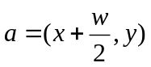
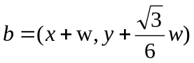
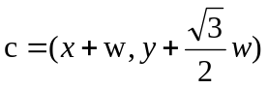
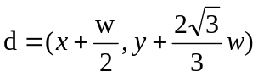
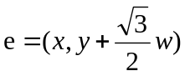
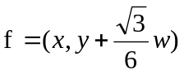

2. Chess Board Display Algorithm
The draw() method from Chess class will only print chess itself, and HexBoard is responsible of organizing the whole chess e.g. 9 * 9
X X X X A X X X X
X X X A A X X X
X X X A A A X X X
X X A A A A X X
X X A A A A A X X
X A A A A A A X
A A A A A A A A
A A A A A A A A A
A A A A A A A A
X A A A A A A X
X X A A A A A X X
X X A A A A X X
X X X A A A X X X
X X X A A X X X
X X X X A X X X X
1> data structure
The whole data structure is a dimension by dimension matrix.
(0, 0) (0, 0) (0, 1) (0, 2)
(0,1) (1,0) (1, 0) (1, 1) (1, 2)
(0,2) (1,1)(2,0) --> (2, 0) (2, 1) (2, 2)
(1,2)(2,1)
(2,2)
2> board display algorithm
1. vague board display: not considering space offset and border
(0, 0)
(0, 1) (1, 0)
(0, 2) (1, 1) (2, 0)
(1, 2) (2, 1)
(2, 2)
row here is the row of matrix, but the actual column of graph.
col is column of the matrix but the row of graph
2. space offset
(row + col) * (chess_x_size + chess_x_offset)

3. border
The most straightforward way is use the outer layer as border
X X X X A X X X X
X X X A A X X X
X X X A A A X X X
X X A A A A X X
X X A A A A A X X
X A A A A A A X
A A A A A A A A
A A A A A A A A A
A A A A A A A A
X A A A A A A X
X X A A A A A X X
X X A A A A X X
X X X A A A X X X
X X X A A X X X
X X X X A X X X X
To make a 9 * 9 games, we at least need 11 * 11 to make border happen.

3. mouse click event alogrithm
When mouse is clicked, the cooridination (x,y) will be checked by each chess object.
We use circle to mimic the actual body of our hexgon.
the original point and the radius are calculated by:
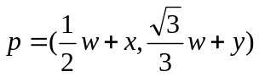
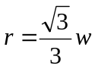
Then check if mouse cooridnation is within r

1> Check if clicked cooridinator is within circle
4. Algorithm Interface
1> to matrix representation
Only need to remove the border layer and keep the content.
Only keep the ChessType.
2>. Winner Check Interface
Convert to matrix
Use Algorithm to check if Any player wins
3> AI algorithm interface
1> send function:
send changed coordinator to the algorithm
2> listener function:
wait result from the algorithm
count how many time for this algorithm

