COMP3123 Lab Test 1 - Output Screenshots
Junyong Choi (101539862)
https://github.com/Junyong0619/101539862_comp3123_labtest1
Date: October 8, 2026

Question 1
File: q1/lowerCaseWords.js
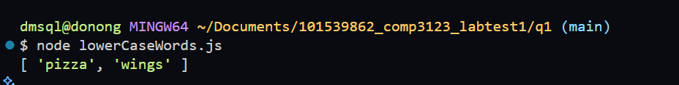

Question 2
File: q2/promises.js
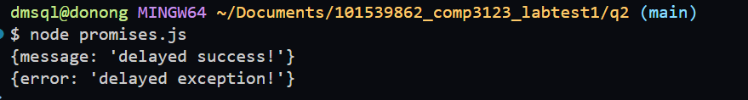

Question 3-1
File: q3/add.js
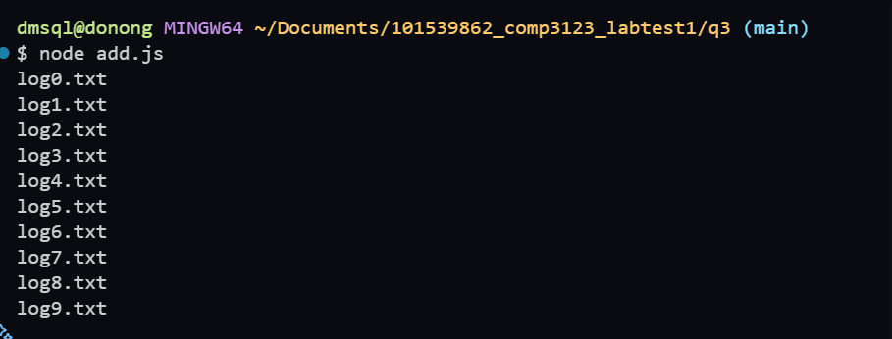

Question 3-2
File: q3/remove.js
