1. ***Midterm 1***

*Unit 1: Mathematical modeling, numerical programming, Monte Carlo, and floating point*

* How to turn a verbal problem description into a model we can use the computer to solve
* How to use the Matlab programming language and environment
* How computers represent numbers like (1/3) and floating point arithmetic
* How randomized and Monte Carlo methods let us approximate complicated mathematical quantities quickly.

*Topics* round-off analysis, numerically stable method, mathematical model, Matlab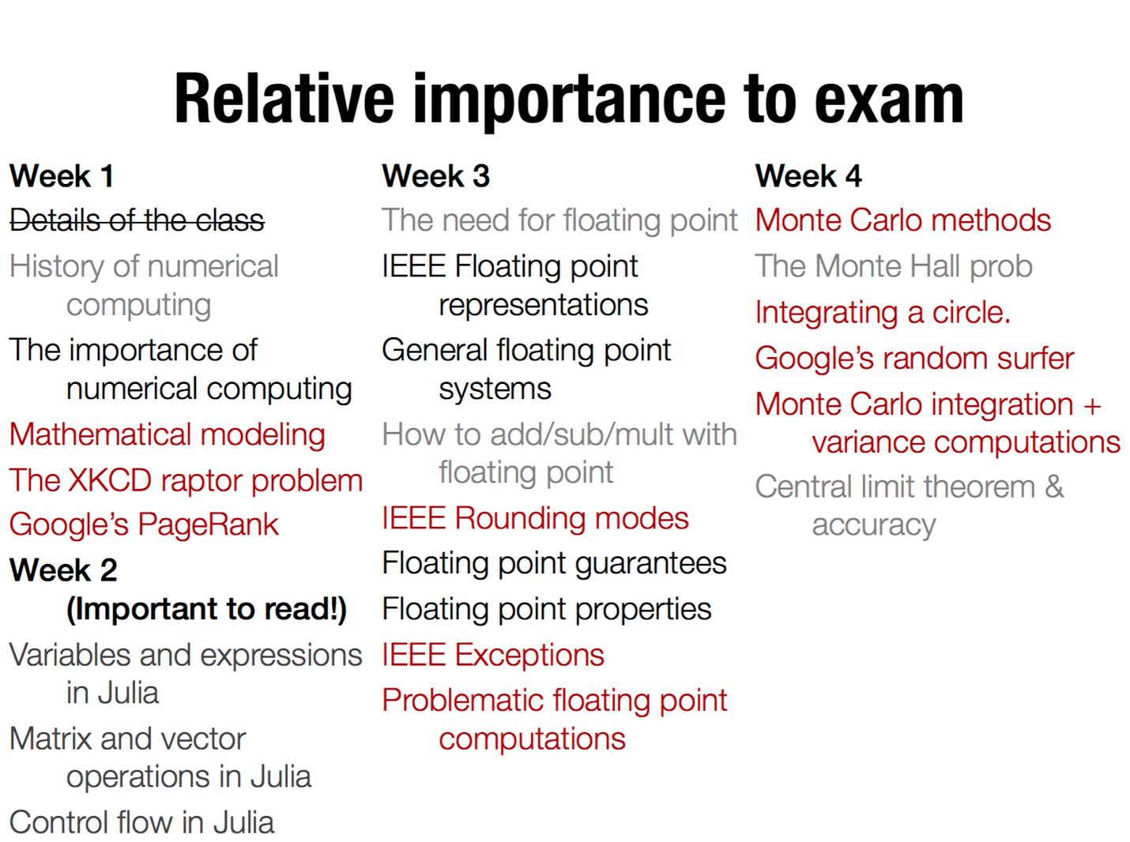

function circle_intersect()

c1 = randn(2)

c2 = randn(2)

if norm(c1-c2) <= 1

# if the distance between

return 1

else

return 0

# centers <= 1, they intersect

end

end

Wins = 0

for t=1:ntrials

wins += circle_intersect()

End

Wins/ntrials

------------------------------------------------------------------------------------------------------------------------------

N = 50

x = linspace(0,1,N)

y = zeros(N)

For i=1:N

y[i] = sin(x[i]^2)

End

Plot(x,y,title=@sprintf(“.18f”, sum(y)))

======================================

1. **Mathematical Model**

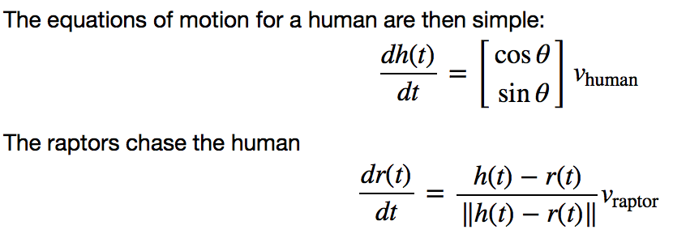

这个是：

raptor 新方向的unit vector

Page Rank：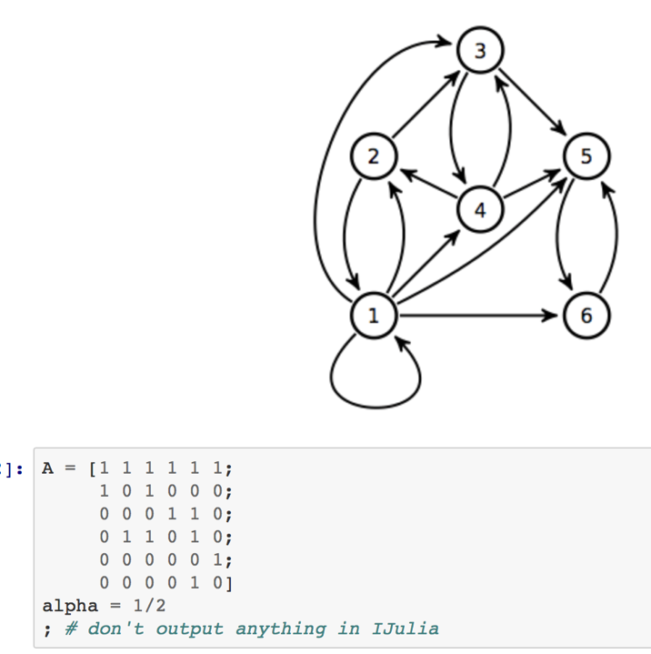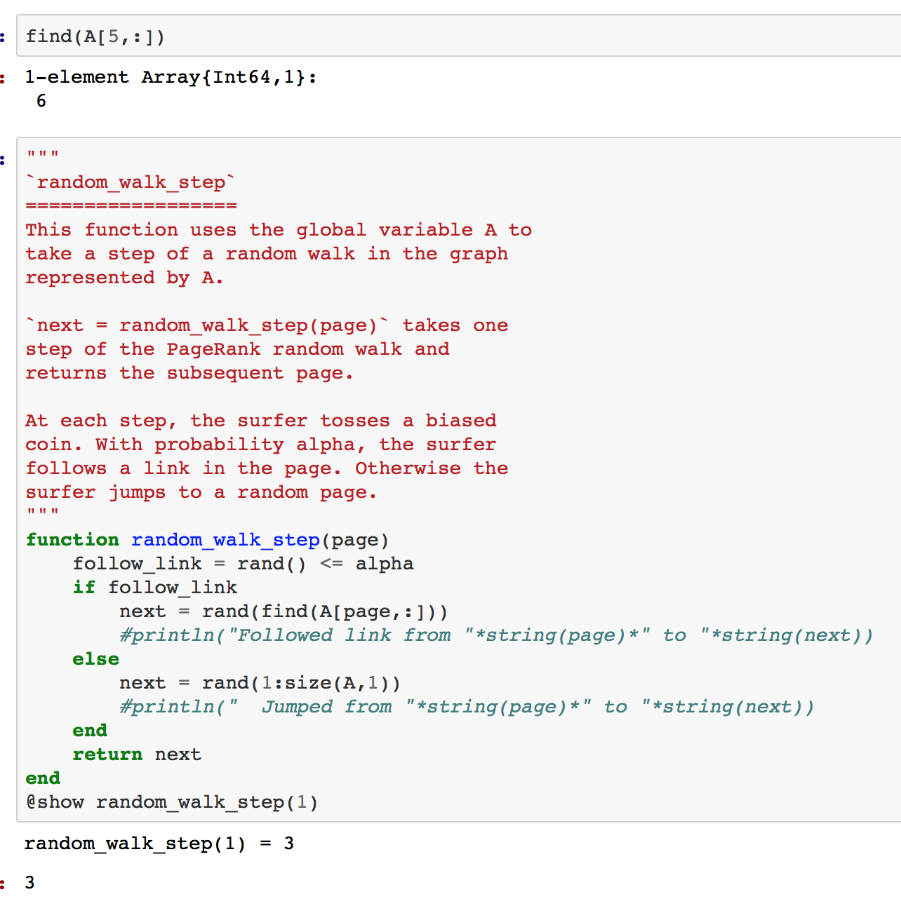

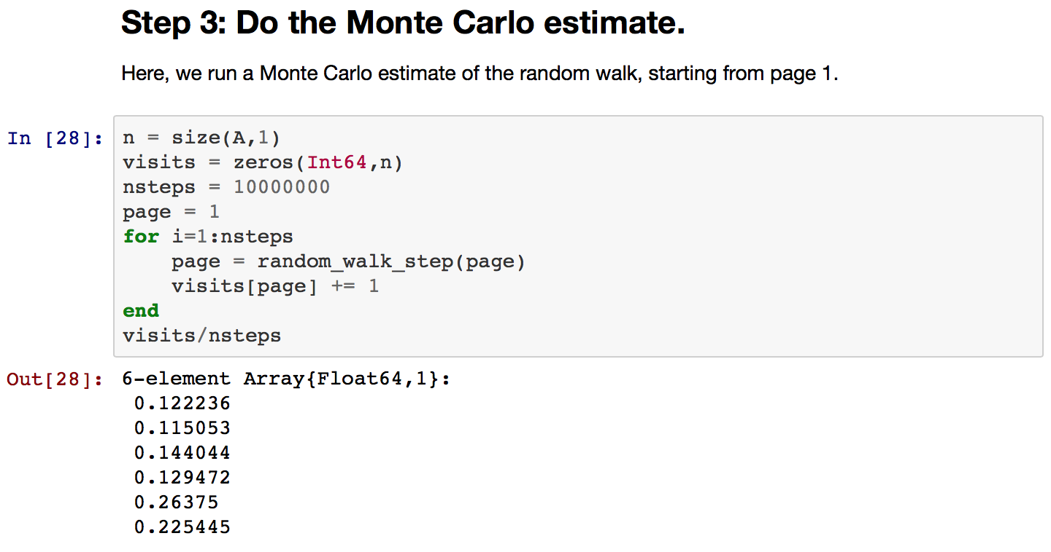

======================================

1. IEEE Floating point number

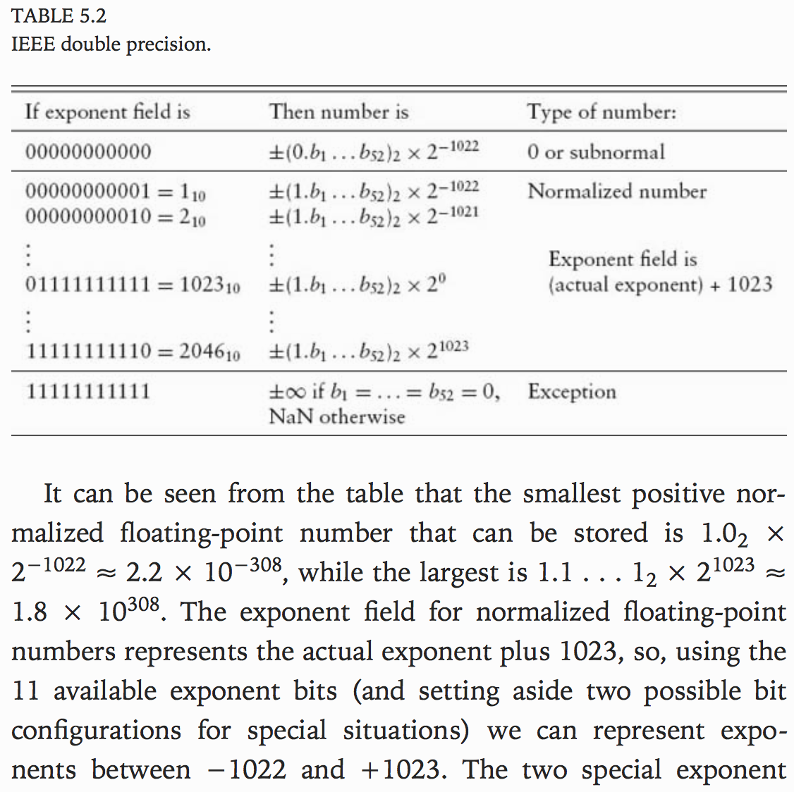

======================================

1. Monty carol

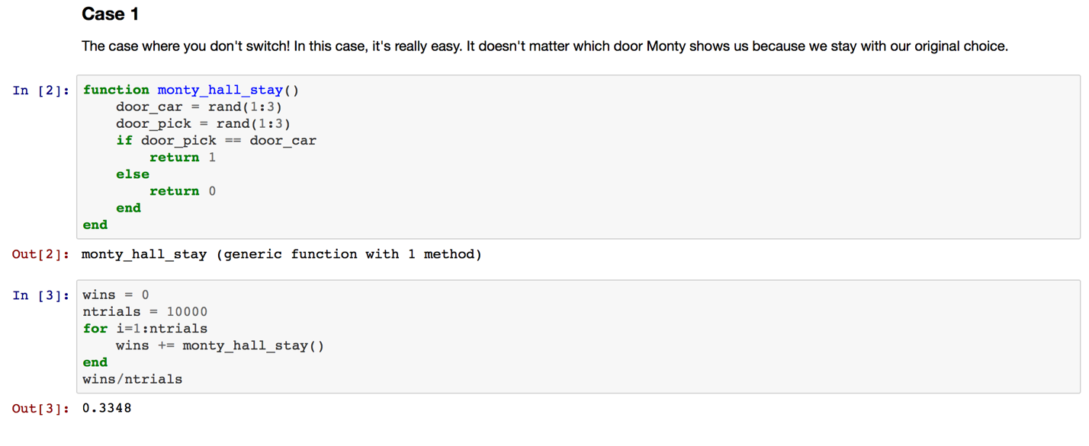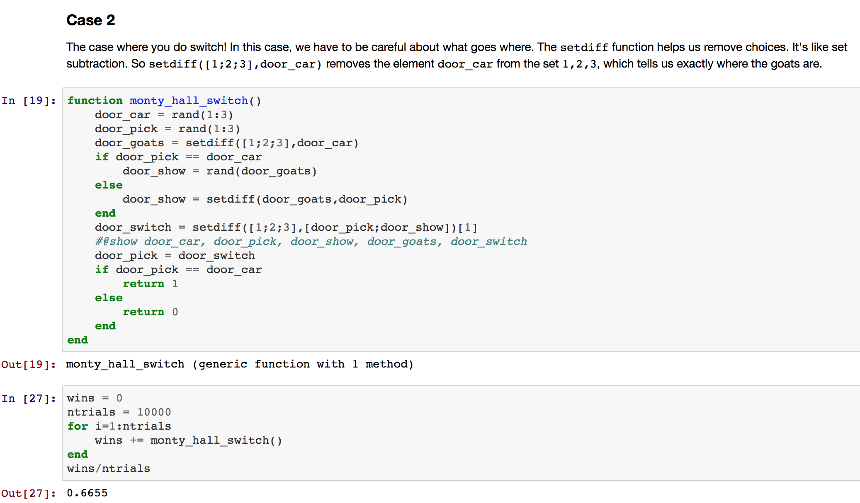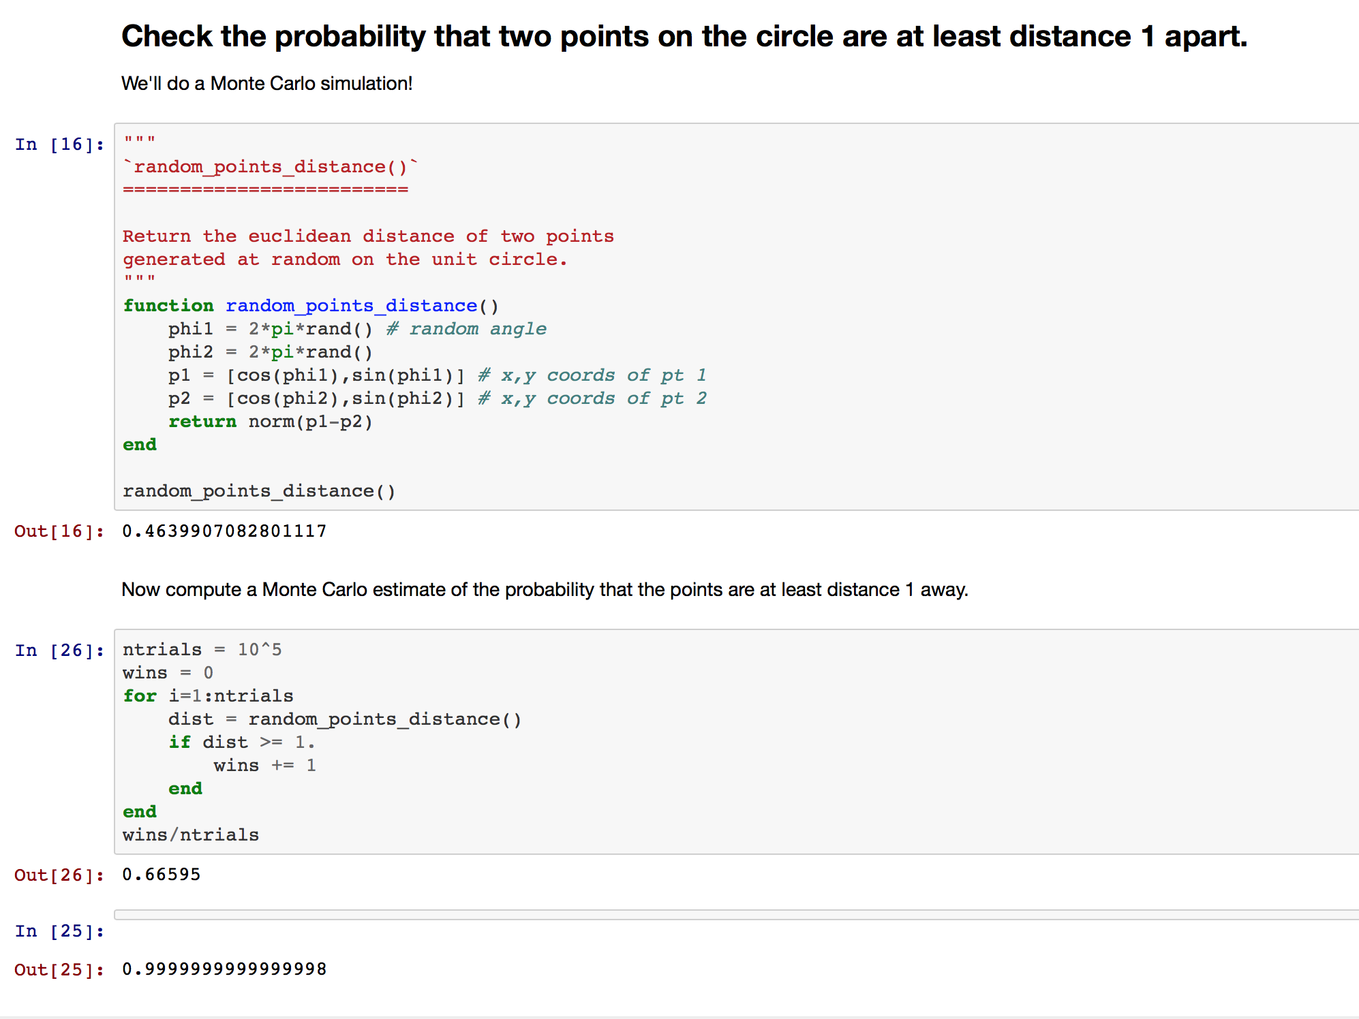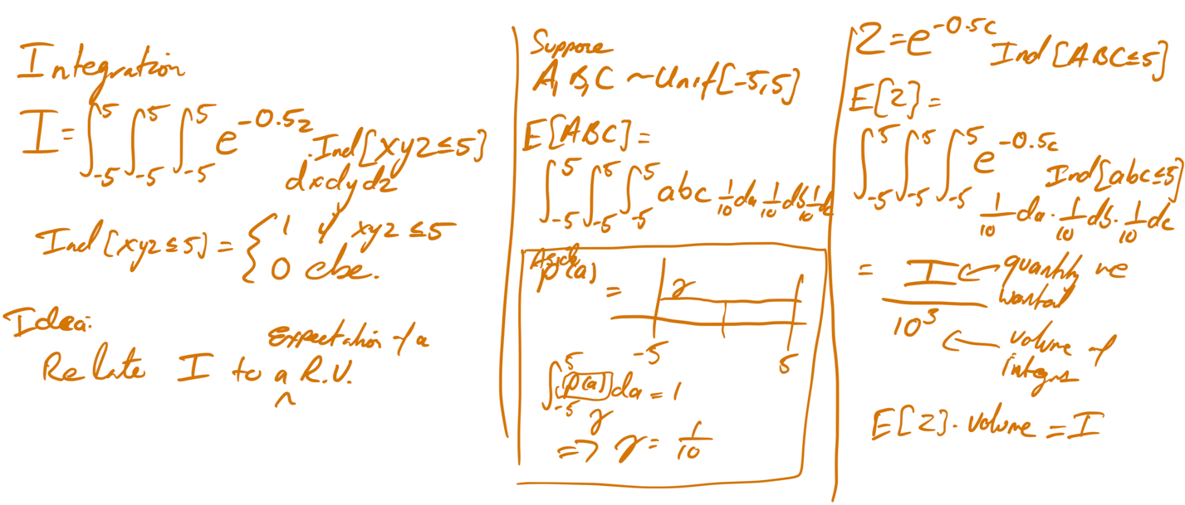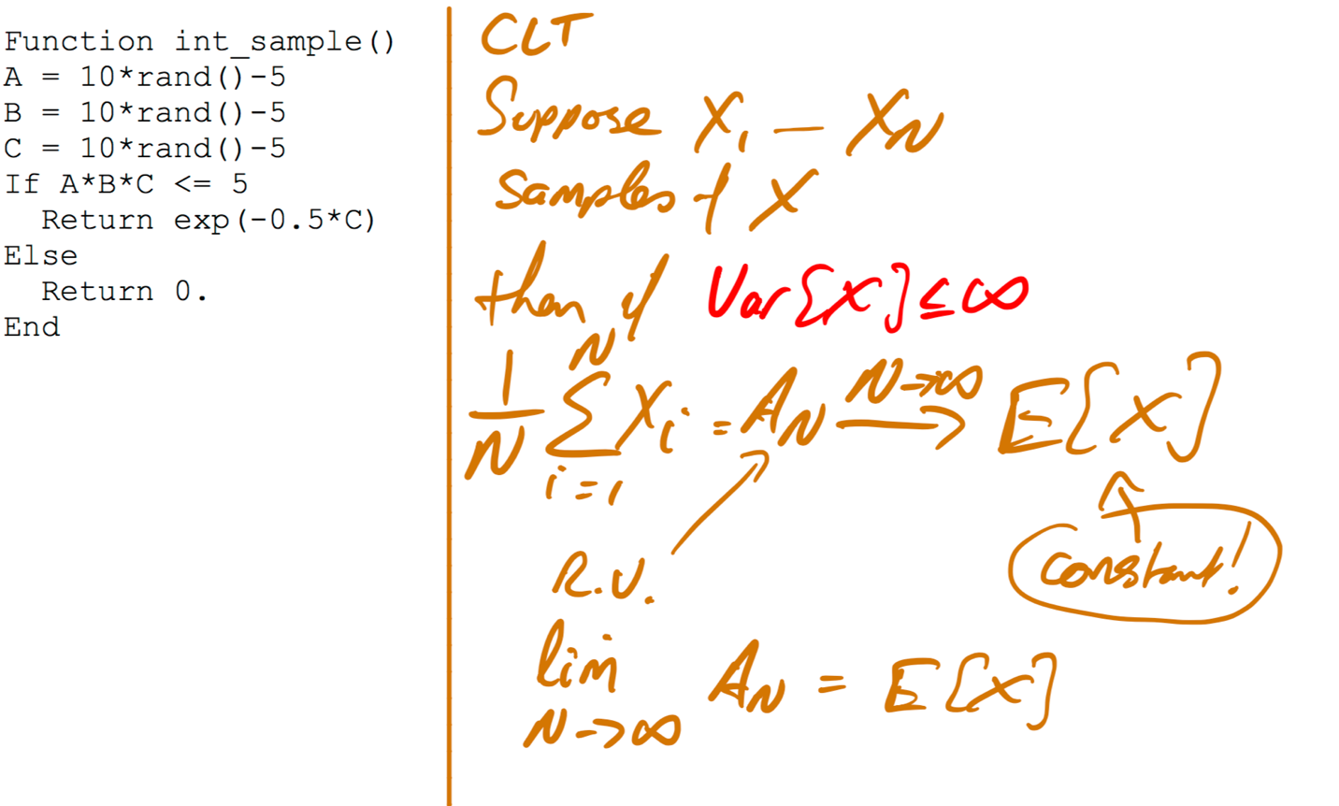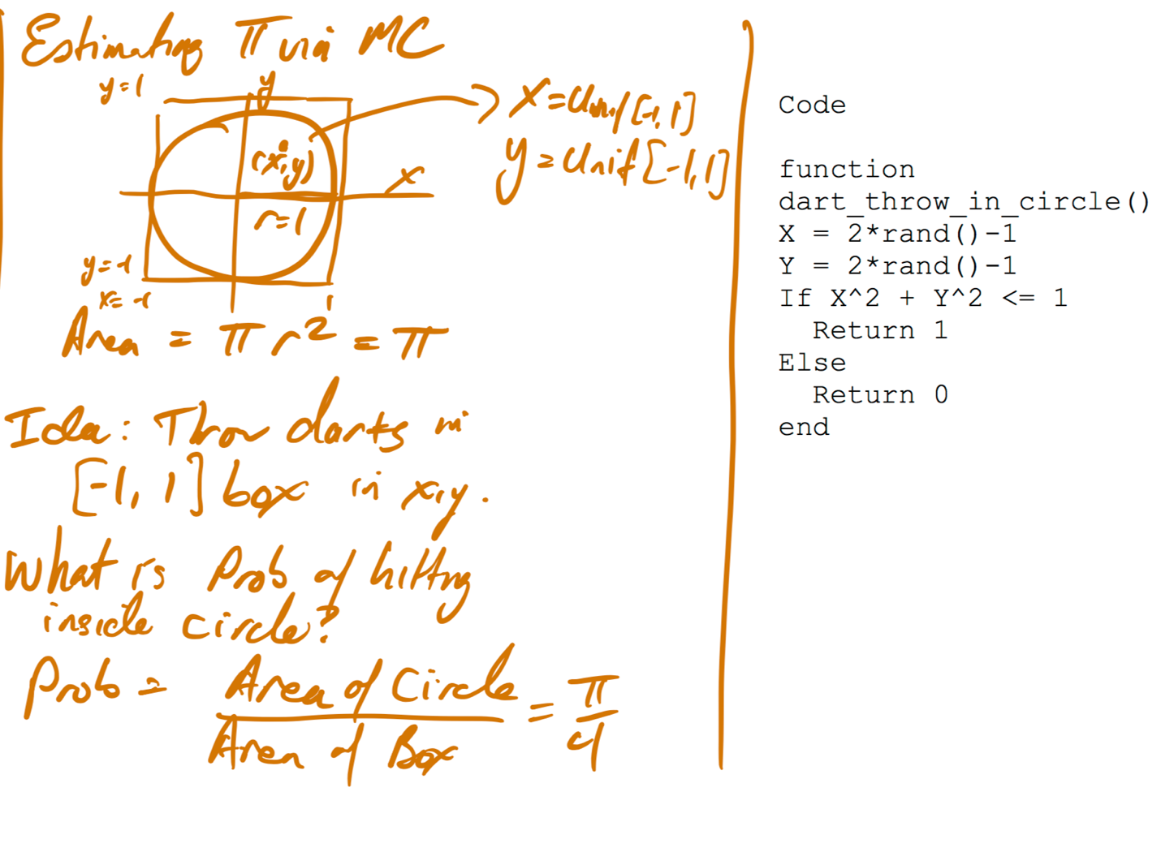

function goodvar(x)

n = length(x); mean = 0.0; m2 = 0.0; N = 0;

for i=1:n

N=N+1  
delta = x[i] - mean  
mean = mean + delta/N  
m2 = m2 + delta*(x[i]-mean)

end

return m2/(n-1)