Tian Qiu CS314 HW5

**Problem 1**

1. a).

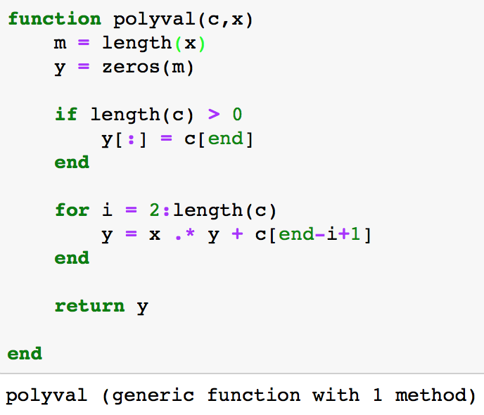

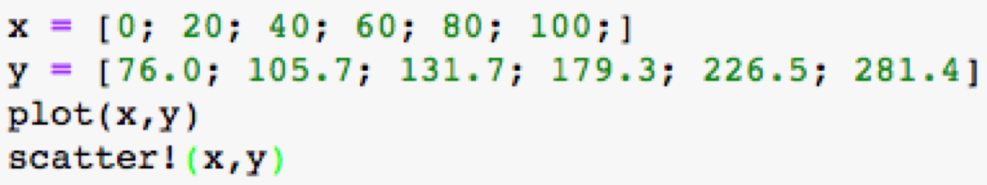

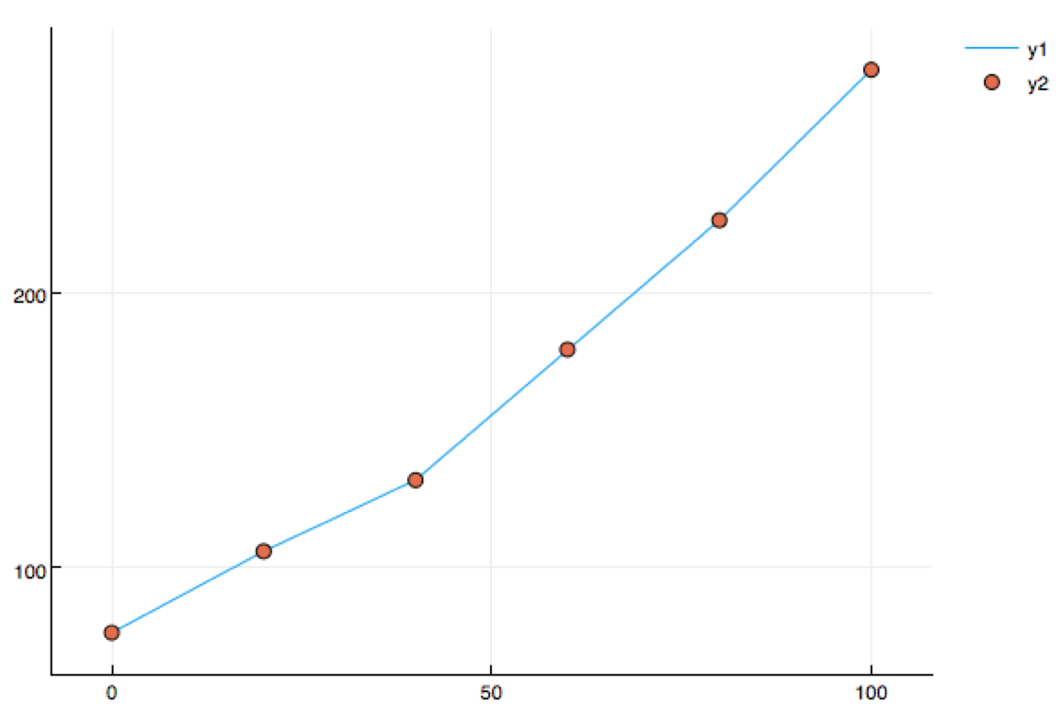

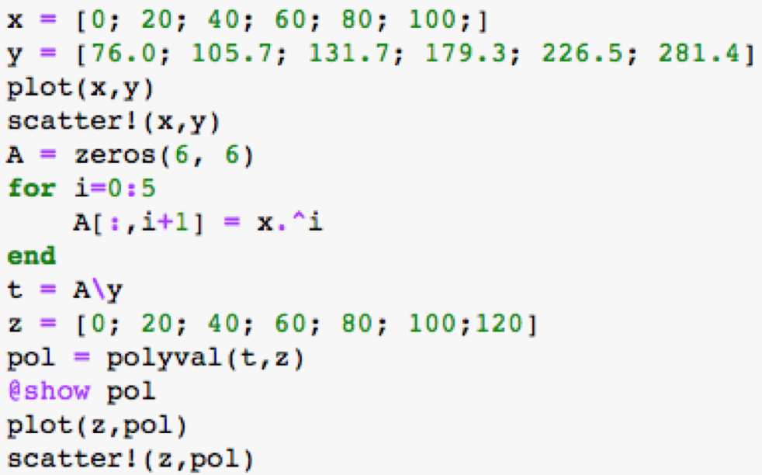

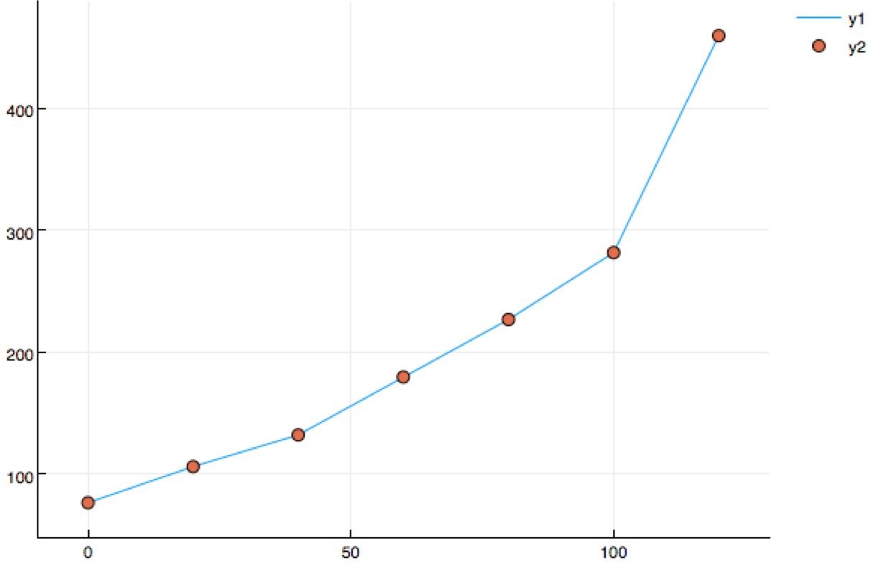

I think it is a reasonable way to estimate the population of the US in the future years.

However, the data points are quite small. Based on this these data cannot give us an accurate estimation even we used the right method.

The population in 2020 based on interpolation will be around 460 million.

1 b). F



function barylag(x,y,xx)

# direct port of

# http://www.mathworks.com/matlabcentral/fileexchange/...

# 4478-barycentric-lagrange-interpolating-polynomials-...

# and-lebesgue-constant/content/barylag.m

# to Julia. Not that better implmentations in Julia are possible.

M = length(x)

N = length(xx)

@assert M == length(y)

X = repmat(x,1,M)

W = repmat(1./prod(X-X'+eye(M),1),N,1)

xdist=repmat(xx,1,M)-repmat(x',N,1)

fixi,fixj = findnz(xdist.==0)

H=W./xdist

p=vec((H*y)./sum(H,2))

p[fixi] = y[fixj]

return p

end

**Problem 2**

**The Chebyshev interpolation points in (8.15) are defined for the interval [−1, 1]. Suppose we wish to approximate a function on an interval [a, b]. Write down the linear transformation that maps the interval [−1, 1] to [a, b], with (a) = −1 and (b) = 1.**



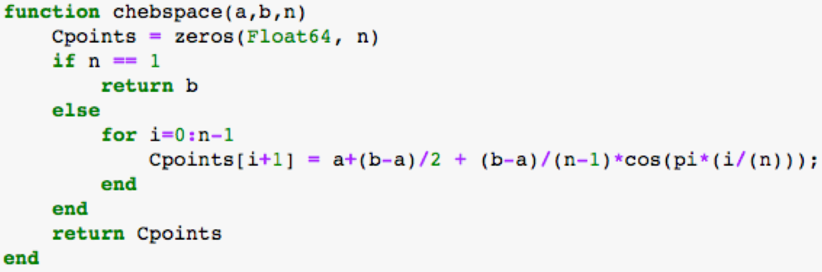

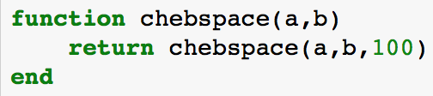

**Problem 3**

I have learnt that the polynomial interpolation is a method to interpolate the given data set by a polynomial. Even when the data set is not continuous, the polynomial interpolation can go exactly through these points. For polynomial interpolation, we have many methods to accomplish this task like Vandermonde system, least squares and Lagrange interpolation. Also, we learnt the interpolation at Chebyshev points and the method to judge the error of polynomial interpolation.

I definitely used the polynomial interpolation before. One example is that in introduction to statistics course, we used least square method to get the linear interpolation. Also, we learnt Lagrange interpolation in high school chemical experiment course to calculate the equations of a data set which contains experimental data and control data.

**Problem 4**

1. Done.

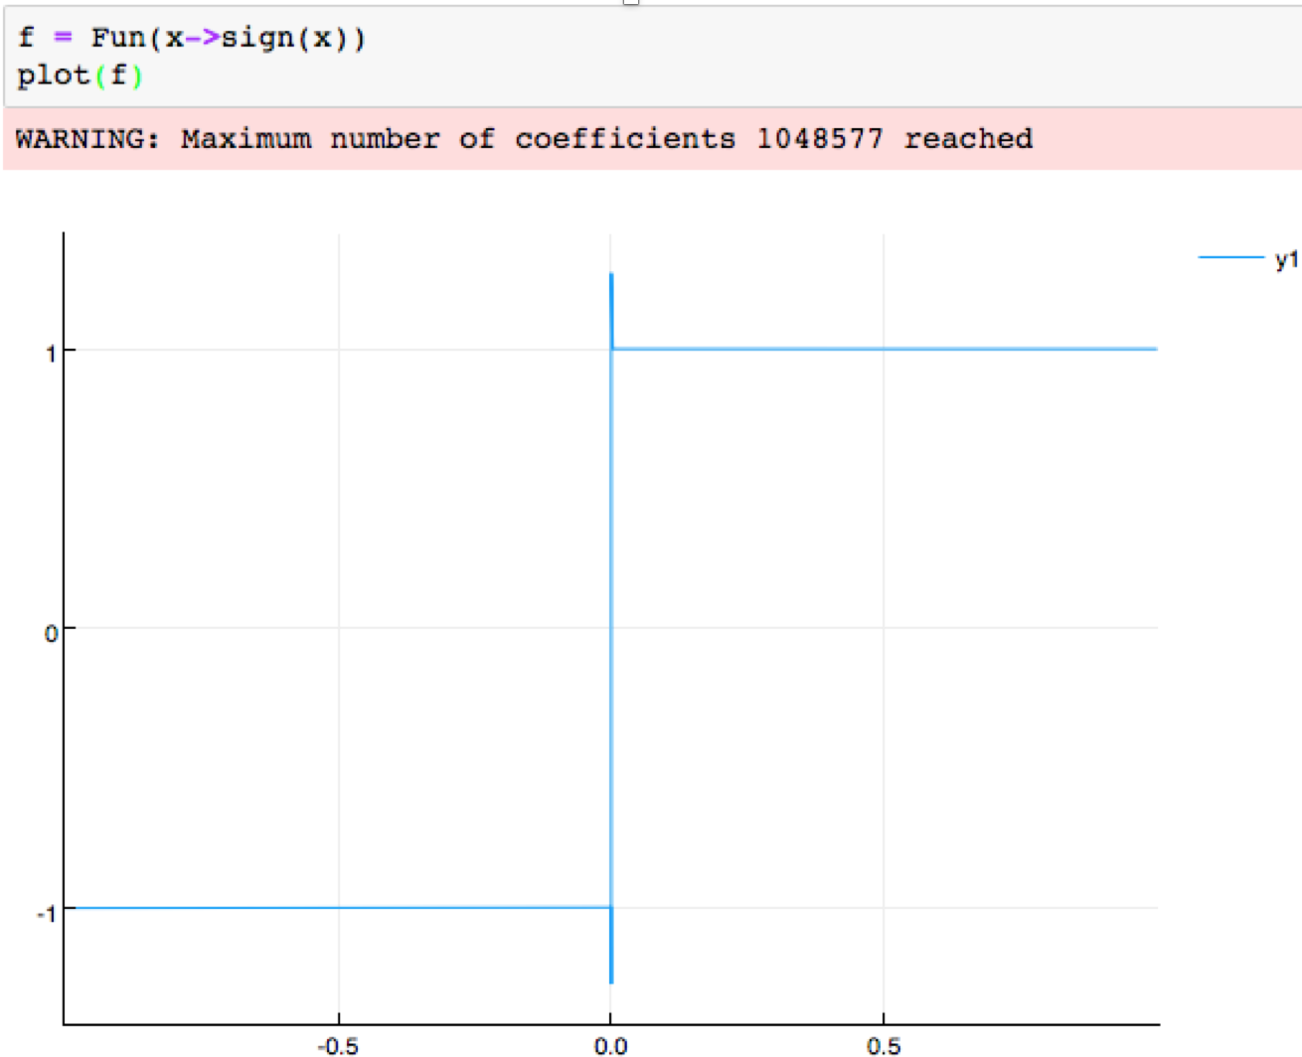

To use Weistrauss approximation theorem, we need the function to be continuous from -1 to 1. As we can see from the graph, it is a continuous function defined on [-1, 1]. So, the Weistrauss approximation theorem can be used.

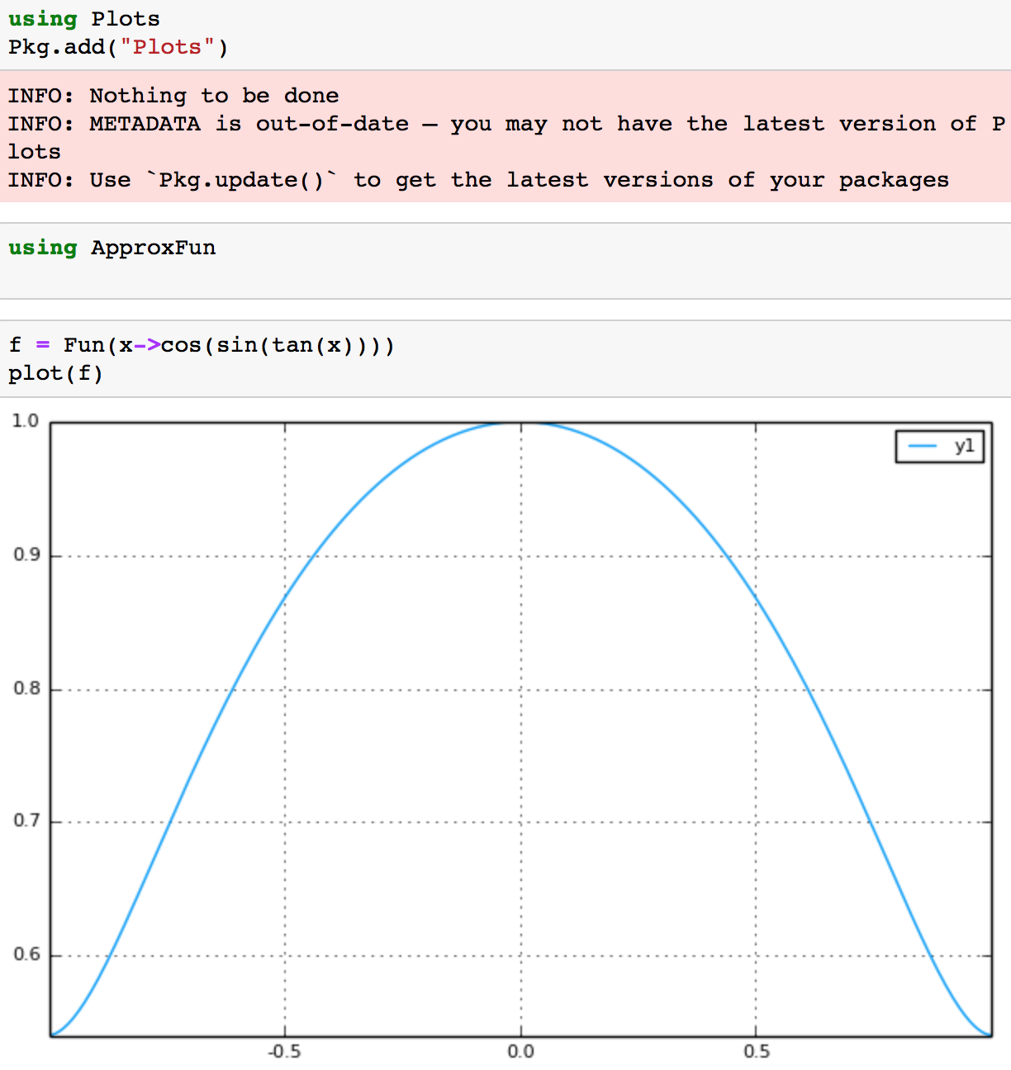

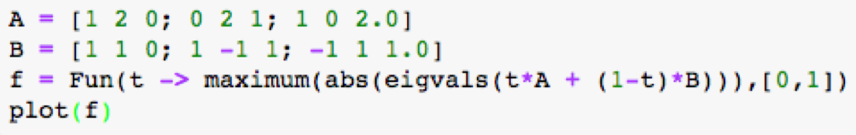

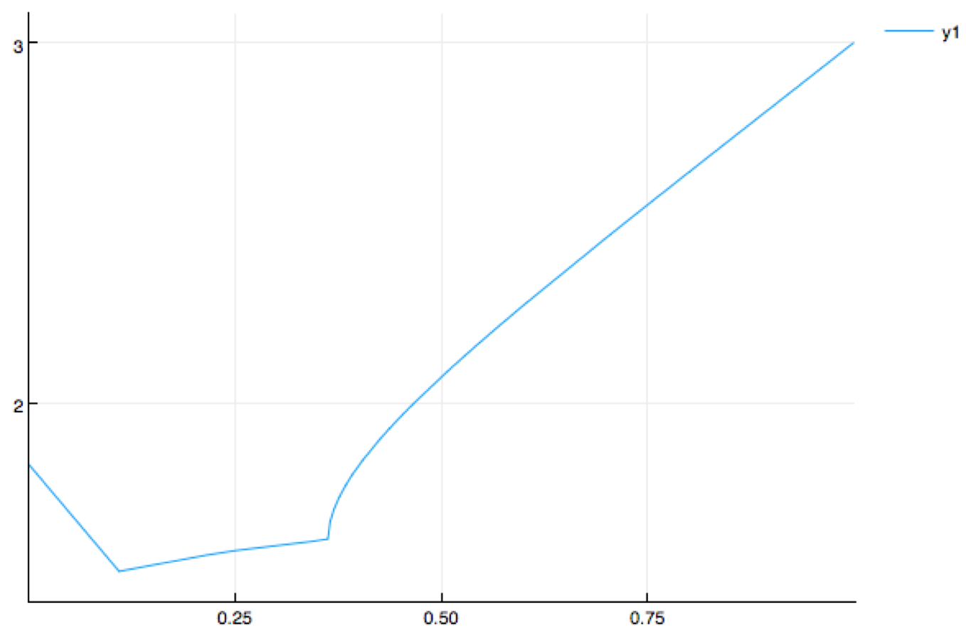

1. Skip

**Problem 5**

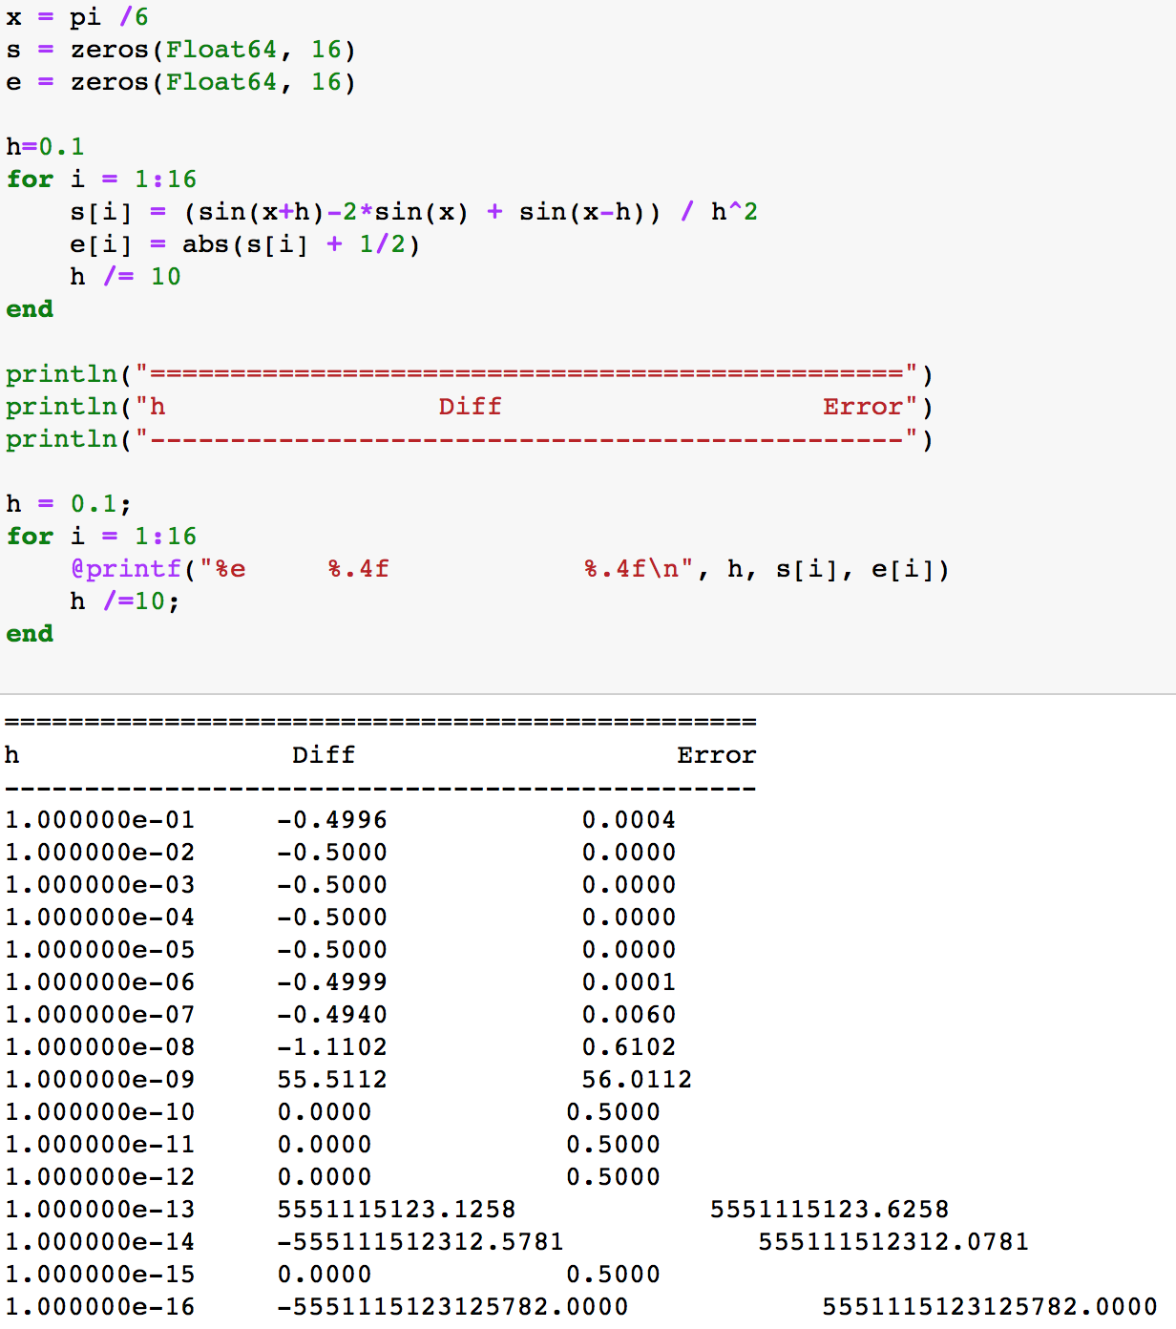

As we can see in the table, the best approximation is when h is around . When h gets lesser, the error becomes larger and larger. Because for the equation

s[i] = …. / h^2, when h gets lesser, h^2 will dominate the whole equation and make the error larger.

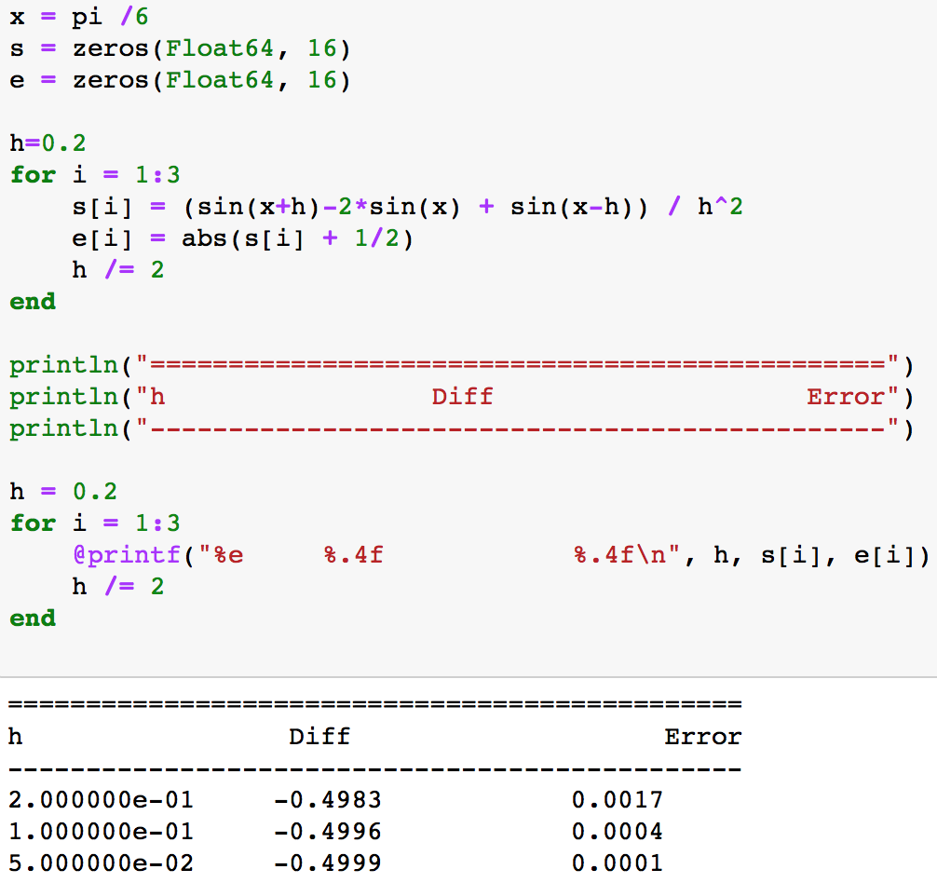

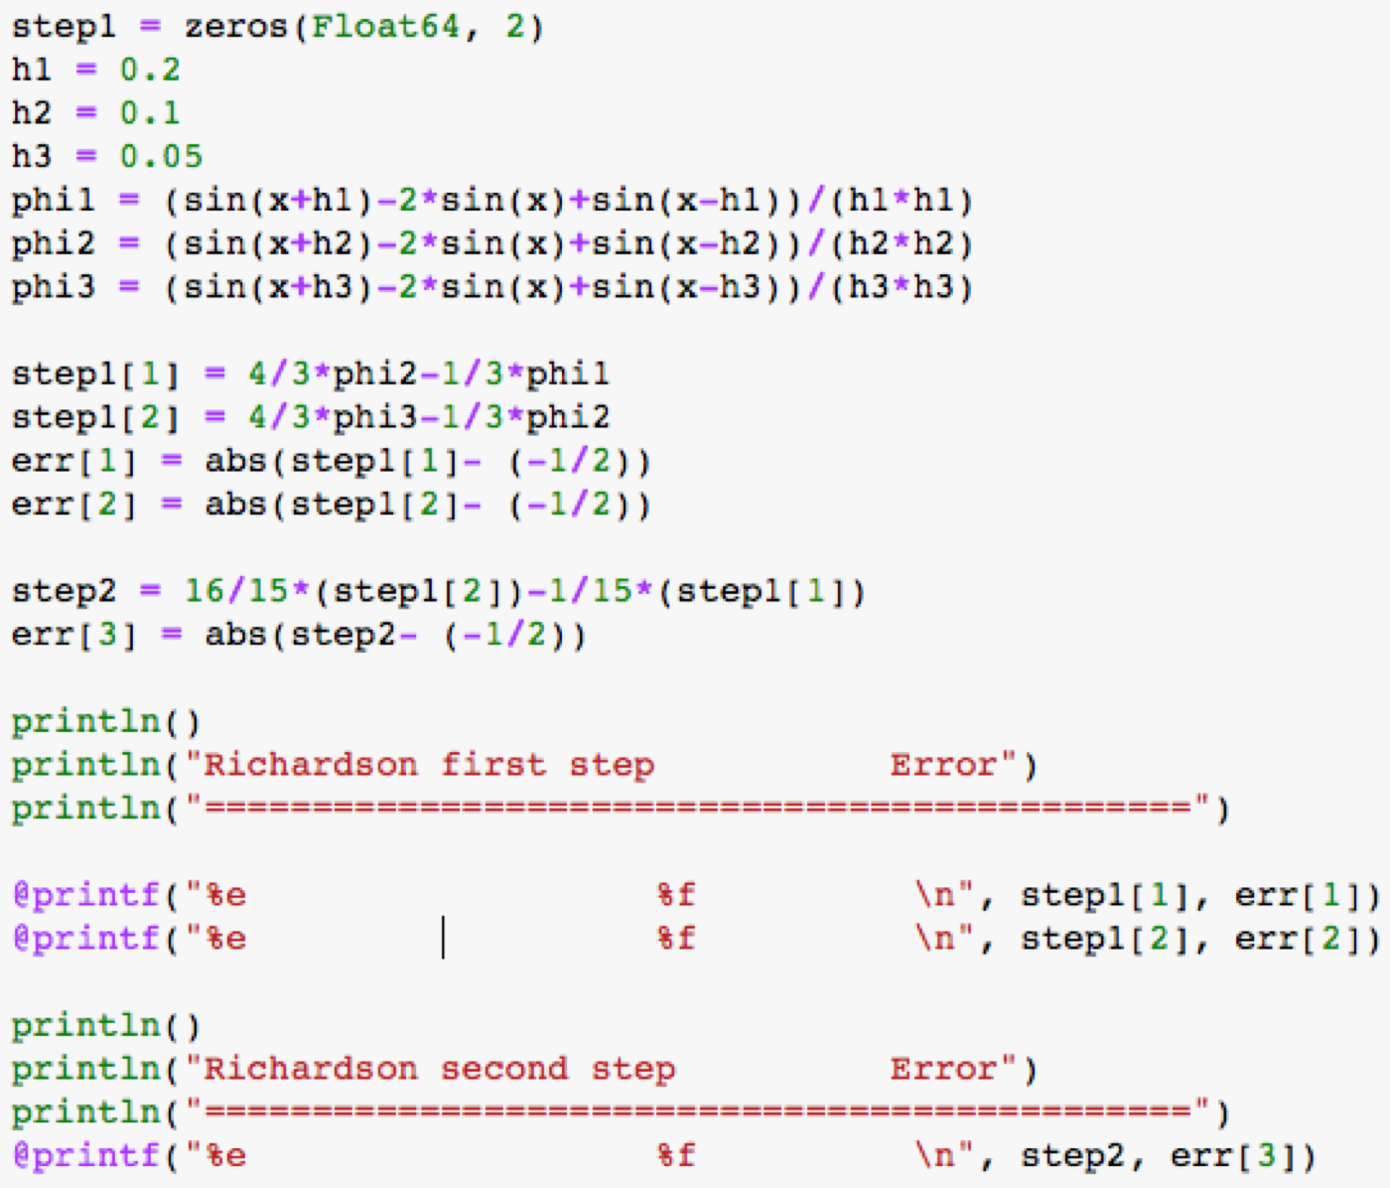

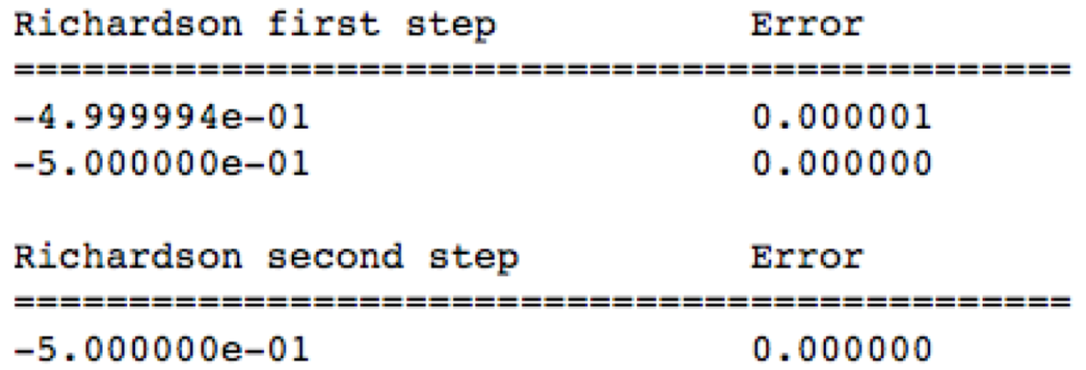

The order of accuracy for Richardson extrapolation after one step is After two steps is

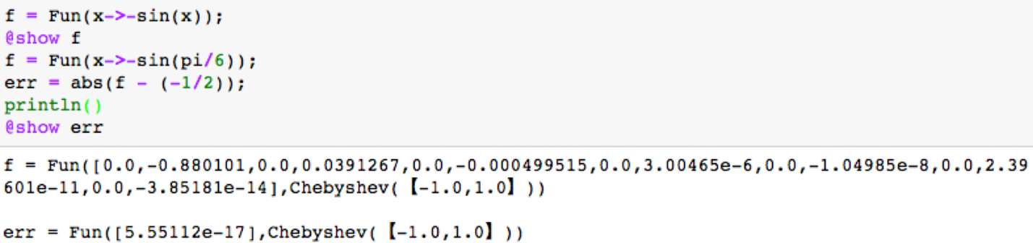

The degree of the interpolation polynomial that it produces for f is 13.

The error in its approximation is 5.55e-17.

Error term: .