Tian Qiu

00265 35063

HW6

CS 314

Problem 1

1.

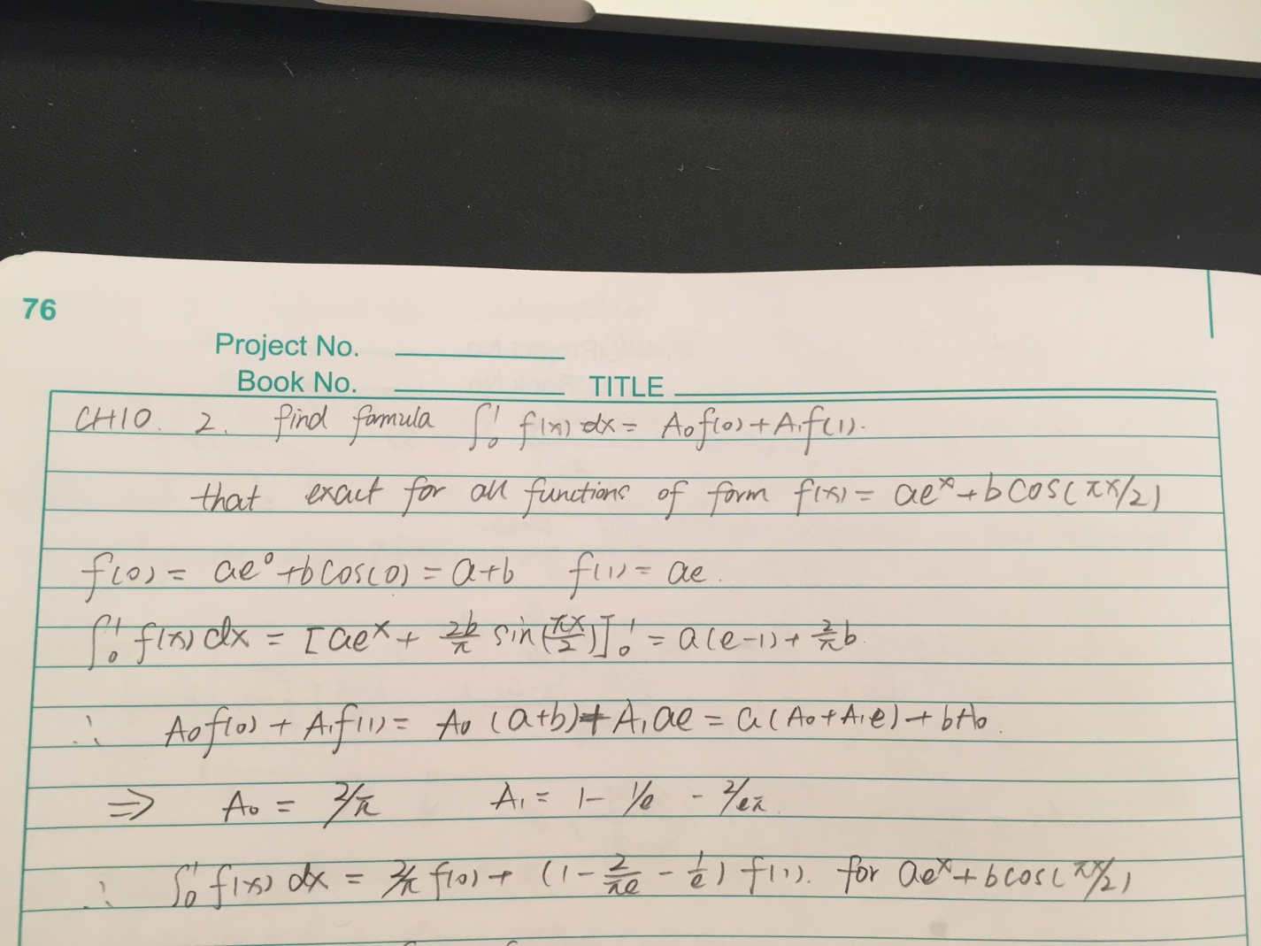

2.

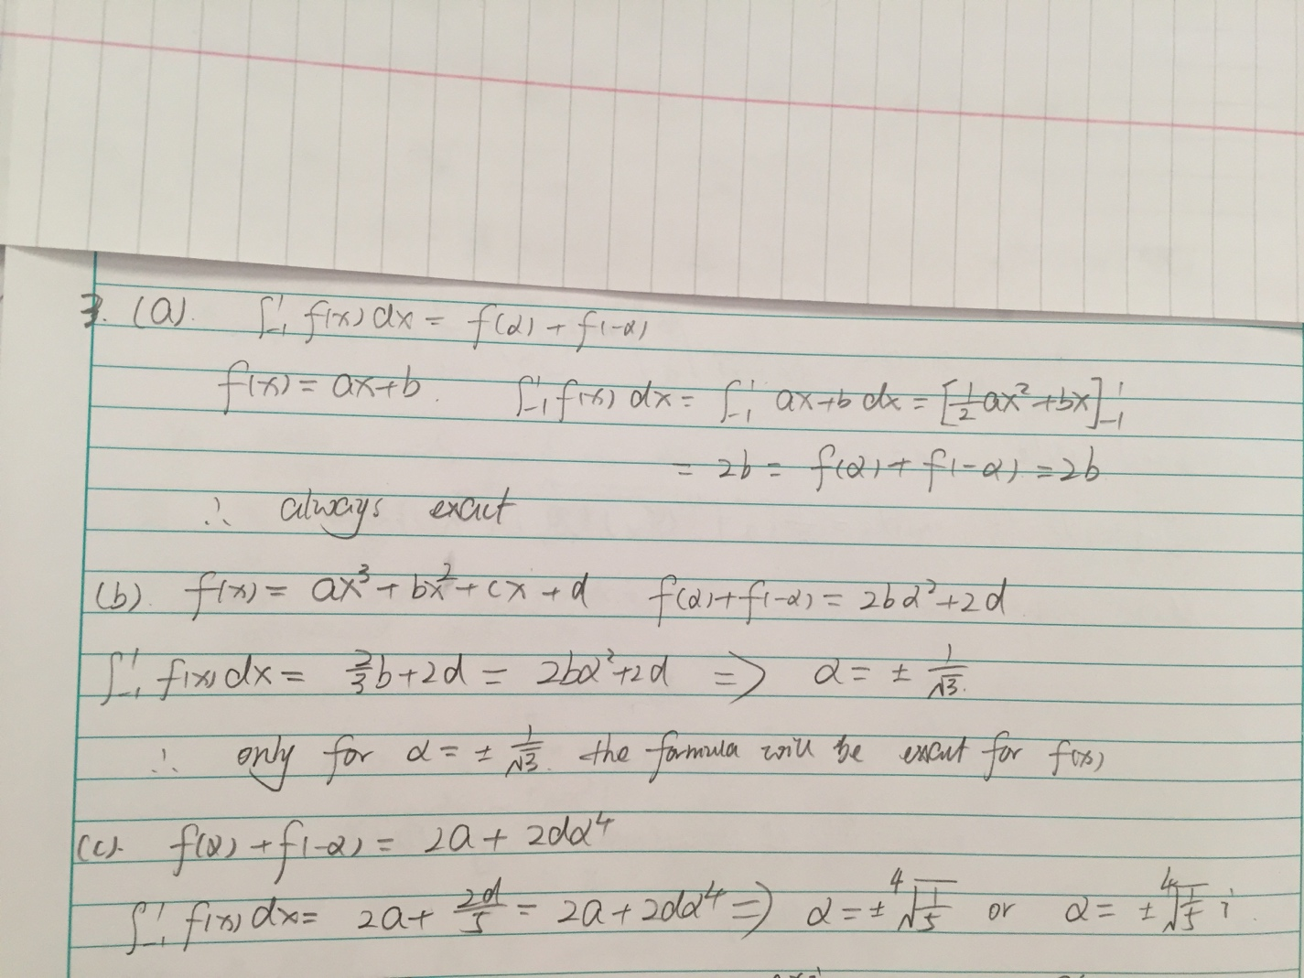

Problem 2

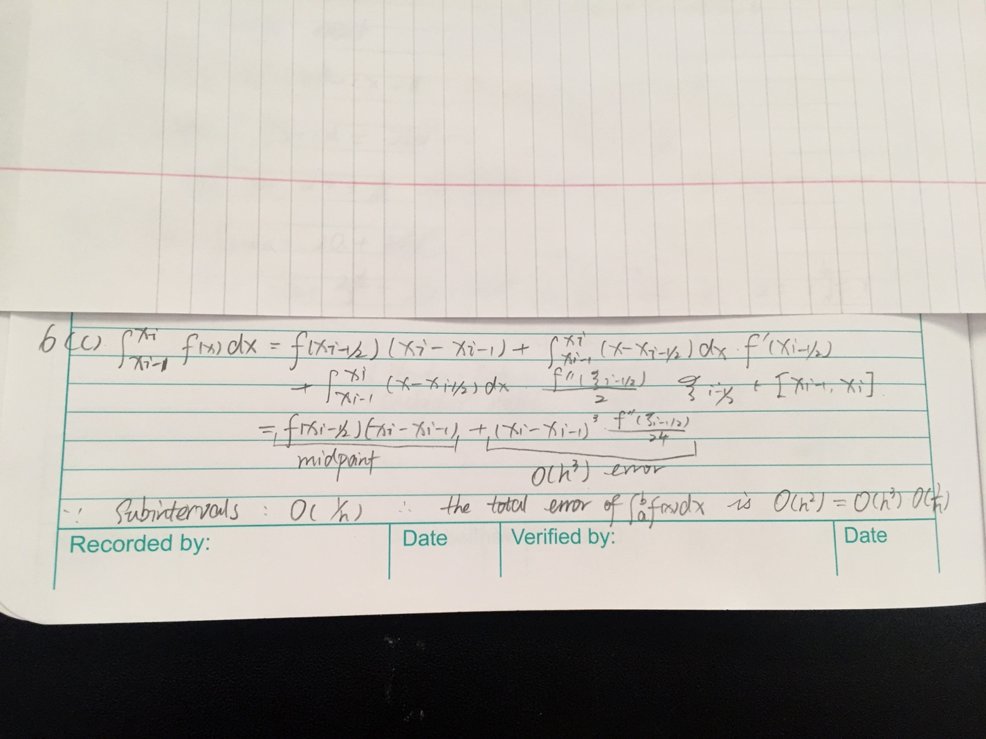

Problem 3

By integration, The real value should be 0.9045

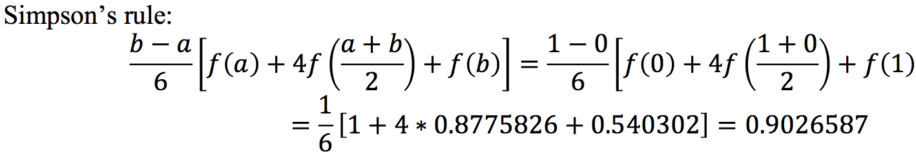

Error: 0.00186

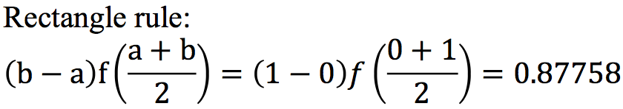

Error: 0.02694

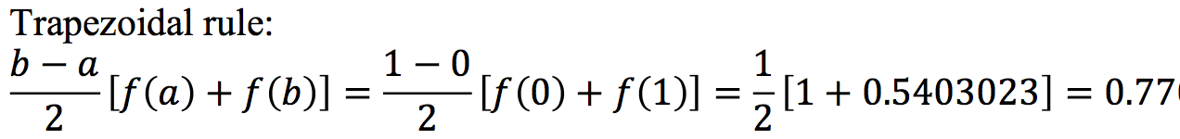

Error: 0.1344

For this integration, Simpson’s rule works best.

Problem 4

1.

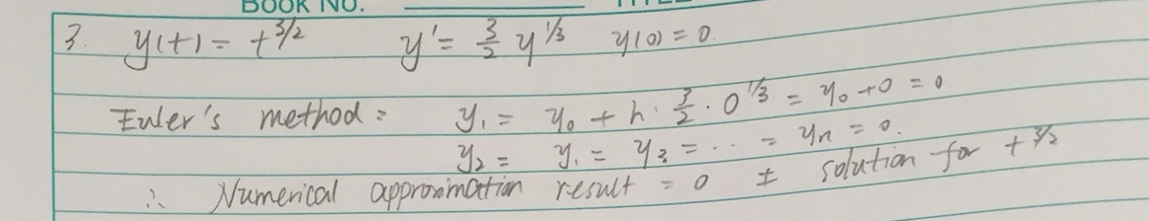

2.

(a)

Juliet at this time is feeling terrible and has an bad feeling towards Romeo.

(b)

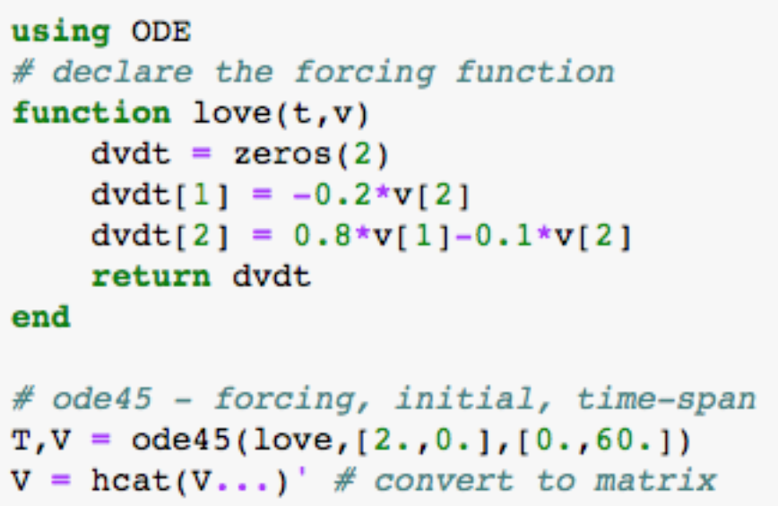

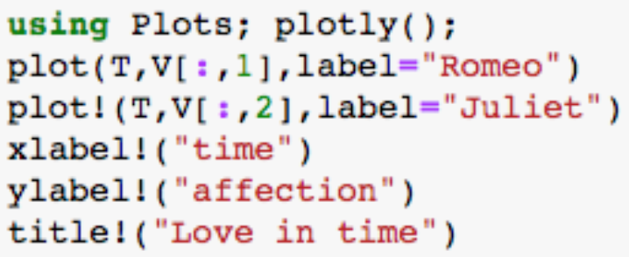

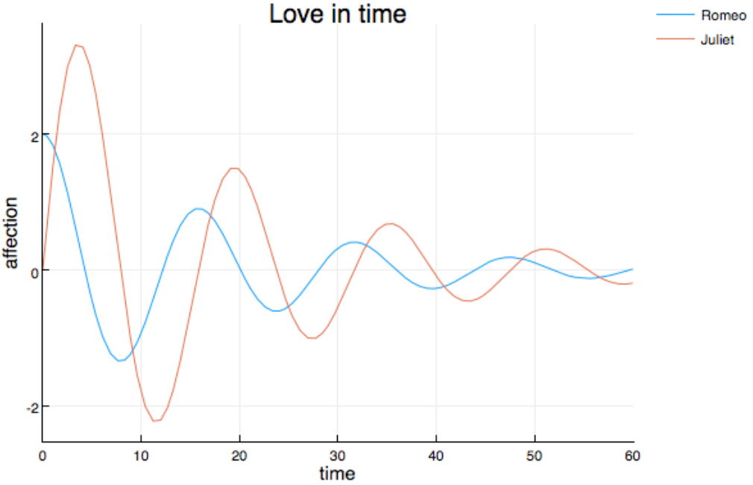

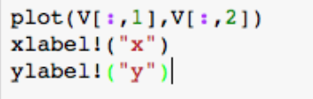

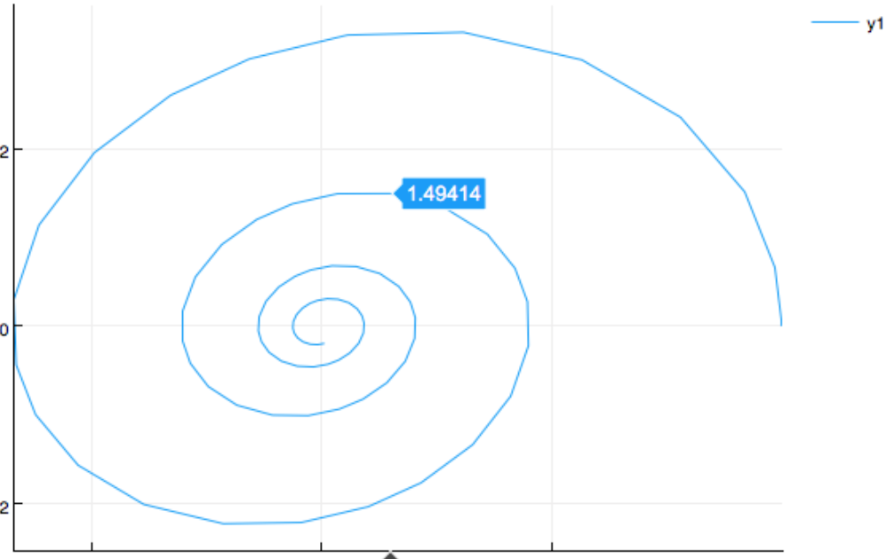

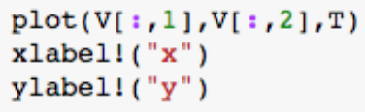

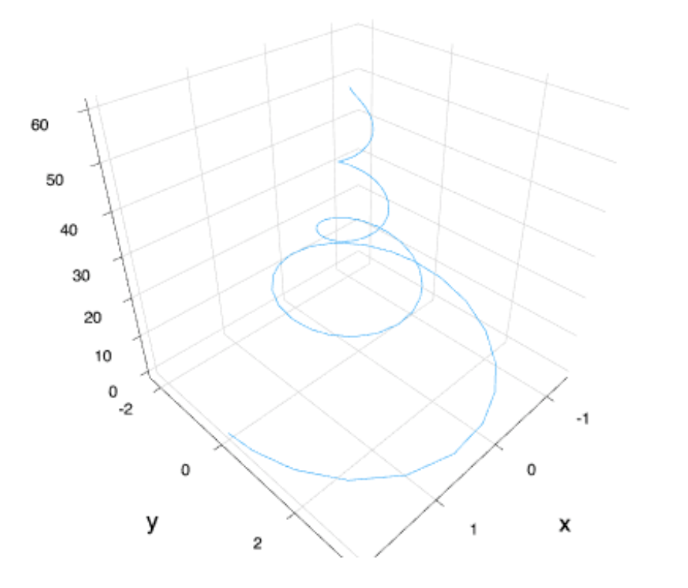

(c)

From the graph we can see that Romeo’s emotion and Juliet’s emotions are going to be zero at the end. They will become unfamiliar with each other gradually.

Problem 5.

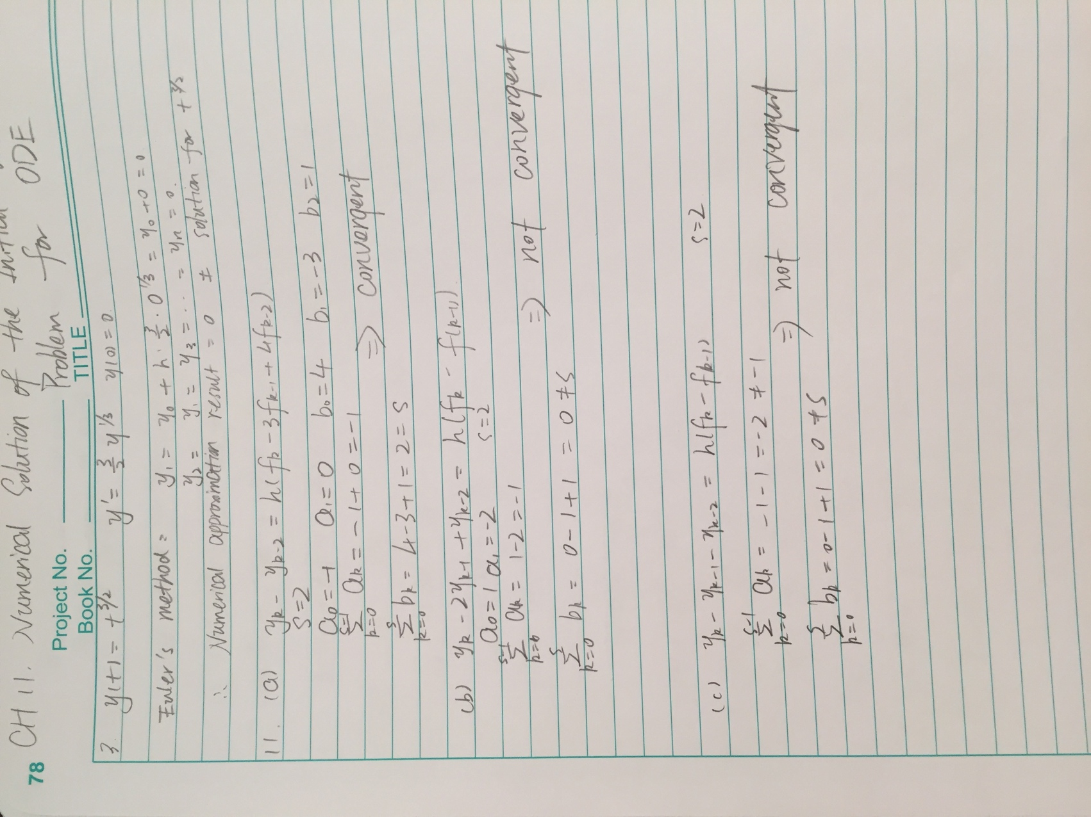

Problem 6.

First section is the initialization for all variables.

Second section is using function to compute derivatives of human and raptor’s position. Human’s position is calculated by the direction and velocity. Raptor’s position is calculated by the degree between their velocity and human’s direction.

Third section is using function to simulate. This function uses forward Euler approximation to approximate the raptors. Loop is used to check the distance between human and raptors. While updating the position, the function can determine whether the human get caught by any of the raptors.

The final section is showing raptors. This function is to plot the process of raptor’s chasing. By showing the exactly how raptors chasing the human, we can conspicuously see the procedure that human finally get caught or not.