Name: Tian Qiu [Ti’an, just too hard to pronounce Qiu, so leave it]

Major: Computer Engineering

Mathematics with Computer Science

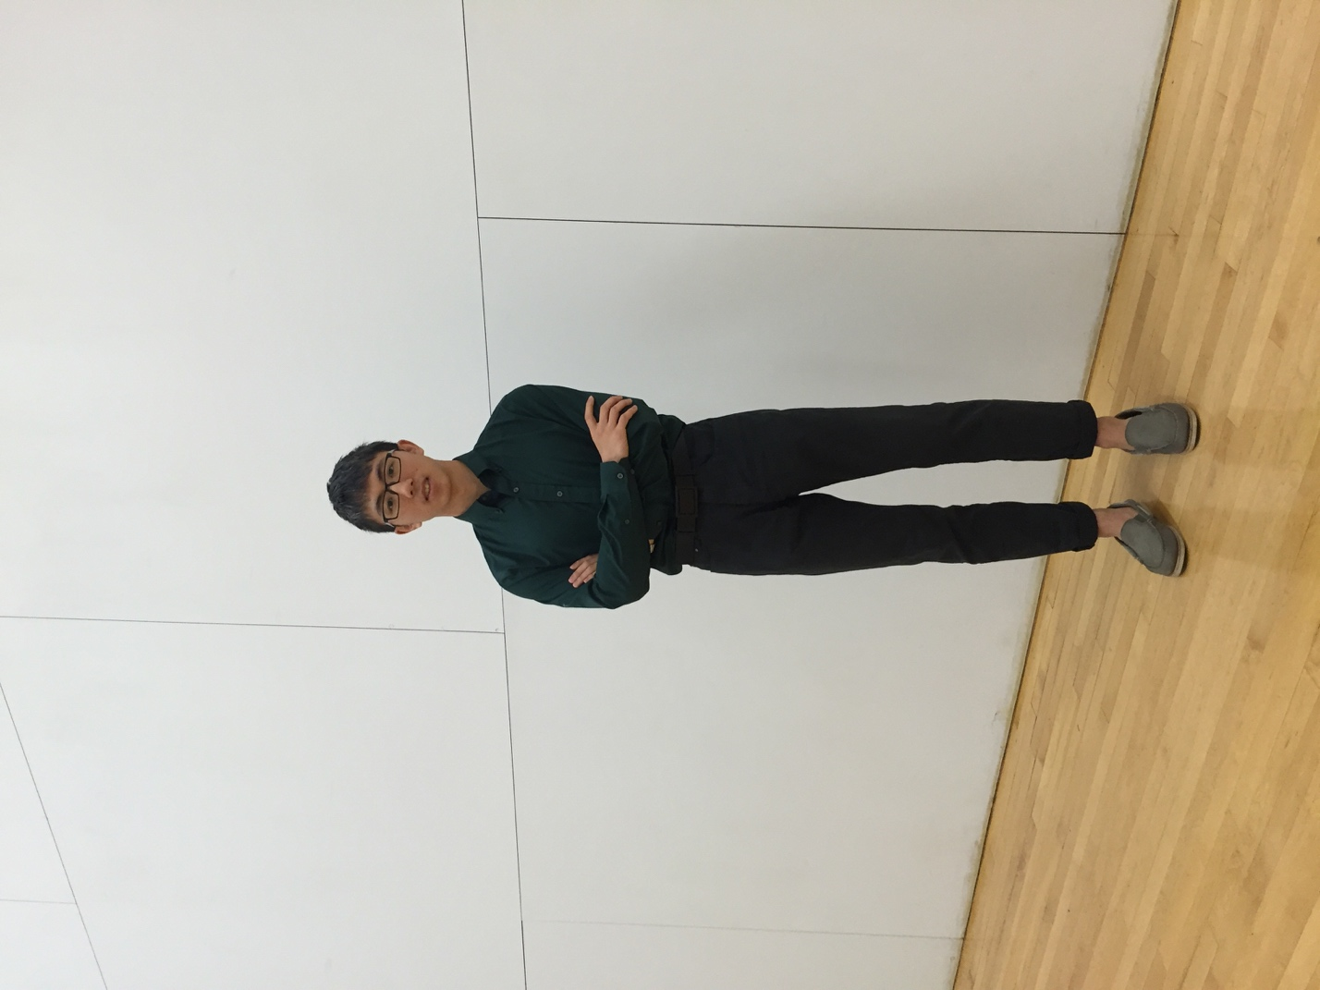

1) MACS major Required

2) A short Chinese name with black frame glasses.

3) MA351 MA353. Like all of it.

4) I think so.

5) Debug when hungry or sleepy.

*Numerical computing software*

6) No

7) All the time

8) Yes

9) Once

10) All the time

11) No

*The course*

12) Extra credits

13) Grading percentage. Like 5% A; 50% B; 45% C

14) Extra Credits

15) ok

16) A little bit. I like it unless you teach us a lot.

*Computer access*

17) my 15’ mac pro

*Videos*

18) ok

*Fun things*

19) No

20) I am in 22 level and blue team. CP2042 Snorlax is my friend.

21) No

22) No