Tian Qiu

00265 35063

CS 381 HW 2

1. (a)

S has at least 3 people. MEGA-guy only knows one MEGA-guy.

Suppose in a set which has n people.

Then the number of MEGA-guy can only be 0 or 2 in one set when n >= 3.

Proof:

Assume the number of MEGA-guy is x, where x is non-negative integer.

If x == 0:

Works. Because no MEGA-guy in this set.

If x == 1:

Only one MEGA-guy can be known by everyone. Also he/she knows a person who also should be MEGA-guys. But only one MAGA-guy in this set. Proofed Wrong.

If x == 2:

Two MEGA-guys in this set, who only knows each other. But every other people in this set knows these two MEGA-guys.

If x > 2:

MEGA-guy should be known by every other MEGA-guys which is at least 2. But for each MEGA-guy, he/she knows at most one person in these set. This situation comes into a contradiction.

To recapitulate above discussion, the number of MEGA-guy can only be 0 or 2 in one set when n >= 3.

(b)

Given a people set P.

Choose a person who is for sure not a MEGA-guy or celebrity, denoting as I.

Pick up any three people in this set denoting as a, b and c.

If know (a, b) == 1: O (1)

then

If know (a, c) == 1: O (1)

Then

I = a // celebrity and MEGA-guy cannot know two person

Else:

I = c // c is not known by everyone

End

Else:

I = b // b is not known by everyone

End

(c)

Assume the number of MEGA-guy is x. The number of celebrity is y, where x and y are non-negative integers.

1. Prove only when x = 0, celebrity can exist which means y = 0 or 1.

If x > 0, the MEGA-guy should be known by every other person in this set. But celebrity knows no one, which comes into a contradiction. So celebrity cannot exist.

If x == 0, then at most one celebrity in this set, because he/she is known by every one in this set. Two celebrities cannot be co-exist. So y = 0 or 1.

Proofed.

As proofed above, there are only three situations.

1. No MEGA-guy and no celebrity.
2. Two MEGA-guys and no celebrity.
3. No MEGA-guy and one celebrity.

(II)

To call (b) recursively P 🡨 P – {PI}, where Pi is the person who is neither MEGA-guy nor a celebrity we got in b, until the size of people set is two.

Finally, a set of three people can be concluded, including Pi is for sure neither MEGA-guy nor a celebrity.

Denote the rest two persons as d and e, which we cannot determine their identity right now.

If know (d, e) == 1: O (1)

then

If know (e, d) == 1: O (1)

Then

E and D are both MEGA-guy, no celebrity.

Else:

E is the only celebrity, no MEGA-guy

End

Else:

If know (e, d) == 1: O (1)

Then

D is the only celebrity, no MEGA-guy

Else:

No celebrity and no MEGA-guy

End

(III)

Time analysis:

Denote R(n) as time for recurrence, and T(n) as total time.

For n >= 3, T (3) = 3

R(n) = R(n-1) + 2

R(n) = R(3) + 2(n-3) = 3 + 2n – 6 = 2n – 3

So T(n) = R(n) – 3 = 2n – 6 = O(n)



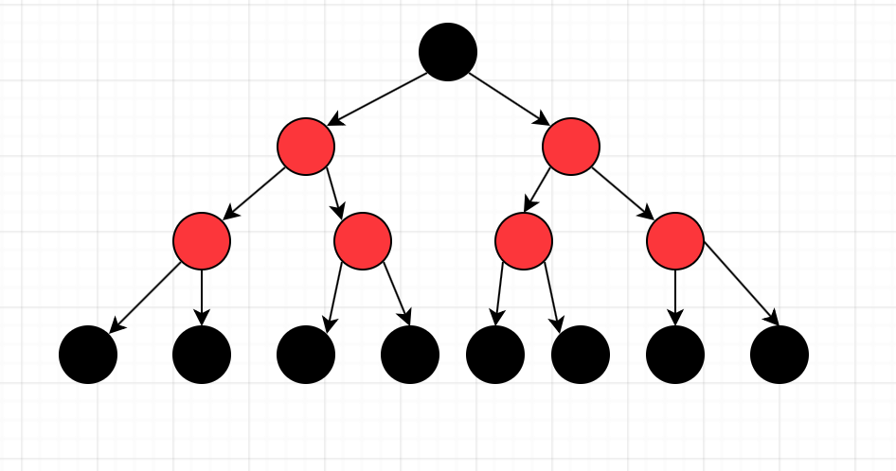

(a)

For k = 0, the tree has zero node which means M (0) = 0

For k > 0,

as is shown in the graph, in this format we can strictly follow the three rules that question gives us.

So for each base case, there are one black node and six red nodes

1 + 6 = 7

For each M(k-1), there are four red nodes which can two connect a new base case.

4 \* 2 = 8

So the whole equation should be

M(k) = 7 + 8 \* M (k – 1) for k > 0.

(b)

Base case: M (0) = 0, For k = 0, the tree has zero node which means M (0) = 0

Induction step:

Assume M(k) = $2^{3k}$- 1

Then M (k + 1) = 8 \* M (k) + 7

= 7 + 8 \* ( $2^{3k}$- 1)

= $2^{3}* 2^{3*k}- 8+7$

= $2^{3(k+1)}- 1$

proofed