Tian Qiu

00265 35063

CS 381

Assignment 5



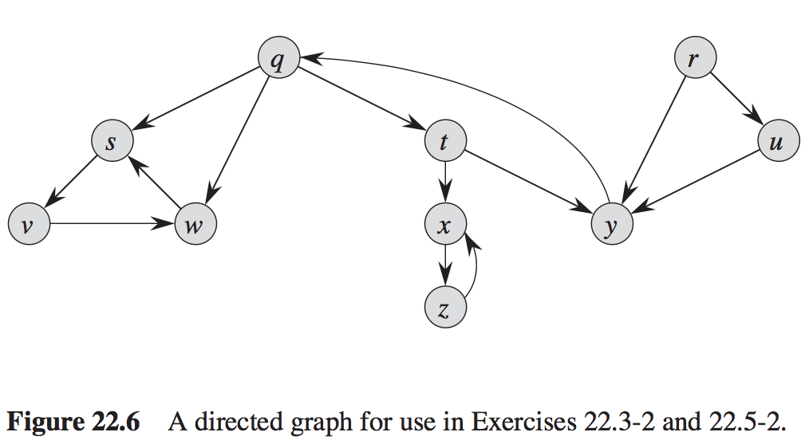

Finished time:

|  |  |  |  |  |  |  |  |  |  |
| --- | --- | --- | --- | --- | --- | --- | --- | --- | --- |
| Q | R | S | T | U | V | W | X | Y | Z |
| 16 | 20 | 6 | 15 | 18 | 5 | 7 | 12 | 14 | 11 |

Forest produced in line 3:

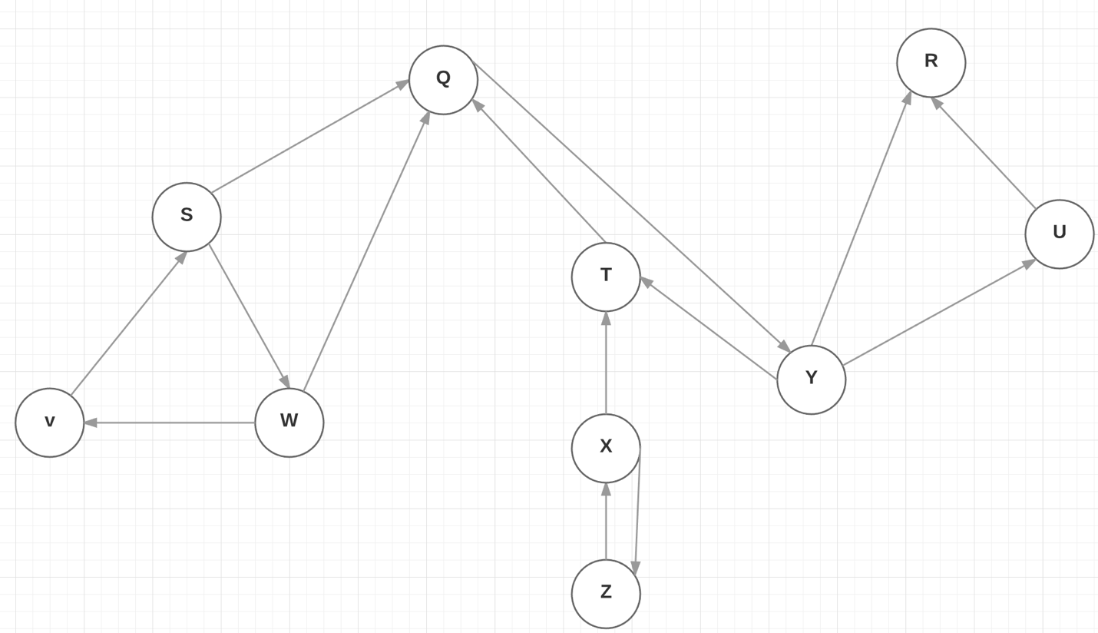

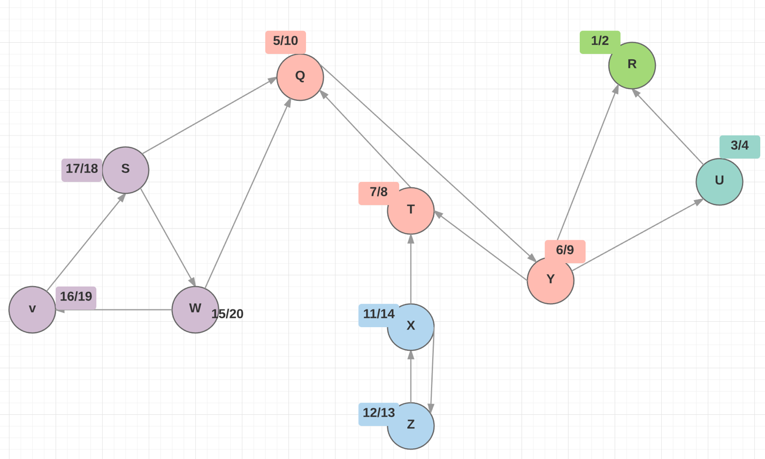



Floyd-Warshall-Plus(G, W)

n = G.rows

For I = 1 to n

For j = 1 to n

$d_{ij}=w_{ij}$

$b_{ij}=Nil$

if $d_{ij} !=∞$

$N_{ij}=1$

for k = 1 to n

for I = 1 to n

for j = 1 to n

if $d_{ij}> d_{kj}+ d_{kj}$

$d_{ij}> d_{kj}+ d_{kj}$

$b_{ij}=k$

$N_{ij}=N_{ik}*N_{kj}$

else if $d_{ij}== d_{kj}+ d_{kj}$

$N_{ij}=N_{ij}+N_{ik}*N_{kj}$

return $N_{ij}$

Time: because if and else if statement in nested for loop take constant time,

The three nested for loop dominate the time, which is O $(n^{3})$

Space: we initial three matrices, for each matrix is n by n.

So the space should be O $(n^{2})$