Tian Qiu

HW 8

CS 381

1.

X: unordered {v1, .., vn}

Element uniqueness problem: vi = vj

Worst case in algebraic computation tree model: Ω(n logn)

a.

For each value vi, i = 1,…,n

Create a point pi = (xi, yi), where xi = vi, yi = 0

Time: O(n) for reduction, since we just need to go over all the points and create in O(1) for each point.

b.

Use the method discussed in class, which can find the closest pair of points.

If the distance of the closest pair of points is not zero, then we do find element uniqueness.

Time: O(n logn) for find the closest pair of points.

O(1) for conversion the closest points problem back to element uniqueness problem.

If the distance of the closest pair of points is not zero, then we do find element uniqueness. Else we do not find element uniqueness.

Total time: O(n logn)

c.

Since we reduced element uniqueness problem to closest pair problem, if closest pair problem is faster than proportional to n logn, then element uniqueness problem must be faster than proportional to n logn, which is contradicting to the proved claim that element uniqueness requires Ω(n logn) time in the worst case in the algebraic computation tree model.

2.

../../Screen%20Shot%202016-11-29%20at%2012.17.02%20AM.png

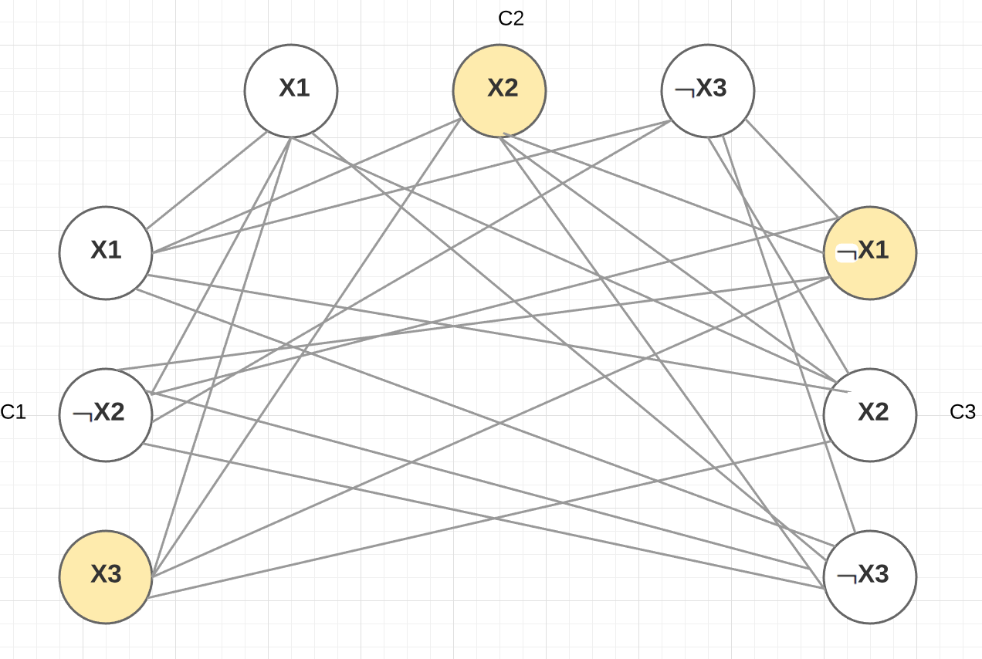

Do reduction from 3-CNF-SAT to clique question.

Sample Clique is shown in the graph as yellow vertices.

In this case, X3 = true, x2 = true, x1 = false.

Original equation = (T) and (T) and (T) = True

Proved.