STAT 350 (Spring 2016) Homework Written 2

Name: Tian Qiu

Email: qiu58@purdue.edu

Instructor: Chris Womble

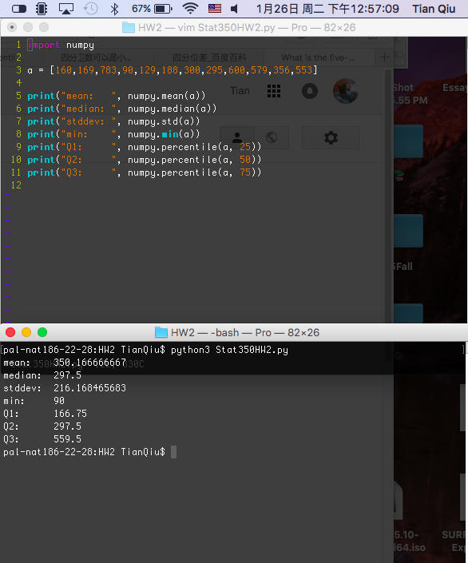

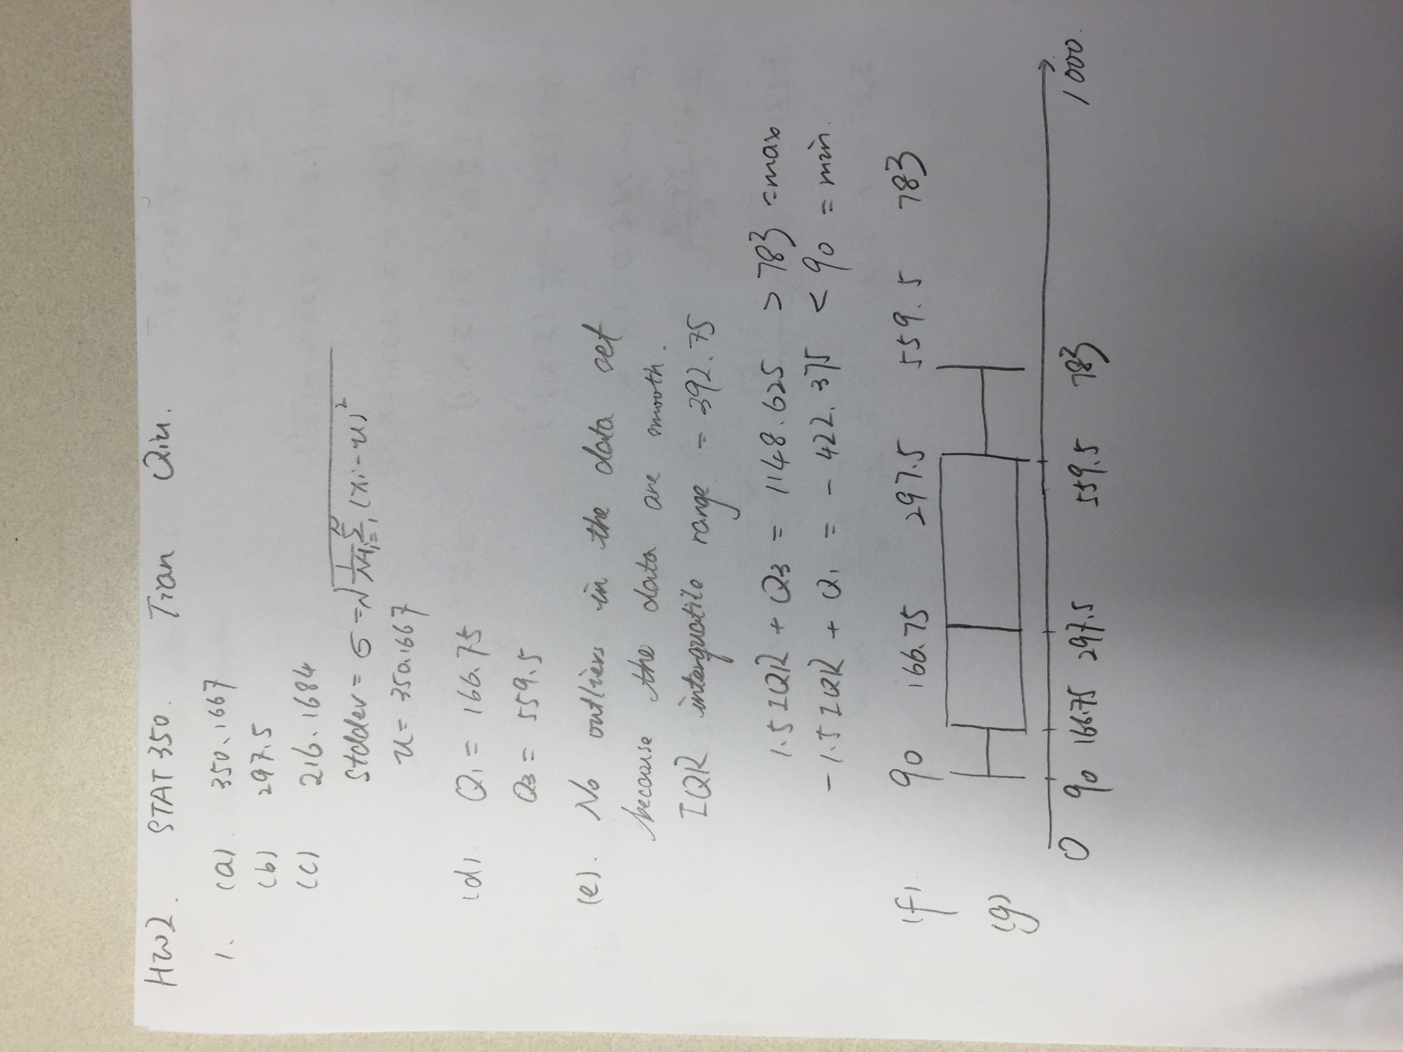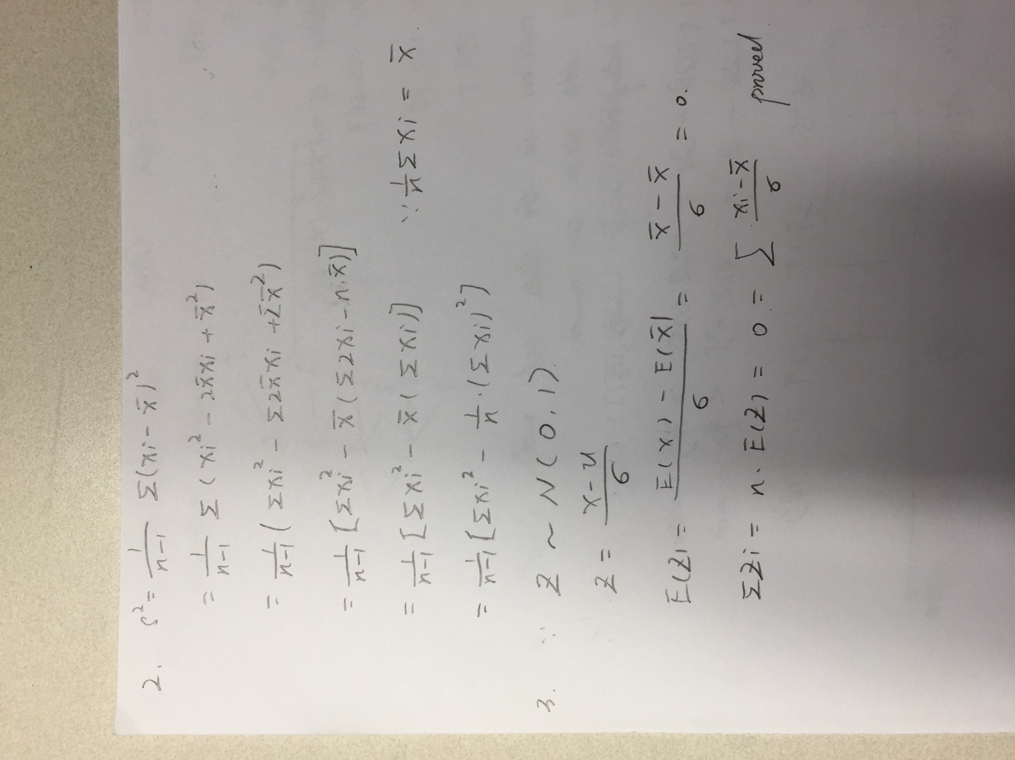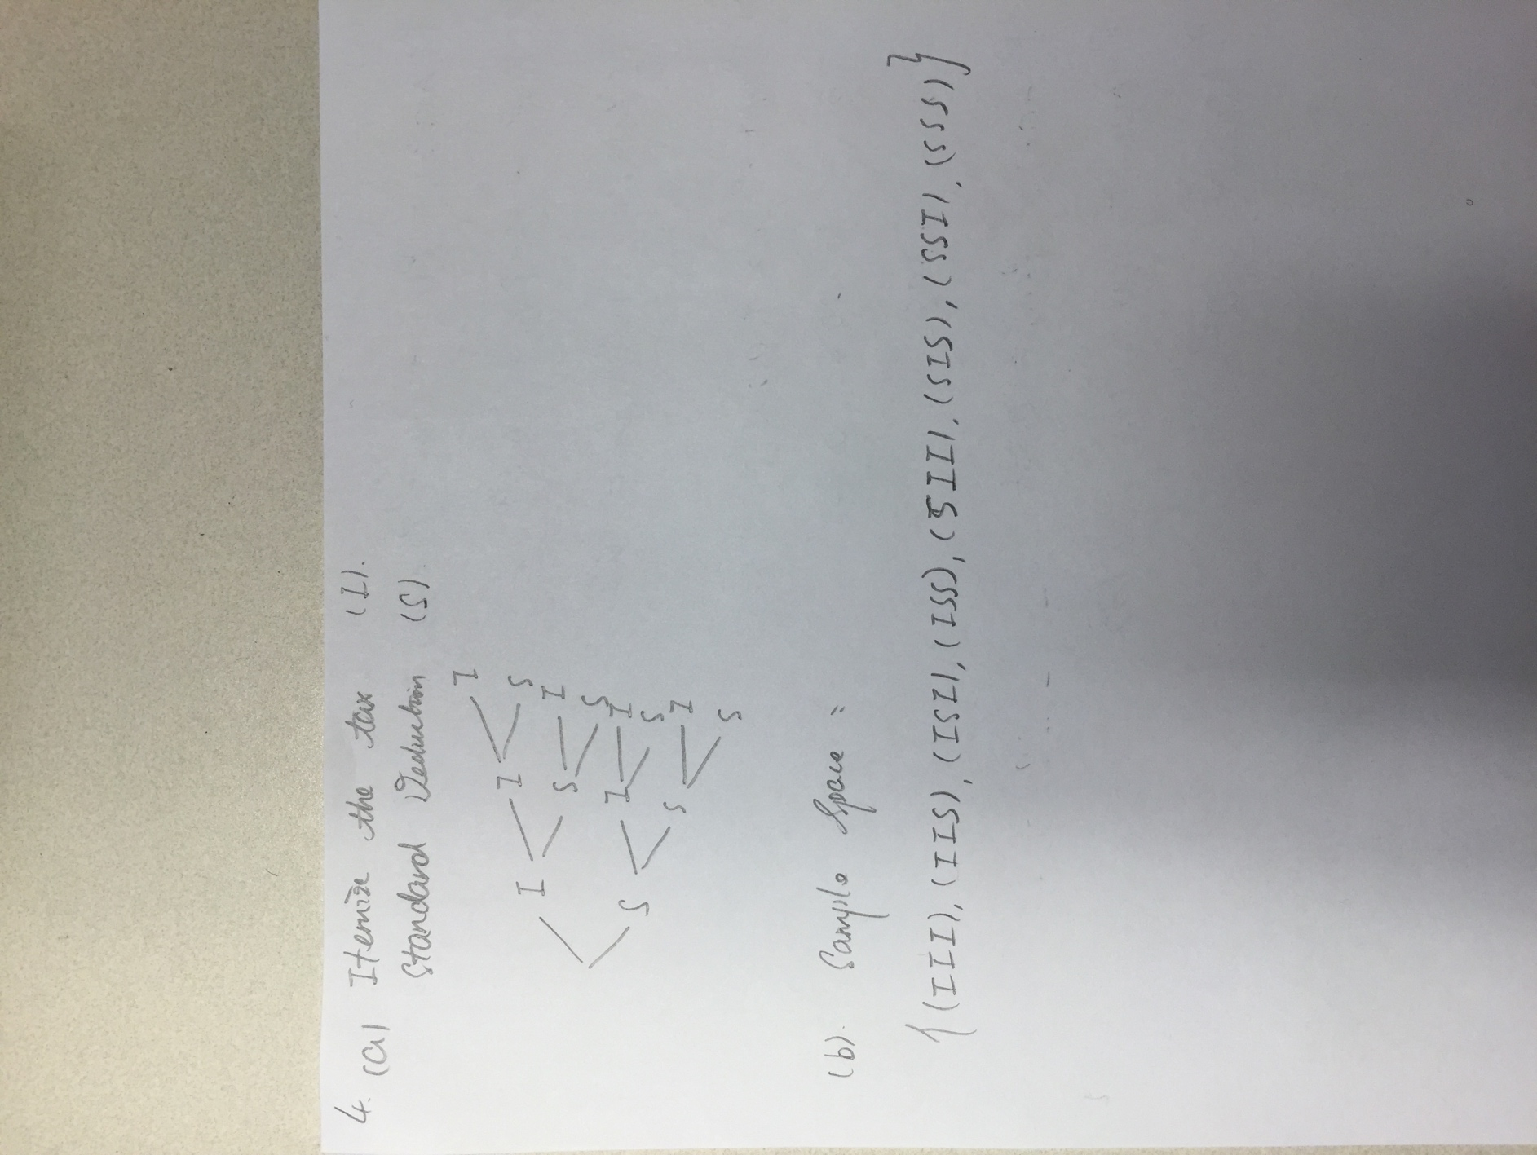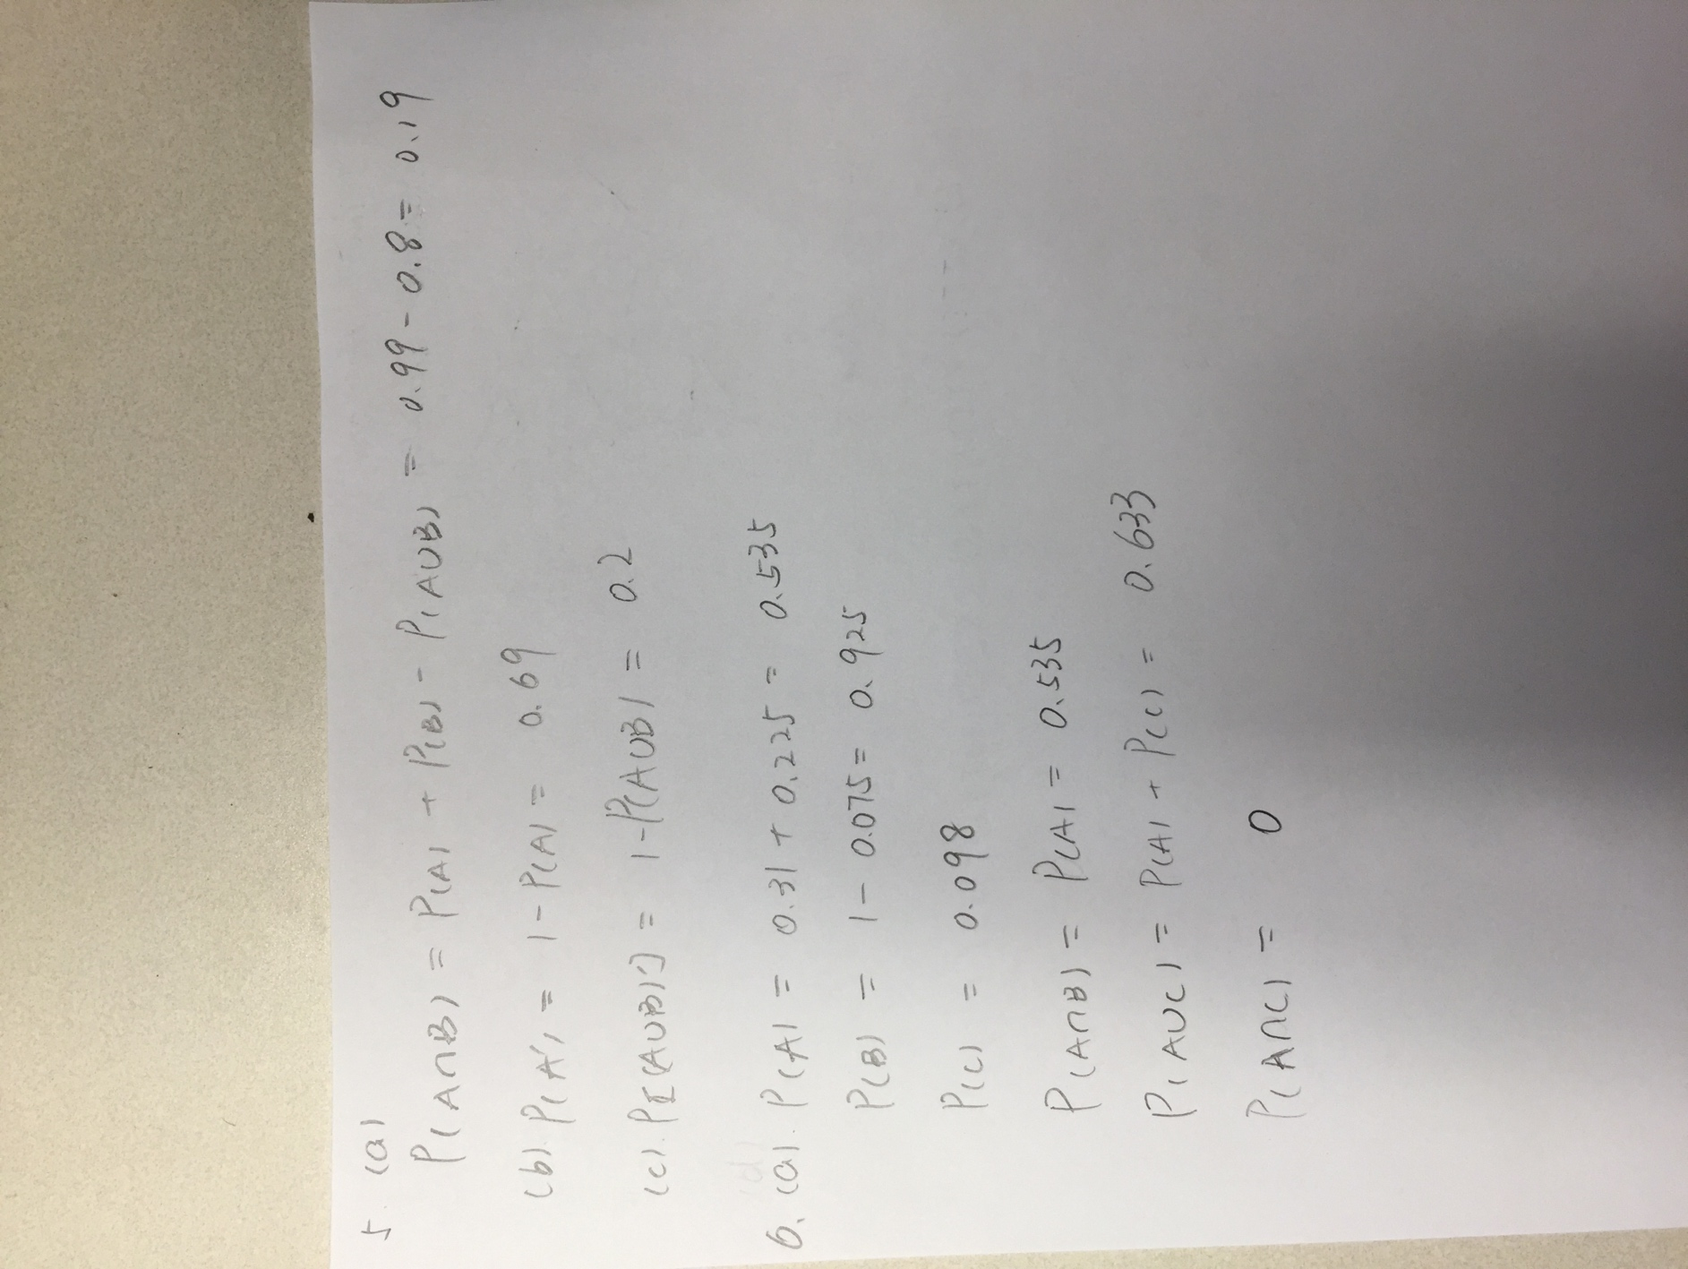

Also, can I ask a question for HW1?

For question(a), I think it may do not need a reason because it says “how many”.

Appreciate a lot for your help.

.