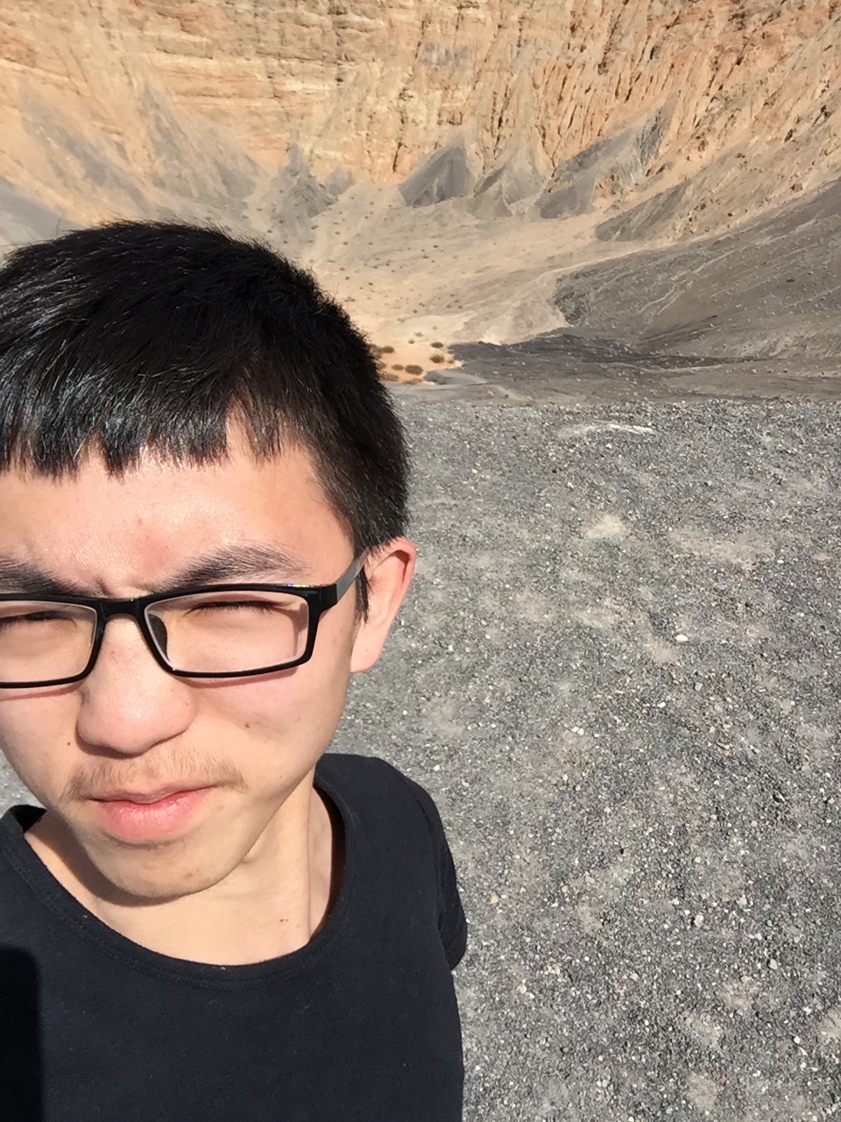

Name: Tian Qiu

Usually sit at front if I am not late.

I am proud that I got several research opportunities in college and internship in Siemens.