Personas
Persona 1: Ontario CS Student
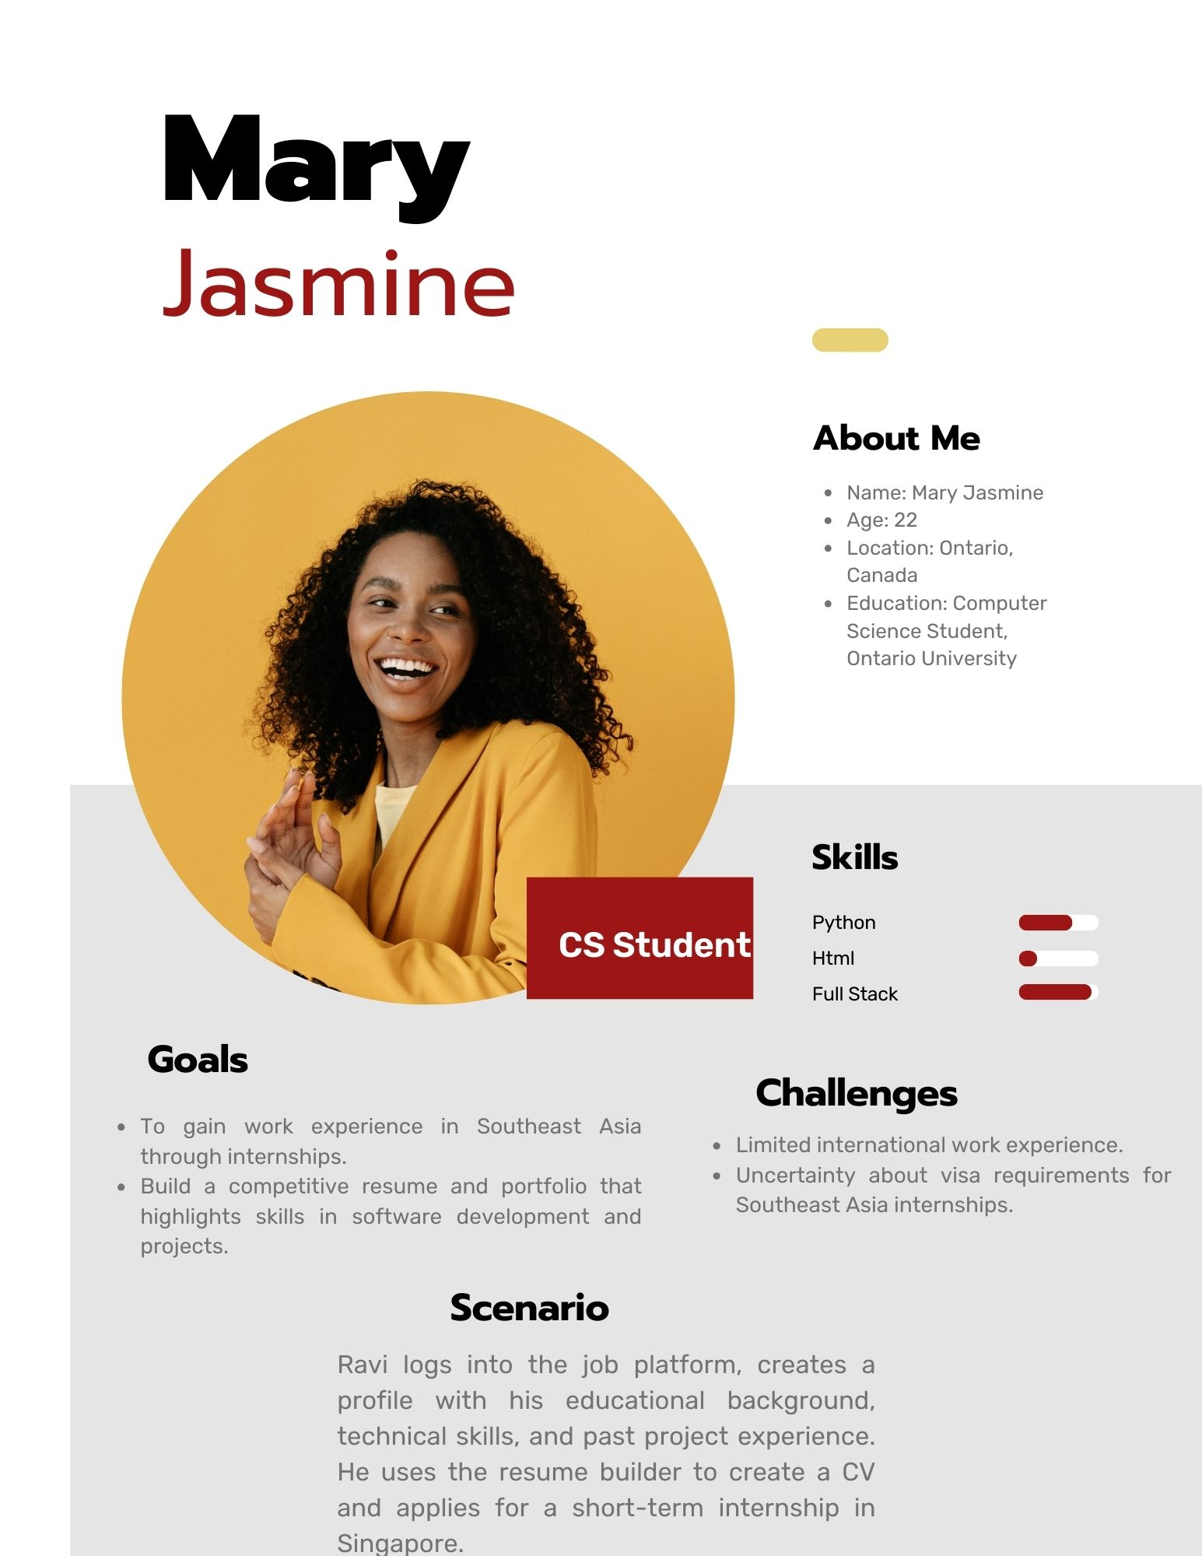
Persona 2: Technology Startup HR Manager
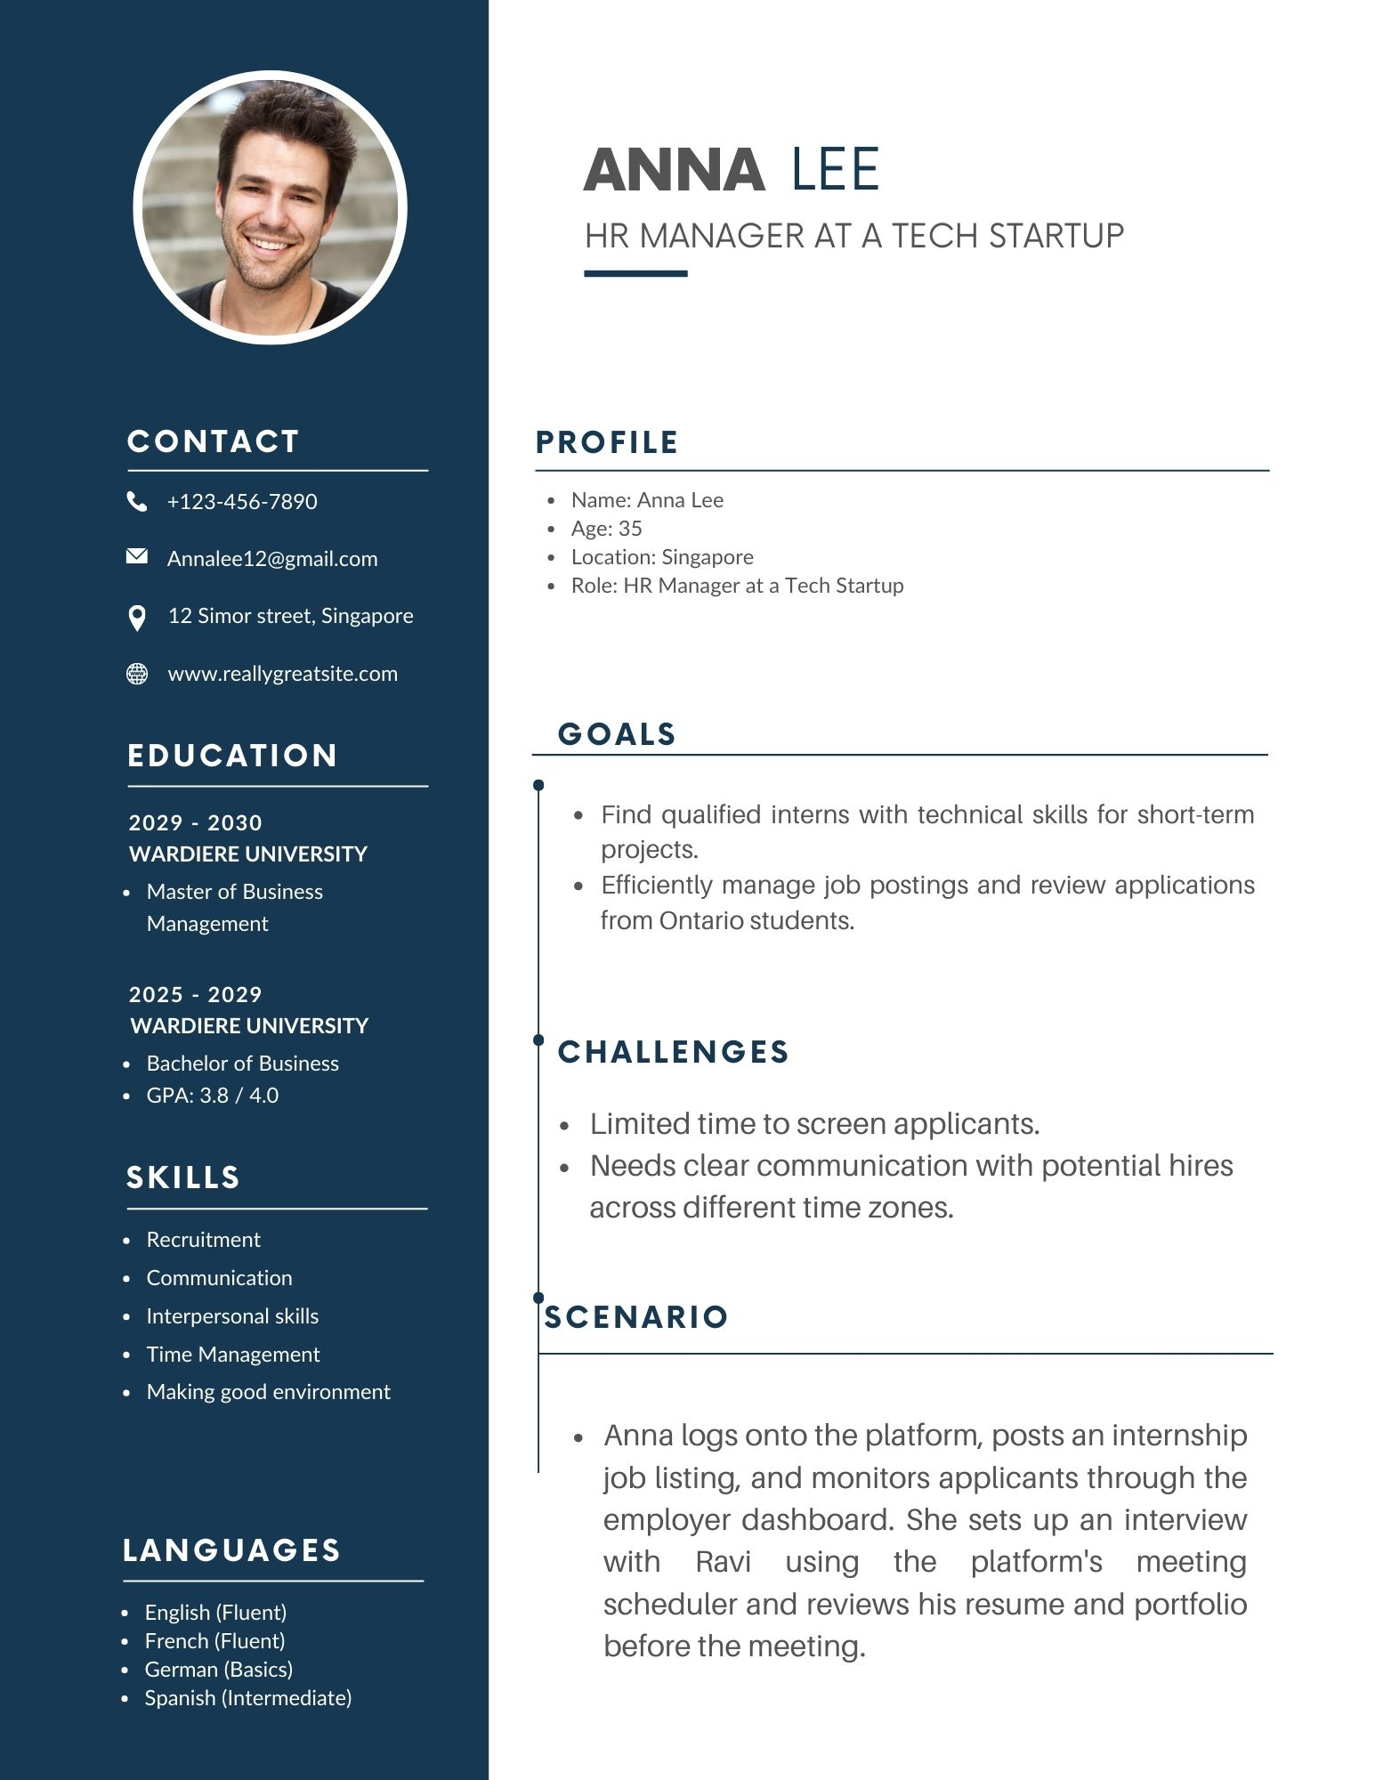

Persona 3: Platform Admin
