Testing Get Started- Onbooarding Questionnare

1. User should be able to progress without selecting era.
2. User should be able to progress without selecting an option each time.

Movie Interaction
1. Color scheme makes it hard to know how to access movie, Title should be a hyperlink
2. Can't see other menu options in Dropdown lists
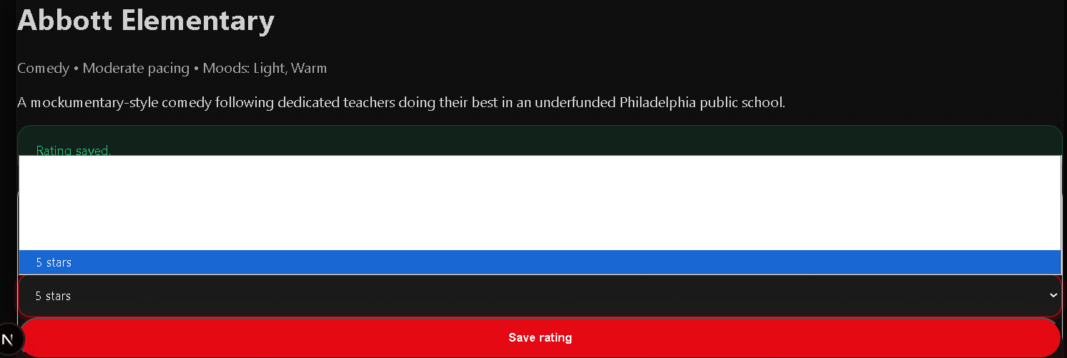
AI Manual Recommender
1. AI gives too similar descriptions for shows, and not specific enough to what its recommending.
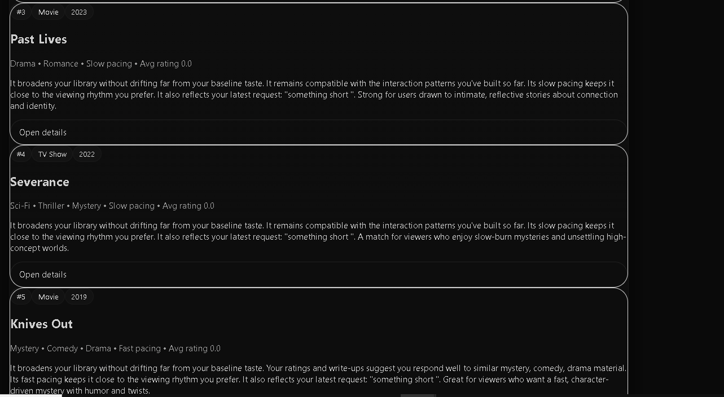
No login button on home page

