Bais City Information Hub: An Integrated Local Services

A
Capstone Project Presented
to the Faculty of the
Computer Science and Information Technology
Department College of Arts and Sciences
Negros Oriental State University Bais Campus

In Partial Fulfillment of
the Requirements for
the degree of
Bachelor of Science in Information Technology

By:
CRIA MEA C. ACADEMIA
FRANK AVEL D. LARA
CRESTINE MAE M. ROMANO
REYCHIEL T. ZAMORA

2026
APPROVAL SHEET

In partial fulfillment of the requirements for the degree BACHELOR OF SCIENCE IN INFORMATION TECHNOLOGY (BSInT), this ITS 403 (Capstone Project) entitled: “Bais City Information Hub: An Integrated Local Services” prepared and submitted by, ZAMORA, REYCHIEL, ROMANO, CRESTINE MAE, ACADEMIA, CRIS MEA, LARA, FRANK AVEL has been examined and is recommended for oral defense.

HHHHHHHHHHH
English Critic
JETTY A. CASIDO, MSIT
Instructor, ITS 403

DIONGE C. FUNDADOR
Project Adviser

APPROVED by the PANEL of EVALUATIONS for ORAL DEFENSE on April 2026 with a grade of .

JAN REY NIÑO ESTROSAS MARK JULIUS V. BADOY
Member Member

MA. ARCHEL L. CALUNSAG
Chairperson

ZENAIDA D. CALUMPANG, MSIT Ed. D.
Dean College of Arts and Sciences

ACCEPTED and APPROVED in partial fulfillment of the requirements for the Degree of BACHELOR OF SCIENCE IN INFORMATION TECHNOLOGY.

MA. SARAH FATIMA P. VALENCIA,Ed.D.,PH.D.
Campus Director
ABSTRACT

The Bais City Information Hub: An Integrated Local Services, developed for Barangay II in Bais City, Negros Oriental, is a web-based system designed to modernize and simplify the delivery of local government services. This platform, built using modern web technologies, allows residents to conveniently request certificates, view announcements, and stay updated on barangay and city activities through an accessible online interface. It provides a user-friendly experience where individuals can create accounts, track their requests, and receive timely updates without the need for physical visits. On the administrative side, barangay officials and staff benefit from efficient management tools that enable them to process requests, manage user information, and post important announcements with ease. The system enhances communication between the local government and the community while ensuring organized data handling and secure transactions. Overall, the project improves service efficiency, reduces processing time, and promotes a more responsive and transparent approach to public service delivery.

DEDICATION

We wholeheartedly dedicate this capstone project to our families, whose unconditional support and encouragement have been our source of strength throughout this journey. To our friends, who inspired and motivated us to keep moving forward. To our professors and mentors, thank you for your guidance, patience, and invaluable insights that helped shape this project. To the resort’s owner, thank you for giving us the opportunity to develop a system for your establishment, which became the foundation of this project. Above all, we thank God for granting us the wisdom, perseverance, and courage to overcome every challenge. This accomplishment is a reflection of all the love and support we have received.

CHAPTER 1

Introduction

Project Context

Over the past years, local government units across the Philippines have been gradually shifting toward digital systems to make public services more efficient and citizen-friendly. As communities continue to grow, along with people's reliance on government offices for different transactions, such manual processes often cannot keep up with the demand. One of the most frequently requested services at the barangay level pertains to the issuance of certifications. These documents are essential in various day-to-day needs whether for employment, school enrollment, opening a business, compliance with legal requirements, or perhaps applying for government programs. Because of the importance of their need, how barangays deal with requests for certificates is a major determinant of the experiences of the people living in them.
Certification processing in Bais City Barangay 2, Negros Oriental, is still handled manually. Although this system has served the community over the years, it has become increasingly hard to manage in today's fast-moving environment. The residents are always required to personally visit the barangay hall and wait for the staff to prepare the documents by hand. Everything from writing details in logbooks to checking records-also takes some time and effort, so there are usually slow processes, which can be very much inconveniencing both the citizens and the barangay personnel in the event of many people requesting their services at the same time.
As these activities and its population increase, some of the shortcomings of these manual procedures have become more apparent. Some of the staff members occasionally experience mislaid or difficult-to-find records, repetitive handwriting and encoding, and delays due to inadequate manpower. On the part of the residents, they may face longer queues, discrepancies in the time of processing, or being told to return the next day if documents are not yet ready. These cases indicate that there is a need for a more systematic and reliable system that can handle certification requests with efficiency. This is very important, as more and more government offices around the country are adopting digital solutions. Almost all LGUs have initiated digital systems that have improved the way they deliver services in terms of transparency, accuracy, and convenience. Without a similar step forward, Barangay 2 runs the risk of lagging behind such improvements. Given the rising demand for faster, more efficient public services and the ongoing challenges of manual processing, developing a Digital Barangay Certification System presents a practical and timely solution for community.

Purpose and Description
The primary goal of this capstone project is to design and implement a modern, user friendly Bais City Information Hub: An Integrated Local Services Platform. This system is intended to automate the entire process of requesting, approving, and issuing barangay certifications documents that are essential for various legal, administrative, and personal transactions of residents. By transitioning from a manual to a digital process, the project aims to significantly improve the efficiency, accuracy, and accessibility of barangay services.
Currently, the barangay relies on traditional methods such as handwritten logs, manual approvals, and physical document issuance, which are time-consuming, prone to errors, and often inconvenient for both residents and barangay staff. These outdated processes can lead to delays, miscommunication, and difficulties in tracking records. The proposed system addresses these challenges by introducing a centralized digital platform that simplifies certification requests, enables real-time status tracking, and ensures secure digital recordkeeping.
Key features of the system include an intuitive online request form, automated approval workflows, digital, and a secure database for storing resident and certification records. Residents will be able to request certifications online, receive updates on their application status. For barangay officials, the system will streamline administrative tasks, reduce paperwork, and provide tools for monitoring requests, generating reports, and managing resident data more effectively.

Objectives of the Study
General Objective

The main goal of this study is to create a Bais City Information Hub: An Integrated Local Services Platform that will make the process of requesting and issuing barangay certificates faster, easier, and more organized for both residents and barangay officials.

Specific Objectives

- To build an online system where residents can request their barangay certificates without needing to visit the barangay hall.
- To lessen the manual work of barangay officials by automating the steps for checking, approving, and releasing certificates.
- To set up a secure database where all resident information and certificate records can be safely stored and quickly accessed.
- To help prevent mistakes in issuing certificates by using a digital process that checks the information automatically.

- To give barangay officials an easy-to-use dashboard so they can monitor requests, track progress, and generate reports when needed.
- To protect the privacy of residents by
- Making sure the system has login security and proper access control.
- To allow online certificate requests and information transparency regarding barangay and city activities.
- To provide real-time notifications for document requests
Scope and Limitations

Scope
The scope of this capstone project, “Bais City Information Hub: An Integrated Local Services Platform,” focuses on two main functions: online request for certificates and transparency of city and barangay activities. The system provides residents of Bais City with a convenient and reliable way to request official certificates online, such as barangay clearances and other commonly required documents. Through this feature, residents no longer need to frequently visit the barangay office in person, which helps reduce waiting time and makes the administrative process more efficient for both citizens and local staff. The scope of this function includes the design, development, and initial implementation of a secure, user-friendly, and responsive online request module that meets the needs of the community.

In addition, the platform serves as an information hub where residents can easily access updates about barangay and city activities, programs, and initiatives. By publishing announcements, schedules, and project details on the system, the platform promotes transparency, accountability, and greater citizen engagement in local governance. This also includes the integration of an activity feed or bulletin board where residents can stay informed about ongoing and upcoming community events. Furthermore, the platform is designed to be accessible on multiple devices such as laptops, tablets, and mobile phones, ensuring that residents can use the system anytime and anywhere as long as an internet connection is available.

Limitations

The Bais City Information Hub: An Integrated Local Services Platform has several limitations that must be considered. First, the system is implemented only in Barangay II, Bais City, which serves as the pilot area of the project. Because of this, the results and effectiveness of the system may not fully represent the conditions of other barangays within the city. Second, the platform is limited to two main services: online certificate requests and information transparency regarding barangay and city activities. Other government services, such as online payments, financial transactions, and more advanced e-governance functions, are not included in the current version of the system. In addition, the platform requires a stable internet connection and access to digital devices such as mobile phones, tablets, or computers, which may limit its accessibility for some residents. Finally, the study focuses mainly on the design, development, and initial testing of the system, and does not cover long-term system maintenance, large-scale deployment, or integration with other government information systems.

CHAPTER 2
REVIEW OF RELATED LITERATURE AND RELATED STUDIES

Related Literature
According to Ballaran et al. (2023) in their study titled “Development and Evaluation of Web- Based Barangay Profiling and Issuance System” emphasized that the rapid advancement of technology has enabled local government units, particularly barangays, to improve administrative operations through web-based systems. The researchers developed a Web-Based Barangay Profiling and Issuance System (BPIS) designed to help barangay offices efficiently manage resident information and process the issuance of certificates, permits, and other official documents. The system allows barangay personnel to collect, store, analyze, and retrieve data more effectively, improving record organization and speeding up document processing. The study highlighted that implementing digital systems enhances efficiency, transparency, and data-driven decision-making in local governance. The findings support the development of the Bais City Information Hub: An Integrated Local Services Platform in Barangay II, as both systems aim to improve public service delivery and promote transparency through web-based technologies.
The study of Indama et al. (2023) entitled “The Effectiveness of E-Government Initiatives in Improving Public Service Delivery: A Review of the Literature” emphasized that electronic government systems play an important role in improving public service delivery and citizen engagement. By reviewing empirical research conducted between 2010 and 2021, the study highlighted key aspects of e-government implementation, including service accessibility, service quality, citizen participation, and public trust. The findings showed that e-government initiatives enhance efficiency and accessibility by allowing citizens to access information and services digitally without physically visiting offices, while also promoting transparency. In the context of the Bais City Information Hub, these insights suggest that a web-based local services platform can provide residents with convenient access to barangay services and updates. The study also noted challenges such as the digital divide, data privacy concerns, lack of legal frameworks, and resistance from users unfamiliar with technology, emphasizing the need for proper infrastructure, strong leadership, stakeholder collaboration, and user-centered design.
The study of Melendres and Aranda (2024) entitled “Development and Evaluation of a Web- Based Resident Information Management System” emphasized that web-based information systems can greatly enhance the management of resident records and the delivery of public services in local government units. Their study focused on a system that allowed barangay officials and residents to access, manage, and process community information online, with features such as resident information management, document request processing, complaint reporting, data visualization, and report generation, which improved administrative efficiency. In the context of the Bais City Information Hub, a similar platform can provide residents with easier access to local services, enable online document requests, and allow officials to manage community information more effectively, reducing manual processes and processing time. The study also highlighted challenges such as internet connectivity and users’ familiarity with digital systems, suggesting that proper technological infrastructure, user training, and continuous support are essential to ensure the platform enhances service accessibility, administrative efficiency, and decision-making for both officials and residents.
According to Iyoha et al. (2025) in their study titled “E-Government Implementation and Its Impact on Public Service Delivery,” the adoption of electronic government systems has become an important strategy for improving efficiency and effectiveness in public administration. The researchers explained that e-government refers to the use of information and communication technologies (ICT) by government agencies to provide services, share information, and improve communication with the public. The study highlighted that implementing digital government systems can streamline administrative processes, reduce paperwork, and allow faster access to services, enabling citizens to complete transactions more conveniently. In the context of the Bais City Information Hub, such a platform can provide residents with easier access to local services, announcements, and community information, while enhancing transparency, accountability, and responsiveness among barangay officials. The study also noted challenges such as limited technological infrastructure, lack of technical expertise, and insufficient management support, emphasizing the need for proper planning, adequate resources, and continuous support to ensure successful implementation.
The study of Kristoffer Angelo Pinon et al. (2021) in their study titled “Barangay Certificate Issuance and Record Management System with Descriptive Analytics” emphasized that implementing a web-based management information system can address challenges in managing barangay records and services. The researchers explained that traditional manual record-keeping often results in disorganized data, slow document processing, and difficulty monitoring resident information. To overcome these issues, they developed a system that allows barangay officials to store and manage resident data, while enabling residents to request services such as residency, indigency, and business closure certificates, as well as file blotter reports. The system also provides a dashboard with descriptive analytics showing population statistics, gender distribution, age categories, and the number of blotter reports. Findings showed that the system improved efficiency, organization, and accessibility of barangay records and administrative processes. In the context of the Bais City Information Hub, a similar platform can streamline the management of resident information, facilitate online service requests, and provide analytics to support better decision-making, ultimately enhancing local service delivery and administrative efficiency.
Collectively, these scholarly works (2021–2025) demonstrate a consistent pattern: barangay- level digital systems that integrate resident profiling, automated certificate issuance, administrative dashboards, and basic analytics result in faster processing, more organized records, and higher stakeholder satisfaction. They also consistently highlight critical non-technical success factors, including stakeholder engagement, staff training, and system usability, which the Bais City Information Hub must prioritize. Drawing on the methods and findings of these studies provides a solid foundation to ensure that the proposed system is not only technically robust but also practically adoptable within the local context of Barangay II, Bais City.

Related Studies
Aliling, Santa Ana, & Soberano (2025) – Digitalizing Governance: A Transformation on the Processes of One Community in the Philippines. According to Aliling et al. (2025), their study emphasized that the transition from manual to digital systems in barangay governance significantly improves operational efficiency and service delivery. The researchers examined the implementation of the Electronic Barangay Information Management System (E-BIMS), which allows barangay offices to manage resident records, monitor service requests, and process documents in a centralized digital environment. The system facilitates accurate record-keeping, reduces administrative errors, and promotes faster response times. Their findings support the development of the Bais City Information Hub, as both aim to enhance local governance by integrating services into a single, accessible platform that improves efficiency and transparency.
Ballaran et al. (2023) – Development and Evaluation of Web-Based Barangay Profiling and Issuance System. According to Ballaran et al. (2023), the rapid advancement of technology has enabled local government units, particularly barangays, to improve administrative operations through web-based systems. The researchers developed a Web-Based Barangay Profiling and Issuance System (BPIS) designed to help barangay offices efficiently manage resident information and process the issuance of certificates, permits, and other official documents. The system allows barangay personnel to collect, store, analyze, and retrieve data more effectively, improving record organization and speeding up document processing. The study highlighted that implementing digital systems enhances efficiency, transparency, and data-driven decision-making in local governance. The findings support the development of the Bais City Information Hub, as both systems aim to improve public service delivery and promote transparency through web-based technologies.
Padilla (2025) – Enhancing Local Governance in Surigao del Norte through Barangay Connect: A Total Management Information System for Barangays. Padilla (2025) emphasized the importance of integrating multiple barangay services into a unified digital platform to improve governance and administrative efficiency. The study introduced Barangay Connect, a system that consolidates resident data, document processing, and real-time reporting for barangay operations. By providing a centralized hub for data management and service monitoring, the system helps officials make informed, data-driven decisions and enhances accessibility for residents. These findings are relevant to the Bais City Information Hub, as both platforms aim to provide a comprehensive, integrated service solution that improves local government transparency and responsiveness.
Enaño et al. (2025) – BarangayConnect: A Web-Based Information Portal for Resident Data, Administrative Services, and Community Records Using Data Analytics. According to Enaño et al. 2025), the study demonstrated that web-based platforms integrating resident services with data analytics significantly improve the efficiency of barangay operations. The BarangayConnect system allows residents to request services online, while providing barangay personnel with analytical tools to track requests, monitor community needs, and optimize service delivery. This digital approach reduces manual processing, increases transparency, and supports evidence-based decision-making. The findings support the Bais City Information Hub, as both systems seek to combine multiple services into an accessible digital platform that improves public service delivery and decision- making.. Taruc et al. (2023) Docu-Go: The Development and Assessment of a Web-Based Barangay Document Requesting System.
Taruc et al. (2023) highlighted that digital document requesting systems can streamline barangay operations by automating service requests and improving accessibility for residents. The Docu-Go platform allows users to submit and track requests for certificates and other official documents online, while barangay personnel can process and manage these requests more efficiently. The study demonstrated that such systems reduce administrative workload, minimize errors, and enhance citizen satisfaction. These findings support the Bais City Information Hub, as both platforms aim to integrate services into a user-friendly system that promotes efficiency, transparency, and convenience for both barangay staff and residents.

Theoretical Framework
Age
Usage Behavioural
Behavioural Intention (BI)
Gender
Experience
Voluntariness
To use
Facilitating Condition
(FC)
Social Influence
(SI)
Effort Expectation
(EE)
Performance Expectation
(PE)

Figure 1. UTAUT Model

The Unified Theory of Acceptance and Use of Technology (UTAUT), developed in 2003 by Venkatesh, Morris, Davis, and Davis, provides a comprehensive framework for understanding how individuals accept and use new technologies. This model integrates elements from eight earlier theories, such as the Technology Acceptance Model (TAM), the Theory of Planned Behavior (TPB), and the Innovation Diffusion Theory (IDT), making it widely applicable in studies involving information systems. In the context of the Bais City Information Hub: An Integrated Local Services Platform the UTAUT model helps explain the factors that influence residents’ willingness to adopt the digital system. It examines how performance expectation, effort expectation, social influence, and facilitating conditions shape users’ behavioral intention to use the platform. By understanding these factors, the Barangay can ensure that the system is user-friendly, beneficial, and accessible to all residents. Applying the UTAUT model also supports the development of a more efficient and accurate certification process, minimizing errors and delays. Ultimately, the model aids in enhancing public service delivery, increasing user satisfaction, and promoting smoother adoption of the digital certification system within the community.

Conceptual Framework
OUTPUT

Integrated Local Services Platform

Efficient Service Delivery

Improved Accessibility
INPUT

Requirements & Feasibility Study
Development
Testing
Design
Implementation
Analysis
Maintenance
Planning

Figure 2. Software Development Life Cycle (SDLC) Model
The Software Development Life Cycle (SDLC) model is a structured software development methodology that emphasizes systematic planning, analysis, design, implementation, testing, deployment, and maintenance of a system. It ensures that all stages of development are carefully organized and executed to produce a reliable and high-quality system. The SDLC follows sequential phases that start with planning, where the needs of the users and the objectives of the system are identified; analysis, where requirements are gathered and evaluated; design, where the system architecture, database structures, and user interfaces are developed; implementation, where coding and module integration take place; testing, where the system is verified for accuracy, efficiency, and reliability; and finally deployment and maintenance, which ensures the system remains functional, updated, and responsive to user needs. The study relies on the SDLC model because the Bais City Information Hub: An Integrated Local Services Platform for Barangay II requires careful planning and structured execution to manage multiple local services efficiently. Through SDLC, processes such as resident registration, online requests, approvals, and community announcements are organized systematically, reducing errors, ensuring data integrity, and providing a dependable platform for both barangay personnel and residents. The structured approach of SDLC ensures that the system is comprehensive, accurate, and sustainable, providing a solid foundation for delivering integrated local services effectively.
OUTPUT

Efficient Services Delivery
Improved Transparency
Accessible Information
Enhanced Governance
Construction
Testing & Evaluation
Implementation & Feedback
User Design
Requirements Planning
INPUT

Community Needs
System Requirements
Stakeholder Input

Figure 3. Rapid Application Development Model

The Rapid Application Development (RAD) model is a software development methodology that emphasizes speed in development, continuous user participation, and iterative prototyping. It is intended to produce working systems faster than the traditional linear models. RAD does not necessitate the completion of all design and planning before starting of development, instead it adopts an approach that cuts across phases that allow for continuous feedback and up gradation. These phases comprise of requirements planning, user design, rapid construction, and implementation. During each phase, the close interaction between the developers and the users ensures that the system is developed along the lines of real needs rather than assumptions. RAD is well suited for projects that need constant updates and changes depending on user feedback since it emphasizes speed, flexibility, and early testing of working models.
The study relies on the RAD model because the Bais City Information Hub: An Integrated Local Services Platform for Barangay 2 is subjected to constant validation by the residents and the barangay personnel which cuts across the system ensuring its being in line with the real workflows and the community's needs. Errors and delays that often occur in traditional manual methods of operation in the barangay such as handwritten logs, repetitive verification, and long waiting times are a thing of the past through RAD as developers can immediately generate prototypes of functionalities like online request forms, approval dashboards, and automated certificate generation that the end-users can try out and give their opinions on. The suggestions of the users are then utilized for modifications resulting in a system that is user-friendly, accurate, and quick to respond. The overall process of the Bais City Information hub: An Integrated Local Services Platform has benefited enormously from the application of RAD. It produces a system that aligns with actual operations, cuts down development time, and raises user happiness

CHAPTER III

TECHNICAL BACKGROUND AND METHODOLOGY OF THE SYSTEM

This section explains how the Bais City Information Hub: An Integrated Local Services Platform was developed and the methods used throughout the process. It describes how information was gathered, how the system was designed, and how feasibility in terms of schedule and cost was considered. The section also includes the system’s Data Flow Diagram (DFD), Context Flow Diagram, Top-Level Diagram, and Use Case Diagram to clearly show how the system works and how users interact with it. In addition, the required hardware and software, as well as the interface design, are discussed to present a clear and complete approach to the system’s development and implementation.

Data Gathering Procedure

To develop a system that effectively addresses the information and service needs of Bais City, the proponents began the study by conducting field visits and consultations within selected barangays and city offices in Bais City, Negros Oriental. These visits allowed the proponents to observe how public information and local services are currently delivered and accessed by residents. In-depth interviews were conducted with barangay officials and administrative staff to gain a clear understanding of the existing manual processes used in handling announcements, service requests, and public inquiries.
Through these initial engagements, the proponents were able to observe the current workflow, identify common challenges, and gather important details that served as the foundation for proposing a digital solution tailored to the city’s needs. Data gathering focused on how information is traditionally disseminated through bulletin boards, verbal announcements, social media posts, and face-to-face transactions at barangay halls and city offices.
The manual nature of these processes often resulted in delayed announcements, repetitive inquiries, and difficulty in tracking service requests, miscommunication, and limited access to updated information, especially for residents living far from government offices. These concerns were consistently highlighted during interviews and discussions with both officials and residents.
While documenting these challenges, the proponents carefully considered the daily routines and limitations faced by local government staff. In response, they proposed the development of a centralized, web-based information hub as a modern solution. The proponents explained how transitioning from manual to digital processes could improve efficiency, transparency, and accessibility. The proposed features included centralized announcements, online service request submission, downloadable forms, real-time updates, and a feedback mechanism for residents.
Additionally, the advantages and possible limitations of implementing the system were openly discussed. The benefits included faster access to information, reduced manual workload, improved record accuracy, and greater convenience for both residents and administrators. Possible limitations, such as dependence on internet connectivity and the need for basic digital skills, were also acknowledged to ensure informed decision-making.
The insights gathered from these field activities became the basis for designing the Bais City Information Hub, with the goal of replacing fragmented manual processes with a more organized, accessible, and user-friendly digital platform for local government services.

System Design
The Bais City Information Hub: An Integrated Local Services Platform is designed to provide residents of Barangay II, Bais City with an efficient and accessible digital platform for requesting certificates and receiving updates about barangay and city activities. Residents can access the web- based system through any internet-enabled device such as mobile phones, tablets, or computers without complicated procedures. The platform interface, developed using modern web technologies such as HTML5, CSS, JQuery, and Tailwind CSS, allows users to easily navigate the website, create an account, log in, and submit online requests for documents such as barangay clearances and other certificates. Once a request is submitted, the system records the information in the database and notifies the barangay administrator for review and processing.
For the administrative side, the system is supported by a backend developed using PHP and MySQL, which manages the storage, retrieval, and processing of data. Barangay administrators can access a secure admin dashboard where they can review certificate requests, approve or reject applications, and manage records of residents and issued documents. The platform also includes an activity and announcement module where barangay captains can post updates, schedules of activities, announcements, and community programs. These updates are displayed on the residents’ dashboard to promote transparency and keep the community informed.
The system is designed with a responsive interface, ensuring that the platform functions properly on different screen sizes and devices. Security measures such as user authentication, protected login credentials, and controlled administrative access are implemented to protect sensitive user information. Additionally, the system maintains organized records of requests and announcements to support efficient barangay management. By integrating these technologies, the Bais City Information Hub improves service delivery, enhances transparency, and strengthens communication between barangay officials and residents.
Schedule Feasibility

The researchers used a Gantt chart to plan and monitor the development of the Bais City Information Hub: An Integrated Local Services Platform efficiently. The chart outlines the major activities of the project such as title formulation, proposal preparation, system design, development, testing, and final defense. Each phase was carefully scheduled to ensure that tasks were completed within the given timeframe. This structured scheduling approach helped the researchers track progress, manage deadlines, and maintain an organized workflow. By following the planned timeline, the project activities were completed systematically, contributing to the successful development.

Cut Over

Construction

Task
Creating Tittle | Sep  2025
Preparation for Presentation
Presentation of Tittle
Tittle Defense
Revisions & Passing of Chapter 1-2
Continuation of Doing System
Discussion of the System
Finalization of the System
Scheduling of Final Defense
Final Defense
Feb
2026
Mar
2026
Apr
2026
Jan
2026
Dec
2025
Oct
2025
Nov
2025

RAD Phase

Requirements for Planning

User Design

Construction

Cut Over

Table 1. Gantt Chart

The Gantt chart presented above illustrates the projected timeline of the project from September 2025 to April 2026. The schedule begins in September 2025 with the Creating Titles phase, followed by the Preparation for Presentation of Title, which spans October to November 2025. The Presentation of Title is conducted in December 2025, while the Title Defense takes place April 2026.
The Revision of Corrections and Passing of Chapters 1–2 are completed in February 2026. The system development phase, labeled as Continuation of Doing System, extends from February to March 2026. This is followed by the Discussion of the System and Finalization of the System, both occurring in March 2026. The Scheduling of Final Defense is also conducted in March 2026, with the project concluding through the Final Defense in April 2026.
This visual representation presents a clear sequence of project activities and their expected durations, providing an effective tool for project management and monitoring of key milestones throughout the development of the Bais City Information Hub.
Economic Feasibility
HARWARE | PRICE
Laptop/Desktop | 34,380.00
Wi-fi router & access point | 4,500.00
Android Phones | 6,000.00
Total | 39,880.00

BENEFITS
1. Boosts efficiency in management and service delivery.
2. Improves resident experience and satisfaction
3. Residents can request, check status, and modify transactions anytime, anywhere.

Table 2. Cost and Benefits Analysis

A cost-benefit analysis assesses the financial viability of a proposed system by comparing its potential benefits with development costs. It includes anticipated expenses like software, hardware, and maintenance, alongside expected gains such as efficiency, cost savings, and revenue. This evaluation helps determine if the system is a worthwhile investment.

DATA FLOW DIAGRAM

Context Flow Diagram

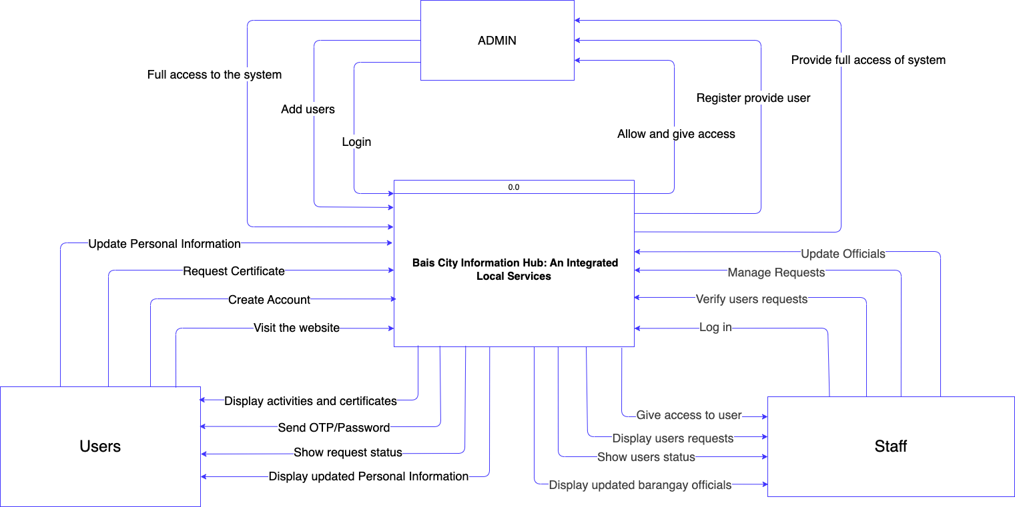

Figure 3. Context Flow Diagram
The Context Flow Diagram of the Bais City Information Hub: An Integrated Local Services Platform provides a high-level view of how the system interacts with its external entities and how information flows between them. It defines the boundaries of the system and identifies the main actors involved in its operation, which are the Users, Admin, and Staff. This diagram simplifies the system’s interactions to give a clear overview of the main data exchanges without delving into the internal processes.
At the center of the diagram is the Bais City Information Hub System, which serves as the main platform responsible for processing online certificate requests, updating personal and barangay information, and providing notifications about activities and announcements. The system manages the storage, processing, and retrieval of information necessary to support the digital services offered to residents and the local government.
Users interact with the system by creating accounts, logging in, updating personal information, and submitting requests for certificates. Through these interactions, the system provides feedback such as OTP/password verification, status updates on requests, and access to announcements and activities posted by the barangay. This allows residents to conveniently request documents, track their applications, and stay informed about community programs and public notices.
On the administrative side, the admin has full control over the system. Admins manage user accounts, provide access permissions, and oversee the overall operations of the platform. This ensures that all users and staff have proper access while maintaining the security and integrity of the system.
The Staff supports operational processes by logging into the system to verify and manage user requests, update barangay officials, and maintain accurate records. The system provides them with data such as user requests, statuses, and updated information, allowing them to perform their tasks efficiently and ensure smooth service delivery.
Overall, the diagram illustrates how data flows into and out of the system between the Users, Admin, and Staff. It emphasizes the structured communication between the actors and the platform, highlighting how the system facilitates secure, organized, and efficient local government services.

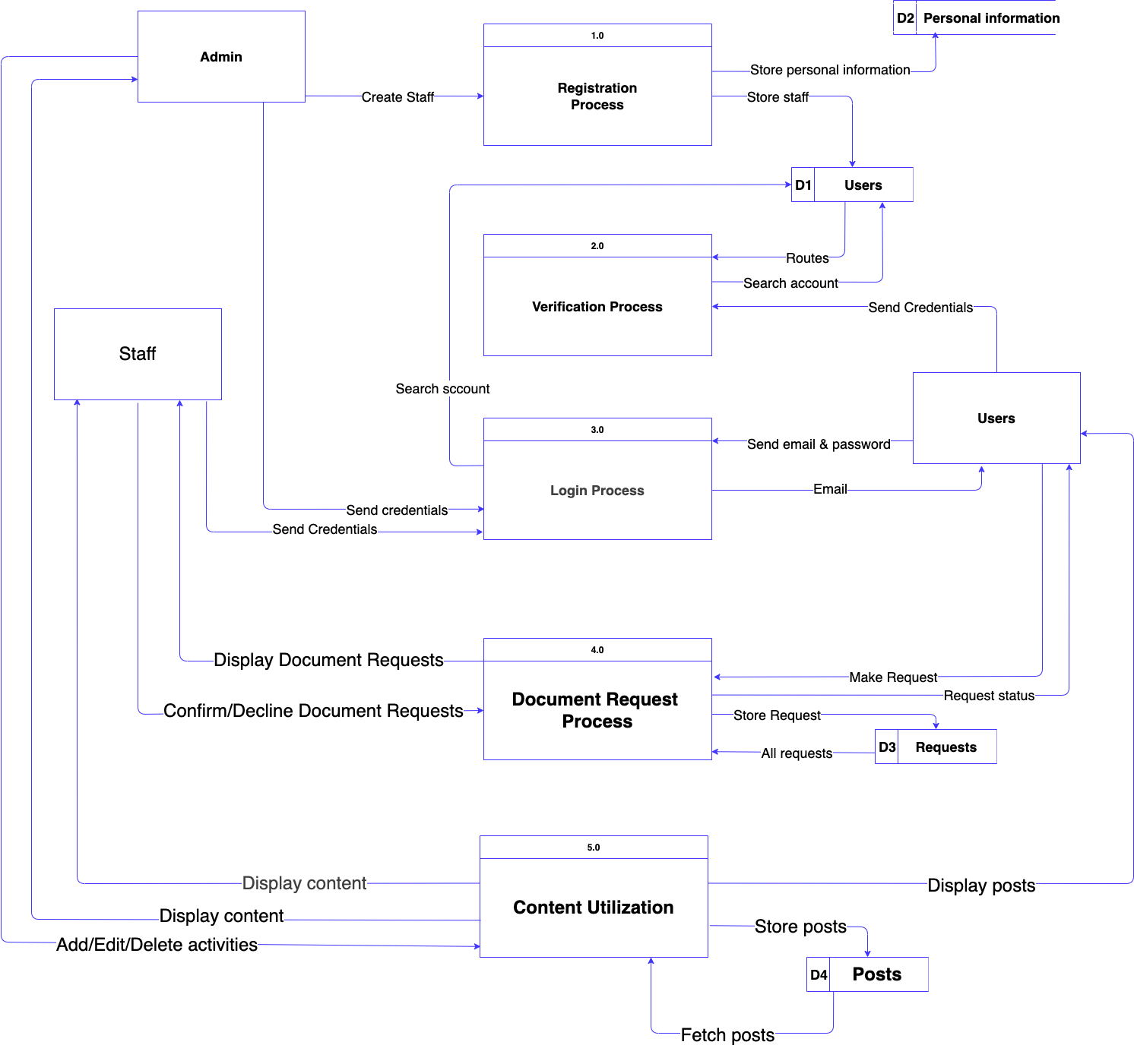
Top Level Diagram

Figure 4. Top Level Diagram

The Bais City Information Hub: An Integrated Local Services System is designed as a streamlined digital ecosystem that connects administrators, staff, and residents through well- structured processes and organized data management. At its core are interconnected workflows that ensure smooth operations, from user registration and authentication to document requests and content delivery. The system begins with the admin, who acts as the primary controller by creating and managing staff accounts through the Registration Process (1.0). During this stage, user credentials and personal information are securely stored in the Users (D1) and Personal Information (D2) databases, establishing a reliable foundation for all system activities. When users or staff attempt to access the platform, the Verification Process (2.0) and Login Process (3.0) work together to validate credentials and grant secure access.
Once authenticated, users can explore services and request documents through the Document Request Process (4.0). Here, requests such as barangay clearances or financial assistance are submitted and stored in the Requests database (D3), where staff can review, approve, or decline them. The system also keeps users informed by updating the status of their requests, ensuring transparency and efficiency. On the other hand, staff and administrators manage information dissemination through the Content Utilization Process (5.0), where posts and announcements are created, updated, and stored in the Posts database (D4) before being displayed to users. Throughout the system, data flows securely between these processes and storage units, ensuring accuracy, consistency, and protection of sensitive information.

From administrative control to user interaction, each component of the system works in harmony to deliver accessible and efficient local government services. The structured flow of data, combined with clearly defined roles for admin, staff, and users, creates a reliable platform that simplifies traditional processes. Ultimately, the system transforms how residents engage with government services, offering a more convenient, transparent, and digitally empowered experience for the community.

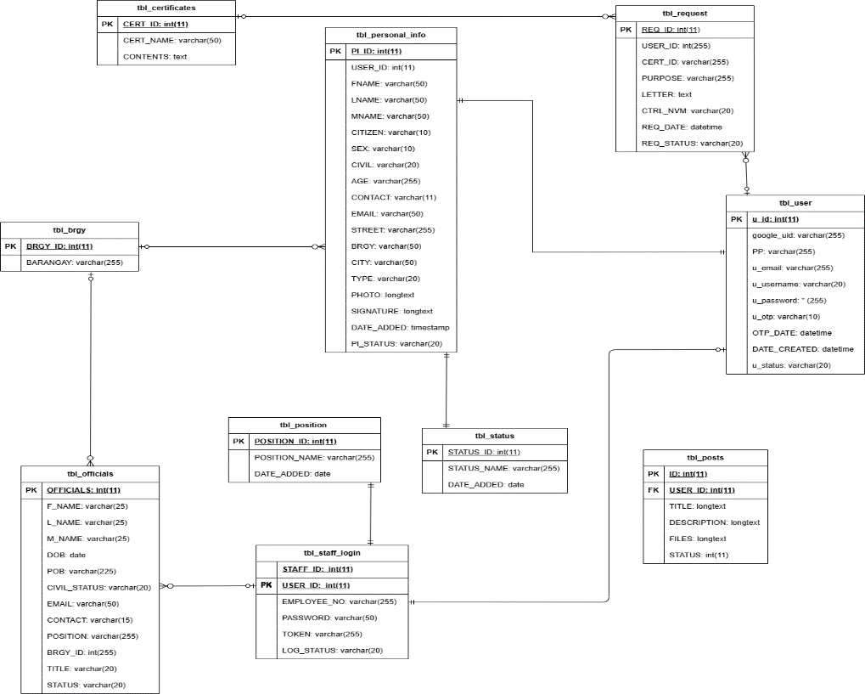
Entity Relationship Diagram

Figure 5. Entity Relationship Diagram

The Entity Relationship Diagram (ERD) of the proposal Barangay Information System present show data flows and interacts within the system in a structured and meaningful way. At the center of the system is the tbl_user, which represents all registered users who can access the platform. Each user is linked to a corresponding record in tbl_personal_info, forming a one-to-one relationship where every user has exactly one personal profile containing their demographic details such as name, address, and contact information. This personal information is further associated with tbl_brgy, indicating to only one barangay.

As users interact with the system, they are able to request official documents. This process in handled by the tbl_request entity, where a one-to-many relationship exists because a single user can submit multiple requests, but each request belongs to only one user. Each request is also linked to tbl_certificates, ensuring that every request corresponds to a specific type of certificate, such as a barangay clearance or indigency certificate, while allowing each certificate type to be requested multiple times.

To keep track of progress and updates, the system uses tbl_status, which standardizes the condition of records across the system. Each request is assigned a status, forming a one-to-many relationship where one status can apply to many requests, but each request has only one status. Similarly, this status entity is also connected to other components like tbl_posts and tbl_personal_info, ensuring that posts and user records are properly monitored and categorized.

In addition to requesting services, users can also engage with the community through tbl_posts. This entity stores announcements and updates, where a one-to-many relationship exists because a user can create multiple posts, but each post is authored by only one user. Each post is also assigned a status to indicate whether it is active, archived, or under review.

On the administrative side, the system manages barangay personnel through tbl_officials, which stores the details of officials assigned to a specific barangay. This establishes a one-to-many relationship where one barangay can have multiple officials, but each official belongs to only one barangay. Each official is assigned a role defined in tbl_position, where a single position can be held by multiple officials, but each official has only one designated role.

To enable secure access for administrators, tbl_staff_login is used. This entity is connected to tbl_officials in a one-to-one relationship, meaning each official has one corresponding login account. Through this, officials can manage requests, monitor posts, and oversee system operations efficiently.

Overall, the ERD demonstrates a well-organized system where users, services, and administrators are interconnected through clearly defined relationships. These relationships ensure data consistency, reduce redundancy, and support the efficient processing of barangay services, making the system reliable and scalable for real-world implementation.

User Case Diagram
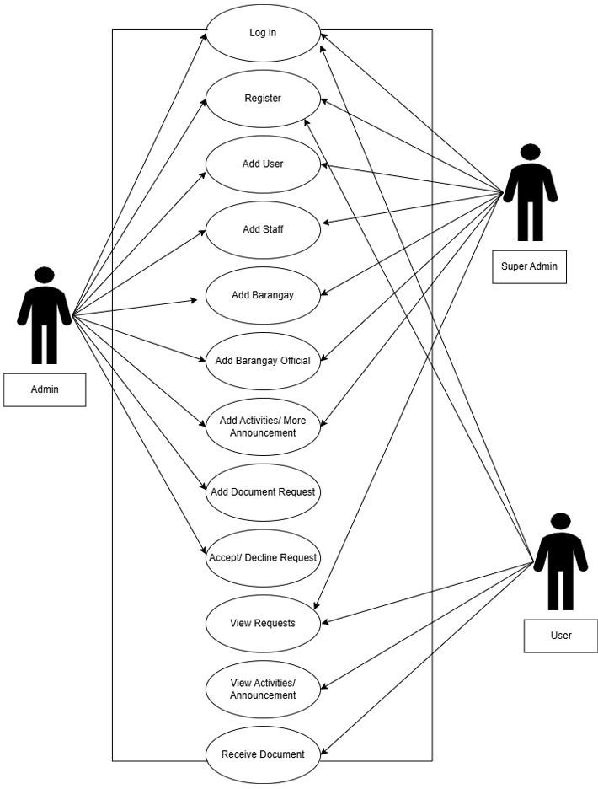

Figure 6. Use Case Diagram

The Use Case Diagram of the proposed Barangay Information System illustrates how different types of users interact with the system and perform various functions. The system is composed of three primary actors: the User, Admin, and Super Admin, each with specific roles and access levels that define their interactions within the platform.
The process begins when any actor accesses the system through the Log in or Register functions. These features allow users to securely enter the system or create a new account, ensuring that only authorized individuals can access its services. Once authenticated, the level of access depends on the role assigned to the actor.
The User, who represents the residents, primarily interacts with the system to access services and information. After logging in, the user can view activities or announcements posted by the barangay, keeping them informed about community updates. Additionally, the user can submit document requests, such as barangay certificates, through the system. Once a request is processed, the user can view the status of their requests and eventually receive the requested document, completing the service cycle.
On the other hand, the Admin plays a crucial role in managing daily operations. In addition to logging in, the admin has the ability to add users and staff, ensuring that all system participants are properly registered. The admin can also add barangays and barangay officials, maintaining accurate records of local governance. Furthermore, the admin is responsible for posting updates by using the Add Activities or Announcements function, which allows them to communicate important information to users. When users submit requests, the admin can view requests and accept or decline them, ensuring proper validation and processing of documents.
 | HTML5 – The latest version of HyperText Markup Language, used to structure and present content on the web. HTML5 introduces new semantic elements (like <header>, <footer>, <article>), multimedia support for audio and video without plugins, improved forms, and APIs for offline storage, graphics, and interactivity. It enables the development of modern, responsive, and accessible web applications.
 | SQL is used to manage and query the database. It stores all the critical data, such as customer details, reservation information, and payment records.
 | jQuery – A fast, small, and feature-rich JavaScript library that simplifies tasks like HTML document traversal, event handling, animation, and Ajax interactions. It enables developers to write less code while achieving cross-browser compatibility, making web applications more interactive and responsive.
 | PHP is a server-side scripting language that powers the dynamic content of the website. It is used to handle requests from the frontend, manage user inputs, process reservations, and interact with the database.
 | Firebase is a platform developed by Google that provides a suite of cloud-based tools and services to help developers build, improve, and grow web and mobile applications. It is designed to simplify backend development so developers don’t have to manage servers or databases themselves.
The Super Admin holds the highest level of authority within the system. This actor has access to all functionalities available to the admin, including managing users, staff, barangays, officials, and announcements. In addition, the super admin oversees the entire system, ensuring that operations run smoothly and that data integrity is maintained. The super admin can also monitor all requests and user activities, providing an extra layer of control and security.
Overall, the Use Case Diagram demonstrates a well-defined interaction between users and the system. It highlights how responsibilities are distributed among different actors, ensuring efficient service delivery, proper management, and secure access to barangay information and services.
Hardware and Software Requirements

ITEM OF SOFTWARE | Description Specification
 | Tailwind CSS – A utility-first CSS framework that provides a collection of pre-designed classes to quickly style HTML elements. It allows developers to build responsive, modern, and customizable user interfaces without writing custom CSS from scratch. Tailwind promotes faster development, consistent design, and easy maintenance by using utility classes for spacing, typography, colors, layout, and more

Table 3. Software Requirements

ITEM OF HARDWARE | Description specification
 | A smartphone is a mobile device that combines the functionality of a traditional mobile phone with advanced computing capabilities. It typically has a touchscreen interface, allowing users to access a wide range of applications and services, such as web browsing, email, and social-media, as well as multimedia playback and streaming.
 | A computer is an electronic machine that collects, stores, and processes information according to user instructions, ultimately returning the results. Functionally, it's a programmable electronic device that automatically performs arithmetic and logical operations using a set of instructions. A specific example mentioned has a core i7 processor, an 18-inch display with 1050x768 resolution, 256-500 GB of SSD storage, 4 GB of RAM, and includes a keyboard and mouse.
 | An internet connection is a system that allows devices to access the internet, enabling communication, browsing, streaming, and more. It can be wired (fiber, DSL) or wireless (Wi-Fi, mobile data, satellite). Connection speed and reliability depend on the provider and technology used.

Table 4. Hardware Requirements
User Interface

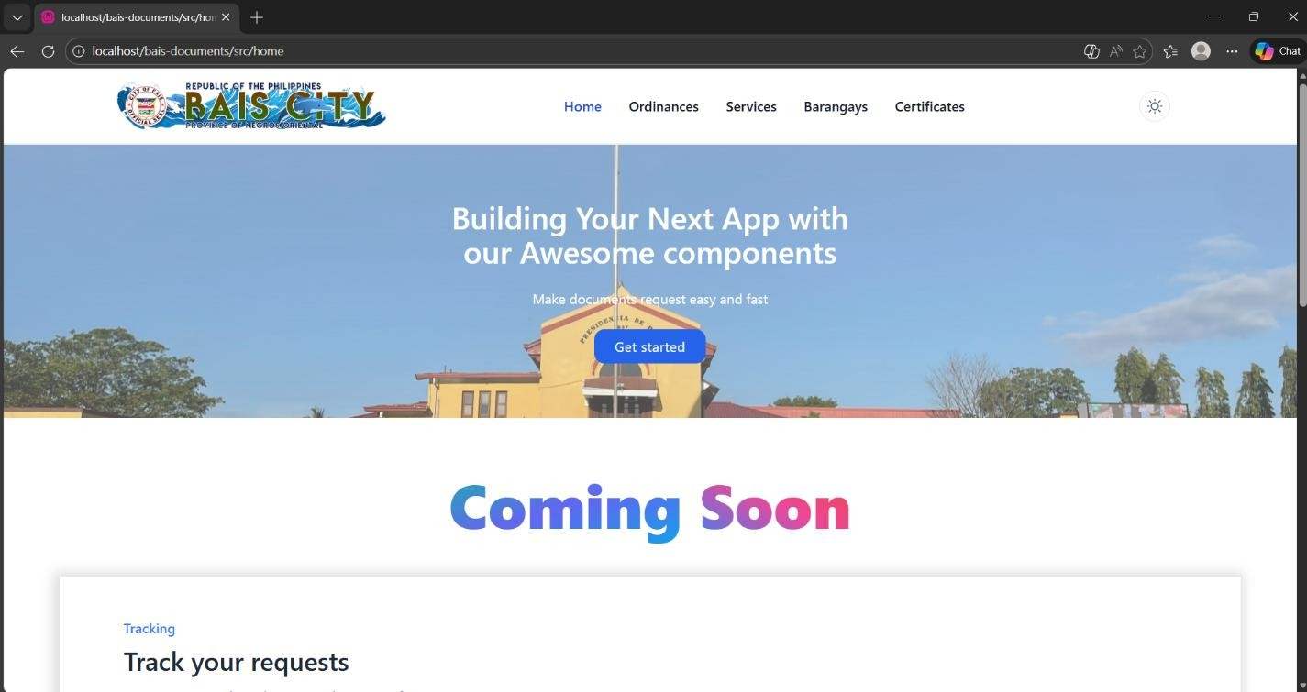

This is the homepage of the Bais City Information Hub: An Integrated Local Services System, designed to provide residents and visitors with a convenient and modern way to access city services. At the top, there is a navigation bar featuring sections such as Home, Ordinances, Services, Barangays, and Certificates, allowing users to easily explore important information and available services. A theme toggle icon is also present for adjusting the display mode. The main banner highlights a welcoming message, “Building Your Next App with our awesome components,” along with a short description emphasizing fast and easy document requests. A prominent “Get started” button encourages users to begin interacting with the system right away, while the background image of a government building reinforces the platform’s official and community- focused purpose. Below the banner, a “Coming Soon” section is displayed, indicating that additional features are still under development. Further down, the system introduces a tracking feature where users will be able to monitor the status of their requests. These elements show that the platform is continuously evolving to improve user experience and service delivery. Overall, the homepage is designed to be user-friendly, informative, and efficient, helping streamline access to local government services in Bais City.

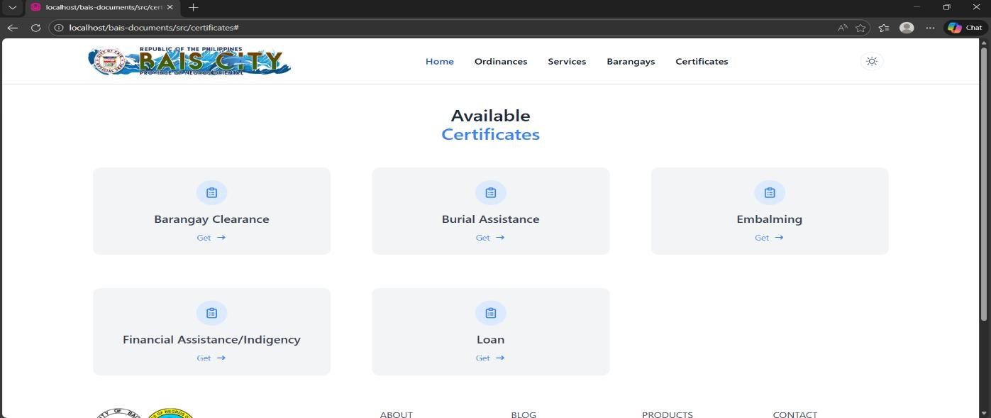

This is the Certificates page of the Bais City Information Hub: An Integrated Local Services System, designed to allow users to easily access and request various city-issued documents and assistance. At the top, the navigation bar remains consistent with options such as Home, Ordinances, Services, Barangays, and Certificates, along with a theme toggle icon for display customization. The page title, “Available Certificates,” clearly introduces the section, guiding users to the services they can request online.
Below the title, several service cards are displayed in a clean and organized layout, including Barangay Clearance, Burial Assistance, Embalming, Financial Assistance/ Indigency, and Loan. Each card includes a simple icon and a “Get” button, allowing users to quickly initiate their request for a specific service. The design emphasizes accessibility and ease of use, ensuring that residents can conveniently select and process their needed documents or assistance through the system without unnecessary complexity.



