CS 446 MJT — Homework 1

junzhew3

haoxuan3

1. **Decision Trees.**

**Solution:**

x1 > 3

x = R2, y = {red, blue}

x1: the abscissa axis

x2: the vertical axis

y=blue

y=red

The training error is the 3 blue points whose x1 values are below 3. So the training error is 3/18 = 1/6



x = R2, y = {red, blue}

x1: the abscissa axis

x2: the vertical axis

x1 > 3

y=blue

x2 > 3

y=blue

y=red



x = R2, y = {red, blue}

x1: the abscissa axis

x2: the vertical axis

x1 > 4

y=blue

x2 > 3

y=blue

y=red

1. **Linear Regression**

**Solution:**

(c)

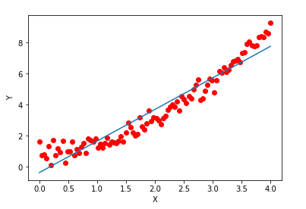

1. **Singular Value Decomposition**

**Solution:**

1. Sufficient condition:

∵ si ≠ 0 for all i∈{1, . . . , n} ∴S is invertible

∵ A = USVT , U and V are orthonormal matrices

∴ UUT = E VVT = E

∴ (VVT)T = ET

∴ VTV= E

∴ AVS-1UT = USVTVS-1UT = USS-1UT = UUT = E

∴ A is invertible and A-1 = VS-1UT

Necessary condition:

∵ A is invertible

∴ ATA is positive definite matrix.

∴ the eigenvalues of ATA are larger than 0

Also ∵ (ATA)vi = sivi

∴ si are eigenvalues of ATA

∴ si ≠ 0 for all i∈{1, . . . , n}

1. According to the definition of USV : (ATA)vi = sivi for all i ∈ {1, . . . , n}, and s1 ≥ s2 ≥ · · · ≥ sn ≥ 0.

∴ (ATA + λI)vi = (ATA)vi + λvi = sivi +λvi = (si + λ) vi

∴ The eigenvalue for ATA + λI are (s1 +λ) ≥ (s2 +λ) ≥· · ·≥ (sn +λ) > 0 for all positive λ ∈ R>0

∴ | ATA + λI | = (s1 +λ)* (s2 +λ)* · · ·*(sn +λ) ≠ 0

∴ ATA + λI is invertible

1. According to the question, I think we have to use the thin SVD definition in this question.

∴ $A^{+}= \sum_{i=1}^{r}{\frac{1}{s_{i}}u_{i}v_{i}^{T}}$

∴ ${(A}^{T}A+λI)A^{+}=A^{T}A A^{+}+ λIA^{+}$

$$=\left( \sum_{i=1}^{r}{s_{i}v_{i}u_{i}^{T}}\right)\left( \sum_{i=1}^{r}{s_{i}u_{i}v_{i}^{T}}\right)\left(\sum_{i=1}^{r}{\frac{1}{s_{i}}v_{i}u_{i}^{T}}\right)+ λ\left(\sum_{i=1}^{r}{\frac{1}{s_{i}}v_{i}u_{i}^{T}}\right)$$

$$=\left( \sum_{i=1}^{r}{s_{i}v_{i}u_{i}^{T}}\right)\left(\sum_{i=1}^{r}{u_{i}u_{i}^{T}}\right)+ λ\left(\sum_{i=1}^{r}{\frac{1}{s_{i}}v_{i}u_{i}^{T}}\right)$$

$$=\left( \sum_{i=1}^{r}{s_{i}v_{i}u_{i}^{T}}\right)+λ\left(\sum_{i=1}^{r}{\frac{1}{s_{i}}v_{i}u_{i}^{T}}\right)$$

$$= A^{T}+λA^{+}$$

∴ $\lim_{λ=0}{{(A}^{T}A+λI)A^{+}}= \lim_{λ=0}{A^{T}+λA^{+}}→ A^{T}$

∵ ATA + λI is invertible

∴ $\lim_{λ=0}{{{(A}^{T}A+λI)}^{-1}A^{T}} →A^{+}$

1. **Polynomial Regression**

**Solution:**



$Ф\left(x\right)= x_{1}+ x_{2}+ x_{3}+ x_{1}x_{1}+ x_{1}x_{2}+ x_{1}x_{3}+x_{2}x_{2}+x_{2}x_{3}+x_{3}x_{3}$

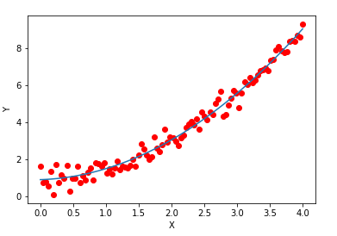

I think the model in this question appears to approximate the data best because you can see from two pictures that the distances between prediction values and actual values are much smaller in the model of this question.

1. Contour lines of linear model:

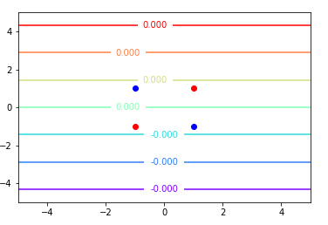

Contour lines of polynomial model:

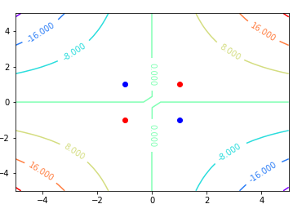

Output label for linear model: [5.55111512e-17, -5.55111512e-17, -5.55111512e-17, 5.55111512e-17]

Output label for polynomial model: [-1. -1. 1. 1. ]

True label: [-1 -1 1 1]

So only polynomial model correctly classifies all points.

1. **Nearest Neighbor**

**Solutions:**



Plot of data:

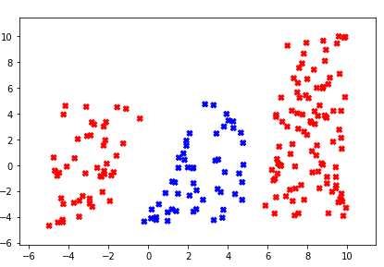

Plot of the Voronoi diagram result:

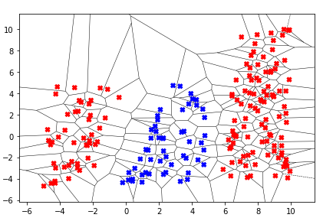

1. My classification accuracy is 0.9777777777777777.
2. **Logistic Regression**

**Solution:**



∵ $w^{'}=w- η∇wR_{log}(w)$

$$R_{log}\left(w\right)= \frac{1}{n}\sum_{i=1}^{n}{l_{log}\left(z\right)= }\frac{1}{n}\sum_{i=1}^{n}{ }\ln\left(1+\exp\left(-z\right)\right)= \frac{1}{n}\sum_{i=1}^{n}{ }ln⁡(1+exp⁡(-y_{i}w^{T}x_{i}))$$

∴ $l_{log}^{'}\left(z\right)= -\frac{1}{1+e^{z}}$

∴ $∇wR_{log}\left(w\right)$

$$= \frac{1}{n}\sum_{i=1}^{n}{l_{log}^{'}\left(z\right)z^{'}\left(w\right)= }\frac{1}{n}\sum_{i=1}^{n}{ }-\frac{1}{1+e^{z}}*y_{i}x_{i}= -\frac{1}{n}\sum_{i=1}^{n}{ }\frac{1}{1+e^{y_{i}w^{T}x_{i}}}y_{i}x_{i}$$

$$w^{'}=w-η∇wR_{log}\left(w\right)=w+\frac{η}{n}\sum_{i=1}^{n}{ }\frac{1}{1+e^{y_{i}w^{T}x_{i}}}y_{i}x_{i}$$

(c)

Plot of logistic regression:

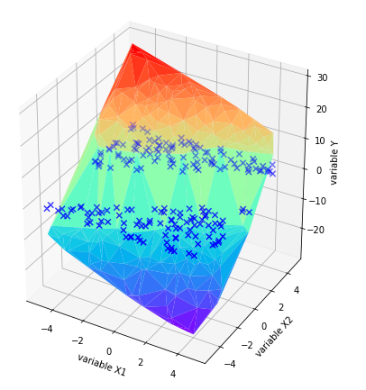

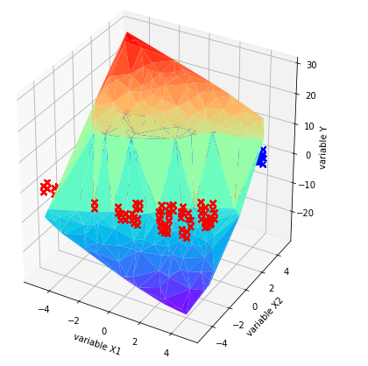

In the second picture, I set the color of points whose true label are 1 is red and the color of points whose true label are 1 is blue.

Plot of linear regression:

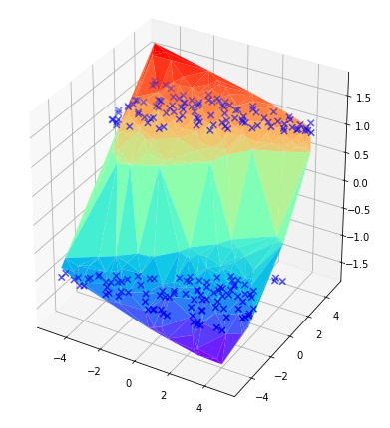

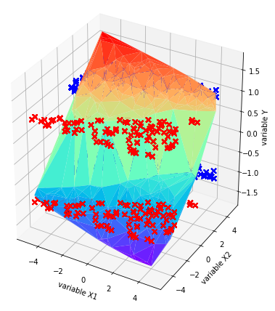

In the second picture, I set the color of points whose true label are 1 is red and the color of points whose true label are 1 is blue.

Contour lines of linear regression:

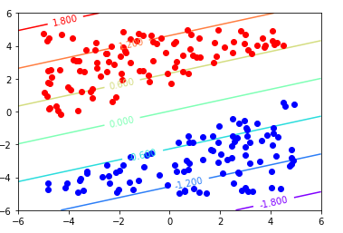

Contour lines of logistic regression:

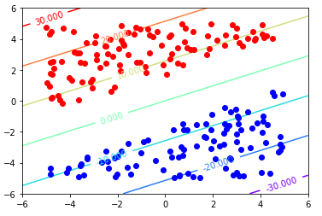

According to the two contour plots, we can say logistic regression model classifies the data better. The values of contour lines are bigger in logistic regression model, so a little move will cause a big error.