Time series analysis methodology
4.1 data source and preprocessing for time series and
In terms of time series analysis, we first preprocessed the raw dataset in sales by converting the date field into a datetime object, in order to set it as the time series index. The data were sorted in chronological order and aggregated into daily total sales amongst all the schools. We examined the dataset for missing values to ensure data quality prior to modeling.

4.2 Time series analysis procedure
To access whether the dataset was stationary for time series analysis, we applied the Augmented Dickey-Fuller (ADF) and Kwiatkowski-Phillips-Schmidt-Shin(KPSS) test. Below is the code for testing ADF and KPSS in order to check whether the dataset is stationary or not. For ADF test, we have the null hypothesis H₀ that the series is non-stationary, we can reject H₀ if p-value < 0.05, meaning the dataset is stationary and no further steps are needed. For KPSS test, which has the opposite hypotheses than ADF test, and we can reject H₀ if p-value >0.05, meaning the dataset is stationary and no further steps are needed. We must prepared data until both tests show that the dataset is stationary.
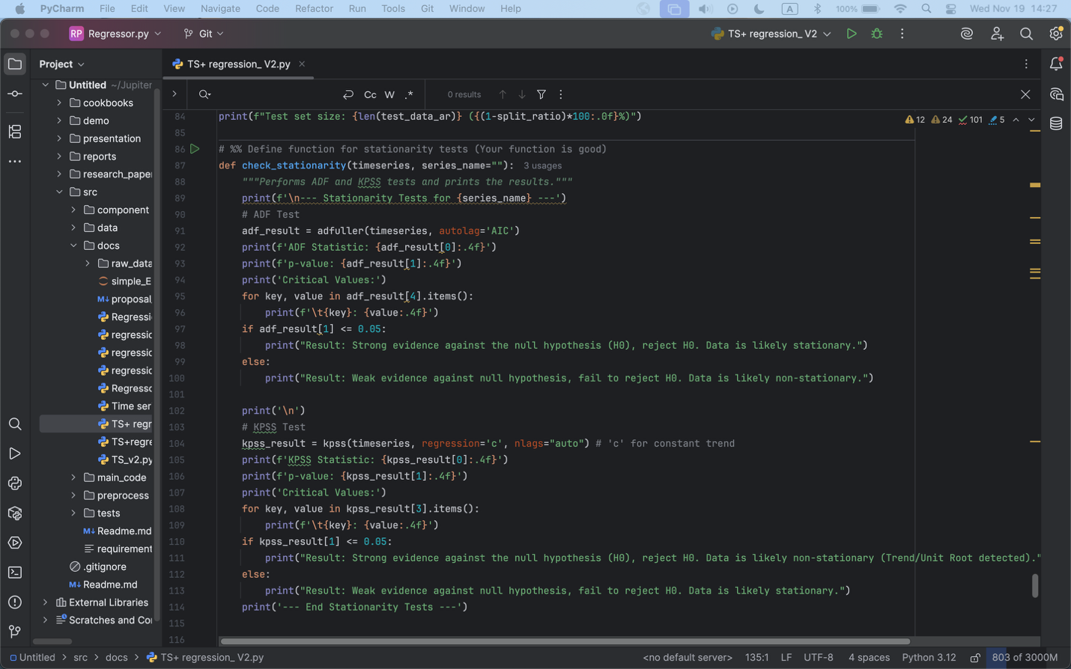

Rolling means and rolling variances were plotted in figure #.

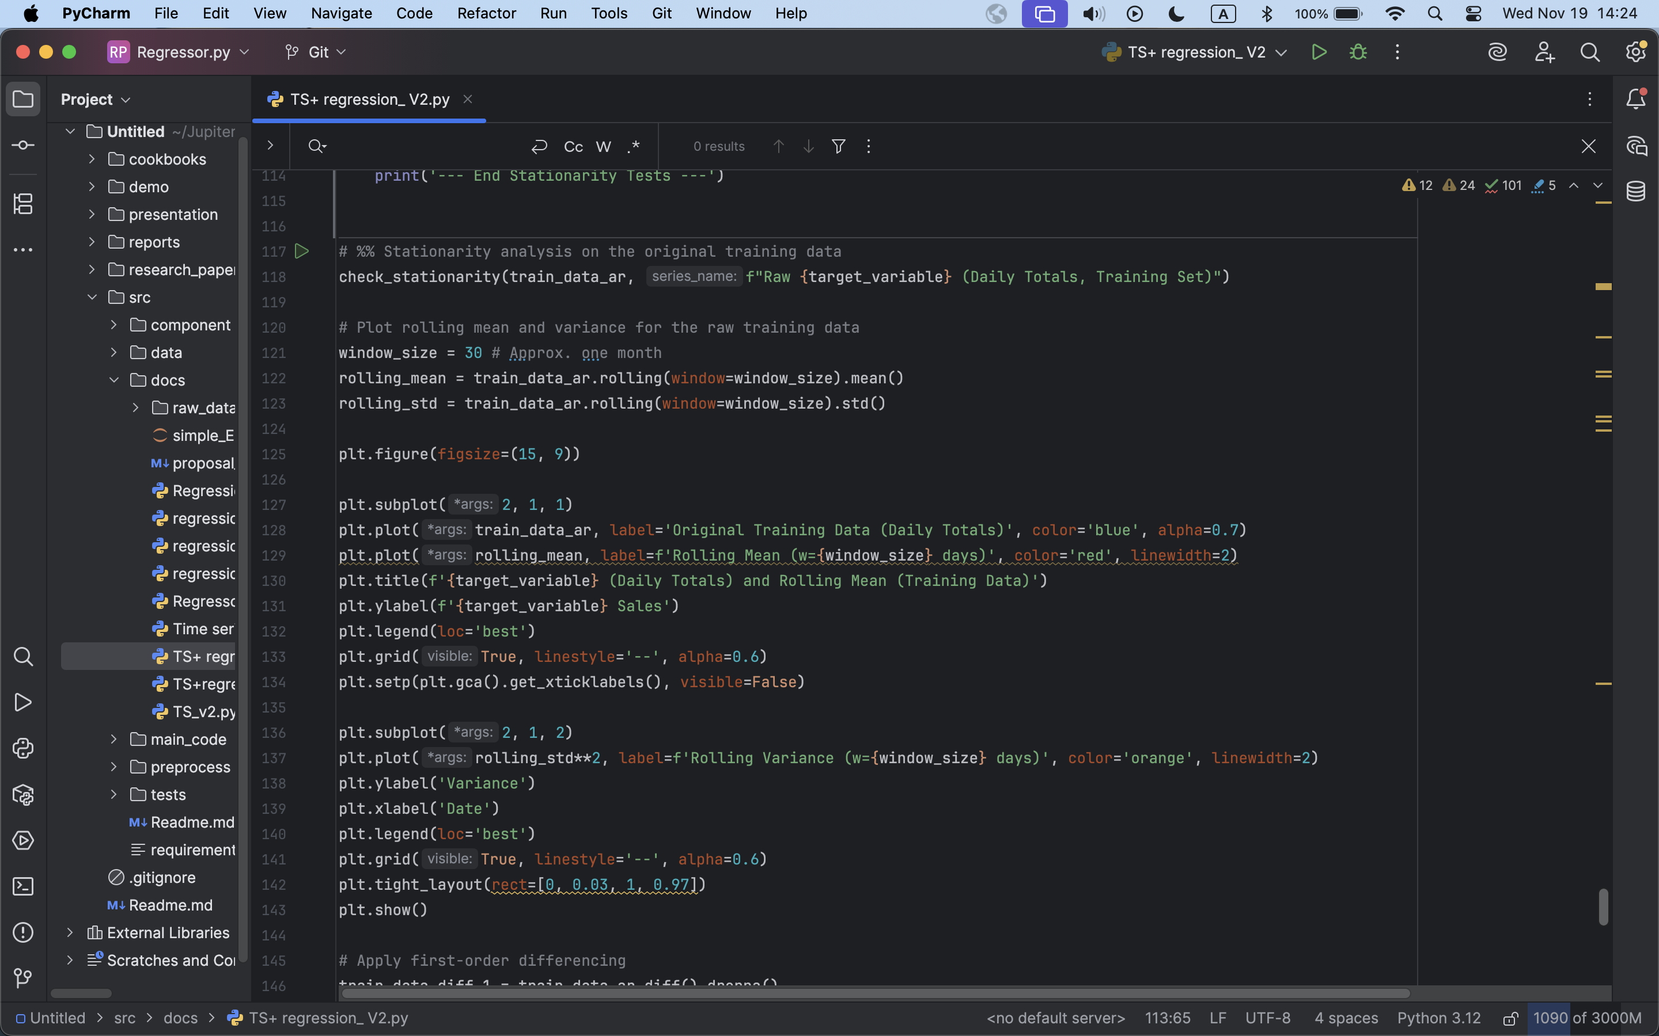
Figure #: rolling mean and rolling variance for the original dataset

Figure # shows the original dataset daily sales on time. This graph uses #### to calculate the rolling mean and rolling variance. We plotted rolling mean and rolling variance to visually inspect the trend and/or variance stability of the dataset. If ADF and KPSS tests shows that the original dataset is in fact non- stationary, we must use differencing method to make the dataset in order to be able to do time series analysis. First order differencing, even second order differencing will be used until the dataset is stationary.

Figure #: ACF and PACF plots

Figure # shows the ACF and PACF plots for the original dataset. We need to plot the new ACF and PACF plots when looking at the different lags to determine if the dataset is seasonal, and if so, what would be the seasonal order for further analysis.

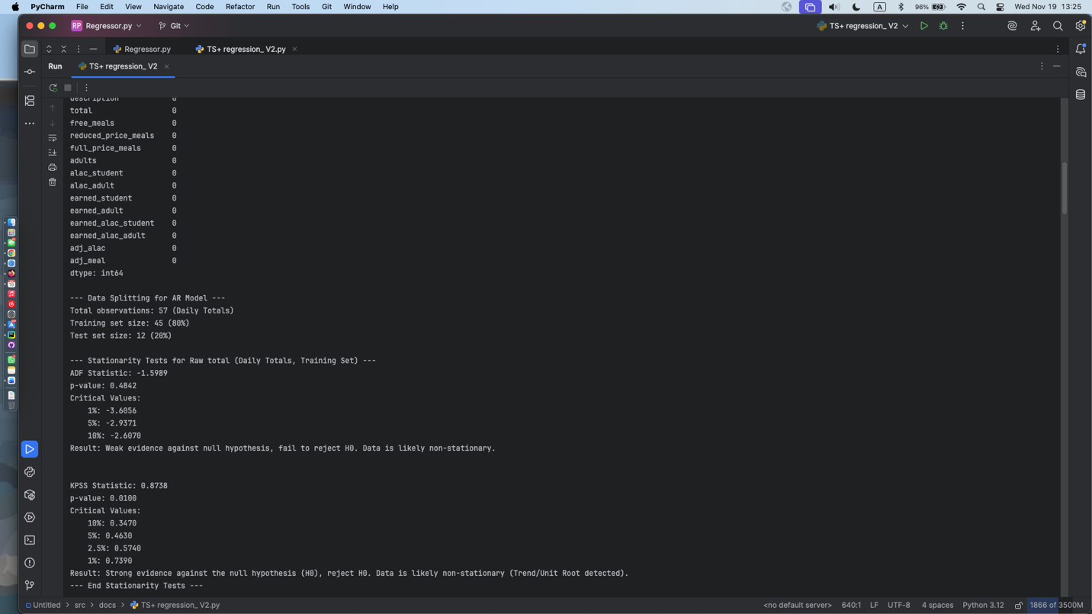
Figure#: original dataset and it’s ADF and KPSS test
From the original dataset plots, we cannot see a clear pattern that shows if the dataset is stationary or not, Using ADF and KPSS test, we can tell that the dataset is in fact non- stational. We need to do a first order differencing and check again.

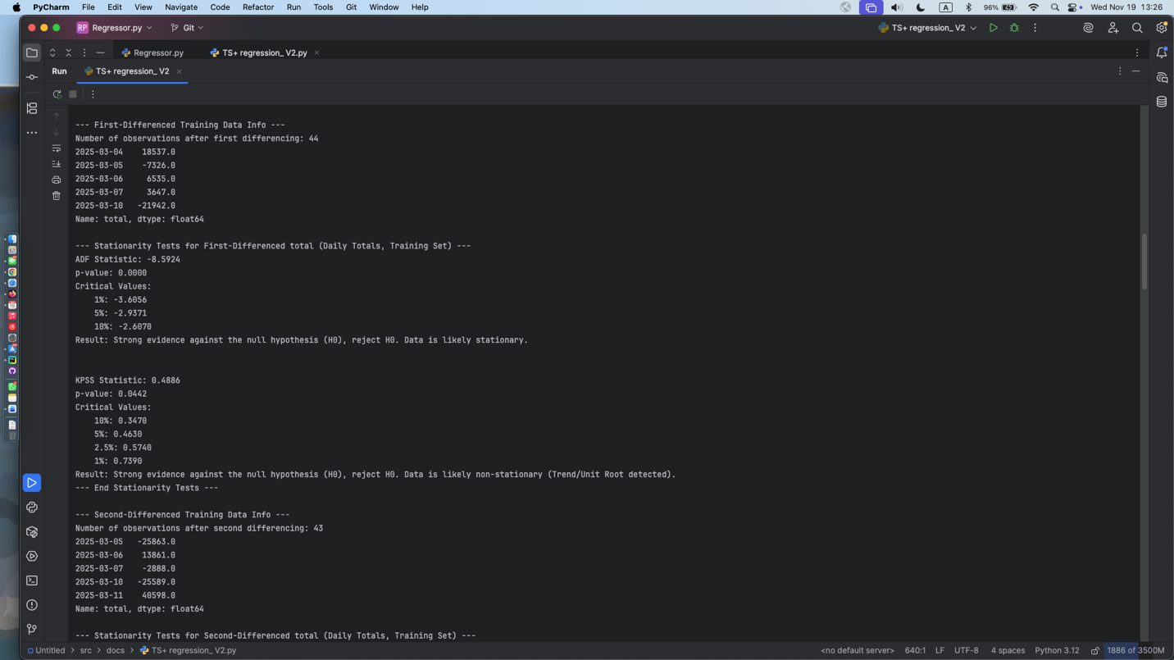
Figure #: ADF and KPSS test after first order differencing
After first-order differencing, we can see that the dataset is still not completely stationary, we need to do a second order differencing for further examination.

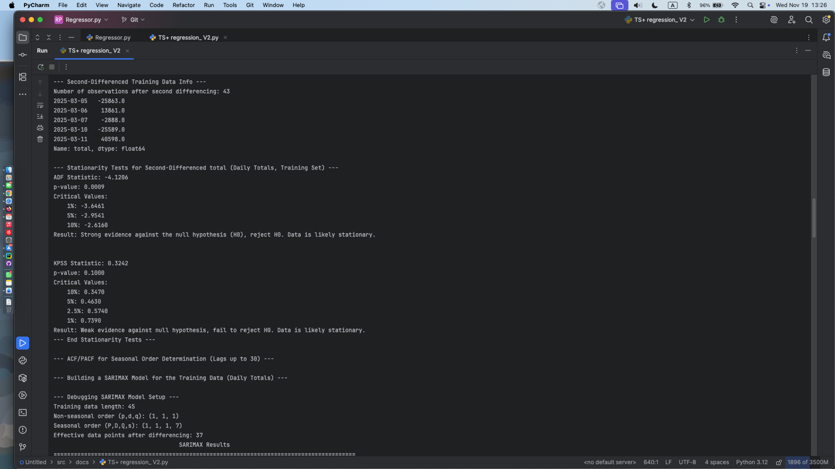
Figure#: ADF and KPSS test for second order differencing
After the second-order differencing, we can see that the dataset is now stationary and ready for use.

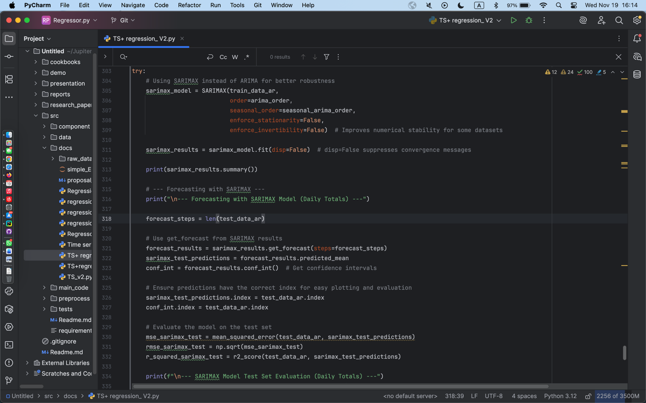
(need to change bc might have seasonal ordering problem)Figure # shows the SARIMA model. (need to explain why choosing the AR, MA order and also whether or whether not having the seasonality factor affecting the model.

4.3 LSTM analysis methodology
In our project, we also implemented a Long Short-Term memory (LSTM) neural network to better capture the non- linear temporal patterns our dataset might have. We used MinMaxScaler to normalize our input data and then applied a sliding-window approach to transform the time series data into a supervised learning samples. The model was then followed by a fully connected dense layer for predicting the future sales. The network was trained using the Adam optimizer with mean squared error (MSE) as the loss function.

4.4 Regression analysis methodology
Besides the above analysis methods, we also wish to see if there’s any linear relations other than a time-based prediction that we can do. We chose to use a different dataset since in sales.csv, the multicollinearity is too strong between each column.

For this dataset, we chose to use the breakfast and lunch, school region to combine them together, in order to analyze the production cost based off regions. We included geospatial region data to assign schools to regions, merged student count data to account for school size (??).

When cleaning the data, we normalize column names and school names, cleaned numerical columns and handling missing values and invalid entries. We also combined the breakfast and lunch dataset into a unified table and converted the geographic coordinates into point geometries and categorized them into regions. The goal of preprocessing is to ensure a consistent, clean and spatially enriched dataset that is suitable for regression analysis.

For model selection, we chose to use a ordinary least squares (OLS) linear regression to quantify the relationships between production cost and operational variables. We performed the regression at regional models as well as on school levels, which is aggregated on elementary/middle/high school. We attached a visualization with an actual vs predicted scatter plots and a residuals vs predicted plots to show the linear relationship of how some of the selected features effect the production cost.

Data Cleaning & Preprocessing Approach
Describe your planned steps (not code):
- Normalize column names and school names.
- Clean numeric columns by removing non-numeric characters.
- Handle missing values and invalid entries.
- Ensure numeric consistency across datasets.
- Combine breakfast and lunch datasets into a unified table.
- Convert geographic coordinates into point geometries.
- Spatially join schools to regional polygons.
State the purpose:
“The goal of preprocessing is to ensure consistent, clean, and spatially-enriched data suitable for regression analysis.”

3. Feature Selection / Variable Design
Explain the reasoning behind choosing dependent and independent variables.
- Dependent variable: production_cost_total
(chosen as the primary measure of operational cost)
- Independent variables
  - planned_total (proxy for production workload)
  - served_total (demand indicator)
  - discarded_total (waste, inefficiency)
  - left_over_total (overproduction indicator)
  - student_count (scale of operations)
Explain why these variables matter conceptually.

4. Statistical Modeling Method
Describe the statistical method without code:
- Use Ordinary Least Squares (OLS) linear regression.
- Purpose: quantify relationships between production cost and operational variables.
- Perform regression at three levels:
  - Global model (all schools combined)
  - Regional models (each geographical region separately)
  - School-level aggregated model (Elementary/Middle/High)

5. Visualization / Diagnostic Strategy
Explain your plan:
- Visualize model performance with:
  - Actual vs Predicted scatter plots
  - Residuals vs Predicted plots
- Use train/test splits where data volume allows.

“Overall, the methodology focuses on merging heterogeneous datasets, cleaning and standardizing them, assigning spatial regions, selecting meaningful operational variables, and applying OLS regression models to understand cost drivers across different organizational structures.”

This section should be specific, code-aligned, and step-by-step.

1. Data Loading
Describe exactly what you ran:
- Loaded breakfast, lunch, and student_count CSVs.
- Loaded region GeoJSON for spatial mapping.
- Handled errors if files were missing.

2. Data Cleaning Implementation
Detail what you executed:
- Normalized column names to lowercase.
- Applied a numeric-cleaning function to ~10 specified columns.
- Converted all numeric fields using pd.to_numeric.
- Normalized school names by lowercasing and stripping spaces.
- Filled missing student_count values with zero.

3. Combining & Merging Datasets
Explain the real actions:
- Concatenated breakfast and lunch records.
- Merged student counts on school_name.
- Performed final cleanup of infinities and NaNs.

4. Geospatial Processing Execution
Document precisely what happened:
- Identified lat/lon columns automatically.
- Created point geometries for each school.
- Reprojected region polygons to EPSG:4326 if necessary.
- Ran a spatial join using within predicate.
- Assigned region names to schools.
Mention exceptions:
- If coordinates were missing, assigned fallback region labels.

5. Global Regression Experiment
Detail what the script did:
- Selected the five independent variables.
- Cleaned the dataset for valid numeric rows.
- Ran the global OLS model.
- Printed full model summary (coefficients, p-values, R²).
- Produced diagnostic scatter plots when feasible.

6. Regional Regression Experiment
Describe the actual loop:
- Filtered out invalid or missing-region rows.
- For each region:
  - Extracted subset of data.
  - Ran OLS regression if ≥2 valid rows existed.
  - Generated train/test split and plots if ≥5 rows.
State what you observed (optional):
- Some regions had small sample sizes → regression skipped.
- Others successfully generated OLS results.

7. School-Level Experiment
Detail steps:
- Inferred school_level from school names.
- Filtered to Elementary, Middle, High.
- Aggregated numeric variables by school level (mean).
- Ran an aggregated-level OLS regression.
- Plotted Actual vs Predicted for aggregated model.

8. Final Output
Explain final outputs:
- Model summaries for each region + global model.
- Diagnostic plots (Actual vs Predicted, Residuals).
- Cleaned combined dataset with assigned regions + school levels.

🎓 Short Version (if you need a super concise outline)

Methodology
- Identify datasets (meal service, region, student counts).
- Plan data cleaning (normalize, numeric cleaning, missing values).
- Plan dataset merging and region assignment using spatial joins.
- Select dependent and independent variables conceptually.
- Choose OLS regression as modeling method.
- Plan evaluation using plots and diagnostics.

Experiment
- Load actual CSVs and GeoJSON.
- Clean numeric columns, normalize school names, merge datasets.
- Build geospatial geometries and assign regions.
- Run:
  - global regression
  - regional regression
  - school-level aggregated regression
- Generate model summaries + plots.

