Time Analysis, LSTM and Regression analysis explanation
1. data source and preprocessing for time series and
In terms of time series analysis, we first preprocessed the raw dataset in sales by converting the date field into a datetime object, in order to set it as the time series index. The data were sorted in chronological order and aggregated into daily total sales amongst all the schools. We examined the dataset for missing values to ensure data quality prior to modeling.

2. Time series analysis procedure
To access whether the dataset was stationary for time series analysis, we applied the Augmented Dickey-Fuller (ADF) and Kwiatkowski-Phillips-Schmidt-Shin(KPSS) test. Below is the code for testing ADF and KPSS in order to check whether the dataset is stationary or not. For ADF test, we have the null hypothesis H₀ that the series is non-stationary, we can reject H₀ if p-value < 0.05, meaning the dataset is stationary and no further steps are needed. For KPSS test, which has the opposite hypotheses than ADF test, and we can reject H₀ if p-value >0.05, meaning the dataset is stationary and no further steps are needed. We must prepared data until both tests show that the dataset is stationary.

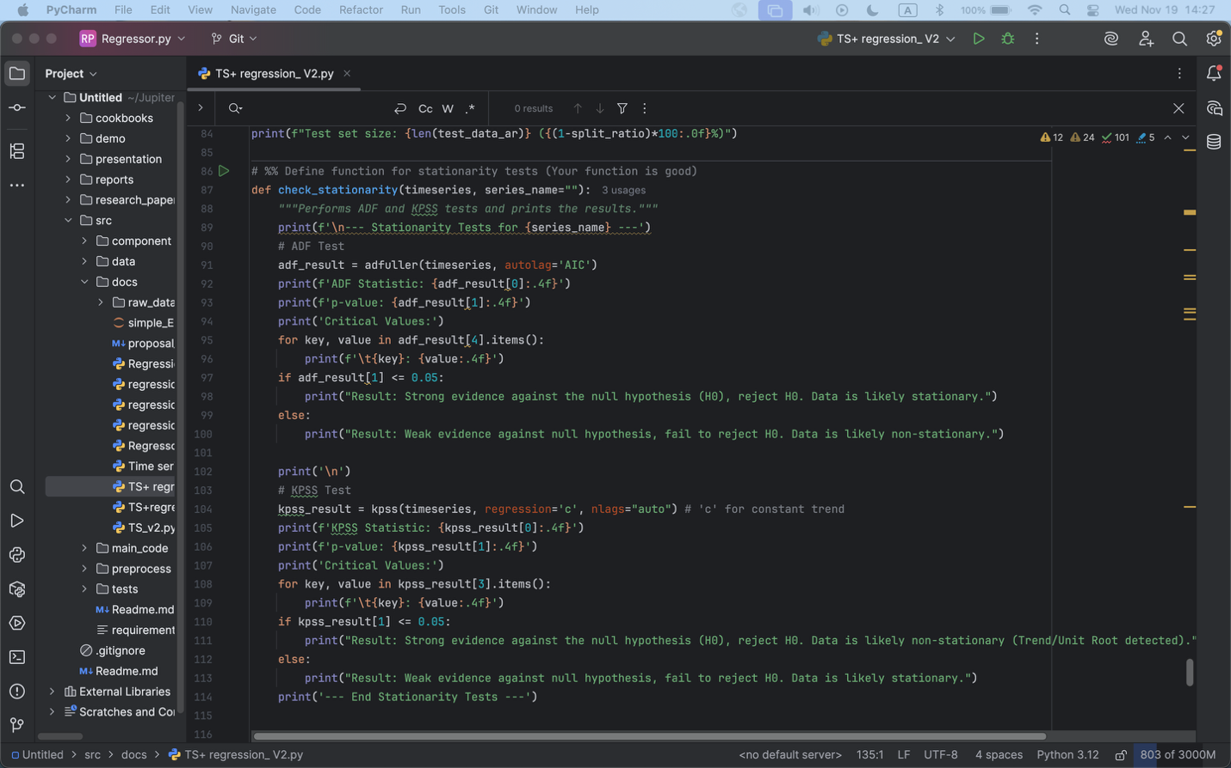

Rolling means and rolling variances were plotted in this figure.

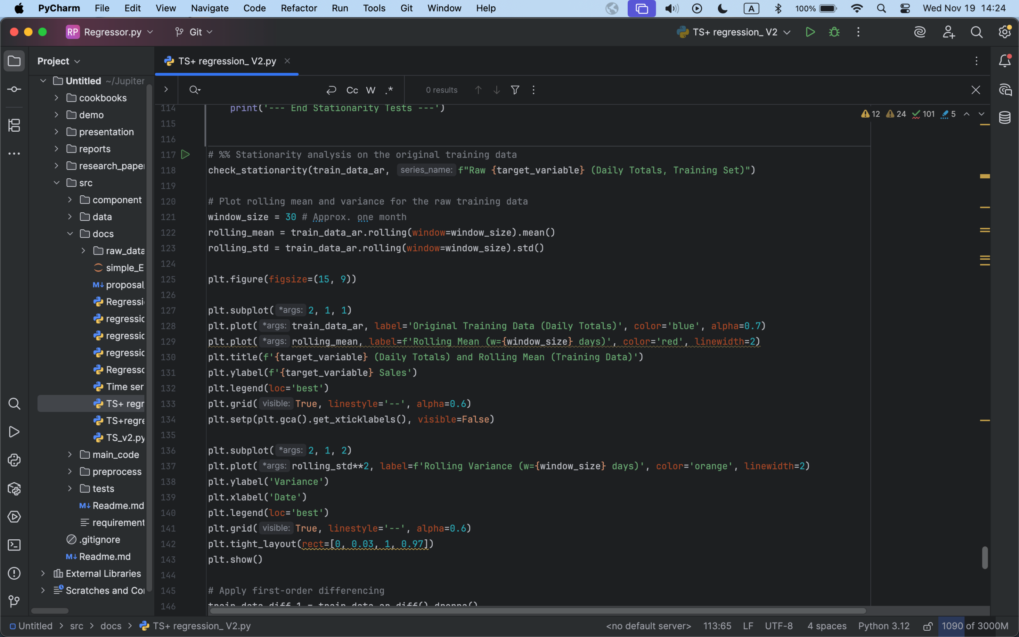
Figure: rolling mean and rolling variance for the original dataset

Figure shows the original dataset daily sales on time. This graph calculates the rolling mean and rolling variance. We plotted rolling mean and rolling variance to visually inspect the trend and/or variance stability of the dataset. If ADF and KPSS tests shows that the original dataset is in fact non- stationary, we must use differencing method to make the dataset in order to be able to do time series analysis. First order differencing, even second order differencing will be used until the dataset is stationary.

Figure: ACF and PACF plots

Figure shows the ACF and PACF plots for the original dataset. We need to plot the new ACF and PACF plots when looking at the different lags to determine if the dataset is seasonal, and if so, what would be the seasonal order for further analysis.

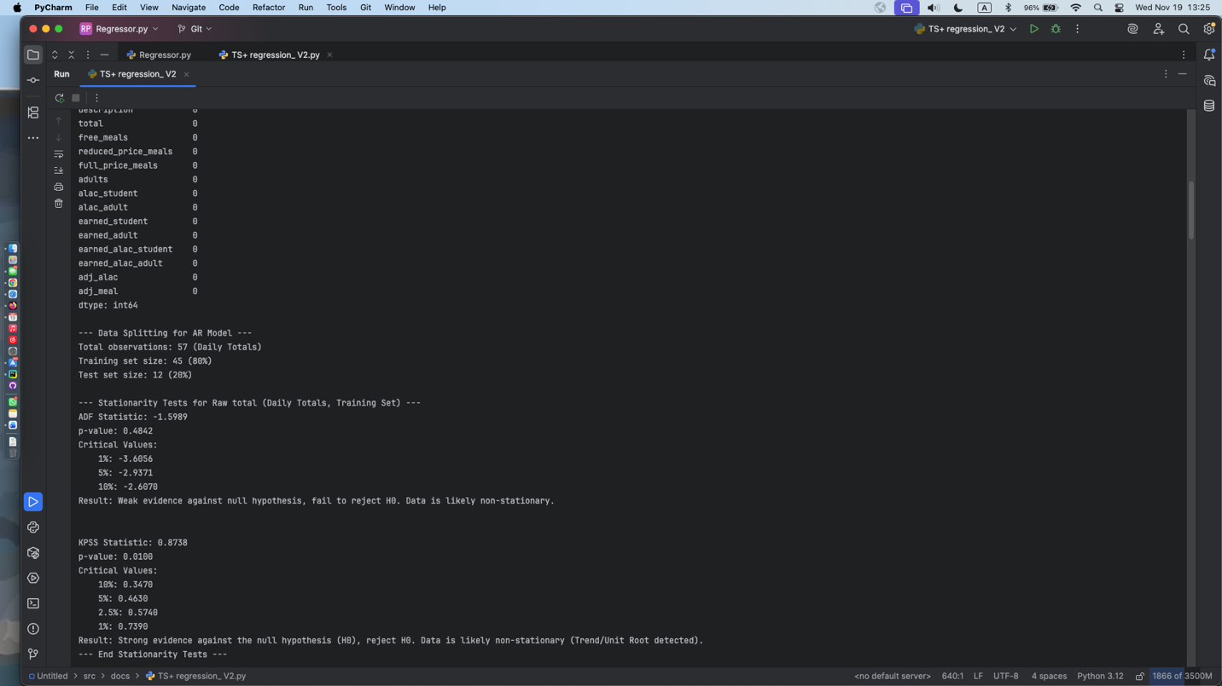
Figure: original dataset and it’s ADF and KPSS test
From the original dataset plots, we cannot see a clear pattern that shows if the dataset is stationary or not, Using ADF and KPSS test, we can tell that the dataset is in fact non- stational. We need to do a first order differencing and check again.

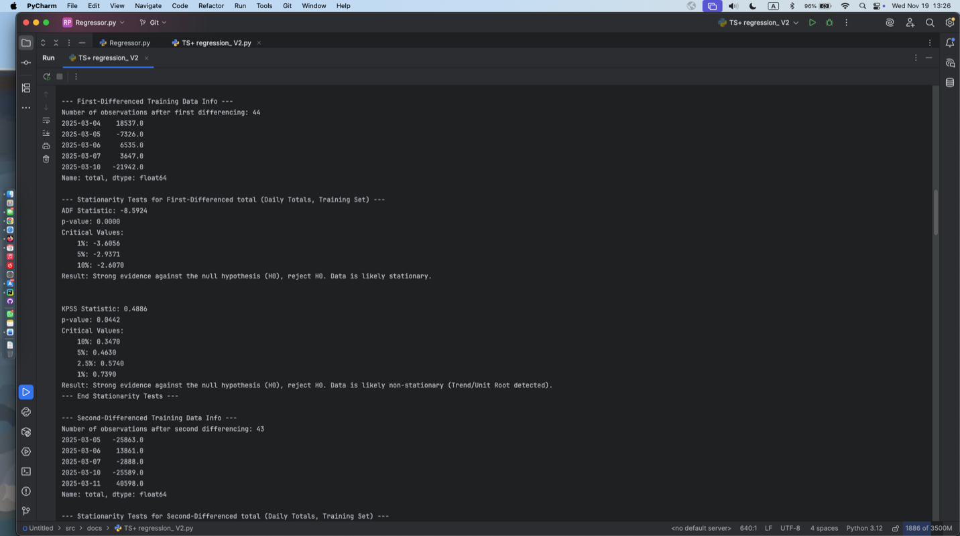
Figure: ADF and KPSS test after first order differencing
After first-order differencing, we can see that the dataset is still not completely stationary, we need to do a second order differencing for further examination.

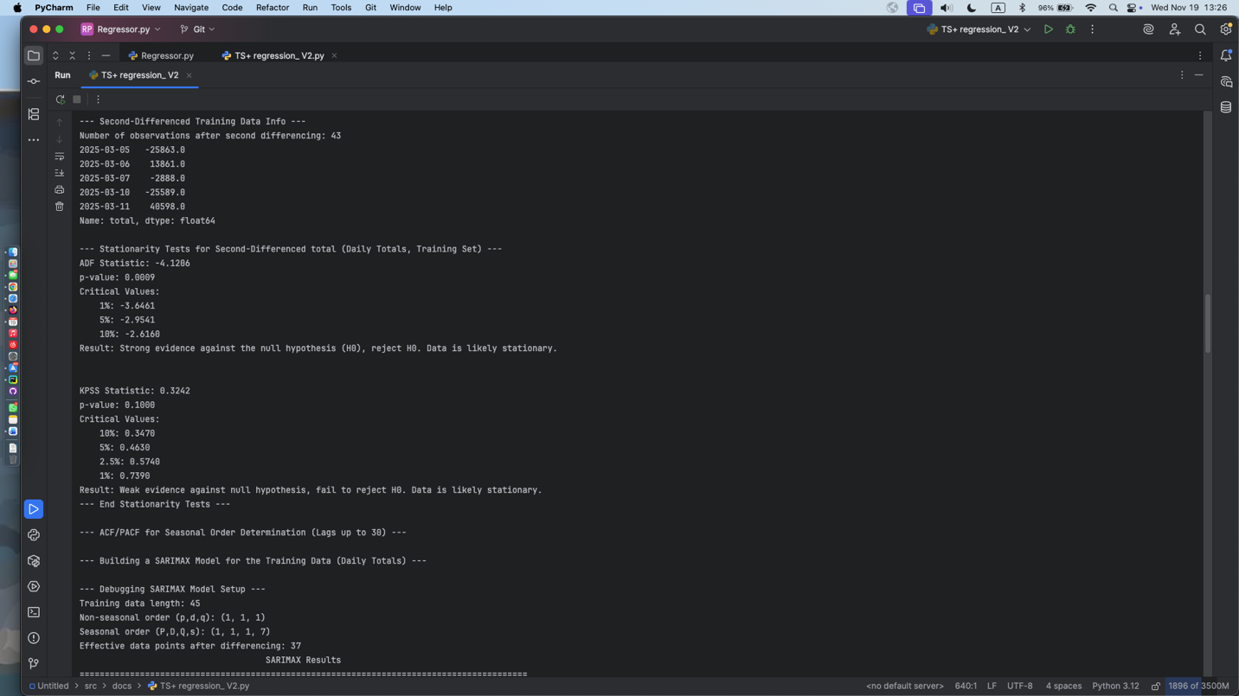
Figure: ADF and KPSS test for second order differencing
After the second-order differencing, we can see that the dataset is now stationary and ready for use.

Figure shows the SARIMA model prediction. From the sixth datapoint (marked in red ink), we can see that the prediction is tending to be more accurately predicting for the future. The prediction line is having a basic trend as the actual datapoint, meaning the model is working on a basic level. However, since our datapoint is very limited, we cannot perform a good time series analysis with only 3 months of data. Thus we are unable to conduct more processing using time series analysis. In our future research, we could adjust our lag number and have a new AR/MA order in order to have a better SARIMA model for prediction.

3. LSTM analysis methodology
In our project, we also implemented a Long Short-Term memory (LSTM) neural network to better capture the non- linear temporal patterns our dataset might have. We used MinMaxScaler to normalize our input data and then applied a sliding-window approach to transform the time series data into a supervised learning samples. The model was then followed by a fully connected dense layer for predicting the future sales. The network was trained using the Adam optimizer with mean squared error (MSE) as the loss function.

Figure shows the LSTM forecasting result. In this figure, we can see that the forecasting result is not entirely aligned with the actual datapoint. We used the previous 7 days of data and performed a 2-step ahead prediction. Due to the limitation of dataset, we are unfortunately unable to use this analysis to forecast sales. We decided to try regression analysis to find whether there’s a linear regression between some of the features and if it can help us predict for the future.

4. Regression analysis
Besides the above analysis methods, we also wish to see if there’s any linear relations other than a time-based prediction that we can do. We chose to use a different dataset since in sales.csv, the multicollinearity is too strong between each column.

For this dataset, we chose to use the breakfast and lunch, school region to combine them together, in order to analyze the production cost based off regions. We included geospatial region data to assign schools to regions, merged student count data to account for school size (??).

When cleaning the data, we normalize column names and school names, cleaned numerical columns and handling missing values and invalid entries. We also combined the breakfast and lunch dataset into a unified table and converted the geographic coordinates into point geometries and categorized them into regions. The goal of preprocessing is to ensure a consistent, clean and spatially enriched dataset that is suitable for regression analysis.

For model selection, we chose to use a ordinary least squares (OLS) linear regression to quantify the relationships between production cost and operational variables. We performed the regression at regional models as well as on school levels, which is aggregated on elementary/middle/high school. We attached a visualization with an actual vs predicted scatter plots and a residuals vs predicted plots to show the linear relationship of how some of the selected features effect the production cost.

We aggregate on school regions (1-6) and ran a regression analysis on production cost. First we chose some of the most component variables like 'served_reimbursable', 'planned_reimbursable', 'discarded_total', 'left_over_total', 'student_count' to find a relationship. Results showed a strong relationship between production cost and these independent features. Using Region 2 as an example, we have an adjusted R^2 = 0.462. However, there’s a heavy multicollinearity between the independent features, causing the adj R^2 not very accurate. Therefore, we switched the independent variables into more operational drivers like 'planned_total', (proxy for production workload), 'served_total', (meals that are actually served), 'discarded_total', (inefficient waste), 'left_over_total', (overproduced leftovers), 'student_count' (scale of school population). Again, using Region 2 as an example:

Figure shows the prediction plot of how well our regression model can predict for the future. After switching to the new independent variables, adj R^2 for region 2 = 0.268. Even though the performance got worse, there’s less multicollinearity affecting the result, which makes the regression more accurate compare to before.

We’ve included some basic functions and explanations for regression analysis in our main report. For our future research, we can try normalizing scalers by using cost per meal for the prediction. In this case we can have a ratio based prediction rather than single factor, in which might be more suitable for analyzing different schools with different size. We can also add more ratio variables that can reflect efficiency, like served_total / planned_total (for execution rate) to better reduce the effect of multicollinearity. We can also include school type ( elememtry/middle/high) as a categorical variable into our model, and using our regression model on optimizer to see different selection choices.

