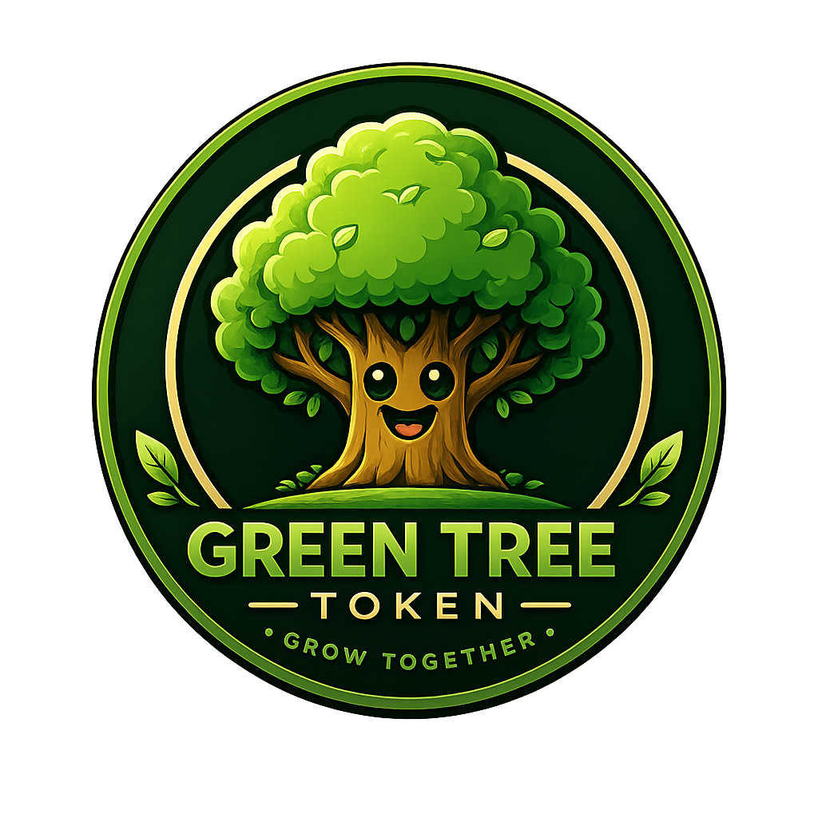
GREEN TREE
WHITEPAPER
Version 2.0.0 - Open Market and Environmental Mission Edition
Grow Together.
https://gtree.land
Publication date: 2026-07-14

Document Status
Version | 2.0.0
Network | Solana Mainnet
Token | GTREE - Classic SPL Token
Launch model | Open market, unrestricted transfer, no launch vesting
This edition replaces the former staged-presale and locked-balance launch model. GTREE is freely transferable from launch, website acquisition follows the public DEX market, and environmental impact is governed by a separate verification policy.

Contents
1. Executive Summary
2. Vision
3. Mission
4. Why Solana
5. Token Identity
6. Transfer and Market Freedom
7. Open Market Distribution
8. Token Allocation
9. Authority and Treasury Model
10. Liquidity Strategy
11. Environmental Commitment
12. Mission Verification
13. Transparency
14. Future Development
15. Risks
16. Official Links
17. Disclaimer
18. Closing

1. Executive Summary
Green Tree is a community-driven Web3 ecosystem built on Solana and inspired by responsibility toward nature.
GTREE launches as a freely transferable market token. From the moment the token is minted and distributed, holders may transfer, buy, sell, and swap GTREE through supported Solana wallets, decentralized exchanges, and the Green Tree website. The project does not impose a buyer lock, vesting schedule, staged release, transfer restriction, or private internal sale price at launch.
The Green Tree website follows the live decentralized-market price. Website acquisition routes must use a market-derived quote, disclose slippage and network costs, and require the user's wallet signature.
Green Tree intends to strengthen market liquidity as cumulative realized project proceeds grow and to organize more than ten substantial environmental missions per year with public verification.

2. Vision
To build a globally recognizable, transparent Web3 ecosystem in which open digital markets, community participation, and verified environmental action reinforce one another.

3. Mission
- Maintain a simple and accessible Solana token.
- Enable unrestricted ownership and transfer from launch.
- Build transparent liquidity and treasury practices.
- Connect community growth with measurable environmental work.
- Publish verifiable evidence for material project actions.
- Develop future products without retroactively restricting existing GTREE holders.

4. Why Solana
Green Tree uses Solana for fast settlement, low transaction costs, broad wallet support, decentralized exchange infrastructure, and standard SPL Token compatibility.
Phase 1 does not require a custom Green Tree program on Mainnet. Future protocol modules may be introduced separately, but they must not retroactively restrict GTREE already held by users.

5. Token Identity
Field | Value
Name | Green Tree
Symbol | GTREE
Standard | Classic SPL Token
Decimals | 9
Maximum supply | 1,000,000,000 GTREE
Network | Solana Mainnet
Mint public key | AYJ2xXLxNrcJfx7ycgZA6FQnpTSoipdRcCvJPLMadpuJ
Metadata | https://gtree.land/assets/token/metadata.json
Image | https://gtree.land/assets/token/green-tree-token-logo.png

6. Transfer and Market Freedom
GTREE is intended to be unrestricted from launch. The launch model contains no buyer lock, transfer lock, vesting schedule, staged unlock, claim period, administrator seizure of user balances, or private internal sale price.
After the complete fixed supply is minted and allocation balances are verified, Mint Authority is permanently revoked. Freeze Authority is not retained for ordinary user-token control in the launch model.

7. Open Market Distribution
Green Tree does not use the former three-stage presale price curve in this launch model. GTREE acquisition occurs through the open Solana market.
The website is an interface to the same public market. It must not create a hidden or preferential price.
- Display the current market-derived GTREE price.
- Show input and estimated output amounts.
- Show route or liquidity source, price impact, slippage, and network fee.
- Expire stale quotes.
- Require the user to review and sign the final wallet transaction.

8. Token Allocation
Category | Allocation | GTREE
Public Distribution | 12% | 120,000,000
Seasonal Growth Fund | 3% | 30,000,000
Community Pool | 15% | 150,000,000
Liquidity | 15% | 150,000,000
Treasury | 15% | 150,000,000
Core Contributors | 10% | 100,000,000
Marketing and Partnerships | 10% | 100,000,000
Ecosystem Growth Fund | 10% | 100,000,000
Strategic Reserve | 10% | 100,000,000
Total | 100% | 1,000,000,000
These labels are public accounting categories. Project-controlled balances remain under the official treasury-control structure. The launch token itself does not impose vesting or transfer restrictions on these balances.

9. Authority and Treasury Model
Role | Address
Squads v4 Program | SQDS4ep65T869zMMBKyuUq6aD6EgTu8psMjkvj52pCf
Multisig Account | 9q5h51uR7ePgdwFyTUpuF98yREdkBM2MX5yk74a74JfR
Treasury Vault PDA | AZzDWNJQWuvwxwCDXhdHNAnj9dgFXMbD6NMQG851hyY7
Founder member 1 | BwDQaHc6NTUtbaesL6SERjhLggrAkTmPFYBSrsYW3qcZ
Founder member 2 | DwV3RocJcWn9DxYs5Mb88PPHjQFfzb4Khyjn5mFZFrBF
Threshold | 2-of-2
The complete fixed supply is minted once. Mint Authority is revoked after allocation verification. Metadata Update Authority and project-controlled treasury authority remain under the approved Squads structure.

10. Liquidity Strategy
Cumulative realized proceeds | Target cumulative liquidity contribution
USD 50,000 | up to 18%
USD 100,000 | up to 22%
USD 200,000 | up to 32%
The percentages are cumulative target ratios, not additive percentages. Material liquidity actions should be executed through the approved 2-of-2 treasury process and publicly reported with transaction references.
This strategy does not promise a fixed secondary-market price, permanent price floor, guaranteed buyback, or guaranteed liquidity value.

11. Environmental Commitment
Green Tree is a nature-aligned ecosystem, not merely a nature-themed brand.
The project intends to organize more than ten substantial environmental missions per year, subject to feasibility, funding, permissions, local execution capacity, and public verification.
- Defined location and environmental objective.
- Capable executor or local partner.
- Required permissions and legal feasibility.
- Documented budget and measurable outputs.
- Evidence and reporting plan.
- Milestone-based execution where practical.
- Final public outcome report.

12. Mission Verification
The official website is the permanent record for funded environmental missions. Each record should publish the mission location, executor, approved scope, budget, timeline, payments, evidence, measurable outputs, final expenditure, and final status.
X and Telegram may distribute updates, but social posts do not replace the website evidence record.

13. Transparency
- Token identity and authorities.
- Treasury-controlled addresses.
- Liquidity contributions.
- Material allocation movements.
- Environmental mission budgets and evidence.
- Material protocol or policy changes.
- Incidents affecting users or treasury assets.
Transparency does not require publishing private keys, seed phrases, personal information, or security-sensitive material.

14. Future Development
Future products may include Digital Tree, Green Score, TreeDrop, mission participation, governance, marketplace features, and other ecosystem modules.
Future presale, vesting, freeze, or smart-contract modules are not active at launch. Any future module must be separately reviewed, versioned, tested, and published. It must not silently or retroactively reduce the transfer rights of existing holders.

15. Risks
GTREE participation involves market, liquidity, technical, wallet, operational, legal, tax, regulatory, custody, governance, and environmental-execution risks.
The token price may be volatile. DEX liquidity may be limited. Quotes may expire. Slippage may be material. Environmental missions may be delayed or fail. Listings, adoption, market value, mission funding, and future product delivery are not guaranteed.

16. Official Links
Website: https://gtree.land
X - Official: https://x.com/GreenTreeHQ
X - Green Tree Labs: https://x.com/greentree_labs
Telegram: To be announced
Token metadata: https://gtree.land/assets/token/metadata.json
Token image: https://gtree.land/assets/token/green-tree-token-logo.png

17. Disclaimer
This document is informational and does not constitute financial, investment, legal, tax, environmental, or regulatory advice. GTREE is not presented as a guaranteed-return product. Users are responsible for evaluating applicable law, market risk, wallet security, transaction details, and their own financial circumstances.

18. Closing
A tree alone cannot become a forest. A token alone cannot become an ecosystem. Communities create lasting value.
Grow Together

