PERSONAL INFORMATION
Name, Surname |  | Mehmet Sabancıoğlu |  |  | 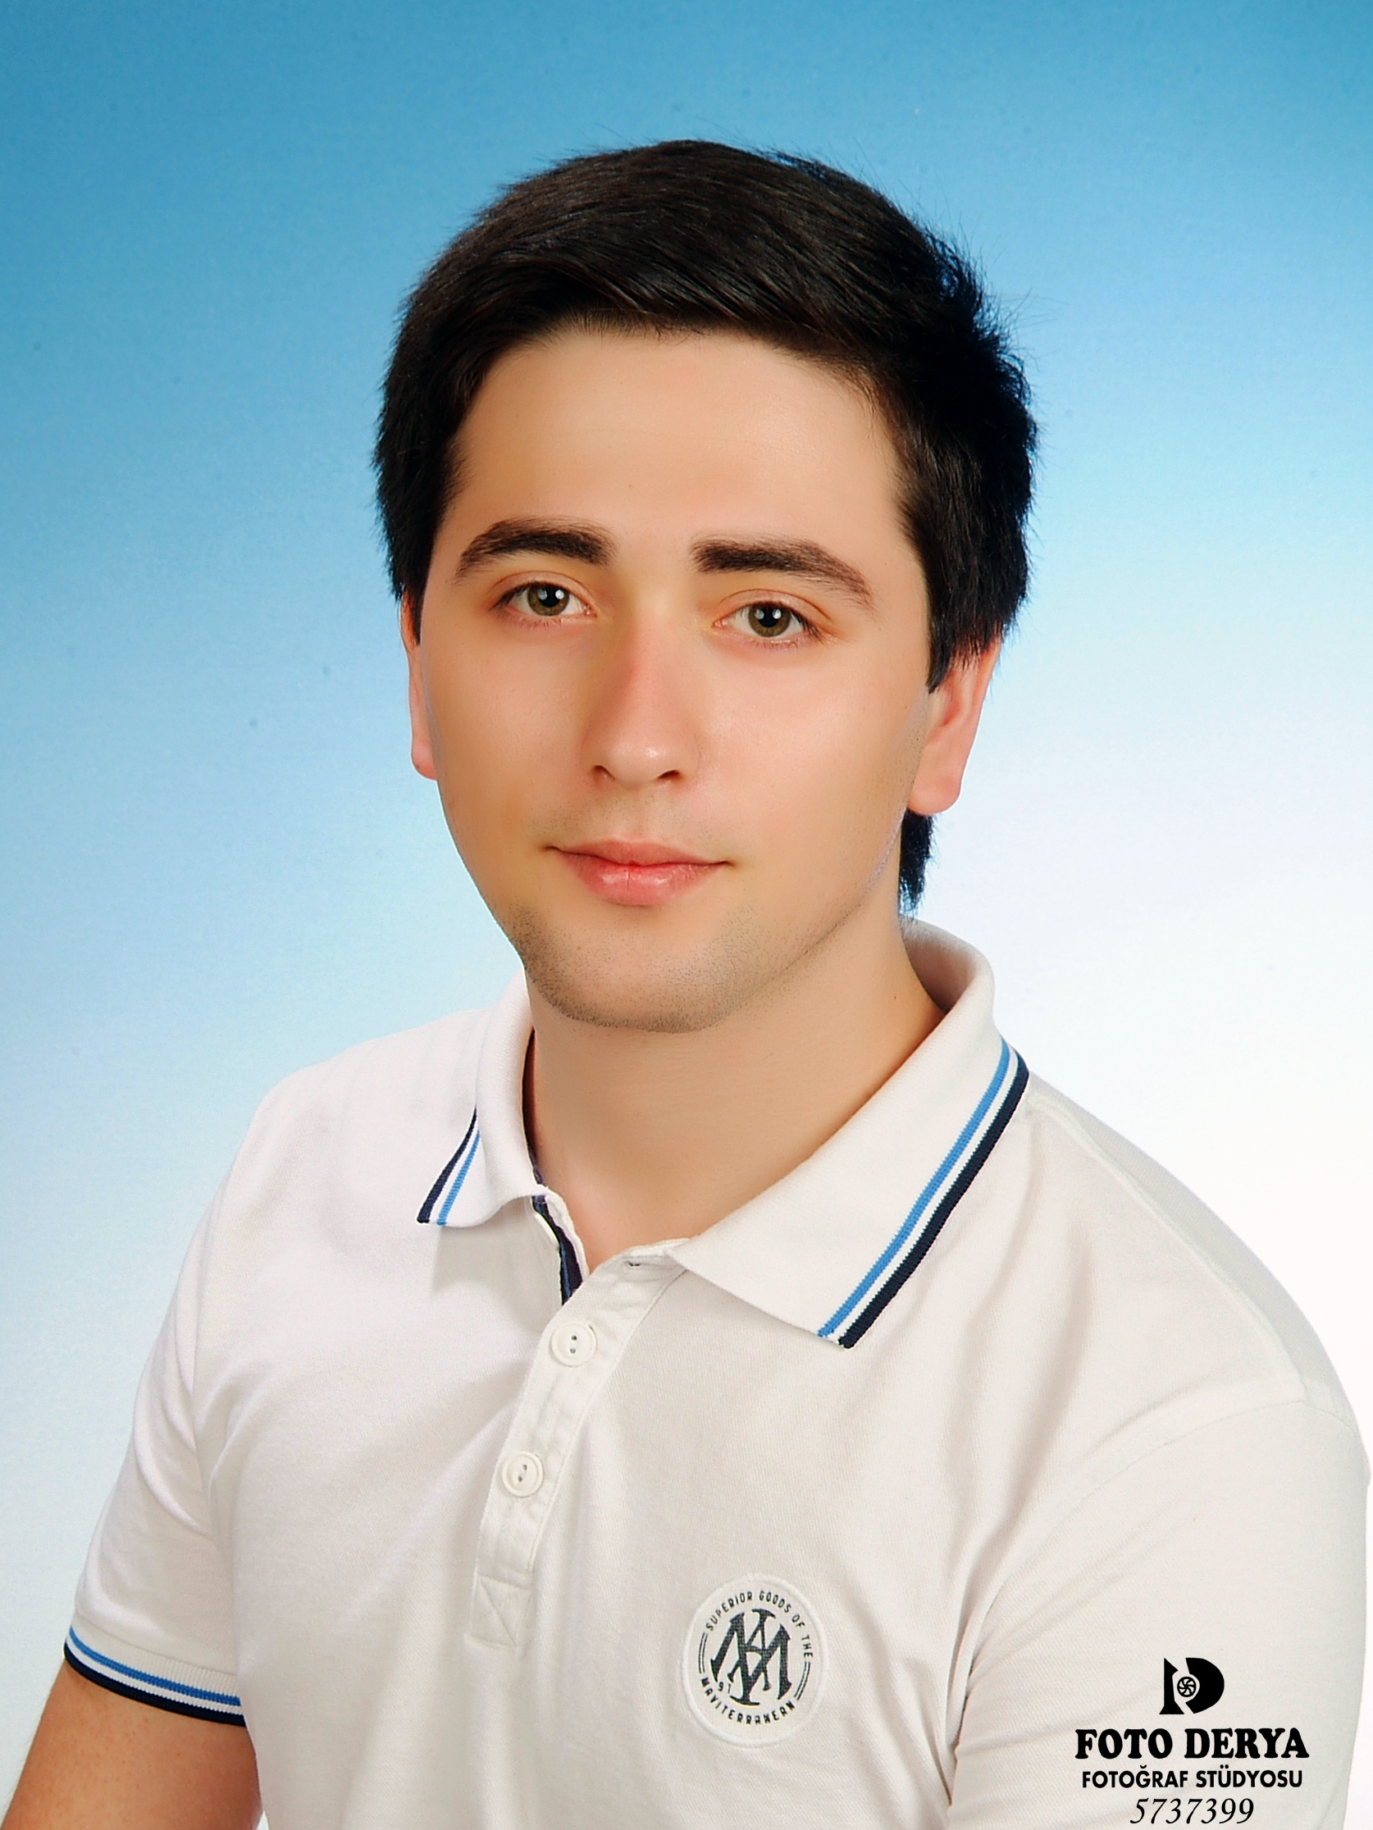
Gender |  | Male
Date of Birth |  | 09.10.1992
Marital Status |  | Single
Nationality |  | T.C
Driving Licence |  | B Class
Military Service |  | Postponed (2018)

CONTACT
Address |  | Hancıoğlu Cad. yalçın sk. No: 18 Daire: 3 Findikli / ISTANBUL / TURKEY
GSM Number |  | (531) 335 76 61
E-mail |  | Mehmet.sabancioglu@gmail.com
Website |  | www.mehmetsabancioglu.com

CAREER OBJECTIVE
Can be found more info in https://www.linkedin.com/in/msabancioglu .
Professional .NET Developer with a passion for software development especially with agile practices such as Test Driven Development,with an in depth knowledge of OOP and GoF Design Patterns.
Over 3 years of software development experience spanning ASP.NET 2.0 to ASP.NET 4.5.1 in C# including high transactional enterprise xrm applications, with team member,team leadership and mentoring experience. Expert in full system Development Life Cycle(SDLC)
Has the ability to understand and transform complex business requirements into software, ensuring applications are delivered on time, to specification, are scalable, performance optimized and maintainable. Experience of non-Microsoft .Net Technologies including Teamcity,JQuery, Git, NUnit, Moq, NHiberNate,TFS
A highly motivated individual who is always learning, able to work to tight deadlines, and who can communicate effectively with technical peers as well as business users. Someone who encourages learning and the sharing of ideas and is always open to new ways of working.

EDUCATION
University  2013 - ∞ | Anadolu University | Faculty of Management | Management
University  2011 - 2013 | Marmara University | Vocational School of Technical Sciences | Computer Programming
High School  2007 - 2011 | Tasdelen IMKB Anatolian Technical High School | Information Technologies | Database Programming

EXPERIENCE
01.09.13 - ∞ | Argeset Yazilim | Web Application Developer (www.argeset.com)
2013 – Internship | IKEA TURKEY | IT Departmant (www.ikea.com.tr)
2009 – Internship | IBM GLOBAL SERVICES | IT Departmant (www.ibm.com/us-en)
2008 – Internship | IBM TURKEY | IT Departmant (www.ibm.com/tr-tr )

KEY SKILLS
Core Programming Languages | C#, SQL, Javascript, HTML, CSS, XML, VB.NET, PowerShell, JSON, UML, MSbuild, SASS, LESS, Java
Databases | MS SQL Server (2000-2014), Azure SQL, ORACLE (10 , 11), My SQL, MongoDB
Technologies and Frameworks | .NET Framework (2.0-4.5.3), Microsoft Azure, ASP.NET, MVC, WCF, ADO.NET, AJAX, jQuery, AngularJS,Knockout,Crystal Reports, SSIS, SSRS, WPF, IS 6-8.5, NUnit, LINQ, Web Services, Adobe AE
Development Methodologies | Agile Develelopment, Scrum, Kanban, Test Driven Development

CERTIFICATES
LOGO Adaptation Expert | LOGO Business Solutions – Windows - Certification Number : 201403006002
Bilge Adam | MsHowTo Microsoft Future Technology Seminar – Web applications

FOREIGN LANGUAGES
English | Reading : Upper Intermediate
English | Writing : Upper Intermediate
English | Speaking : Intermediate

HOBBIES
Web Design, Rafting, chess, table tennis, Writing blog, Watching movies, Photography and Paragliding.

REFERENCE
İsmail ATIK | IBM GLOBAL SERVICES - IT  Phone : +90 545 653 0908 E-mail : ismaila@tr.ibm.com
Vedat TOPUZ | Marmara University Vocational School of Technical Sciences, Associate Professor  Phone : +90 535 663 38 49 E-mail : vtopuz@marmara.edu.tr

