Risk Categories — Summary Report
2025-11-15
Overview
This report summarizes the frequency of risk categories across the dataset. Here, “count” refers to the number of documents associated with each risk category (based on the semantic similarity metric we use).
Key figures:
- Raw rows: 143
- Unique categories: 140
- Total count: 1,486,624
- Mean per category: 10618.7
- Median per category: 10253.5
- Standard deviation: 5814.9
Top 10 categories by count:
Category | Count
Net Stable Funding Ratio (NSFR)-related Risk | 28,875
Liquidity Coverage Ratio (LCR)-related Risk | 27,612
Rollover / Refinancing Risk | 26,650
Violations of laws, regulations, or internal policies | 26,562
Risk transfer failure | 23,118
Dependence on external providers or counterparties | 22,734
Bank may be unable to roll over central-bank credit once it expires | 22,729
Vendor or service-provider failures | 22,392
Losses from staff errors, negligence, or misconduct | 22,157
Network or application failures | 22,020

Figure: Top 20 categories
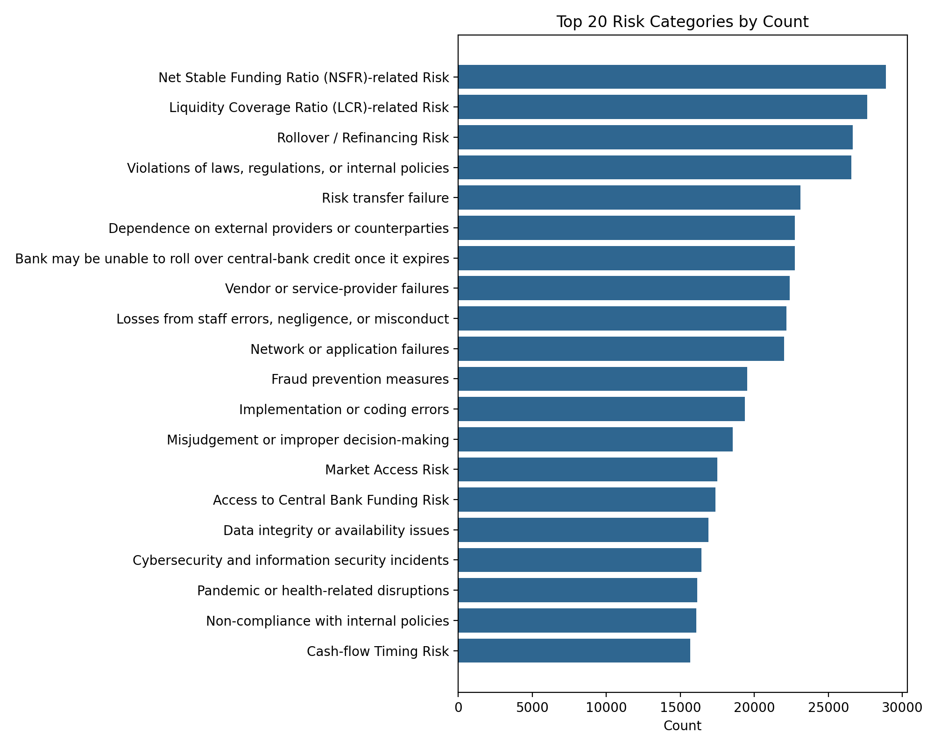

Bottom 10 categories by count:
Category | Count
Collateral underperformance | 2,022
Hardware or infrastructure disruptions | 1,806
Mitigation shortfall | 1,773
Counterparty deterioration | 1,765
Settlement and reconciliation failures | 1,733
Haircuts / Margin insufficiency | 1,659
Recovery shortfall | 1,630
Hedging insufficiency | 1,154
Portfolio diversification | 1,075
Collateral devaluation | 987

Figure: Bottom 20 categories
