ACKLEY FUNCTION

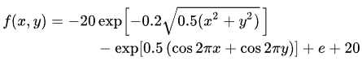

Rastrigin FUNCTION



Rosenbrock Function



Griewank Function

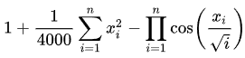

Schwefel Function

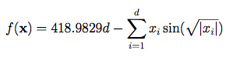

Sphere Function

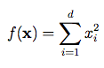

Levy Function

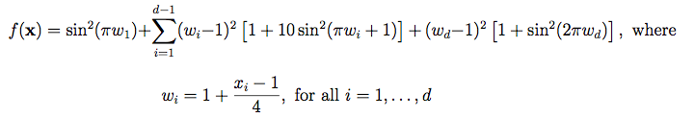

Beale Function



Booth Function



Easom Function



Michalewicz Function

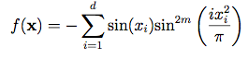

Zakharov Function

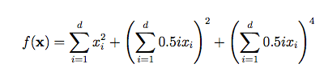

Sum of Different Powers Function

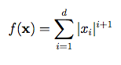

Three-Hump Camel Function



Xin-She Yang Function

