# Project Two Dashboard README

## About the Project

*This project aims to create a working dashboard for Grazioso Salvare that incorporates the functionality of the CRUD python module and MongoDB database functionality. The UI will feature the ability to access the Austin Animal Center Outcomes data set and perform queries based on dependent criteria set by Grazioso Salvare. It will allow searching and sorting of various data fields. It will show geolocation data in the form of an interactive map. It will also feature charts that display breeds dependent on individual queries.*

## Motivation

*We believe in this company and its mission. Assisting in data management and ensuring data accuracy will only go on to help this mission. This interactive dashboard is a useful tool for this.*

## Getting Started

*With the CRUD.py file, AAC database file, and provided Grazioso Salvare image file located within the directory where the Project_Two_Justin_Smith.ipynb file is located, simply run the Jupyter Notebook file to access the dashboard.*

## Installation

* *Linux OS*
* *MongoDB*
* *Python 3.9*

## Usage

*The following will detail some examples of the functionality*

***Logging in:***

*CRUD.py will handle logging into the system and accessing the database. With the appropriate user name and password, the system will connect. All other user variables are hard-coded within the system*

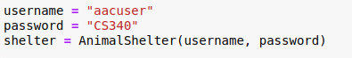

Look for “connected” status indication



***Data Read:***

*Upon initial startup, the dashboard will access the entirety of the database, excluding the “ID” field.*

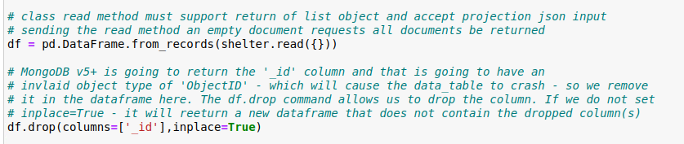

***Initial Layout:***

*The dashboard will display a table of all results. This table can be modified with filtering and sorting capabilities.*

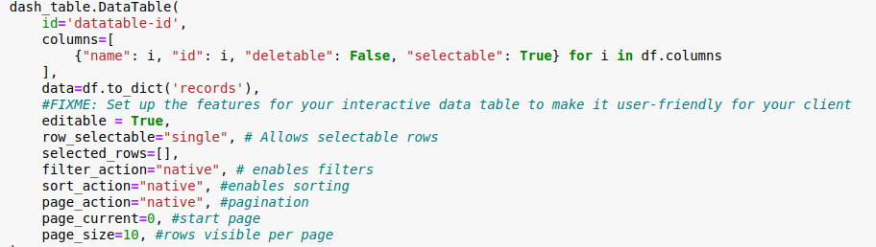

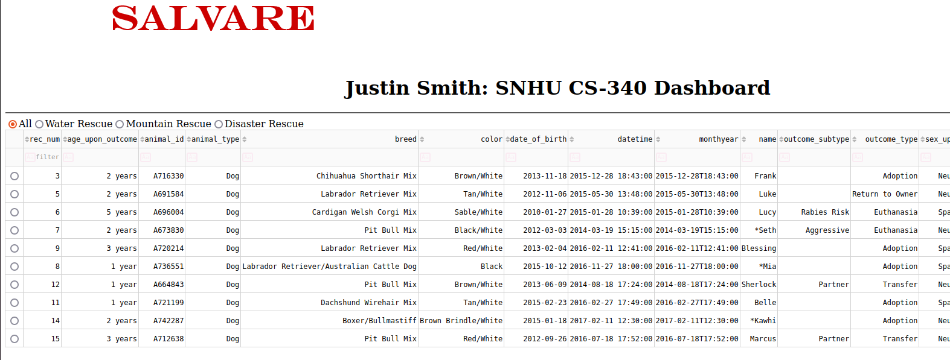

*The full logo is proudly displayed on the top of the screen:*

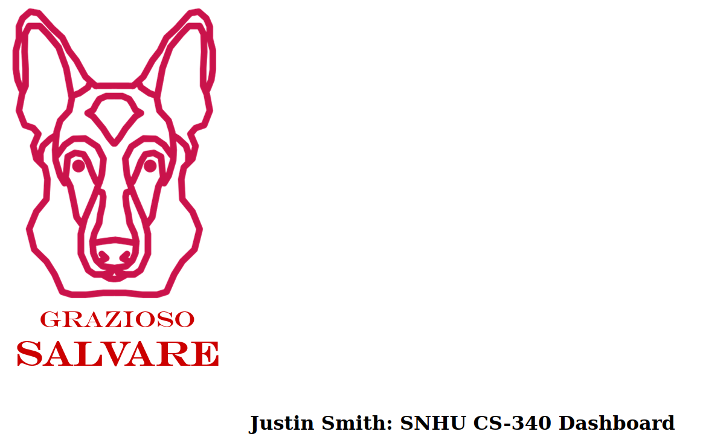

*Four radio buttons exist to automatically filter results based on predetermined rescue dog criteria. This allows for quick searching for dogs that meet the match for water rescue, mountain rescue, and disaster rescue. Once one of these buttons is clicked, the search results will be displayed, along with a pie chart showing the percentage of each breed.*

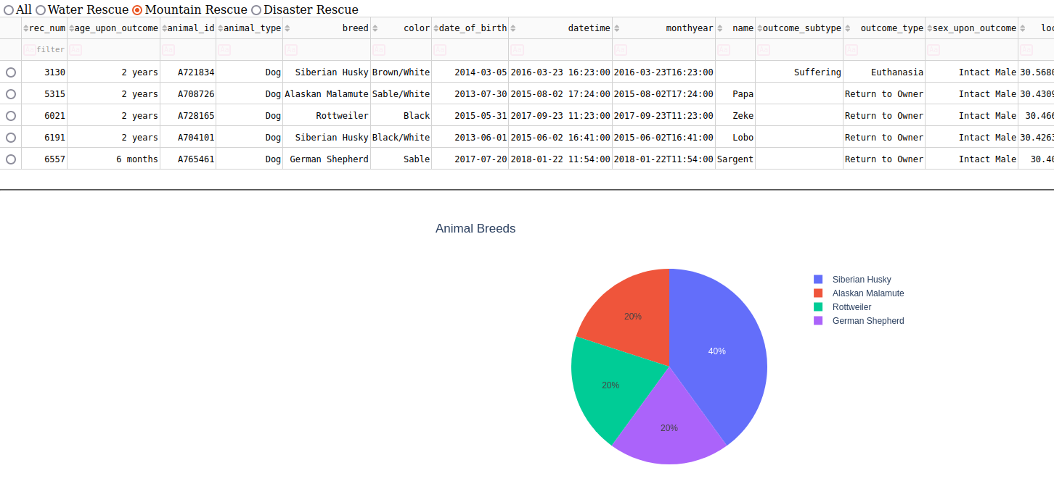

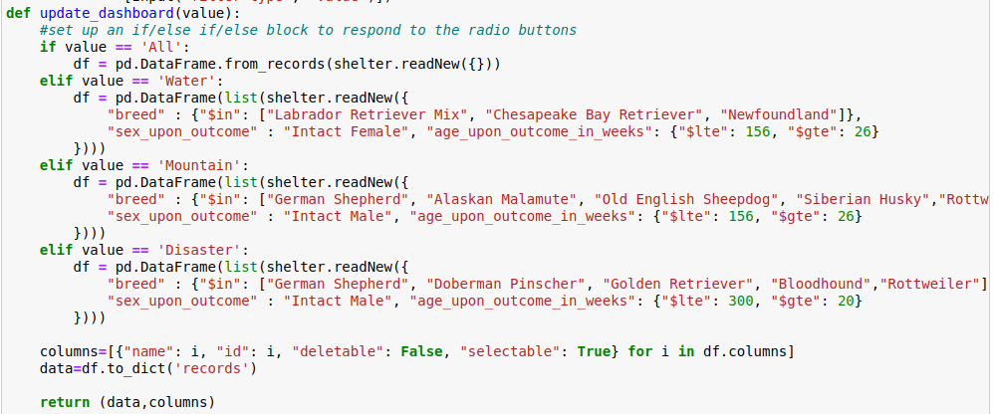

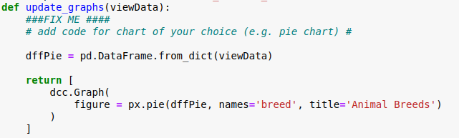

*Furthermore, when an individual result is selected via the radio buttons on the far right of the data table, a map will be shown indicating the location of that specific animal.*

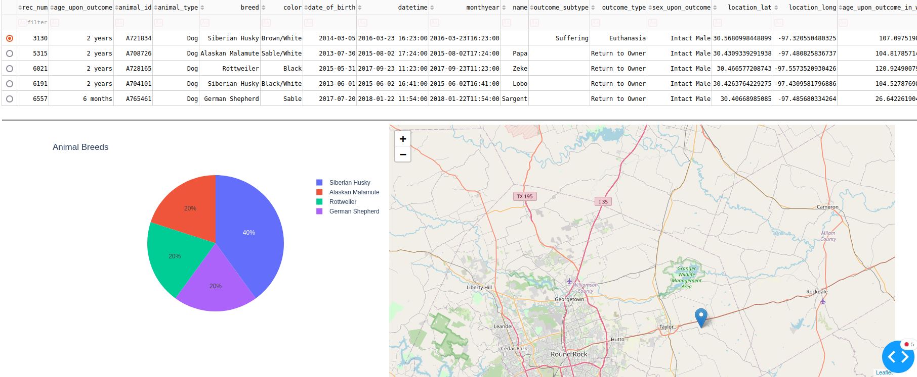

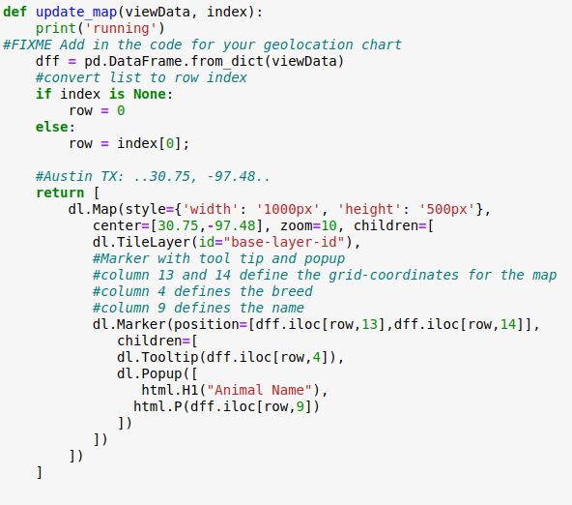

***Reasoning for MongoDB:***

*There are a few reasons why MongoDB was the appropriate selection for handling this large database of information. For one, MongoDB’s ability to scale horizontally though sharding (Schaefer, 2022), which allows for less expensive storage when the stored information grows. Another strong advantage is MongoDB’s faster query ability. MongoDB is known for speed.*

***Dash Framework:***

*By using Dash framework, we can easily achieve data visualization on the web without a complicated knowledge set required. Web development is no easy task, and the functionality that Dash provides with Flask makes this much simpler.*

***References:***

Schaefer, L. (2022, September 23). *The top 4 reasons why you should use mongodb*. MongoDB. https://www.mongodb.com/developer/products/mongodb/top-4-reasons-to-use-mongodb/

## Contact

Justin M. Smith

Justin.smith23@snhu.edu