Automatic Water Tank Filler

Introduction
With this project I want to share with you a project that my teacher gave to us (me and my classmates, in groups of two) at school during these past few weeks.
It involves creating an automatic watering system with a cistern.
The project is divided into two parts: the automation for filling the water tank and the automation for the watering system.
Due to time constraints, in this document, I will mainly focus on the automatic cistern filler.

Elements (Components and tools)
COMPONENTS:
2x Common cathode seven segment display
2x CD4511
2x Resistor pack with 8x 10KΩ resistors
1x Soil Moisture sensor
1x 10KΩ trimmer
1x 6.8KΩ resistor
1x 1KΩ resistor
1x 330Ω resistor
1x red LED
TOOLS:
1x Arduino UNO microcontroller (ATMEGA328P)
Software “Arduino IDE”
Software “Proteus”
Software “Siemens Logo soft comfort”
1x Tester

Project guidelines
1. Make a circuit on proteus that can simulate the soil moisture sensore (using the trimmer and a voltage divider)
2. There are 2 fixed levels, WaterLevel 30% and WaterLevel 90%
The behaviour of this smart system should follow this cycle
Part | WaterLevel | WhatHappens
1 | <30% | If the WaterLevel is under 30% for more than 5 seconds, the tank starts to be filled with water
2 | 30% < WaterLevel < 90% | If the WaterLevel is between 30% and 90% and the Water level was under 30% before, the tank continues to be filled with water until the WaterLevel reaches 90%
3 | WaterLevel > 90% | If the WaterLevel reaches the 90% for more than 5 seconds, the tank stops to be filled
4 | 30% < WaterLevel < 90% | If the WaterLevel goes between 30% and 90% after it was more than 90% the tank will still not be filled, it will be filled the time the WaterLevel will return under 30%

The "more than 5 seconds" condition is simply a way to be absolutely sure that the water has reached the desired levels. This is because, as the water level rises or falls, it might fluctuate like a wave, causing the level to go up and down repeatedly.
To measure these 5 seconds, the teacher advised us to use the millis() function. This was the first time we used it.
In my opinion, it was a bit hard to understand, but not impossible.

The code
int livello, percent, decine, unit, var, i, preset, preset2, entered;
unsigned long myTime, saveTime, diffTime;

void setup() {
// put your setup code here, to run once:
Serial.begin(9600); //starting the serial communication
for (i = 2; i <= 11; i++) { //setting all the used pins as OUTPUTs
pinMode(i, OUTPUT);
}
preset = 0;
preset2 = 0;
entered = 0;
}

void display(int numero)
{
//This function is used to give the 4511 the right configuration in order to see the right number at any moment
switch (numero) {
case 0:
digitalWrite(2+var, LOW);
digitalWrite(3+var, LOW);
digitalWrite(4+var, LOW);
digitalWrite(5+var, LOW);
break;
case 1:
digitalWrite(2+var, HIGH);
digitalWrite(3+var, LOW);
digitalWrite(4+var, LOW);
digitalWrite(5+var, LOW);
break;
case 2:
digitalWrite(2+var, LOW);
digitalWrite(3+var, HIGH);
digitalWrite(4+var, LOW);
digitalWrite(5+var, LOW);
break;
case 3:
digitalWrite(2+var, HIGH);
digitalWrite(3+var, HIGH);
digitalWrite(4+var, LOW);
digitalWrite(5+var, LOW);
break;
case 4:
digitalWrite(2+var, LOW);
digitalWrite(3+var, LOW);
digitalWrite(4+var, HIGH);
digitalWrite(5+var, LOW);
break;
case 5:
digitalWrite(2+var, HIGH);
digitalWrite(3+var, LOW);
digitalWrite(4+var, HIGH);
digitalWrite(5+var, LOW);
break;
case 6:
digitalWrite(2+var, LOW);
digitalWrite(3+var, HIGH);
digitalWrite(4+var, HIGH);
digitalWrite(5+var, LOW);
break;
case 7:
digitalWrite(2+var, HIGH);
digitalWrite(3+var, HIGH);
digitalWrite(4+var, HIGH);
digitalWrite(5+var, LOW);
break;
case 8:
digitalWrite(2+var, LOW);
digitalWrite(3+var, LOW);
digitalWrite(4+var, LOW);
digitalWrite(5+var, HIGH);
break;
case 9:
digitalWrite(2+var, HIGH);
digitalWrite(3+var, LOW);
digitalWrite(4+var, LOW);
digitalWrite(5+var, HIGH);
break;
default:
digitalWrite(2+var, LOW);
digitalWrite(3+var, HIGH);
digitalWrite(4+var, LOW);
digitalWrite(5+var, HIGH);
break;
}
}

void loop() {
// put your main code here, to run repeatedly:
myTime = millis();
diffTime = 0;

livello = analogRead(A0);
percent = map(livello, 352, 1023, 99, 0); //regolating the right voltage values in order to simulate the behaviour of a soil moisture sensor

//printing the percentual of water level inside the cistern
if(percent != preset)
{
Serial.print("livello dell'acqua: ");
Serial.print(percent);
Serial.println("%");
}
preset = percent;

if(percent < 30)
{
if(entered == 0)
{
Serial.println("Il motore sta per avviarsi");
saveTime = myTime;
entered = 1;
}
diffTime = myTime - saveTime;
if((diffTime >= 1000) && (entered == 1))
{
digitalWrite(10, HIGH);
Serial.println("Motore in funzione");
preset2 = 0;
entered = 2;
}
}
else
{
if((percent>=30) && (percent<90))
{
saveTime = 0;
entered = 0;
if(preset2 == 0)
{
digitalWrite(10, HIGH);
}
else
{
digitalWrite(10, LOW);
}
}
else
{
if(entered == 0)
{
Serial.println("Il motore sta per spegnersi");
saveTime = myTime;
entered = 1;
}

diffTime = myTime - saveTime;
if((diffTime >= 1000) && (entered == 1))
{
digitalWrite(10, LOW);
Serial.println("Il motore si è spento");
preset2 = 1;
entered = 2;
}
}
}

decine = percent/10;
var = 4;
display(decine);
unit = percent%10;
var = 0;
display(unit);

delay(1);
}

Simulation
You can see the simulation on youtube at this link: https://youtu.be/LUVe18jMONY

On the breadboard
I still need to check the 7
segments displays, because
they are not properly working
at this moment

The other part of the project, the watering system
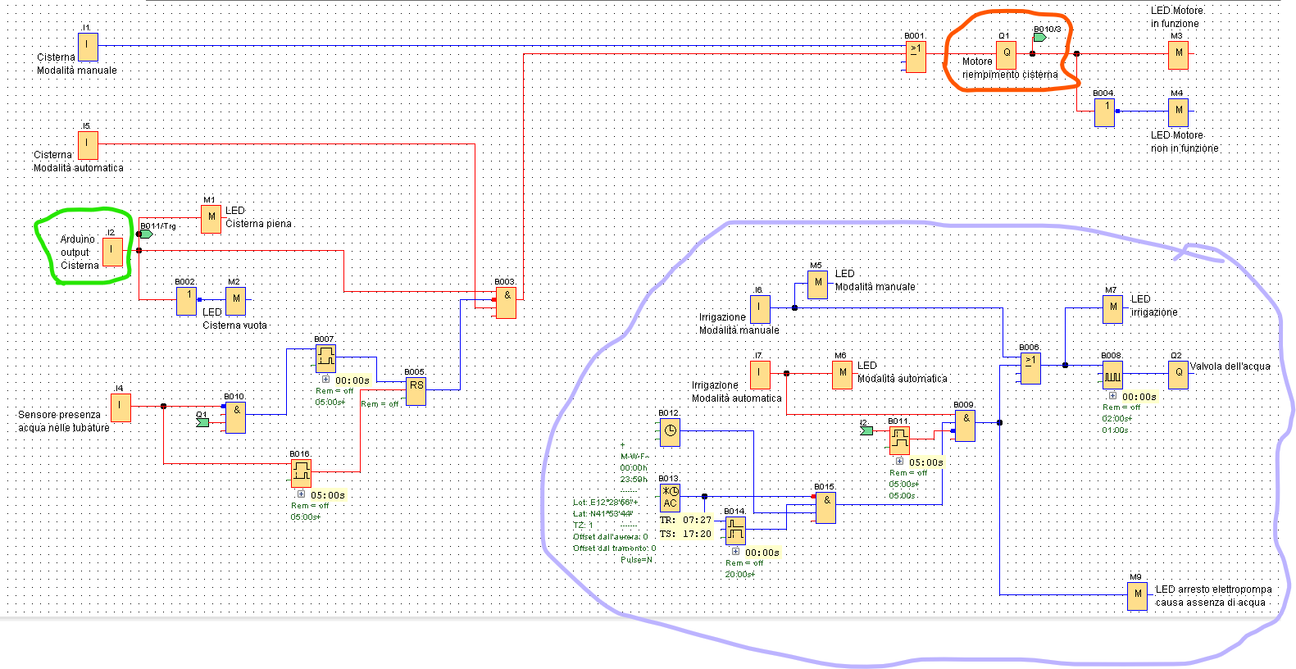
After developing the automatic water tank filler, the motor's output should be used as an input for the second part of the system. To integrate all the mechanical components, we will use a microcontroller, such as a PLC, which will receive the output signal from the Arduino.
In the schematic above, the motor (the square inside the orange “circle”) is not controlled solely by the Arduino. It also depends on other things, such as the presence of water in the pipelines. If no water is detected, a security system will be activated to prevent damage or malfunctions.
Additionally, there is a watering automation system. This system shares most of the functionalities of the water tank automation, with the key difference being its ability to enable watering only on specific days and at specific times.

Conclusions
This project is not finished yet; next week, my teacher will add a new part. However, what my classmate and I have done so far has been well done. I enjoyed coding the Arduino program and designing the PLC schematic. It was also interesting to discover the "millis()" function.
I hope you'll like our work.
I would like to clarify that I personally reviewed the work we did at school and made improvements to it in order to upload it in high seas (You had in fact watched the revision right now).

Bye!

