**CHAPTER 3**

# DESIGN AND METHODOLOGY

This chapter describes the project's development process, strategy, and structure used. The proponents’ analysis techniques and methods that are aligned with the study objectives were presented in this chapter.

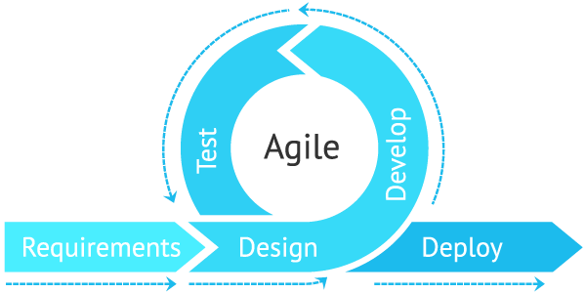

# Figure 2. Agile Development Model

The proponents used Agile Development Model in designing and developing the Wood Furniture Design Customization and Ordering System because it is the most suitable model to used in developing the system. The Agile Development Model is flexible in making changes and allows modification throughout the development process that allows the proponent to analyze and have multiple testing for determining the changes and improvement that needs to be applied.

# Requirement Analysis

The requirements were specified and analyzed in the development of the application. The requirements were the hardware, software, and development tools. The hardware required for the web-based system was a 64-bit i5 processor with 8GB RAM, and 128GB Solid State Drive. The development tools needed were PHP programming language as the frameworks, MySQL for the database, HTML, CSS, and Bootstrap 5 for the design, JavaScript for the system function, Adobe Photoshop for the logo, and Figma for the User Interface Design

# Analysis of the Existing System

The Customer usually goes to the physical store or shop to make a purchase or order. In the Furniture shops, they provide existing designs of their works but most of the time the customer is the one who provides a copy of the design they want, on the other hand, some customers want to customize or be more personalized the furniture to make it unique however the client doesn't have much time to explain the design wanted to include as they have many other things to do and it consumes a lot of time on negotiation and it is more hassle for both owner and customer. Therefore, having an online website where the customer can customize their furniture in their free time, can browse different shops nationwide, and at the same time can place an order and make a purchase would help to improve the negotiation of the customer and owner, as well as the designs and quality offered by the shops that are registered on the website, can be recognized by many and to has opportunities to make a sale.

# Fish Bone Analysis

Figure 3 illustrates a fish bone diagram representation of the project in which the causes of the problems are organized into categories such as equipment, material, process, people, and environment to explain the consequence or statement of the problem.

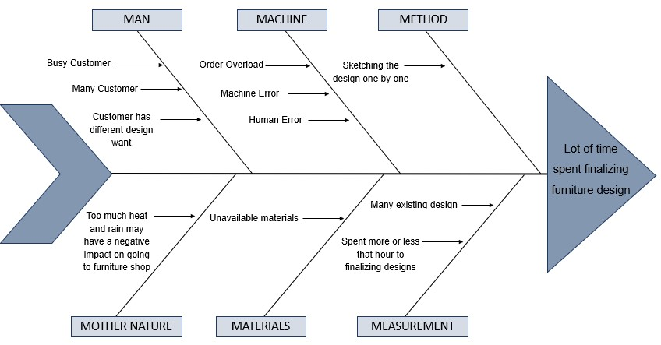

# Figure 3. Fish Bone Analysis

A lot of time spent finalizing furniture design is the main problem along with the sub problems that are presented in the bones of the fish namely man, machine, method, mother nature, materials, and measurements. These problems are the main cause of why the system is important to its user.

The cause is due to issues identified by the researchers, such as too much heat and rain which may harm going to the furniture shop. Due to environmental problems, the customer is unlikely to postpone the scheduled day of going to the furniture shop. Some customers are busy, many other things should prioritize first so that customer experiences delays in finalizing and placing order. Based on the situation in a furniture shop, there’s an instance that customers went to the furniture shop at the same time, some of them have an urgent task to do, some have limited time only as they have many things to do. Customer of wood furniture shop mostly has different design want. Sometimes, the shop has already an album where the furniture image design is in. While sometimes, a customer had already searched designs on the internet which consumed a lot of time to estimate the price of the furniture designs the customer provides. It also includes human error, machine error, and limited equipment and materials for a large number of furniture orders. More often, the customer wants an adjustment of the design he/she wants the furniture shop owner to sketch the designs one by one which also consumed a lot of time instead the owner can do other things or order.

**System Boundary**

The project's framework boundaries, which illustrate the distribution of tasks among all different units involved in the development of the proposed system is shown in Figure 4.

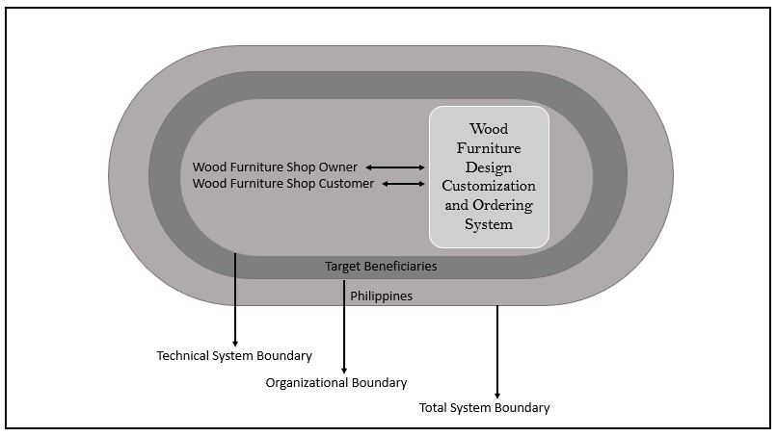

# Figure 4. System Boundary

The proposed system is designed to provide a design customization and ordering system for wood furniture which will be open for all the customers as well as owners of furniture shops nationwide.

In the technical system boundary, this includes the main system bound as design customization and ordering system of wood furniture, as well as admin or owner and its customer. Then it was bound by the organizational boundary, the first benefactors of the proposed system are the person that wants to order an item of wood furniture around the Philippines. Second is the registered wood furniture shop nationwide that will do the service to boost their sales. The total system boundary, if the system is acknowledged in the Philippines the target benefactors will highly benefit from this project.

# Hardware Requirements

This section describes the hardware components needed for the effective and efficient running of the system. For the server-side, the requirements needed for the system to run smoothly are shown in Table 1.

**Table 1**

# Server-Side Hardware Requirements

|  |  |
| --- | --- |
| **Hardware Requirements** | **Specifications** |
| Processor | Intel Core i3 or higher |
| RAM | 4 GB or higher |
| Hard Disk Drive | 500 GB or higher |
| Network | Static IP |

The admin will use the necessary hardware to execute the transactions with no hassle. The server will be using Intel Core i3 as its processor, 4GB RAM, Hard Disk Drive with 500GB or higher and Static IP as its network. Hardware requirements will provide the server with ease in processing all the required documents.

For the client-side, the requirements needed by the customers while using the system are illustrated in Table 2.

**Table 2**

# Client-Side Hardware Requirements

|  |  |
| --- | --- |
| **Hardware Requirements** | **Specifications** |
| Processor | Intel Core i3 or higher |
| RAM | 2 GB or higher |
| Hard Disk Drive | 500 GB or higher |
| Network | Static IP |

The client will use the following hardware requirements to handle the system. The patient’s hardware will also utilize Intel Core i3 as its processor, 2GB RAM, 500 GB or greater for Hard Disk Drive, and Static IP as its network. Client hardware requirements will be helpful to the patient to avoid slow and delayed transactions when using the system.

For both the server and client sides, the requirements needed by the customers and shop owners while using the system with their mobile phones are illustrated in Table 3.

**Table 3**

# Client-Side Hardware Requirements in Android

|  |  |
| --- | --- |
| **Hardware Requirements** | **Suggested Specifications Requirement** |
| Android Phone | Version 7.1 or higher |
| Storage (RAM) | 2 GB RAM or higher |
| CPU Speed | 1.4 GHz |

# Software Requirements

The software requirements specification describes the performance of the software to be developed as indicated in Table 4. The web application can be utilize in any of these operating system.

**Table 4**

# Client-Side Software Requirements

|  |  |
| --- | --- |
| **Software Requirements** | **Specifications** |
| Android OS | Android 7.1 |
| Windows OS | Windows 8 or higher |
| Ubuntu | Ubuntu 14.04.4 LTS |
| MacOs | MacOs 10.3 |

# Functional requirements

The Functional requirements will present the behavior of the system namely the functionalities of the system. The developers will be creating a web-based system and the following functions will be implemented.

● **Homepage**

# ▪ USER/CUSTOMER

- The web system shall display the furniture design by the different furniture shops

- The web system shall display the tab for providing the list of registered furniture shops.

- The system shall display the sign-in button

# ▪ SHOP OWNER

- The web system shall display the customized furniture design by the customers.

- The system shall display the sign-in button

● **Sign-in and Sign-up Page**

- The web system shall display buttons for the registered shop owner and customers

- The web system shall display the login form or sign-up form

- The web system shall detect the wrong username and password .

- The web system shall detect an existing username o The web system shall display forgot password

# ● Customer Account Page

- The system shall be able to edit or update his information

- The user shall be able to browse existing design wood furniture shop products.

- The user shall be able to choose or browse furniture shops nationwide.

- The user shall be able to create and post customized design that is visible to shops only.

- The user shall be able to send customized designs or chosen designs directly to the shop.

- The user shall be able to send order information such as Design, Measure, Price, Down payment, Estimated Time of Delivery, and Delivery Option of the purchased furniture.

- The user shall be able to send down payment via GCASH or CASH o The user shall be able to post feedback/rating on the furniture quality

● **Design Customization Page**

**-** The user shall be able to browse and choose different designs for each part of the kind of furniture chosen.

- The user shall be able to drag and drop chosen design on a specific part of the furniture.

- The user shall be able to edit his or her customized design.

- The user shall be able to save the customized design in JPEG and PNG format.

# ● Owner Page

- The owner shall be able to edit or update shop information o The owner shall be able to upload different types and designs of wood furniture.

- The owner shall be able to view the customized design of furniture that is posted by the registered customer.

- The owner shall be able to confirm an order.

- The owner shall be able to provide account information for the down payments.

- The owner shall be able to view feedback on the purchased furniture o The system shall record the transaction

# Non-functional requirements

It is the other criteria that distinguish the standard functionality of the system. The researchers developed a web-based system to provide a platform in which the customers of the wood furniture shop can customize the furniture that they will purchase as well as order from different shops nationwide online.

* Accessibility

- The system shall allow users to access the system anytime and anywhere.

* Reliability

- The system was supposed to manage errors and avoid data failure and long periods of downtime.

* Maintainability

- The system ensured several updates to help in the maintenance of its overall reliability and consistency. Only the administrator can make changes.

* Accuracy

- The system shall have accounts for different users.

- The system shall provide real-time furniture images

* Usability

- The system shall be user-friendly and easy to use for the customer even without instructions or manual.

- The user can navigate properly through the system’s features.

- The user shall have no problems with the system’s interface like buttons and more.

* Availability

- The system must be always available whenever the user needs it as long as the user had an internet connection.

# Constraints

Constraints are boundaries that must be overcome using a solution-finding process to meet the system's requirements. These depict the numerous programming languages that are available and how to choose the best one for the system. The developers ranked the languages and databases from 1 to 5, with 1 being the least compatible and 5 being the most compatible.

The five languages used in creating web applications are shown in Table 5. In speed, HTML, CSS, JavaScript using Bootstrap, and PHP were both rated 5 while Python and C++ were all rated 3, and C# is rated 1.

**Table 5**

# Evaluation of Programming Language used in the Development

|  |  |  |
| --- | --- | --- |
| **Programming Language** | **Speed** | **Flexibility** |
| HTML, CSS, and JavaScript using Bootstrap 5 | 5 | 5 |
| PHP | 5 | 5 |
| Python | 3 | 3 |
| C++ | 3 | 3 |
| C# | 1 | 1 |

Based on Table 6, the programming language that is given a rate of 5 are the HTML, CSS, JavaScript using Bootstrap 5 and PHP. While Python and C++ were given a rate of 3 and C# is a rate of 1.

**Table 6**

# Database used in the Development

|  |  |  |
| --- | --- | --- |
| **Database** | **Ease-to-use** | **Familiarization** |
| MySQL | 5 | 5 |
| Oracle Database | 2 | 2 |
| Microsoft SQL Server | 2 | 3 |
| PostgreSQL | 2 | 2 |
| MongoDB | 2 | 2 |

Based on the table MySQL was rated as 5 making it the highest. However, Oracle Database, PostgreSQL, and MongoDB were rated 3 in both how easy to use and familiarization. While Microsoft SQL Server ease to use category was rated 2 and for developers’ familiarization is 3.

# Use Case Diagram

Figure 5 shows the actors of the system along with System Requirements.

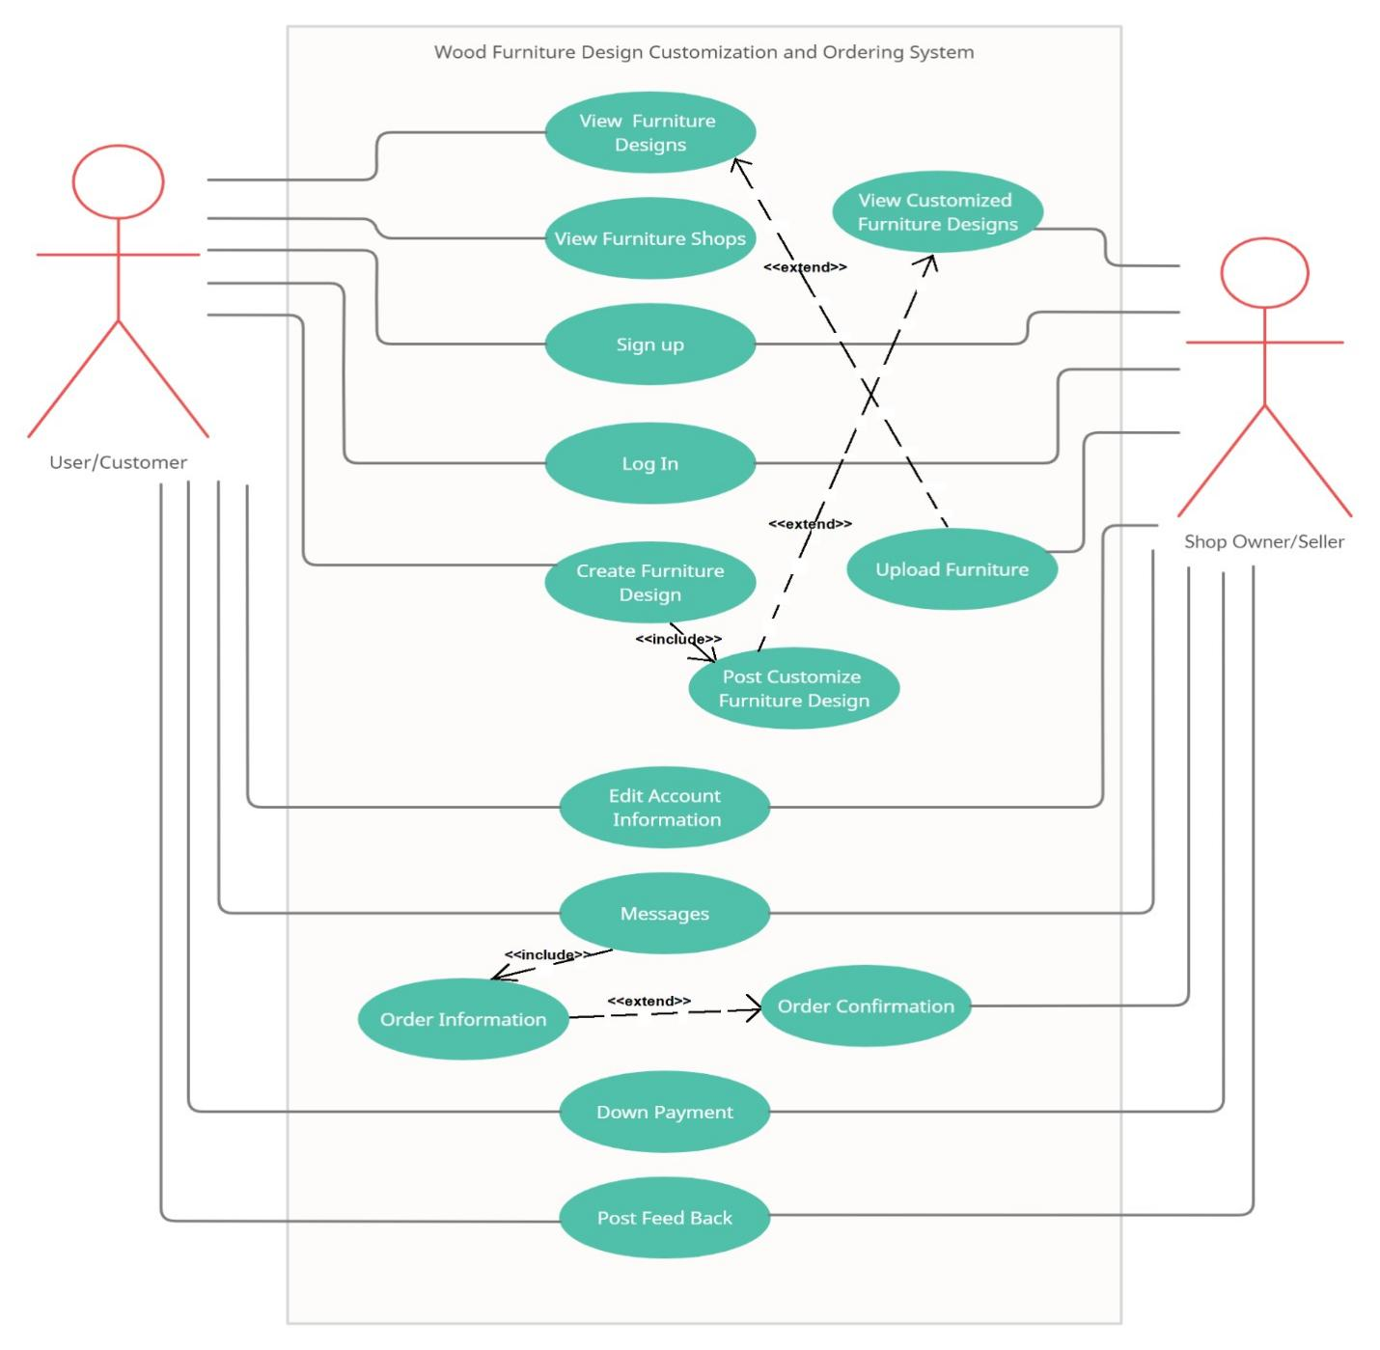

# Figure 5. Use Case Diagram

The user or Customer is able to view different furniture designs provided by the registered wood furniture shops, as well as they can browse and choose shops across the Philippines even if they are not yet logged in. If they already logged in, the user is able to edit their account information. The user is able to customize the design for wood furniture such as beds, doors, chairs, and tables features. When they are done editing their final furniture design, they are able to post it to their feed and they will wait for which shop will reach them first. Customers are able to message shops to ask clarifications and questions about their furniture design or chosen furniture. Through messages, they are able to send the order information which consists of furniture design, measure, price, and delivery options. Users are capable to post feedback on the quality of the furniture they purchased.

The furniture shop or seller is able to view the posted customized furniture designs of the registered user. The furniture shop owner can reach out to the customer for the estimated price of their customized furniture design. The owner of the furniture shop can update or edit the shop account information. The shop should confirm the order of the customer once they sent the order information. The shop owner or seller can view the customer’s feedback.

# Sequence Diagram

Figure 6 shows the sequence diagram of the system. The system diagram displays the interactions between the users and the furniture shop or seller.

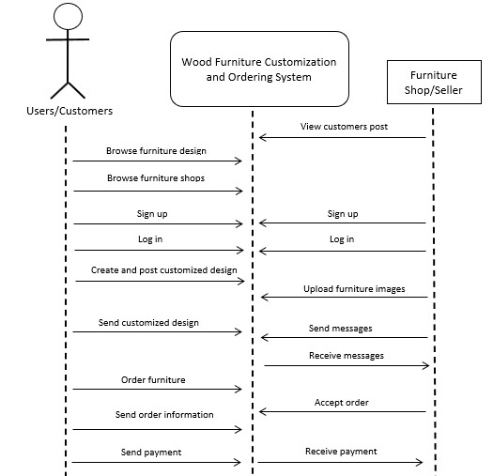

# Figure 6. Sequence Diagram

This figure illustrates that the user will be able to browse the shops and designs even if they are not signing up or logging in. But when it comes to transactions, creating posts, and creating the customized sketch, they need to create an account first. After creating an account and logging in to the web app, they will be able to use all features and communicate with the shop. Then for the shop, the seller will be able to view the post from the customer and communicate with them. And for the customers' posts, there are two options, comment, and direct message. The seller can post their products to the system and accept an order from customers. And for the payment, the seller and the customer are responsible for talking about the installment.

# Database Design

The Database Design or Entity Relationship Diagram of Wood Furniture Design

Customization is shown in Figure 7.

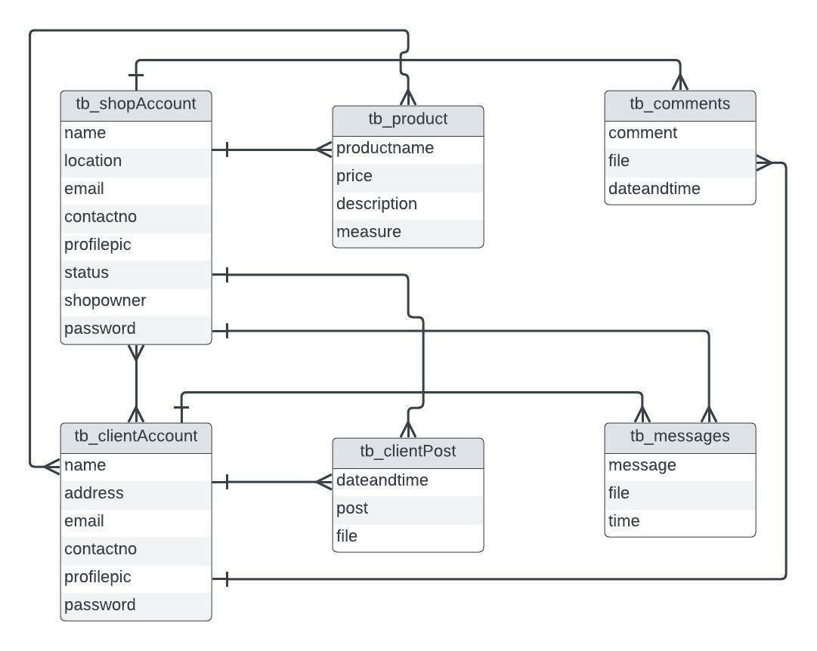

# Figure 7. Database Design

The entity-relationship diagram shows each table in the system database. The database is composed of six tables; tb_shopAccount, tb_clientAccount, tb_product, tb_comments, tb_clientPost, and tb_messages.

The tb_shopAccount contains eight attributes and those are name, location, email, contactno, profilepic, status, shopowner, and password. This table is where the information about the shop is inputted. All data from this table can be edited by the shop admin and sight by the customers. The tb_clientAccount includes the personal information of the customer(user). The tb_product contains the information about the product of the shop. Next is the tb_clientpost where the data posted by the customer will be stored. And lastly, there will be an additional database for the messages(tb_messages) and comments(tb_comments).

# Graphical User Interface Design

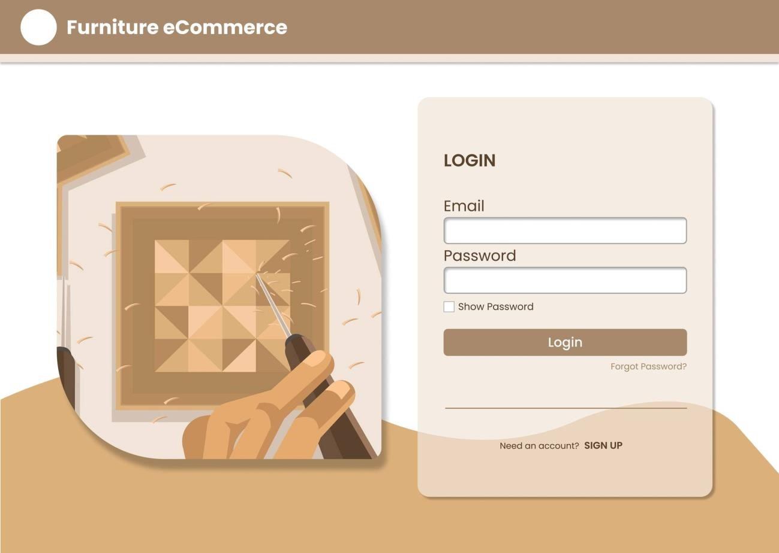

# Figure 8. Log in Page

The figure shows the login page of the web application. It requires user identification and authentication; it is regularly performed by inputting a username and password. After logging in, the user will be having access to the entire part of a web app.

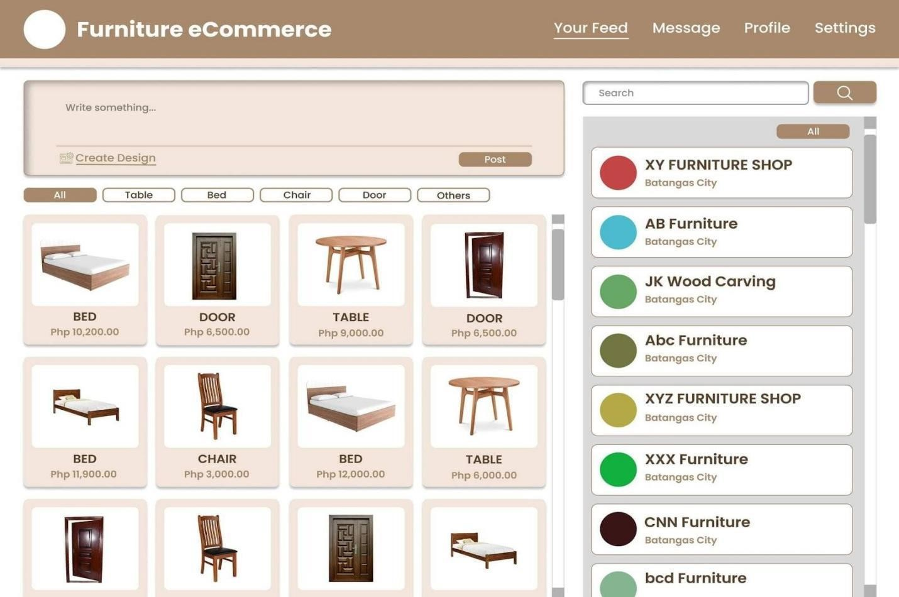

# Figure 9. Feed/Home Page

This figure shows the feed/home screen of the web application which includes the menu, search bar, category, name, and list of the shop, and product.

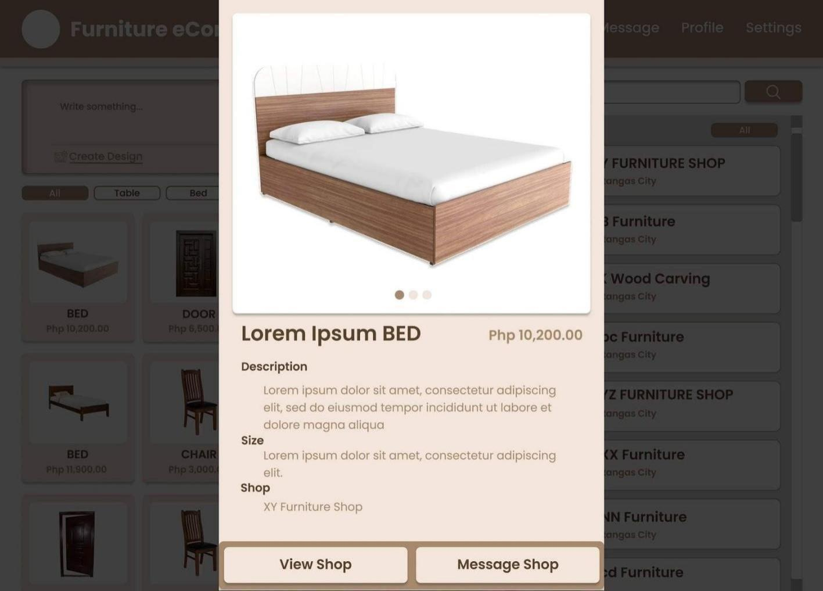

# Figure 10. Transaction Page

The figure shows the transaction page for the customer. It includes the image of the product, product name, price, description, and shop name. It also has a view shop and message button for the customer to visit the products or communicate with the shop.

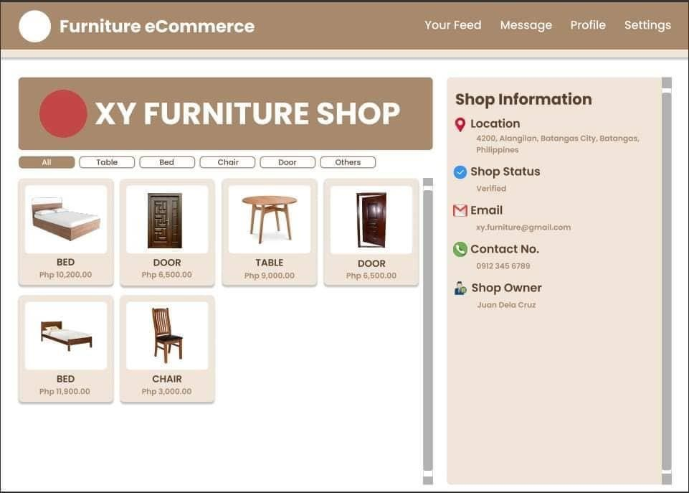

# Figure 11. Shop Profile Page

The figure shows the profile of the shop in a customer. It includes the shop information and product. The category buttons were used to show a specific type of product. While in shop information the client will be able to see the location, shop status if verified or not, email, contact number, and shop owner.

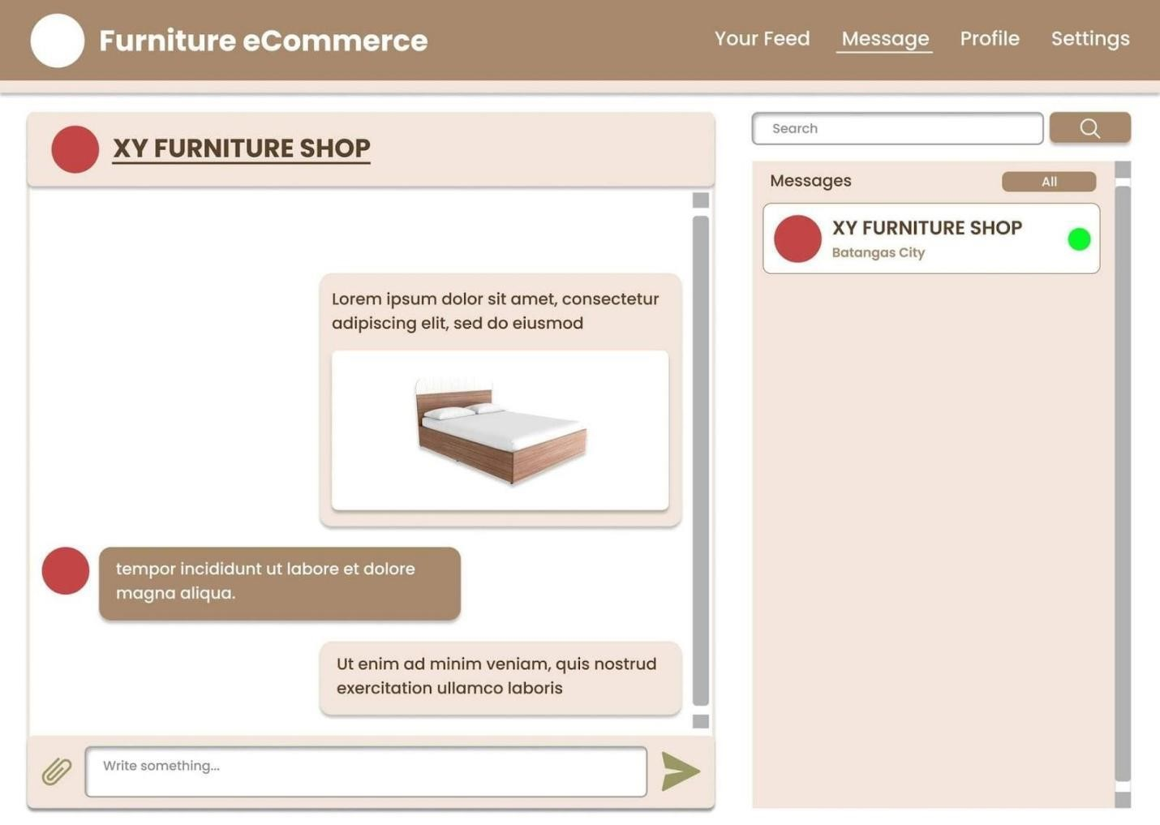

# Figure 12. Inbox or Message Page

This page is where the customer will communicate with the shop. It shows the messages, inbox, and search bar to easily find the message of the customer.

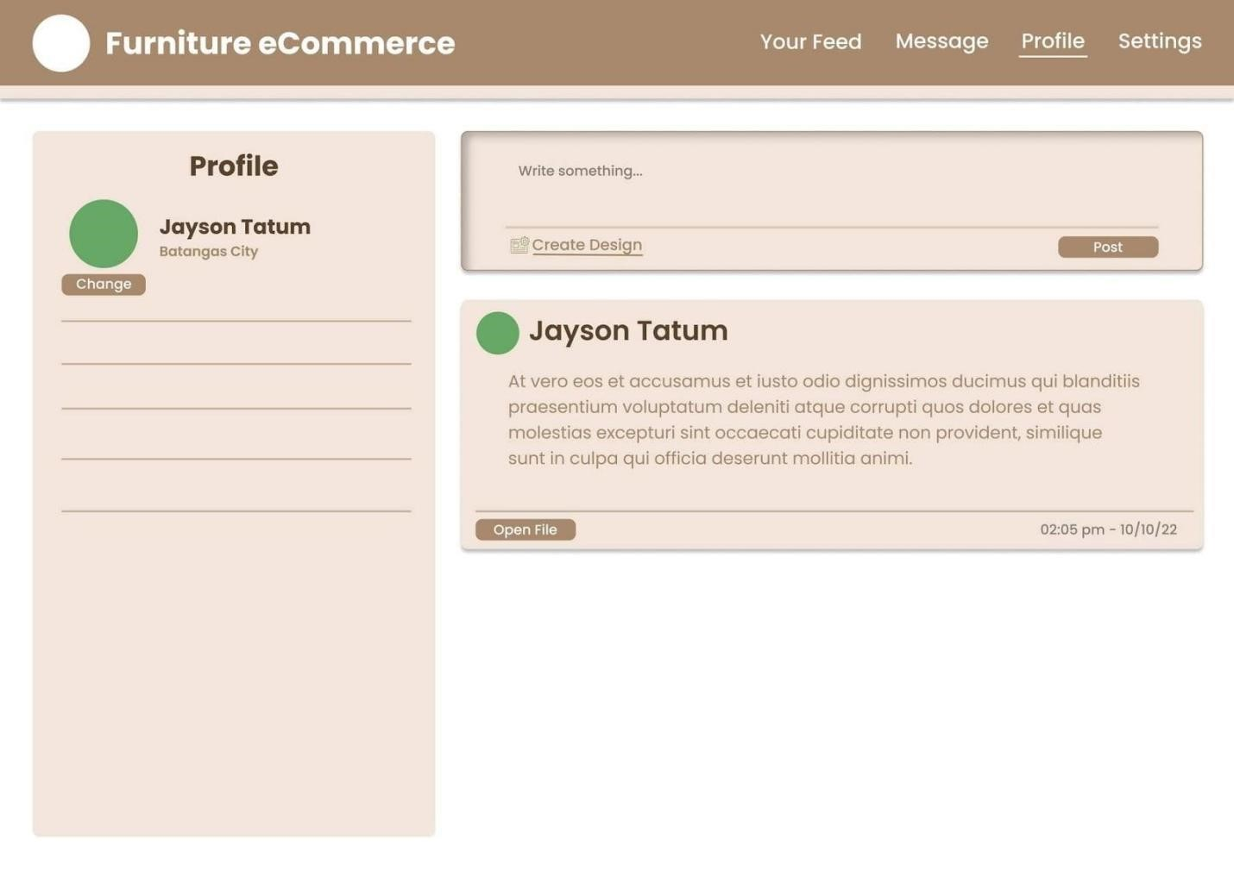

# Figure 13. Customer/Client Profile

The figure shows the customers’ profiles. Here, the clients will be able to edit their personal information. The clients are also able to create and post their own design that is visible to the shop only.

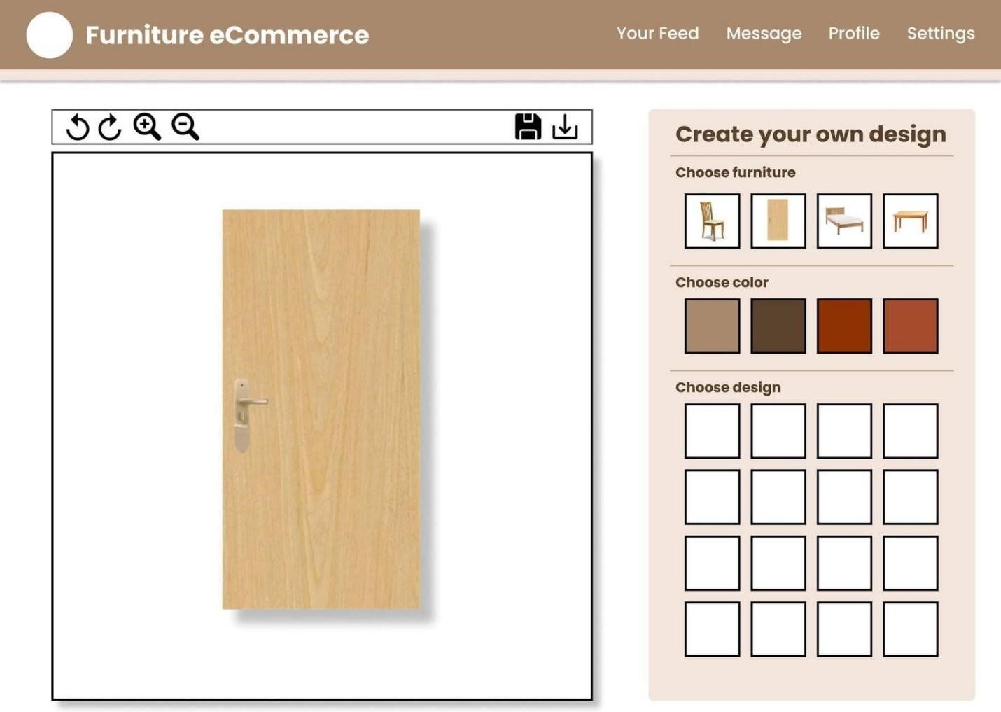

# Figure 14. Customization Page

The figure shows the page where the client is able to customize their furniture design. They can save the customized design and post it directly to the system.

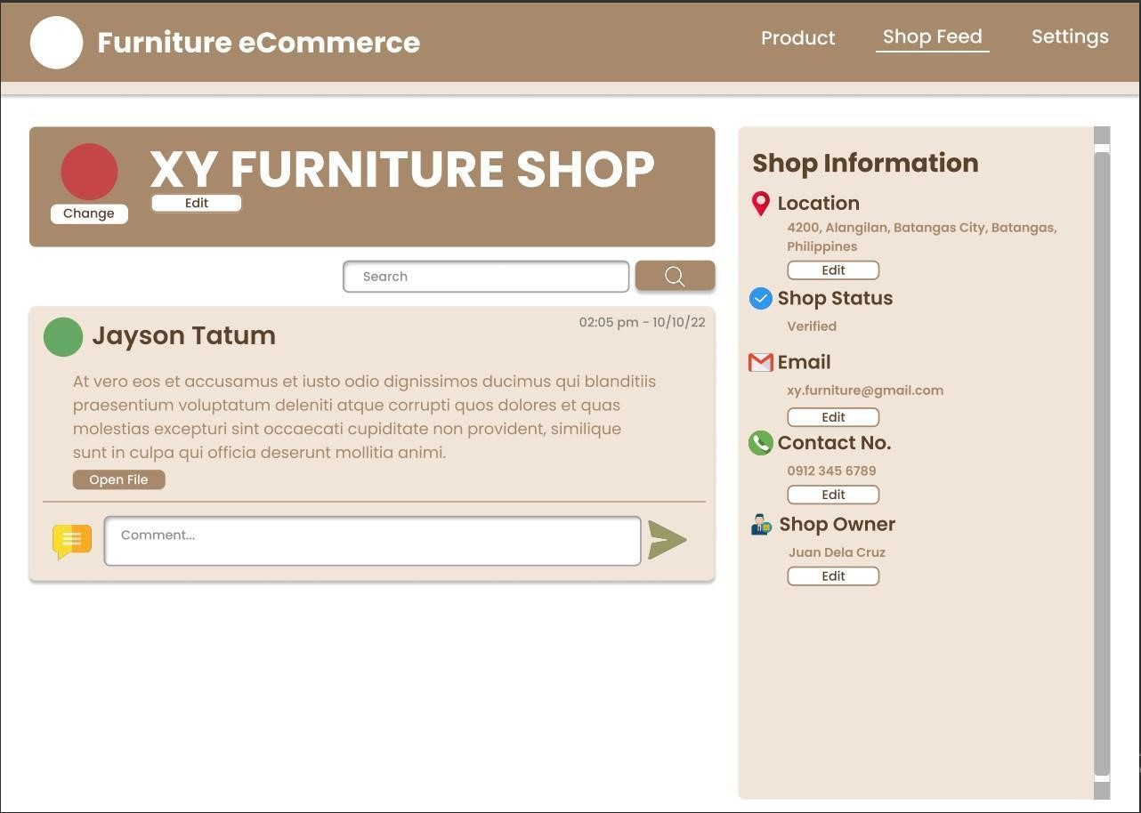

# Figure 15. Shop Feed and Profile

The figure shows the feed and profile of the shop. The shop admin can edit their shop information. And for their feed, they are able to see the post of the customer then they can leave a comment or message if they are interested to accept the project posted.

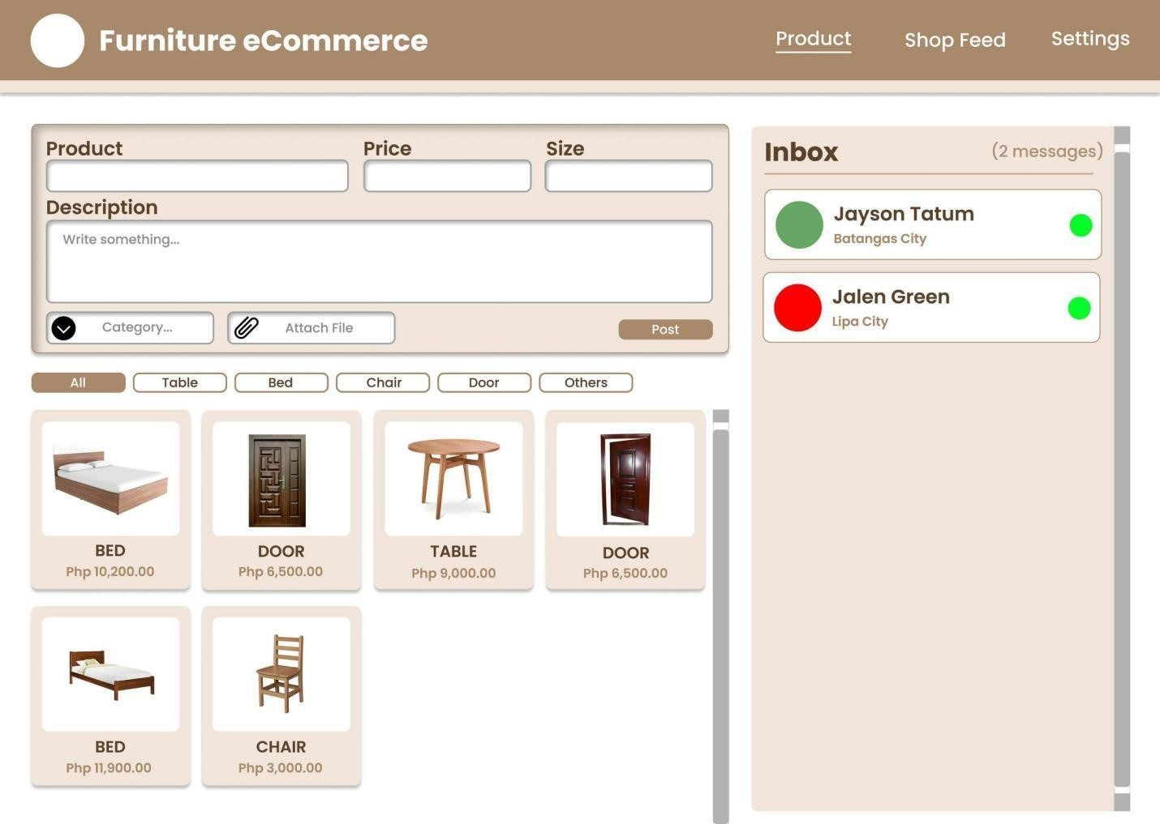

# Figure 16. Product Page

The figure shows the page where the shop admin can post their product. The product page includes a textbox for a product, price, size/measure, description, category, and file attachment. Also, it includes the inbox or messages of the customers.

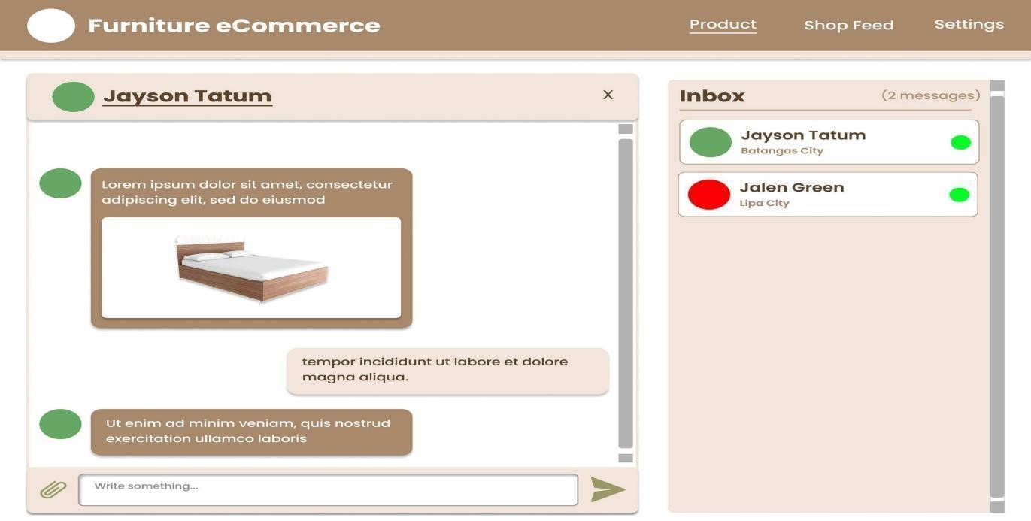

# Figure 17. Shop Inbox and Message Page

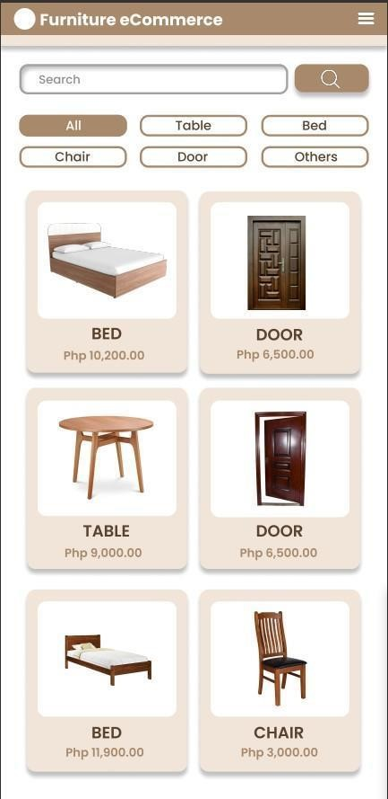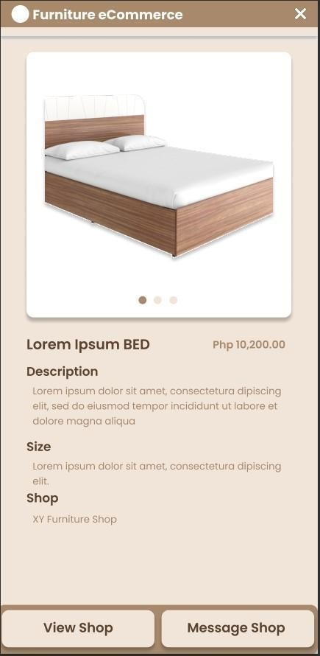

**Figure 18 System for Mobile Devices**

# Development

This stage is where the developers start building the web system. It deals with the creation of the target layout and also

of different functionalities that will provide the expected output of the web system. This process was guided by the requirements needed and was identified right from the planning stage.

# Software

This table 7 shows the software requirements required in order to develop the web system. PHP is the programming language to use for web system development. HTML and CSS, a page structure and style information, will support this programming language.

**Table 7**

# Software Development Requirements Specifications

|  |  |
| --- | --- |
| **Operating System** | Windows 10 |
| **Database** | MySQL |
| **Programming Language** | PHP |
| **Scripting Language** | HTML and CSS |
| **Development Tool** | Visual Studio |
| **Framework** | Bootstrap 5 |
| **System Function** | JavaScript |
| **Internet Browser** | Google Chrome and Microsoft Edge |
| **Web Platform** | w3schools and YouTube |

**Operating System**

Windows 10 is the operating system that the developers used in developing the web system. This operating system will manage all the applications programmed in the computer which will be used in coding and developing the proposed system project.

# Web Platform

The developers used YouTube for system tutorials and W3schools for coding instructions in designing the web system as a source of more intelligible knowledge that will be applied to creating the system. As an internet browser search engine, the developers will use either Chrome or Microsoft Edge, depending on what is available or what platform they are comfortable with. These web browsers will also act as a reference and guide for the developers to test if the system works properly.

# Database

The database used is MySQL. Using the framework, MySQL is the easiest choice for the developers. The database will be connected to the web system using

WAMP.

# Subscription

000webhost includes all you need to host a single website. It's a web hosting platform used to deploy and manage the website. The developers chose a dependable web hosting platform for their projects. It is simple to use, configure, and deploy, and it allows the administrator to keep track of any modifications to the online system. 000Webhosting is free and provides excellent service.

# Hardware for development

Table 8 shows the minimum hardware requirements needed to develop the web system.

**Table 8**

# Hardware Development Requirements Specification

|  |  |
| --- | --- |
| **Hardware** | **Required Specifications** |
| **System Type** | 64-bit operating system, x64 based processor |
| **Processor** | Intel® Core™ i5-7200U CPU @ 2.50GHz, up to 2.70  GHz) |
| **Hard Drive Size** | 8 GB |
| **RAM** | 128GB Solid State Drive |
| **Others** | Mouse and Keyboard |

# Testing

Testing phase covers the system testing to identify the errors and bugs. This will also determine the quality of the system as it will check the actual system whether it matches the requirements and identify the errors and gaps. It is the stage of determining the loopholes of the system as well as if the service meets the expected outcome.

# Testing Procedure

In this section, every page is being tested to ensure that the functions are working properly.

# Table 9 Shop/Customer Login Page Testing Result

|  |  |
| --- | --- |
| **Testing Activity** | **Expected Output** |
| Input Username and Password | The system should accept registered accounts |
| Input invalid Username and Password | The system should not accept registered accounts |

**Table 10**

# Customer’s Feed/Home Page Testing Result

|  |  |
| --- | --- |
| **Testing Activity** | **Expected Output** |
| Browse feed/Home page | Display different images of furniture design |
| Browse feed/Home page | Display registered shops nationwide |

# Table 11

**Shop’s Feed/Home Page Testing Result**

|  |  |
| --- | --- |
| **Testing Activity** | **Expected Output** |
| Browse feed/Home page | Display the customized furniture designs posted by the customer's |

# Table 12

**Shop’s Feed/Home Page Testing Result**

|  |  |
| --- | --- |
| **Testing Activity** | **Expected Output** |
| Click Shop Profile | Display shops information such as furniture designs, location, shop status, email, contact number, owner’s name, and customers feedbacks. |

# Table 13

**Shop/Customer Message Page Testing Result**

|  |  |
| --- | --- |
| **Testing Activity** | **Expected Output** |
| Send message | User message the Shop Shop/Seller message the customer |

# Table 14

**Design Customization Page Testing Result**

|  |  |
| --- | --- |
| **Testing Activity** | **Expected Output** |
| Click, Drag, and Drop Furniture color and design | Design Furniture such as bed, table, chair, and door features. |

# Data Gathering

In gathering data for the Wood Furniture Design Customization and Ordering System, the proponents will be using Google Forms to gather insights and feedback from the respondents and potential users, particularly regarding the efficiency, functionality, security, and usability of the system.

# Deployment

The activities that must be done in this phase will be stated by the researchers. The system is accessible over the internet by customers, and furniture store owners/sellers. In this case, the system is fully developed, bug-free, and ready for deployment.

The web system deployment plan was to be deployed via the internet by 000webhost. It will be feasible to use the system after it has been deployed to the internet. It will be available to anybody, particularly firm clients and furniture shop owners/sellers. Before using the system, researchers will provide instructions on how to use all of the web application's features and buttons. They will also publish a short advertisement about their web system on their social media accounts

# RISK MANAGEMENT PLAN

The risk management process serves as a blueprint for the steps that must be done. The risk management process consists of five essential phases that must be followed to manage risk. It starts with identifying risks, then analyzing risks, prioritizing risks, implementing a solution, and lastly monitoring the risks.

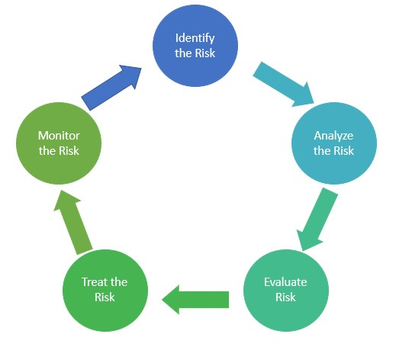

**Figure 19. Risk Management Process**

# Identified the Risk

In this section, researchers identified the risk that could have an impact while doing the project. As the project is being built, risks are being discovered one by one ranging from system failures to human failures.

**Table 15**

# Identified the Risk

|  |  |
| --- | --- |
| **ID** | **Risk Identified** |
| 01 | Poor Internet Connection |
| 02 | Cyber Attacks |
| 03 | Power Outage |
| 04 | Technical Failure |
| 05 | Human Failure |

# Analyze the Risks

In this part the group determined the severity and likelihood of each risk as it was identified. The group is aware of the risk and what it can do to or affect the project's goals and objectives.

**Table 16**

# Analyze the Risks

|  |  |
| --- | --- |
| **Risk Severity** | **Description** |
| Acceptable | Minimal effect on the system |
| Tolerable | Can deal or endure the effect |
| Undesirable | Has a serious impact on the outcome |
| Intolerable | May result to a massive impact |

# Table 17 Likelihood of the Risk

|  |  |
| --- | --- |
| **Risk Likelihood** | **Description** |
| Improbable | Risk is unlikely to occur |
| Possible | Risk will likely occur |
| Probable | Risk will occur |

The proponents understand the possibility of the risk and what it can do or affect the goal and objectives of the project.

# Evaluate the Risk

The group ranks and prioritizes the dangers to determine which ones are severe enough to require treatment. It is also ranked in terms of the risk's severity. The risk that may cause a minor inconvenience or annoyance is rated low, whereas the risk that may result in a significant loss or trouble is rated extremely.

# Table 18 Level of Risk

|  |  |  |
| --- | --- | --- |
| **Risk Level** | **Description** | **Action** |
| LOW | Acceptable | Allow |
| MEDIUM | Tolerable | Take a mitigation effort |
| HIGH | Undesirable | Call for support |
| EXTREME | Intolerable | Eye on the risk |

# Treat the Risk

The group reviewed the risks and alternative solutions to replace the present problem after identifying, assessing, and evaluating them. Identifying the highest-ranking risk and developing a treatment strategy to ensure that it does not occur again or that the risk level is within acceptable limits.

# Table 19 Treating the Risk

|  |  |  |
| --- | --- | --- |
| **ID** | **Risk Identified** | **ACTION** |
| 01 | Poor Internet Connection | Have a backup internet service provider/ Mobile Data. |
| 02 | Cyber Attacks | Install Antivirus/Enhanced the system security |
| 03 | Power Outage | Have a generator/power bank |
| 04 | Technical Failure | Have a regular update |
| 05 | Human Failure | Train the employee |

# Monitor the Risk

The four phases have been completed, but that does not mean the risks have been eliminated. The group keeps an eye on the risk because no one knows if it may happen again. It assists the group in preventing issues that may cause doubt during the goal achieving process.