

KAUNAS UNIVERSITY OF TECHNOLOGY

INFORMATICS FACULTY

**T120B169 APP DEVELOPMENT FOR SMART MOBILE SYSTEMS**

*GAME OF FIFTEEN*

Student: Dovydas Jurkonis IFF-6/10 gr.

Lecturer: Rytis Maskeliūnas

**Kaunas, 2018**

**Content**

1. Game of Fifteen description 3

2. Project 3

3. Mockup 6

4. Literature list 6

5. ANNEX 6

# Game of Fifteen description

The Game of Fifteen is a puzzle with numbered tiles that slide. The goal of this puzzle is to arrange the board’s tiles from smallest to largest, left to right, top to bottom, with an empty space in board’s bottom-right corner. Sliding any tile that borders the board’s empty space in that space constitutes a "move." Although the configuration above depicts a game already won, notice how the tile numbered 12 or the tile numbered 15 could be slid into the empty space. Tiles may not be moved diagonally, though, or forcibly removed from the board.

# Project

I created an array and scrambled it and added to the list.

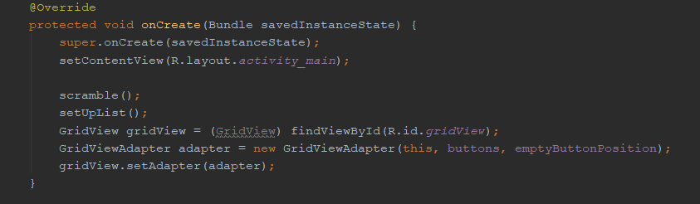

1. Main

I took all list items from bottom except last and switched with random item from the list. Also I remembered empty button position, because later ill need it.

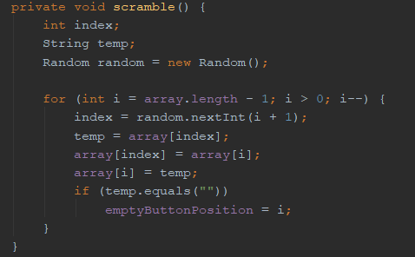

2. Scramble



3. Set up list

I added text and colors to buttons and made them to swap on click.

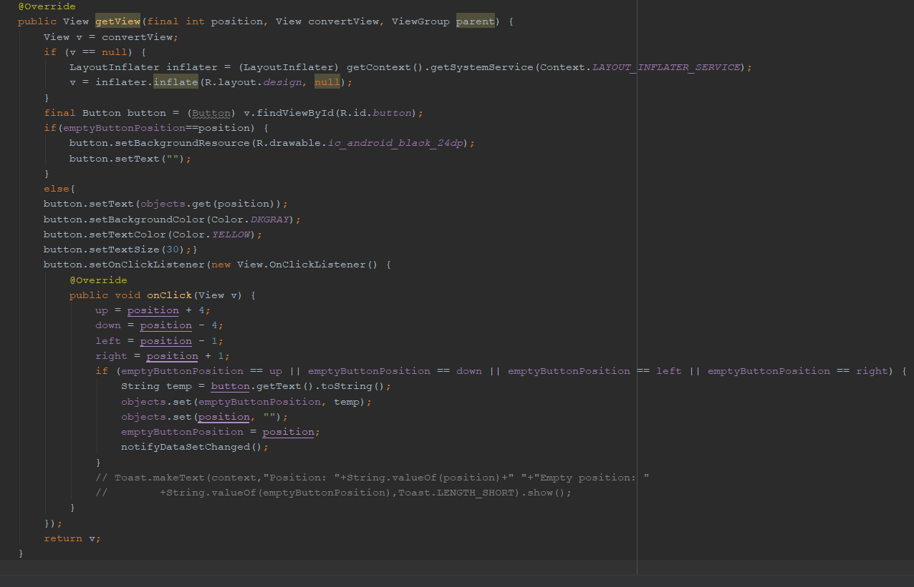

4. Grid view

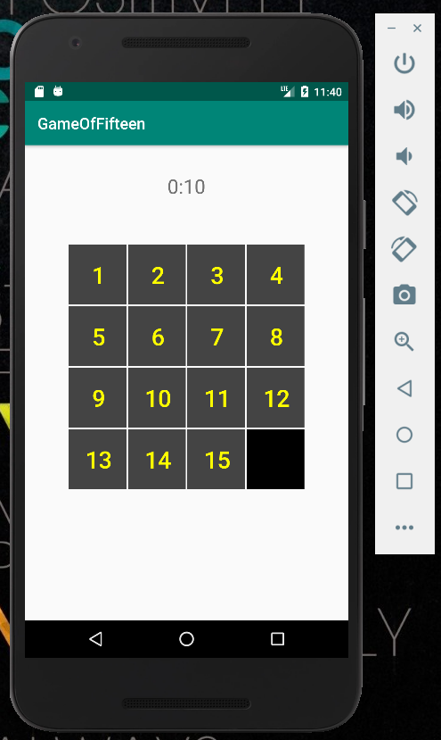

5. Game view

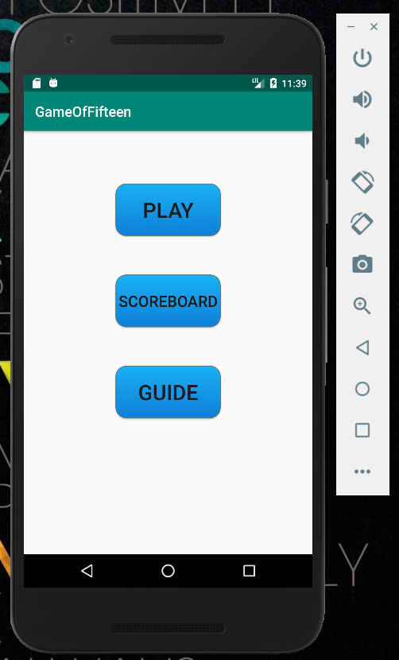

6. Menu view

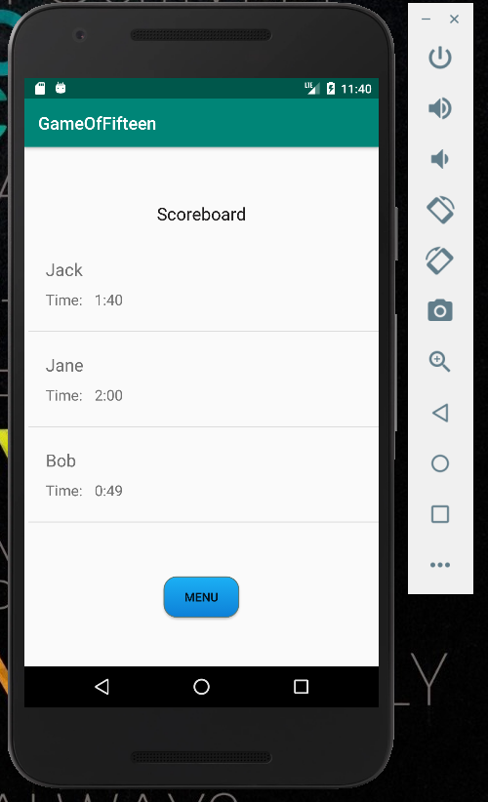

7. Scoreboard view

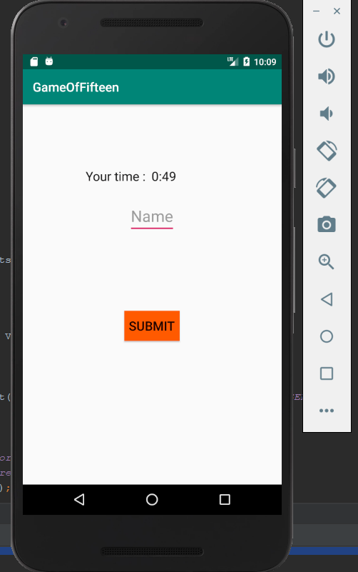

8. Victory screen view

I added timer

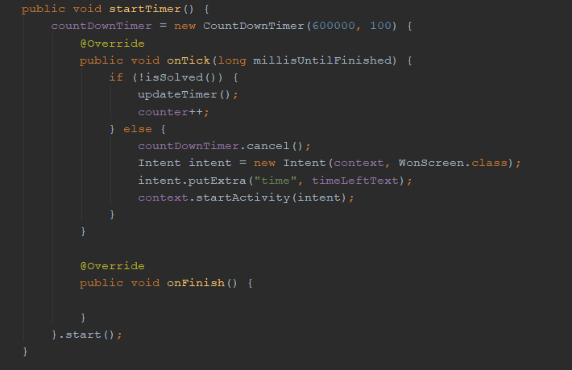

9. Timer

Added function which updates time text

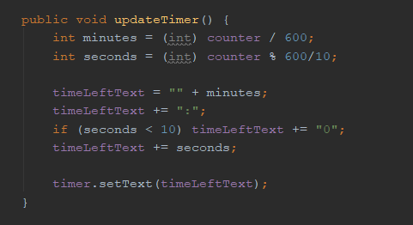

10. Time text update

Added function which shows that puzzle is solved

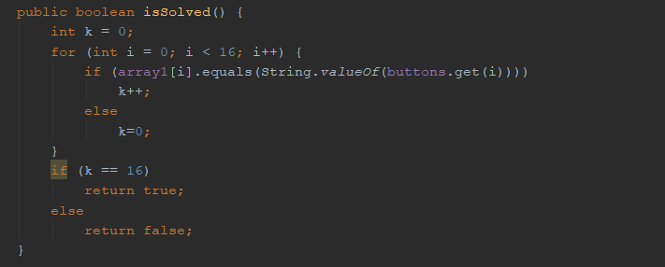

11. Solved function

I added a guide

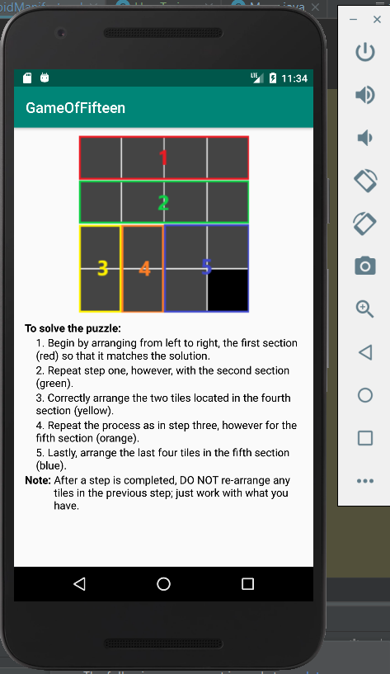

12. Guide

# Mockup

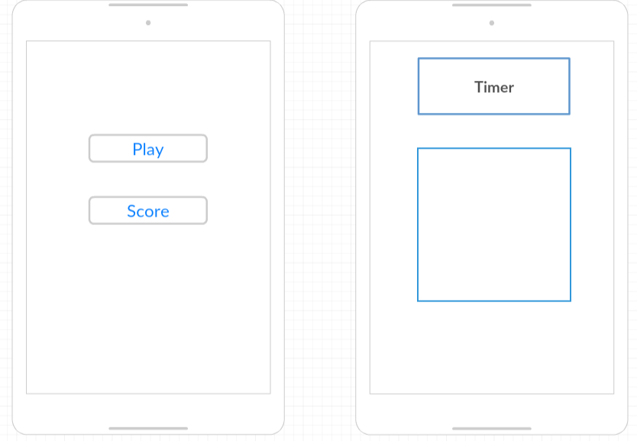

13. Mockup

# Literature list

1. <https://www.youtube.com/watch?v=HbEHxkAEumU>
2. <https://www.youtube.com/watch?v=zmjfAcnosS0>

# ANNEX

