**SOFTWARE REQUIREMENT SPECIFICATIONS**

**Project Topic: Shopping List**

**Submitted by: Tshering Jurmey**

**12190096**

1. **Introduction**
2. **Purpose**

The aim of my project is to develop an application which will help the students to do their shopping easier.

**OBJECTIVES**

1. To develop a platform to make their shopping easier and do grocery shopping more consciously.

2. To reduce workload of the students.

3. To help users to prioritize their items to be purchased.

1. **Scope**

**System cope**

Even today we use paper or diary to take the list of shopping items. Most people collect receipt to keep track what they have purchased and calculates the total expenses manually at the end of the month and even occasionally.

I am going to develop an android based application with the following features:

1. Login

2. Registration

3. User Profile

4. Categories

**User Scope**

The target of my project is the students of GCIT (Gyalpozhing College of Information Technology).

1. **Requirement**
2. **Functional Requirements**

1. Login: The user has to login in order to view all the other details.

2. Registration: The user has to first register in order to access all the features.

3. User Profile: The user can view all the details of the shopping list that they have made.

4. Categories: The user can keep list of their shopping that are made by categorizing them.

1. **Non-functional Requirements**

Some of the non-functional requirements of application are:

1. Portability and compatibility

An application is portable as well as compatible as it can be supported in all the platforms of android versions.

1. Usability

Application is very easy to use as:

* Learnability: The users will be able to use the application very easily since the direction and naming conventions will be properly written with icons. For now, the scope is limited to the students of GCIT therefore the students will be able to use application very easily.
* Errors: The users will not make many mistakes as the features will be named specifically with icons.
* Memorability: Since application is not complex, the users will not face trouble while using application after sometimes.

1. **Software Requirements: The technology used and version**

The technology that is used for developing this application is

* Android studio (Version: 4.1.2 and Gradle Version: 6.5)

Android Studio is the official integrated development environment for Google’s Android operating system, built on JetBrain’s IntelleJ IDEA software and designed specifically for Android development.

* Java Development Kit

The Java Development Kit is an implementation of either one of the Java Platform, Enterprise Edition, or Java Platform, Mirco Edition platforms released by Oracle Corporation in the form of a binary product aimed at Java developers on Solaris, Linux, macOS or Windows.

1. **Hardware Requirement**

**- Users Requirement**

1. 4-8GB RAM

2. 2.00GHz*4 Processors

3. Android Phone (Emulator)

**Hardware requirements for Windows OS:**

1. Microsoft Windows 7/8/10 (64 bits)
2. 4 GB RAM minimum, 8 GB RAM recommended
3. 2 GB of available disk space minimum, 4 GB recommended (500 GB for IDE + 1.5 GB for android SDK and emulator system image)
4. 1280 * 800 minimum screen resolution

**Hardware requirements for Linux** OS**:**

1. GNOME or KDE desktop Tested on gLinux based on Debian
2. 64-bit distribution capable of running 32-bit applications
3. GNU C library (glibc) 2.19 or later
4. 4 GB RAM minimum, 8 GB RAM recommended
5. 2 GB of available disk space minimum, 4 GB RAM recommended (500 GB for IDE + 1.5 GB for android SDK and emulator system image)
6. 1280 x 800 minimum screen resolution

**4.** **System Design**

* 1. Use case

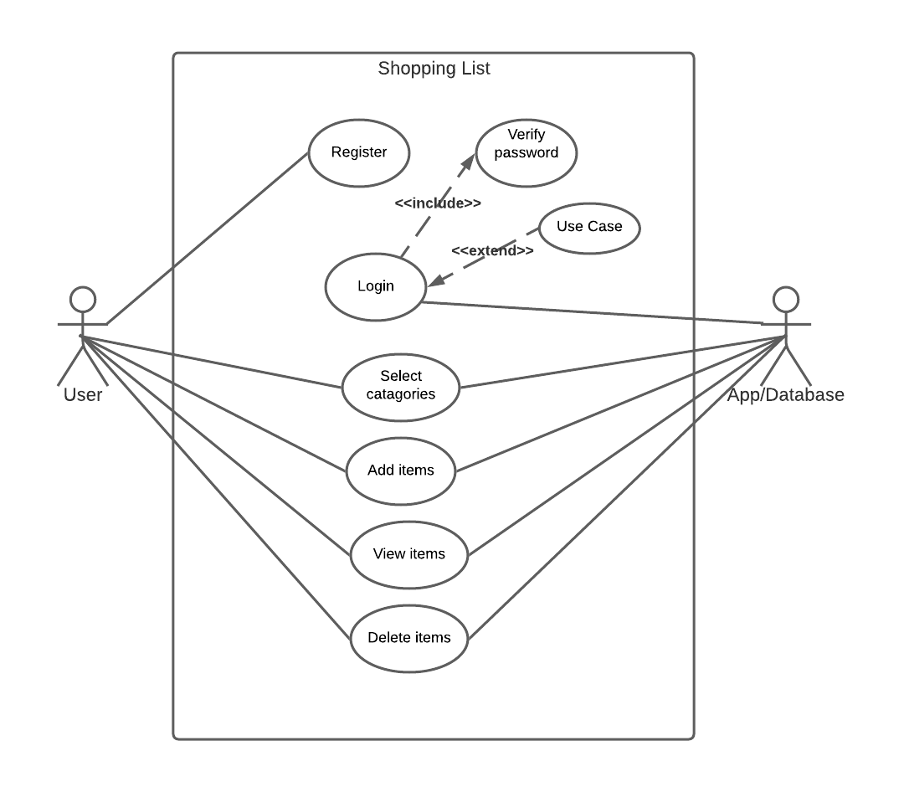

* 1. Sequence diagram

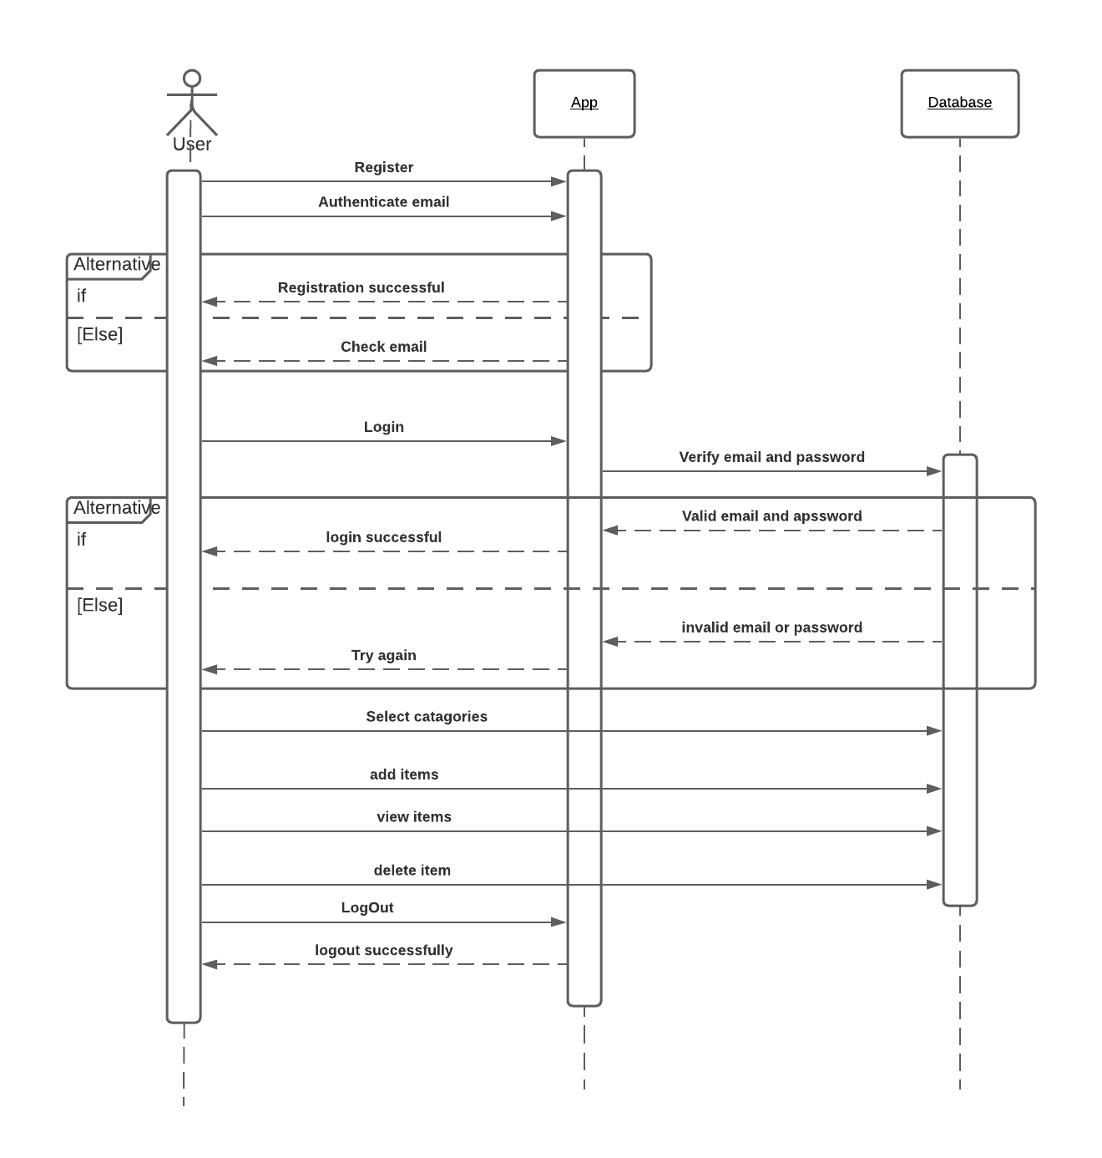

* 1. ERD

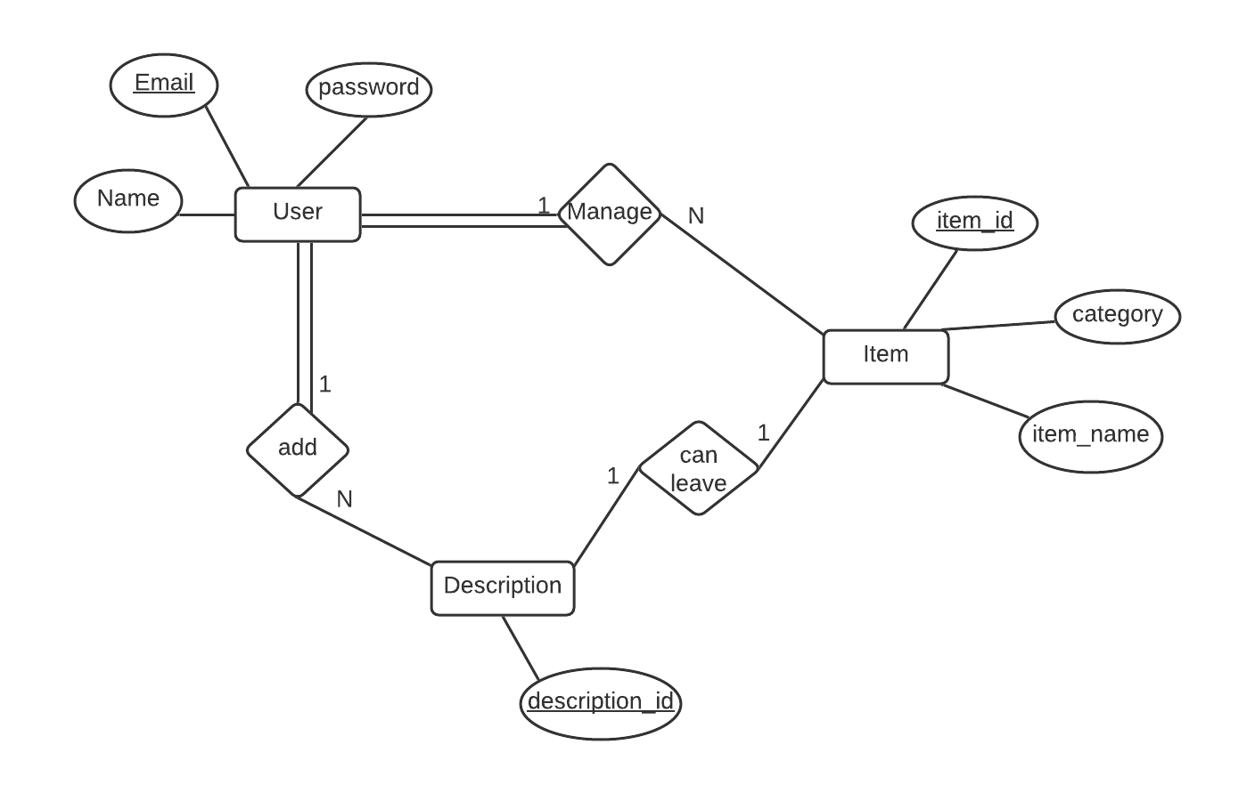

* 1. Relation schema

