产品规格书

|  |  |  |  |
| --- | --- | --- | --- |
| **客户名称** |  | **产品名称** | **TX1812R** |
|  |  |  |  |
| **客户代码** |  | **产品规格** | **HSW4020RGB-TX1812R** |
|  |  |  |  |

|  |  |  |  |  |  |  |  |  |  |
| --- | --- | --- | --- | --- | --- | --- | --- | --- | --- |
|  |  | 客 | | 户 确 | | 认 | | |  |
|  |  |  |  |  |  |  |  |  |  |
|  |  |  |  |  |  |  |  |  |  |
|  |  |  |  |  |  |  |  |  |  |
|  | 制定 | |  | 审核 | |  |  | 核准 |  |
|  |  |  |  |  |  |  |  |  |  |
|  | 黄彪 | |  |  |  |  |  | 陈晓林 |  |
|  |  |  |  |  |  |  |  |  |  |

**版本号（Vension No）：1.0**

◆ **Description（描述）**

TX1812R 是一个集控制电路与发光电路于一体的智能外控 LED 光源。其外型与一个 4018LED 灯珠相同，每个元件即为一个像素点。像素点内部包含了智能数 字接口数据锁存信号整形放大驱动电路，电源稳压电路，内置恒流电路，高精度 RC 振荡器，输出驱动采用专利 PWM 技术，有效保证了像素点内光的颜色高一致性。

数据协议采用单极性归零码的通讯方式，像素点在上电复位以后，DIN 端接受从控制 器传输过来的数据，首先送过来的 24bit 数据被第一个像素点提取后，送到像素点内部的数据锁存器，剩余的数据经过内部整形处理电路整形放大后通过 DO 端口开始转 发输出给下一个级联的像素点，每经过一个像素点的传输，信号减少 24bit。像素点 采用自动整形转发技术，使得该像素点的级联个数不受信号传送的限制，仅仅受限信 号传输速度要求。

LED 具有低电压驱动，环保节能，亮度高，散射角度大，一致性好，超低功率，超 长寿命等优点。将控制电路集成于 LED 上面，电路变得更加简单，体积小，安装更加 简便。

◆ **Applications（领域)**

* LED 全彩发光字灯串,LED 全彩模组,LED 幻彩软硬灯条,LED 护栏管，LED 外观/情景照明。
* LED 点光源,LED 像素屏,LED 异形屏,各种电子产品,电器设备跑马灯。

◆ **Features（特征)**

* LED 内部集成高质量外控单线串行级联恒流 IC；
* 控制电路与芯片集成在 SMD 4018 元器件中，构成一个完整的外控像素点,色温效果均匀且一致性高。
* 内置数据整形电路，任何一个像素点收到信号后经过波形整形再输出，保证线路波形畸变不会累加。
* 内置上电复位和掉电复位电路，上电不亮灯；
* 灰度调节电路（256 级灰度可调），
* 红光驱动特殊处理，配色更均衡，
* 单线数据传输，可无限级联。
* 整形转发强化技术，两点间传输距离超过 10M.
* 数据传输频率可达 800Kbps， 当刷新速率 30 帧/秒时，级联数不小于 1024 点。

◆ **Package Dimensions（封装尺寸)**

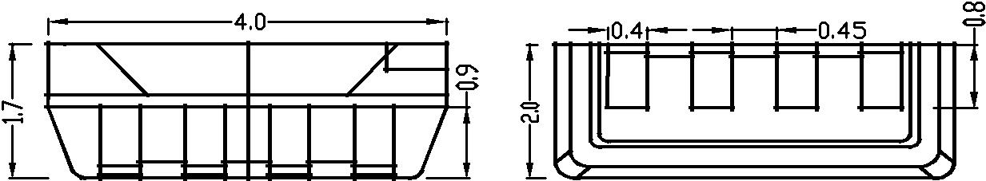

1 D I N 2 V D D 3 D O 4 G N D

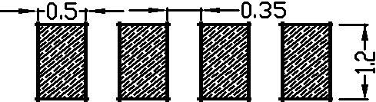

**注；**

**1.所有标注尺寸的单位均为毫米**

**2.除了特别注明,所有标注尺寸的公差均为±0.2mm**

**3.封装尺寸：4.0 X 2.0 X 1.7mm**

2

* **Product naming principle（产品命名原则）**

**TX** **1812** **R**

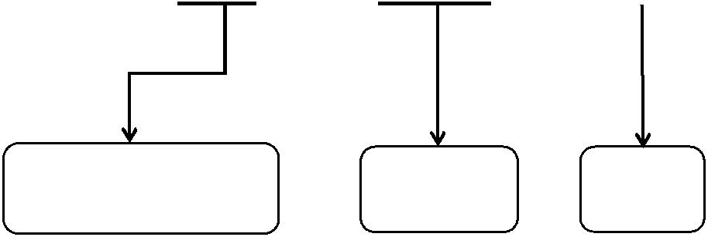

**内置 IC 系列** **IC 型号** **4018**

◆ **Pin figure（引脚图）**

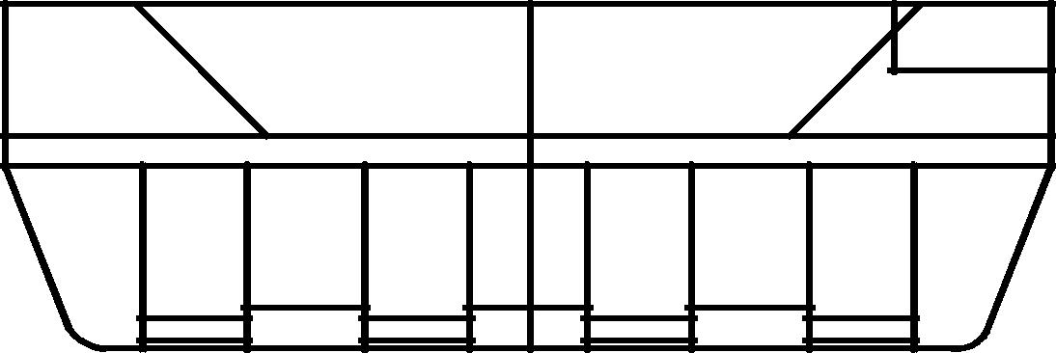

1 D I N 2 V D D 3 D O 4 G N D

◆ **Pin function（引脚图）**

|  |  |  |  |
| --- | --- | --- | --- |
| **序号** | **符号** | **管脚名** | **功能描述** |
|  |  |  |  |
| 1 | DIN | 数据输入 | 控制数据信号输入 |
|  |  |  |  |
| 2 | VDD | 电源 | 供电管脚 |
|  |  |  |  |
| 3 | DO | 数据输出 | 控制数据信号输出 |
|  |  |  |  |
| 4 | GND | 地 | 信号接地和电源接地 |
|  |  |  |  |

3

* **Electro-optical characteristics at Ta=25℃（电光特性）**

|  |  |  |  |  |  |  |  |  |
| --- | --- | --- | --- | --- | --- | --- | --- | --- |
| Item（项目） | Symbol | | Mix | Typ | Max | Unit | Conditions |  |
| （测试条 |  |
| （符号） | | （最小） | （平均） | （最大） | （单位） |  |
|  | 件） |  |
|  |  |  |  |  |  |  |  |
|  |  |  |  |  |  |  |  |  |
|  |  | G | 2.8 |  | 3.2 |  |  |  |
| Forward voltage |  |  |  |  |  |  |  |  |
| VF | R | 2.0 |  | 2.4 | V | IF=20mA*3 |  |
| （正向电压） |  |  |
|  |  |  |  |  |  |  |  |
|  |  | B | 2.8 |  | 3.2 |  |  |  |
|  |  |  |  |  |  |  |  |  |
| Reverse current | IR |  | -- | -- | 5 | μA | VR = 5V |  |
| （反向电流） |  |  |
|  |  |  |  |  |  |  |  |
|  |  |  |  |  |  |  |  |  |
| Dominant |  | G | 520 |  | 525 |  |  |  |
|  |  |  |  |  |  |  |  |
|  |  |  |  |  |  |  |  |
| wavelength | λd | R | 620 |  | 625 | nm | IF=20mA*3 |  |
| （主波长） |  |  |  |  |  |  |  |  |
|  | B | 465 |  | 470 |  |  |  |
|  |  |  |  |  |  |
|  |  |  |  |  |  |  |  |  |
|  |  | G | 1300 |  | 1800 |  |  |  |
| Luminous intensity | IV |  |  |  |  | mcd | IF=20mA*3 |  |
| R | 500 |  | 700 |  |
| （发光强度） |  |  |
|  |  |  |  |  |  |  |  |
|  |  | B | 300 |  | 500 |  |  |  |
|  |  |  |  |  |  |  |  |  |

◆ **Absolute maximum ratings at Ta=25℃（绝对最大额定值）**

|  |  |  |  |  |  |
| --- | --- | --- | --- | --- | --- |
| **参数** | **符号** |  | **范围** |  | **单位** |
|  |  |  |  |  |  |
| 逻辑电源电压 |  | VDD |  | -0.5～+7.0 | V |
|  |  |  |  |  |  |
| DIN端口电压 |  | Vin |  | -0.5～VDD+0.5V | V |
|  |  |  |  |  |  |
| 工作温度 |  | Topt |  | -40-85℃ | ℃ |
|  |  |  |  |  |  |
| 储存温度 |  | Tstg |  | -40-120℃ | ℃ |
|  |  |  |  |  |  |



◆ **Electric****Spec（电气参数）**

|  |  |  |  |  |  |  |
| --- | --- | --- | --- | --- | --- | --- |
| **参数** | **符号** | **最小** | **典型** | **最大** | **单位** | **测试条件** |
|  |  |  |  |  |  |  |
| 电源电压 | VDD | 4.5 | 5.0 | 5.5 | V | -- |
|  |  |  |  |  |  |  |
| OUT输出电流 | Iout | -- | 12 | -- | mA | -- |
|  |  |  |  |  |  |  |
| 高电平输入电压 | Vin | -- | 3.5 | -- | V | VDD=5.0V |
|  |  |  |  |  |  |  |
| 低电平输入电压 | Vil | -- | 0.8 | -- | V | VDD=5.0V |
|  |  |  |  |  |  |  |
| 高电平输出电流 | Ioh | -- | 27 | -- | V | VDD=5.0V，Vdo=4.9v |
|  |  |  |  |  |  |  |
| 低电平输出电流 | Iol | -- | 30 | -- | V | VDD=5.0V，Vdo=0.8v |
|  |  |  |  |  |  |  |
| PWM频率 | FPWM | -- | 2.6 | -- | KHZ | -- |
|  |  |  |  |  |  |  |
| 静态功耗 | IDD | 0.6 | 0.73 | 0.95 | mA | -- |
|  |  |  |  |  |  |  |

4

* **dynamic****parameter（动态参数）**

|  |  |  |  |  |  |  |  |  |  |  |  |  |  |  |  |  |  |  |  |  |  |  |  |  |  |  |  |  |  |  |  |  |  |  |  |  |  |  |  |  |  |  |  |  |  |  |  |  |  |  |  |  |  |  |  |  |  |  |  |  |  |  |  |  |  |  |  |  |  |
| --- | --- | --- | --- | --- | --- | --- | --- | --- | --- | --- | --- | --- | --- | --- | --- | --- | --- | --- | --- | --- | --- | --- | --- | --- | --- | --- | --- | --- | --- | --- | --- | --- | --- | --- | --- | --- | --- | --- | --- | --- | --- | --- | --- | --- | --- | --- | --- | --- | --- | --- | --- | --- | --- | --- | --- | --- | --- | --- | --- | --- | --- | --- | --- | --- | --- | --- | --- | --- | --- |
|  |  |  |  | **参数** | | | | | |  |  | **符号** | | | | | | | | | |  |  | **最小** | | |  |  |  |  |  | **典型** | | | | | | | | | | **最大** | | | | | | | | | |  |  | **单位** | | |  |  |  |  |  |  |  |  | **测试条件** | | | | |
|  | | | | | | | | | |  | | | | | | | | | | | |  | | | | |  | | | | | | | | | | | | | | |  | | | | | | | | | |  | | | | |  | | | | | | | | | | | | |
|  |  | 数据速率 | | | | | | | |  |  |  |  |  | FIN | | | | | | | -- | | |  |  | 800 | | | | | | | | | | | |  |  |  | -- | |  |  |  |  |  |  |  |  |  |  | KHZ | | | -- | | | | | | | | | | | |  |
|  | | | | | | | | | |  | | | | | | | | | | | |  | | | | |  | | | | | | | | | | | | | | |  | | | | | | | | | |  | | | | |  | | | | | | | | | | | | |
|  | 传输延迟时间 | | | | | | | | |  |  |  |  | Tpzl | | | | | | | | -- | | |  |  | 300 | | | | | | | | | | | |  |  |  | -- | |  |  |  |  |  |  |  |  |  |  | ns | | |  |  |  |  |  |  |  |  |  | DIN-DO | | | |
|  | | | | | | | | | |  | | | | | | | | | | | |  | | | | |  | | | | | | | | | | | | | | |  | | | | | | | | | |  | | | | |  | | | | | | | | | | | | |
|  |  | 输入电容 | | | | | | | |  |  |  |  |  |  |  | Ci | | | | | -- | | |  |  | -- | | | | | | | | | | | |  |  |  | 15 | |  |  |  |  |  |  |  |  |  |  | pF | | |  |  |  |  |  |  |  |  |  |  |  |  |  |
|  | | | | | | | | | |  | | | | | | | | | | | |  | | | | |  | | | | | | | | | | | | | | |  | | | | | | | | | |  | | | | |  | | | | | | | | | | | | |
|  | | | | | | | | | | | | | | | | | | | | | | | | | | | | | | | | | | | | | | | | | | | | |  | | |  | | | | | | | | | | |  | | |  | | | | | | | |
|  | | | | | | | | | | | | | | | | | | | | | | | | | | | | | | | | | | | | | | | | | | | | | |  | | | | | | | | | | | | | | |  | |  |  | | | | | |
|  | | | | | | | | | | | | | | | | | | | | | | | | | | | | | | | | | | | | | | | | | | | | | |  | | |  | | | | | | | | | | | |  | | | | | | | | |
|  | | | | | | | | | | | | | | | | | |  | | | | | | |  | | | | | | | | | | | | | | | | | |  | | | | | | |  |  | | | | | | |  | | | | | | |  | | | | |
|  | | | | | | | | |  | |  | | |  | | | | | | | | | | | |  | |  | | |  | | | | | | | | | | | |  | | | |  | | | |  | | |  | |  | |  | |  | |  | | |  |  | | | |
|  | |  | | | | |  |  | | |  |  | | |  | | | | | | | | | | | | |  | | | | | |  | | | | | | | | |  |  | | | | | | |  | | | | | | | | | | | | | |  | | |  | |
|  | | | | | | | | | | |  | |  | | |  | | |  | | | | | | | | |  |  | | |  | | | | | | | | | | |  | | | | | | | | | | | | | | | | | | | | | | | | | | |
|  | | | | | | | | | | |  | |  | | |  |  | |  | | | | | | | | |  | |  | | | | |  | | | | | | | | | | | | | | | | | | | | | | | | | | | | | | | | | | |
|  | | | | | | | | | | |  | | | | | | | | | |  | | | | | | |  | | | | |  | | | |  | |  | | | | | | | | | | | | | | | | | | | | | | | | | | | | | | |
|  | | | | | | | | | | | | | | | | | | | | |  | | |  | | | | | | | | | | | |  | | |  | | | | | | | | | | | | | | | |  | | | | | | | | | | |  | | | |
|  | | |  | |  | | | | | | | | | | | | | | | |  | | | | | | | | | | | | | | | | | |  | | | | | | | | | | | | | | | | | | | | | | | | | | | | | | |
|  |  | | |  | | | | | | | | | | | | | | | |  |  | |  | | | | | | | | | | | | | | |  |  |  | | | | | | | | | | | | | | | | | | | | | | | | | | | | | |
|  |  | | |  | | | | | | | | | | | | | | | | |  | | | | | | | | | | | | | | | | | |  | | | | | | | | | | | | | | | | | | | | | | | | | | | | | | |
|  | | | | | |  | | | | | | | | | | | | |  | |  | | | | | | | | | | | | | | | | | |  | |  | | | | | | | | | | | |  | | | | | | | | | | | | | |  | |  |

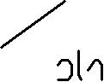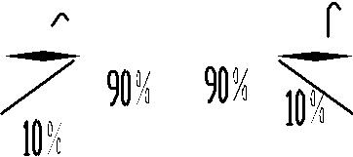

* **The data transmission time（数据传输时间）**

|  |  |  |  |  |  |  |
| --- | --- | --- | --- | --- | --- | --- |
| **参数名称** | **参数符号** | **测试条件** | **最小值** | **典型值** | **最大值** | **单位** |
|  |  |  |  |  |  |  |
| 输入 0 码对应高电平时间 | Tin0h | VDD=5.0V | 320 | 360 | 400 | ns |
|  |  |  |  |  |  |  |
| 输入 1 码对应高电平时间 | Tin1h | VDD=5.0V | 640 | 720 | 800 | ns |
|  |  |  |  |  |  |  |
| 输出 0 码对应高电平时间 | Tdo0h | VDD=5.0V | 320 | 360 | 400 | ns |
|  |  |  |  |  |  |  |
| 输出 1 码对应低电平时间 | Tdo1h | VDD=5.0V | 640 | 720 | 800 | ns |
|  |  |  |  |  |  |  |
| 0 码/1 码周期 | T | -- | 1250 | -- | -- | ns |
|  |  |  |  |  |  |  |
| RST 码低电平时间 | Trst | -- | 200 | -- | - - | us |
|  |  |  |  |  |  |  |



* **Temporal waveform figure（时序波形图）**

**输入码型：** **连接方式：**

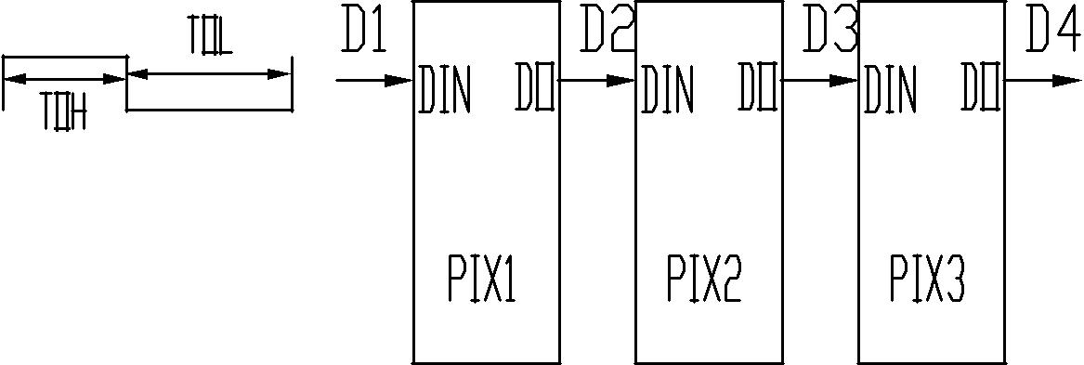

 码

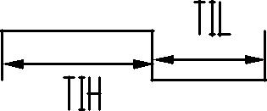

 码

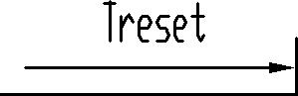

 码 

5



* **mode of data transmission（数据传输方式）**

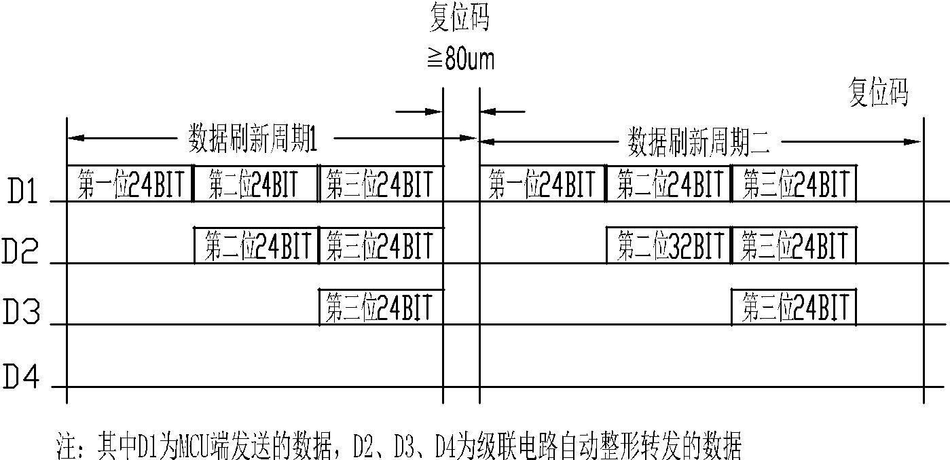

* **mode of data transmission（数据传输方式）**

|  |  |  |  |  |  |  |  |  |  |  |  |  |  |  |  |  |  |  |  |  |  |  |  |
| --- | --- | --- | --- | --- | --- | --- | --- | --- | --- | --- | --- | --- | --- | --- | --- | --- | --- | --- | --- | --- | --- | --- | --- |
| G7 | G6 | G5 | G4 | G3 | G2 | G1 | G0 | R7 | R6 | R5 | R4 | R3 | R2 | R1 | R0 | B7 | B6 | B5 | B4 | B3 | B2 | B1 | B0 |
|  |  |  |  |  |  |  |  |  |  |  |  |  |  |  |  |  |  |  |  |  |  |  |  |
| 注：高位先发，按照 GRB 的顺序发送数据（G7→G6……B0） | | | | | | | | | | | | |  |  |  |  |  |  |  |  |  |  |  |



* **Typical application circuit（典型应用电路）**

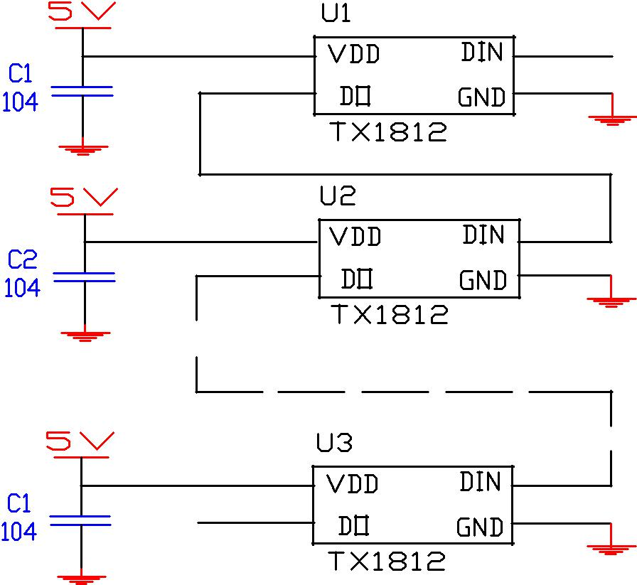

6

* **Typical optical characteristics curves（典型光学特性曲线）**

**Spectral Distribution**

Relative Intensity vs.Wavelength(Ta=25 。 C)

Forward current vs.Forward Voltage(Ta=25 。 C) Relative Intensity vs.Forward Crrent(Ta=25 。 C)

|  |
| --- |
| Relative Intensity |

1.2

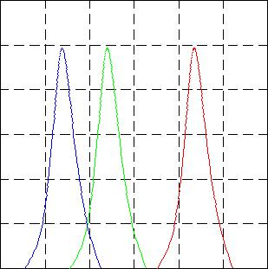

1.0

0.8

0.6

0.4

0.2

0.0

400 450 500 550 600 650 700

Wavelength[nm]

Relative Intensity vs.Ambient temperature

|  |  |  |
| --- | --- | --- |
|  | 20 |  |
| Current(mA) | 10 |  |
|  |  |
| Forward |  |  |
|  | 0.0 |  |

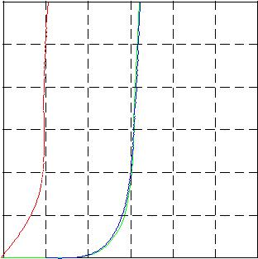

1.5 2.0 2.5 3.0 3.5 4.0 4.5

Forward Voltage VF(V)

**Detrating**

Ambient temperature vs.Maximun Forward Current

1.5

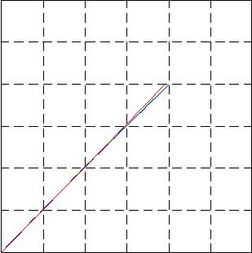

|  |  |  |
| --- | --- | --- |
| Intensity | 1.0 |  |
|  |  |
| Relative | 0.5 |  |
|  |  |
|  | 0.0 |  |

0 10 20 30

Forward Current (mA)

Forward Crrent vs.Chromating (Ta=25 。 C)

|  |
| --- |
| Relative Intensity |

10

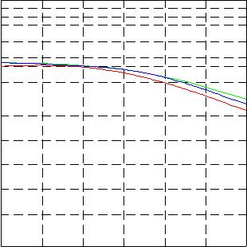

1.0

0.5

0.1

|  |  |  |  |
| --- | --- | --- | --- |
| -50 | 0 | 50 | 100 |
|  | Ambient temperature Ta(25 | | 。C) |

|  |
| --- |
| Forward Current(mA) |

40

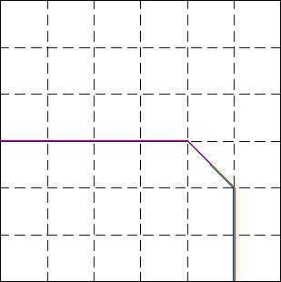

20

0

1. 20 40 60 80 100 Ambient temperature Ta(25

650

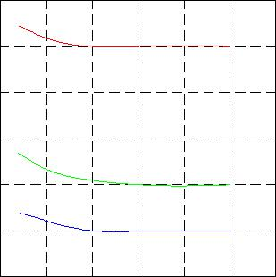

550

450

|  |  |  |  |  |
| --- | --- | --- | --- | --- |
| 120 | 0 | 10 | 20 | 30 |
| 。C) |  | Forward Current (mA) | |  |

**Diagram characteristics of radiation**



|  |  |  |  |
| --- | --- | --- | --- |
| 。 | 。 | 。 |  |
|  |  | 1.0 |  |
| 。 |  | 0.8 |  |
|  |  |  |
|  |  | 0.6 |  |
| 。 |  | 0.4 |  |
|  |  |  |
|  |  | 0.2 |  |
| 。 |  |  |  |
|  | 0 | 。 |  |

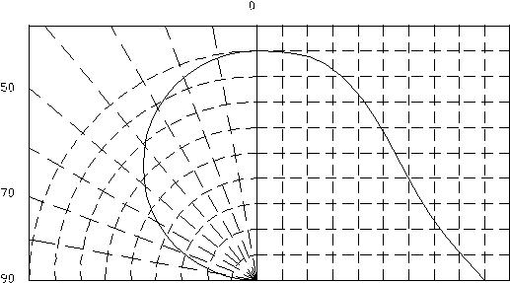

20

|  |
| --- |
| 。 |

40

|  |
| --- |
| 。 |

60

|  |
| --- |
| 。 |

80

|  |
| --- |
| 。 |

100

|  |
| --- |
| 。 |

7

* **Reflow profile（焊接说明）**
  + **SMD Reflow Soldering Instructions（回流焊简介）**

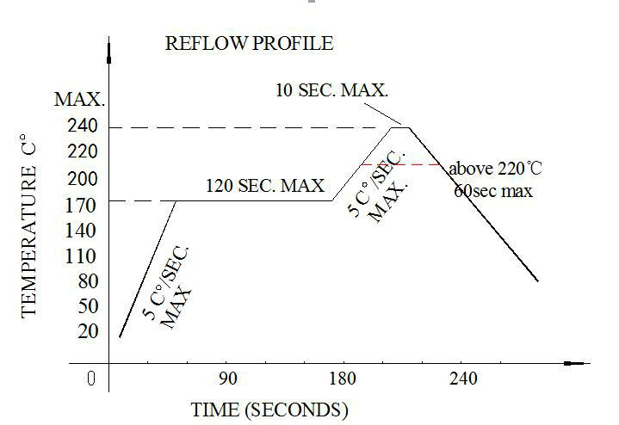

1. Reflow soldering should not be done more than two times 回流焊次数不应超过 2 次

* + 1. When soldering ,do not put stress on the LEDs during heating

焊接时，在加热过程中不能有应力作用于 LED 灯珠

* **Soldering iron（烙铁）**
  1. When hand soldering, keep the temperature of the iron under 300℃, and at that temperature keep the time under 3 sec.

手工焊接时，烙铁温度控制在 300℃以下，且时间不可超过 3 秒

* 1. The hand soldering should be done only a time

手工焊接只可焊接一次

* **Rework（返工）**
  1. Customer must finish rework within 5 sec under 240℃

温度保持在 240℃以下，5 秒内完成返工作业

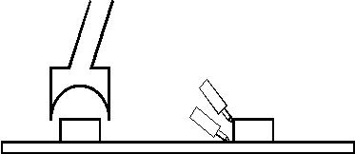

2. The head of iron can not touch the LEDs

烙铁不能碰触到 LED 灯珠

* 1. Twin-head type is preferred.

双头形烙铁为最佳

* **CAUTIONS（注意事项）**



The encapsulated material of the LEDs is silicone. Therefore the LEDs have a soft surface on the top of package. The pressure to the top surface will be influence to the reliability of the LEDs. Precautions should be taken to avoid the strong pressure on the encapsulated part. So when using the picking up nozzle, the pressure on the silicone resin should be proper.

封装的 LED 为硅材料。该 LED 具有软表面的封装顶部。顶部表面的压力会影响 LED 的可靠性。应采取预防措施，以避免有过大的压力作用于在封装件上。因此，在选用吸嘴时，应适用于有机硅树脂的压力。

8

* **Reliability（可靠性）**

TEST ITEMS AND RESULTS（测试项目和结果）

|  |  |  |  |  |  |
| --- | --- | --- | --- | --- | --- |
| Test Item | Ref.Standard | Test Conditions | Note | Conclusion |  |
| （测试项目） | （参考标准） | （测试条件） | （备注） | （结论） |  |
|  |  |  |  |  |  |
| Reflow Soldering | JESD22-B106 | Tsld=240℃,10sec | 3 times | 0/22 |  |
| （回流焊） |  |
|  |  |  |  |  |
|  |  |  |  |  |  |
| Temperature Cycle |  | -20℃ 30min |  |  |  |
| JESD22-A104 | ↑↓15min | 200 cycle | 0/100 |  |
| （温度循环） |  |
|  | 120℃ 30min |  |  |  |
|  |  |  |  |  |
|  |  |  |  |  |  |
| Thermal Shock |  | -40℃ 15min |  |  |  |
| JESD22-A106 | ↑↓15sec | 200 cycle | 0/100 |  |
| （冷热冲击） |  |
|  | 125℃ 15min |  |  |  |
|  |  |  |  |  |
|  |  |  |  |  |  |
| High Temperature |  |  |  |  |  |
| Storage | JESD22-A103 | Ta=100℃ | 1000 hrs | 0/100 |  |
| （高温存储） |  |  |  |  |  |
|  |  |  |  |  |  |
| Low Temperature | JESD22-A119 | Ta=-40℃ | 1000 hrs | 0/100 |  |
| Storage（低温存储） |  |
|  |  |  |  |  |
|  |  |  |  |  |  |
| Power temperature |  | On5min-40℃>15min |  |  |  |
| Cycling | JESD22-A105 | ↑ ↓↑ ↓<15min | 200 cycle | 0/100 |  |
| （点亮高低温循环） |  | Off5min100℃>15min |  |  |  |
|  |  |  |  |  |  |
| Life Test | JESD22-A108 | Ta=25℃ | 1000 hrs | 0/100 |  |
| （老化测试） | IF=40mA |  |
|  |  |  |  |
|  |  |  |  |  |  |
| High Humidity Heat |  | 60℃ RH=90% |  |  |  |
| Life Test | JESD22-A101 | 1000 hrs | 0/100 |  |
| IF=40mA |  |
| （高温高湿） |  |  |  |  |
|  |  |  |  |  |
|  |  |  |  |  |  |

9

* **Packaging Specifications（包装规格）**
  + **Feeding Direction（进料方向）**

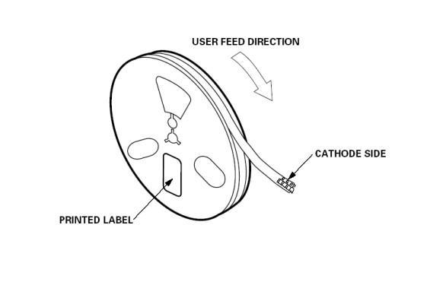

**● Dimensions of Reel (Unit: mm)（卷轴尺寸（单位：毫米））**

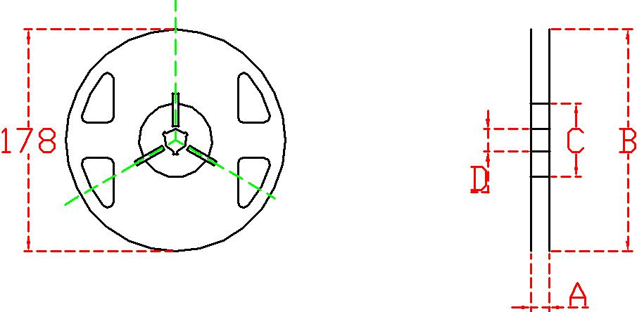

A 8.0±0.1mm

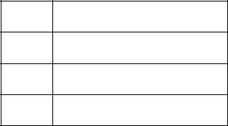

B 178±1mm

C 60±1mm

D 13.0±0.5mm

10

**1、Packing Icon（包装图标）**

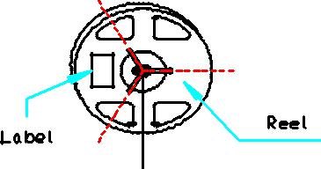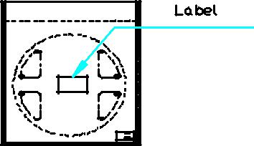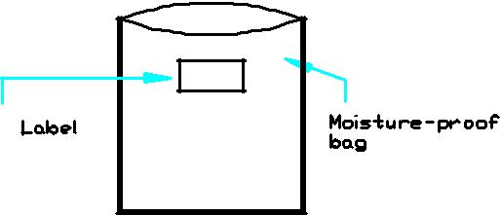

**2、Label Icon（标签图标）**

11