COLLEGE OF ENGINERING AND COMPUTER STUDIES

**OUTCOMES EVALUATION #2**

**[Title of activity]**

Submitted By

Joseph Rafael Manio

Course & Section

CS 1-1

Date

16/09/2021

**OUTCOMES OUTLINE**

1. **DESCRIPTION**

Create a Point of Sales (POS) system with C++. (Refer to the session demo video in your MS Teams)

1. **THEORETICAL FRAMEWORK**

|  |  |  |
| --- | --- | --- |
| INPUT | PROCESS | OUTPUT |
| **Typing a Program in Visual Studio.** | **Inputting the code needed.** | **Assignment to be submitted.** |

1. **SCREEN SHOTS**
2. **Visual Studio Code**

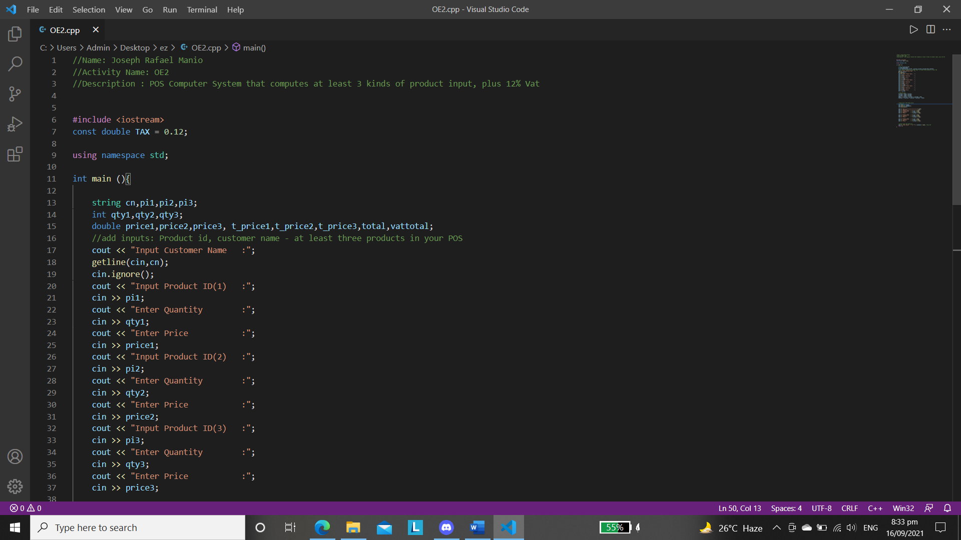

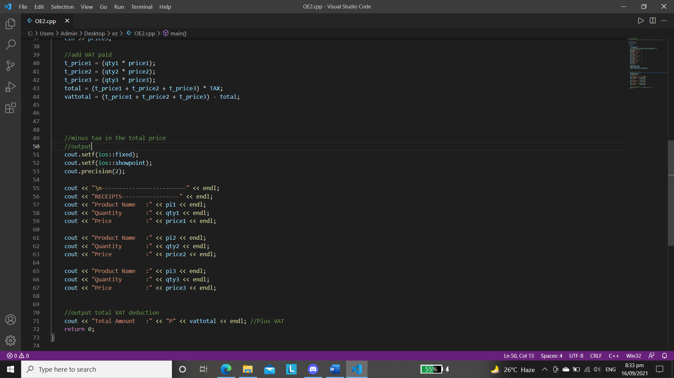

1. **Sample Input/Output**

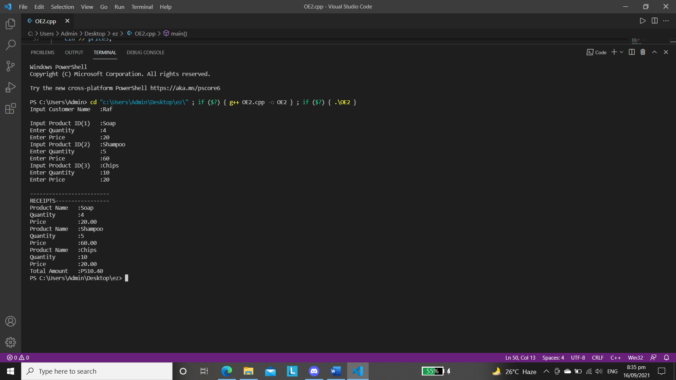

1. **PROGRAM SOURCE CODE**
2. #include <iostream>
3. const double TAX = 0.12;
4. using namespace std;
5. int main (){
6. string cn,pi1,pi2,pi3;
7. int qty1,qty2,qty3;
8. double price1,price2,price3, t_price1,t_price2,t_price3,total,vattotal;
9. //add inputs: Product id, customer name - at least three products in your POS
10. cout << "Input Customer Name   :";
11. getline(cin,cn);
12. cin.ignore();
13. cout << "Input Product ID(1)   :";
14. cin >> pi1;
15. cout << "Enter Quantity        :";
16. cin >> qty1;
17. cout << "Enter Price           :";
18. cin >> price1;
19. cout << "Input Product ID(2)   :";
20. cin >> pi2;
21. cout << "Enter Quantity        :";
22. cin >> qty2;
23. cout << "Enter Price           :";
24. cin >> price2;
25. cout << "Input Product ID(3)   :";
26. cin >> pi3;
27. cout << "Enter Quantity        :";
28. cin >> qty3;
29. cout << "Enter Price           :";
30. cin >> price3;
32. //add VAT paid
33. t_price1 = (qty1 * price1);
34. t_price2 = (qty2 * price2);
35. t_price3 = (qty3 * price3);
36. total = (t_price1 + t_price2 + t_price3) * TAX;
37. vattotal = (t_price1 + t_price2 + t_price3) - total;

40. //minus tax in the total price
41. //output
42. cout.setf(ios::fixed);
43. cout.setf(ios::showpoint);
44. cout.precision(2);
45. cout << "\n-------------------------" << endl;
46. cout << "RECEIPTS-----------------" << endl;
47. cout << "Product Name   :" << pi1 << endl;
48. cout << "Quantity       :" << qty1 << endl;
49. cout << "Price          :" << price1 << endl;
50. cout << "Product Name   :" << pi2 << endl;
51. cout << "Quantity       :" << qty2 << endl;
52. cout << "Price          :" << price2 << endl;
53. cout << "Product Name   :" << pi3 << endl;
54. cout << "Quantity       :" << qty3 << endl;
55. cout << "Price          :" << price3 << endl;
56. //output total VAT deduction
57. cout << "Total Amount   :" << "P" << vattotal << endl; //Plus VAT
58. return 0;
59. }

**LEARNING OUTCOMES**

**As always, I expect a lot of things and learn new stuff in this journey of programming. It took a while to analyze the code, how can I run it properly working. Many trial and errors have been made and manages to finish it today.**

1. **REFERENCES (If any…)**