Software Requirements
Specification
Standard ISO/IEC/IEEE 29148 Compliant Blueprint

Project Name: BentaTrack: A Web-Based POS System for Multi-Category Retail Businesses
Version: 2.1.0
Date: October 1, 2026

Author / Organization: | Van Paulino  Manuel Thomas Medina  Michael John Felices  John Moises Balingasa  Renz Rommel Dasal  Vanna Padilla  Pheche Prudenciado  Dawn Mabutin  Chezza Mae Gonzaga

Status: Draft
1. Introduction

1.1 Purpose
This system is being built for Estetika, a boutique store that currently tracks its products and sales using only a notebook and a calculator. This manual method makes it easy to lose track of items, forget updates, or misplace records.
The goal of this software is to give Estetika a simple, reliable way to manage inventory and sales without paper and manual counting. The strategic driver is convenience: a tool that is easy to learn, works with or without an internet connection, and reduces the daily effort of running the boutique by hand.

1.2 Intended Audience
Audience | Purpose
Owner / Administrator | Primary user; relies on the system for full control of products, sales, reports, and supplier information.
Inventory or Sales Staff | Uses the system daily for stock and sales tasks, within a limited, restricted access level.
Guest | Not a system user. No public catalog or guest-facing feature is included in this version.

1.3 Product Scope
The system focuses on two main areas, inventory management and sales management, supported by a simple dashboard and basic security features.
What the system will include
- Product records with name, code, barcode, category, brand, supplier, prices, stock, low stock threshold, expiration date, image, and date added.
- Adding, editing, and archiving product records.
- Automatic stock deduction whenever a sale is recorded.
- Low stock pop-up notifications.
- An inventory change history log.
- Sales transaction recording, including quantity, price, date, staff, customer, discount, and payment method (Section 4.5).
- Daily, weekly, monthly, and yearly sales reports, plus best-selling products (Section 4.6).
- A dashboard showing totals, stock levels, and recent activity at a glance (Section 4.6).
- Product search by name or code, plus barcode scanning (Section 4.7).
- Role-based user accounts for the Owner/Administrator and Inventory/Sales Staff (Section 4.8).
- A simple, minimal interface in white and brown, with light and dark themes, the Estetika logo, and text labels with icons (Section 3.1).
- Support for desktop, laptop, tablet, and phone use, with offline operation and automatic sync (Section 4.9).
What the system will not include, at least for the initial version
- Automatic receipt generation.
- Credit or debit card payment processing.
- Delivery or rider assignment features, though raised as a possible future addition.
- QR code scanning; barcode-based lookup is the supported method (Section 4.7).
- Report export (PDF/CSV) (Section 4.6).
- Public product catalog for guests.

1.4 Definitions, Acronyms, and Abbreviations
Term | Definition
SRS | Software Requirements Specification, the document describing what the system must do.
POS | Point of Sale, the part of the system that handles sales transactions.
GCash | A mobile wallet and online payment platform commonly used in the Philippines.
QR Code | A scannable code that could serve as an alternative to a barcode. Not implemented in this version.
Auto-sync | The process where offline transactions are automatically saved once the device regains internet access.
Estetika | The name of the boutique store this system is being developed for.
Restock | Adding newly received units of a product to its stock quantity.
Refund | Returning money to a customer for all or part of a recorded sale. The returned units may go back to stock or be kept out, for example if damaged.
Exchange | Swapping a returned item for a different one. Recorded as a refund of the returned item followed by a new sale of the replacement item (FR-056).
Low Stock Threshold | The stock quantity, set per product (default 5), at or below which the product is marked Low Stock.
Discontinued | A product the store no longer sells. Discontinued products are archived, not deleted.
Archived | The state of a discontinued product: hidden from daily use but kept with all its history, and able to be restored.
Gross Profit | Selling price minus purchase price. Shown to the Owner/Administrator only.

1.5 References
- Primary source: interview conducted by the student development team with a staff member of Estetika (“Ma'am Melanie”) during requirements gathering.
- No external design guidelines, APIs, or regulatory codes were used. Shopee and Lazada were mentioned only as casual examples of color and layout style, not as adopted standards.

2. Overall Description

2.1 Product Perspective
BentaTrack is a web application that is responsive across phones, tablets, laptops, and desktop computers. The Owner/Administrator uses it to manage products, monitor stock levels, and view sales reports, while Inventory/Sales Staff use it to record sales and update inventory throughout the day. A barcode scanner or device camera may be used to quickly look up a product during a transaction. The system also works without an internet connection, saving transactions locally on the device and automatically syncing once it reconnects.
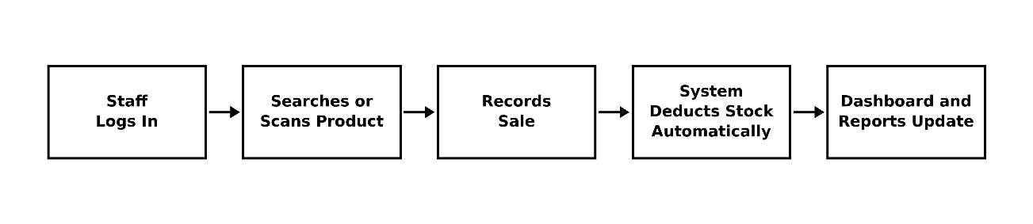
System Flow:

2.2 Product Functions
- Maintain accurate, always-available product and sales records.
- Warn the owner when stock is running low.
- Keep a history of inventory changes for reference.
- Automatically reduce stock the moment a sale is logged.
- Generate sales reports across different time periods.
- Show an at-a-glance dashboard summary whenever the system is opened.

2.3 User Classes and Characteristics
User | Main Tasks | Typical Device / Skill
Owner / Administrator | Monitors stock, sales, and overall store condition. Full access, including supplier information and account settings. | Desktop, laptop, tablet, or phone; basic to moderate computer skill.
Inventory or Sales Staff | Records sales and updates inventory day to day. Restricted from supplier contacts and password settings. | Desktop, laptop, tablet, or phone; basic computer or smartphone skill.

2.4 Operating Environment
Category | Requirement
System Type | Website, accessible through a standard web browser
Devices | Desktop computers, laptops, tablets, and cellphones
Internet | Works online and offline; offline data syncs automatically once reconnected
Client-Side Storage | IndexedDB (browser-native), for holding inventory/sales data locally while offline, before syncing to the central database
Optional Hardware | Barcode scanner or device camera for scanning product codes
Frontend | Next.js (App Router), React, TypeScript, Tailwind CSS, Chart.js with react-chartjs-2, Dexie.js with dexie-react-hooks, Serwist, html5-qrcode, next-themes (light/dark theme), lucide-react (icons), sonner (pop-up notifications)
Backend | Next.js server actions and route handlers on Node.js 22 or later, TypeScript, NextAuth.js v4 (email and password), bcryptjs, Zod, date-fns with @date-fns/tz (Philippine time)
Database | PostgreSQL, Prisma ORM with the @prisma/adapter-pg driver adapter (pg). Hosted on Neon Postgres (via Vercel) in production; PostgreSQL 17 in Docker for local development
File Storage | Vercel Blob (@vercel/blob) for product images. A local folder is used during development
Deployment | Vercel, Singapore region (closest to the Philippines). Database migrations run automatically on each deploy
Region / Locale | Philippine peso (₱), Asia/Manila time zone
Development and Testing | Vitest with Testing Library, jsdom, and fake-indexeddb (unit and integration tests against a real PostgreSQL test database); Playwright (end-to-end tests on a desktop and a phone screen size, plus page-load timing on a throttled phone); ESLint and Prettier; Docker Desktop for the local database

2.5 Design and Implementation Constraints
- Delivered as a functioning website, not a native mobile application. The website can be installed on a phone, tablet, or computer (a Progressive Web App). Once installed, it has its own icon and name on the home screen and opens full-screen without the browser's address bar or buttons, like a mobile app. It is still delivered as a website, not through an app store.
- No automatic receipt generation in the initial version.
- Simple, minimal interface using white and brown as the primary color scheme.
- Must support both a light theme and a dark theme. The theme follows the device's setting until the user picks one, and the choice is remembered on that device.
- Buttons and menus must use text labels together with icons, not icons alone.
- Must display the Estetika logo in an original, non-elaborate style.
- No specific programming language or data compliance standard required; left to the development team.

2.6 Assumptions and Dependencies
Assumptions
- Estetika will have at least periodic internet access for syncing.
- The owner will supply the official logo and branding materials.
- The store has, or will acquire, a compatible barcode scanner, or will use a smartphone camera instead.
- The Owner/Administrator and Inventory/Sales Staff have enough basic digital literacy to use a website-based system.
- The store uses the system from one device at a time, so conflicting offline edits from multiple devices are not handled.
- Until the owner supplies the official logo, a simple text wordmark ('Estetika') is used as a placeholder.
- On iPhone and iPad, the app is installed from Safari.
Dependencies
- Internet connection, for syncing offline data
- Web server and database
- Supported web browser
- File storage for product images
- Authentication system for login

3. External Interface Requirements
This section describes how BentaTrack will interact with users, hardware, other software, and networks.

3.1 User Interfaces
The interface shall be simple, minimal, and easy to learn, while still looking business appropriate for a boutique brand.
Screen / Page | Purpose
Login Page | Authenticates the user and routes them to the correct dashboard by role
Dashboard | Shows totals, stock levels, low stock alerts, recent transactions, and best sellers at a glance. Inventory/Sales Staff see a limited dashboard (FR-023a)
Product / Inventory Management | Add, edit, archive, restore, view, and restock products. The list can be filtered by category, by Low Stock or Out of Stock, and (owner only) by products that still need a purchase price or that are archived
Sales / Checkout | Record a sale, apply a discount, select a payment method, and complete a transaction
Sales History | List of past sales, searchable, with each sale's items, payment, and refunds. Refunds and exchanges are started here. Owner and staff
Sales Reports | View daily, weekly, monthly, and yearly sales, and best-selling products
Product Search | Look up a product by name, code, or barcode scan
Inventory History | View past inventory changes and purchase history for a product
User Accounts (Owner only) | Manage staff accounts and access levels
My Account (Owner only) | Change the owner's own password
Suppliers (Owner only) | Add, edit, and delete supplier records
Categories (Owner only) | Add, rename, and delete categories
Offline Page | Shown when a page that was never opened on this device is requested without a connection
No Access Page | Shown when Inventory/Sales Staff open an owner-only page; offers a link back to the dashboard
Session Ended Page | Shown when a user is signed out because their account was deactivated or their password was reset
Design Requirements
- Light theme and dark theme options.
- White and brown as the primary and secondary colors.
- Estetika logo, in an original, simple design.
- Simple, minimal visual style.
- Text labels paired with icons on menus and buttons.
- Consistent layout across desktop, laptop, tablet, and phone.

3.2 Hardware Interfaces
The system is expected to run on common devices already available to the business, rather than specialized equipment.
- Barcode scanner, for identifying and retrieving product records.
- Standard desktop computers, laptops, tablets, and smartphones; no proprietary hardware required.

3.3 Software Interfaces
Interface | Purpose
Web Browser | Displays the BentaTrack pages; no native mobile app required
Central Database | Stores product records, inventory data, and sales transactions. Product images are kept in file storage (Section 2.4)
Local Device Storage | Holds data temporarily while offline, before syncing to the central database
Barcode Scanner / Camera Input | Reads product barcodes for quick lookup
Notification Component | Shows pop-up alerts for low stock items
Health Check | A public address (/api/health) that reports whether the website and its database are working, for deployment checks and uptime monitoring. It reveals no business data

3.4 Communications Interfaces
- The system shall use a secure connection (HTTPS with TLS) when exchanging data between a user's device and the central database. Browsers shall be told to use HTTPS only (HSTS, two years).
- The system shall automatically synchronize all changes made offline with the central database once an internet connection becomes available.
- The system shall apply encryption (HTTPS with TLS) when transmitting user credentials and business data over the network.
- The system shall inform the user once synchronization is complete, or if a connection issue prevents it from finishing.

4. System Features and Functional Requirements

4.1 Feature Framework Overview
Each feature below lists its priority level and the specific requirements the system must satisfy, based on the needs shared by the establishment staff during the interview.

4.2 Inventory Management
Lets the Owner/Administrator and Inventory/Sales Staff maintain accurate product records.
ID | Requirement | Priority
FR-001 | The system shall allow authorized users to add a new product record. | High
FR-002 | Each product record shall include product name, code, barcode (optional, unique when provided), category, brand, supplier, purchase price, selling price, stock quantity, low stock threshold, expiration date (optional), image, and date added. Product images must be JPEG, PNG, or WebP and no larger than 900 KB. Images are shown only to signed-in users. A barcode may contain only letters, numbers, and dashes, up to 64 characters. | High
FR-003 | The system shall allow editing of any existing product record. Editing a product may also correct its stock quantity. The correction is logged in the inventory history as an Edit, with the change in quantity. If the user changed the stock count but the stock had already changed after the edit form was opened (for example, a sale was made meanwhile), the edit is refused and the new count shown, so it is not overwritten by mistake. | High
FR-004 | The system shall allow the Owner/Administrator to archive a product when it is discontinued, and to restore an archived product. Products are never permanently deleted. | Medium
FR-005 | The system shall automatically reduce the stored quantity of a product once a related sale is recorded. | High
FR-006 | The system shall automatically label a product as “Out of Stock” when its quantity reaches zero, without deleting the record, so historical data is preserved (see Section 6.1). An out-of-stock product is not discontinued and shall not be archived automatically. | High
FR-038 | The system shall allow authorized users to restock a product by entering the quantity received and an optional note. The stock quantity shall increase by that amount, and the change shall be logged in the inventory history as a Restock. | High
FR-057 | An archived product shall not appear in the product list (except under an Archived filter for the Owner/Administrator), product search, barcode lookup, checkout, the offline catalog, low stock alerts, or dashboard stock figures. Its past sales, refunds, inventory history, and report figures remain. | High
FR-058 | Archiving and restoring shall be logged in the inventory history as Archive and Restore, with the user who did it. An archived product keeps its stock count, image, and other details, so restoring it brings it back exactly as it was. | Medium
FR-059 | An archived product cannot be sold, restocked, or edited until it is restored. Its product code and barcode stay reserved, so no new product can reuse them. | Medium

4.3 Low Stock Alerts
Warns staff when a product's stock is running low, so resupply can be arranged before the item runs out.
ID | Requirement | Priority
FR-007 | The system shall continuously monitor the stock quantity of every product. | High
FR-008 | The system shall send a pop-up notification when a product reaches a low stock level. In addition to the pop-up when a product reaches low stock, the system shall show a summary pop-up of low and out-of-stock products when the app is opened, and a count of them on the navigation menu. | High
FR-009 | The system shall flag low stock products separately from products that are out of stock. | Medium
FR-037 | Each product shall have a low stock threshold, set by the user, defaulting to 5 units. A product's status shall be Low Stock when its quantity is greater than zero and at or below its threshold, Out of Stock when its quantity is zero, and Active otherwise. | High

4.4 Inventory Change History
Keeps a record of inventory activity over time, so the owner can trace what happened to a product and when.
ID | Requirement | Priority
FR-010 | The system shall log inventory changes with the date and time they occurred. | Medium
FR-011 | The system shall record which product was affected by each change. | Medium
FR-012 | The system shall keep a history of sales, restocks, edits, refunds, archiving, and restoring per product. For sales and refunds, the history entry records only the change in stock and links to the sale or refund record in Sales Management (Section 4.5), where the transaction details are kept. | Medium

4.5 Sales Management
Records the details of every transaction at checkout, and any later refund of it, forming the basis for inventory changes and sales reporting.
ID | Requirement | Priority
FR-013 | The system shall record the product sold and the quantity sold for every transaction. A sale may contain up to 50 different products. | High
FR-014 | The system shall record the unit price, total amount, date, and time of every transaction. | High
FR-015 | The system shall record the staff member who processed the transaction. | High
FR-016 | The system shall record customer information when provided. Customer information is optional free text (name and/or contact). No customer accounts are kept. | Medium
FR-017 | The system shall allow a discount on the whole sale, entered either as a fixed peso amount or as a percentage. The discount shall not exceed the sale subtotal. | Medium
FR-018 | The system shall record the payment method used, limited to cash and GCash. | High
FR-019 | The system shall not process credit card or debit card payments. | High
FR-020 | Automatic receipt generation is not required for the initial version of the system. | Low
FR-039 | The system shall allow authorized users to refund all or part of a recorded sale. For each refunded item, the user shall choose whether the units go back to stock (the default) or not, for example because they are damaged. Only units returned to stock increase the stock quantity. Every refunded item is still logged in the inventory history as a Refund, with a quantity change of zero for units not returned. Each refund shall record the original sale, the items and quantities returned, the amount returned, the staff member who processed it, the date and time, and the reason. When the sale had a discount, the money returned for each item is its share of what the customer actually paid (the discount is spread over the items in proportion to their price). Refunding every item of a sale, in one refund or several, returns exactly the sale's total. Units refunded for an archived product go back to its stock, and it stays archived. The money is returned by the same payment method as the original sale (cash or GCash), and reports count the refund under that method. | High
FR-040 | A sale item shall not be refunded for more than the quantity originally sold. A refund shall not be dated before the sale it refunds. | High
FR-056 | An exchange shall be handled as a refund of the returned item followed by a new sale of the replacement item, processed one after the other by the same staff member. Any price difference is paid by or returned to the customer through the new sale or the refund. | Medium
FR-052 | The system shall not sell more units than are in stock. If a product's price or stock changed after it was added to the cart, the sale shall be refused and the cashier asked to review the cart. | High

4.6 Sales Reporting and Dashboard
Gives the owner and staff quick visibility into sales performance and stock status.
ID | Requirement | Priority
FR-021 | The system shall generate daily, weekly, monthly, and yearly sales reports. Report periods use Philippine time (Asia/Manila). Weeks run Monday to Sunday. Amounts are in Philippine pesos (₱). Each report shows gross sales, refunds, and net sales (sales minus refunds), a breakdown by payment method (cash and GCash), and a chart of net sales across the period. The user can step to the previous or next period. | High
FR-022 | The system shall generate a best-selling products report. The best-selling products report covers the selected period. The owner's dashboard shows the best sellers of the current month. | High
FR-023 | The system shall display total products, available stock, and low stock items on the dashboard for the Owner/Administrator. The owner's dashboard also shows the number of out-of-stock products and the total units in stock. | High
FR-023a | The system shall show Inventory/Sales Staff a dashboard limited to today's sales, low stock items, and recent transactions, without sales reports, purchase prices, or profit figures. | High
FR-024 | The system shall display recent transactions and best-selling products on the dashboard. | High
FR-025 | The system shall present today's sales summary on request. | Medium
FR-047 | Sales reports shall show gross profit (selling price minus purchase price) to the Owner/Administrator only. Products with no purchase price are left out of profit figures and listed on the owner's dashboard as “needs cost”. | Medium
FR-048 | Report export (PDF/CSV) is not required for the initial version. | Low

4.7 Product Search and Barcode Scanning
Helps staff locate a specific product quickly during daily operations.
ID | Requirement | Priority
FR-026 | The system shall allow product search by product name. | Medium
FR-027 | The system shall allow product search by product code. | Medium
FR-028 | The system shall support barcode scanning to identify and retrieve a product record. | Medium
FR-029 | QR code scanning is not required for this system. | Low

4.8 User Accounts and Security
Priority: High
Protects sensitive business data by giving different types of users different levels of access.
ID | Requirement | Priority
FR-030 | The system shall require a password for every user account. | High
FR-031 | The system shall grant the Owner/Administrator full access, including supplier contact information. | High
FR-032 | The system shall grant Inventory/Sales Staff access to record sales, process refunds, restock products, and add or edit product details. Staff shall not be able to archive or restore products, view supplier information or purchase prices, view sales reports, manage categories, or manage user accounts and passwords. Purchase prices and suppliers stay hidden from staff and are optional on products staff create; the Owner/Administrator fills them in later. | High
FR-033 | The system shall support two distinct levels of user access: Owner/Administrator and Inventory/Sales Staff. | High
FR-041 | The system shall allow the Owner/Administrator to add, edit, and delete supplier records containing supplier name and contact details. Deleting a supplier removes the link from its products, including archived ones; the products themselves are kept. | Medium
FR-042 | Each product may reference one supplier record. Supplier details shall be visible only to the Owner/Administrator. | Medium
FR-043 | The system shall allow the Owner/Administrator to add, rename, and delete product categories. A category that still has products, including archived ones, cannot be deleted. | Medium
FR-044 | Users shall log in with a unique email address and password. | High
FR-045 | The Owner/Administrator shall be able to create staff accounts, reset staff passwords, and deactivate or reactivate accounts. Deactivated users cannot log in, but their past records remain. Deactivating an account or resetting a staff password signs that user out of every device. Devices that are online are affected immediately; devices that are offline are affected as soon as they reconnect. These account changes need an internet connection; they cannot be made offline (FR-049). The Owner/Administrator manages staff accounts only. The first Owner/Administrator account is created when the system is set up, and the owner types its password at that time so no one else knows it. | High
FR-046 | Passwords shall be at least 8 characters and stored only as a hash. | High
FR-060 | The Owner/Administrator shall be able to change their own password by entering their current password and a new one (at least 8 characters, FR-046). Inventory/Sales Staff cannot change their own password; the Owner/Administrator resets it for them (FR-045). After a password change, every device signed in to that account, including the one used, is signed out, and the owner logs in again with the new password. A device that is offline is signed out as soon as it reconnects. Changing a password needs an internet connection; it cannot be done offline (FR-049). | Medium

4.9 Offline and Online Data Synchronization
Allows daily operations to continue even without an active internet connection.
ID | Requirement | Priority
FR-034 | The system shall allow every change, including sales, refunds, restocks, products, categories, and suppliers, to be made while offline. Changes to user accounts and passwords need an internet connection (FR-049). | Medium
FR-035 | The system shall automatically sync offline data once an internet connection becomes available. | Medium
FR-036 | The system shall not lose any data recorded during offline use. | High
FR-049 | All features of the system shall work offline after the user has logged in online once on the device (FR-050). This includes recording sales, refunds, and restocks; adding, editing, archiving, and restoring products; managing categories and suppliers; and viewing the dashboard, sales history, inventory history, and reports. Changes made offline are saved on the device and sent to the server, in the order they were made, when the connection returns. The exception is managing user accounts and changing passwords (FR-045, FR-060): these need an internet connection, so the account pages can be opened offline but their changes are refused with a message that a connection is needed. A device whose session was ended while it was offline (account deactivated, or password changed or reset) is signed out as soon as it reconnects. A sale recorded offline can be refunded before it has synced. Pages and figures viewed offline reflect the data on the device, including changes made offline that have not yet synced. | Medium
FR-050 | A user must log in online at least once on a device before offline use. The session then stays available offline. A signed-in session lasts 30 days, so a phone used offline stays signed in. | Medium
FR-051 | The system shall show whether it is online or offline and how many changes are waiting to sync. | Medium
FR-053 | When any change made offline is refused during sync, it shall stay on the device with the reason shown. The user can try it again or discard it and make it again. Refused changes are never silently dropped. Changes a staff member made offline before their account was deactivated are not lost: when the Owner/Administrator signs in on that device, they can send them, and the changes are still recorded under the staff member's name. Changes made after the deactivation are refused. | High
FR-054 | The time recorded for an offline change is the device's time when it was made. A change dated more than 5 minutes in the future is refused, so the device clock must be roughly correct. | Medium
FR-055 | The system shall keep on each signed-in device a copy of the data that user is allowed to see, so every page and feature works offline. Purchase prices, suppliers, reports, and user accounts are kept only while the Owner/Administrator is signed in, and are removed from the device when they sign out. | Medium
FR-061 | The system shall offer to install itself where the browser allows it (for example, an Install app button on Android and desktop Chrome). On iPhone and iPad, where Apple allows installing only through Safari's Share → Add to Home Screen, the system shall show those steps instead. | Low

5. Non-Functional Requirements (NFRs)
This section describes how the system should behave, rather than what it should do, based on the needs shared by the store staff.

5.1 Performance Requirements
The store is small, with only a few users, so the system does not need to support heavy traffic. What matters most is speed and convenience during stock checks and sales.
- Dashboard and product pages should load in under 1 second, measured on a mid-range phone over a 4G connection after the first visit, and in under 2 seconds on a weak 4G signal.
- Product search, by name, code, or barcode, should return results within 500 ms for a catalog of up to 5,000 products.
- Inventory numbers should update immediately after a sale is recorded.
- Performance should stay consistent whether the device is online or offline.

5.2 Security Requirements
Access to the system depends on the user's role, protecting sensitive business information while still letting staff do their work.
- Each user logs in with their own password except guests (see section 1.2).
- The Owner/Administrator has full access, including supplier contact details.
- Inventory/Sales Staff cannot view or change supplier information or account settings.
- Actions are tied to the account of the user who performed them.

5.3 Reliability and Availability
The system must keep working even without an internet connection, since the store cannot depend on always having stable wifi or data.
- The system continues accepting all changes, including transactions, inventory updates, and product, category, and supplier changes, while offline. User account and password changes need a connection.
- Offline changes are saved on the device first and are not lost.
- Data automatically syncs with the main database once the connection is restored.

5.4 Software Quality Attributes
Usability is one of the most important qualities for this system, since ease of learning and use was specifically emphasized by the owner.
- Simple, minimal interface using text labels together with icons.
- White and brown color scheme, with both light and dark themes, and the Estetika logo.
- Consistent core features across desktop, laptop, tablet, and phone.
- Room to add future features, such as receipt printing or delivery tracking, without a full redesign.
6. Supplemental Artifacts

6.1 Database Schema Requirements
The database supporting BentaTrack has nine tables: Product, Category, Supplier, Sale, Sale Item, Refund, Refund Item, Inventory History, and User Accounts. They are summarized below, with role-based access rules tied to user accounts. Sale items and inventory history rows store a copy of the product name and code, so they show what the product was called at the time even if it is later renamed.
Table | Purpose
Product Table | Stores product details, pricing, stock levels, low stock thresholds, and images
Category Table | Stores the product categories managed by the Owner/Administrator
Supplier Table | Stores supplier names and contact details; Owner/Administrator only
Sale Table | Records each sale: date, staff, customer, discount, total, and payment method
Sale Item Table | Records each product in a sale, with quantity, price, cost, and refunded quantity
Refund Table | Records each refund, with its date, staff member, amount, and reason
Refund Item Table | Records each refunded sale item, its quantity, amount, and whether it went back to stock
Inventory History Table | Tracks sales, restocks, edits, refunds, archiving, and restoring over time
User Accounts Table | Stores login credentials, role-based access levels, and account status

Product Table
Field | Data Type | Description
Product Name | Text | Name of the product shown to customers and staff
Product Code | Text, unique | Identifier used for manual search and lookup
Barcode | Text, optional, unique | Value scanned for quick lookup
Category | Reference to Category | Grouping such as bags, accessories, or perfumes (Category Table)
Brand | Text | Manufacturer or brand of the product
Supplier | Reference to Supplier, optional | Supplying vendor (Supplier Table); Owner/Administrator only
Purchase Price | Number, currency | Cost paid to the supplier per unit
Selling Price | Number, currency | Price shown to customers
Quantity in Stock | Number | Current available units; auto-decremented on each sale
Low Stock Threshold | Number, default 5 | Used for Low Stock status (FR-037)
Expiration Date | Date, optional | Applicable for products with a shelf life
Product Image | Image file | Photo used for identification and display
Date Added | Date | When the product was first recorded
Status | Text (Active / Low Stock / Out of Stock) | Updated automatically based on quantity in stock and the low stock threshold
Archived | Date and time, optional | When the product was archived; empty for products in use
Category Table
Field | Data Type | Description
Category ID | Unique ID | Identifier for each category
Name | Text, unique | Category name, e.g. Bags, Accessories, Perfumes
Supplier Table
Field | Data Type | Description
Supplier ID | Unique ID | Identifier for each supplier
Name | Text | Name of the supplying vendor
Contact Person | Text, optional | Person to contact at the supplier
Phone | Text, optional | Supplier phone number
Email | Text, optional | Supplier email address
Address | Text, optional | Supplier address
Sale Table
Field | Data Type | Description
Sale ID | Unique ID | Identifier for each sale
Date and Time | Date and time | When the sale happened (device time if recorded offline)
Staff | Reference to User | Employee who processed the sale
Customer Information | Text, optional | Name or contact details, when provided (free text)
Subtotal | Number, currency | Sum of item totals
Discount Type | Amount / Percent, optional | Whether the discount is a peso amount or a percentage
Discount Value | Number, optional | Size of the discount
Total Amount | Number, currency | Subtotal minus discount
Payment Method | Text (Cash / GCash) | Credit and debit cards are not supported
Sale Item Table
Field | Data Type | Description
Sale Item ID | Unique ID | Identifier for each line of a sale
Sale | Reference to Sale | The sale this line belongs to
Product | Reference to Product | Product sold; products are archived, never deleted
Product Name / Code (snapshot) | Text | Copied at the time of sale
Quantity Sold | Number | Units sold
Unit Price | Number, currency | Selling price at the time of sale
Unit Cost | Number, currency | Purchase price at the time of sale (for profit, FR-047)
Refunded Quantity | Number, default 0 | Units refunded so far (FR-039, FR-040)
Refund Table
Field | Data Type | Description
Refund ID | Unique ID | Identifier for each refund
Sale | Reference to Sale | The original sale
Date and Time | Date and time | When the refund was given
User | Reference to User | Who processed it
Amount | Number, currency | Money returned to the customer
Reason | Text, required | Why the refund was given
Refund Item Table
Field | Data Type | Description
Refund Item ID | Unique ID | Identifier for each refunded line
Refund | Reference to Refund | The refund this line belongs to
Sale Item | Reference to Sale Item | Which line of the sale was refunded
Quantity | Number | Units refunded
Returned to Stock | Yes/No | Whether the units went back to stock or were kept out, e.g. damaged (FR-039)
Amount | Number, currency | Money returned for this line

Inventory History Table
Field | Data Type | Description
History ID | Unique ID | Identifier for each recorded change
Product Reference | Reference to Product | Product the change relates to
Product Name / Code (snapshot) | Text | Name and code at the time of the change
Change Type | Text (Sale / Restock / Edit / Refund / Archive / Restore) | Type of inventory change recorded
Quantity Change | Number (+/-) | For example -2 for a sale, +10 for a restock
Stock After | Number | Stock level after the change
Related Sale | Reference to Sale, optional | Linked sale, when applicable
Related Refund | Reference to Refund, optional | Linked refund, when applicable
User | Reference to User | Who made the change
Date and Time | Date and time | When the change occurred
Notes | Text | Short reason or remark about the change
User Accounts Table
Field | Data Type | Description
User ID | Unique ID | Identifier for each user account
Name | Text | Name of the account holder
Email | Text, unique | Login name (FR-044)
Role | Enum | Owner/Administrator or Inventory/Sales Staff; determines access level
Password | Text, hashed | Login credential for the account
Active | Yes/No | Deactivated users cannot log in (FR-045)

6.2 Appendices and Analytical Frameworks
The diagrams below illustrate how the sales process, refunds, inventory updates, user access levels, and offline syncing work step by step, based on the requirements in Sections 4, 5, and 6.1.
6.2.1 Sales Transaction Flow
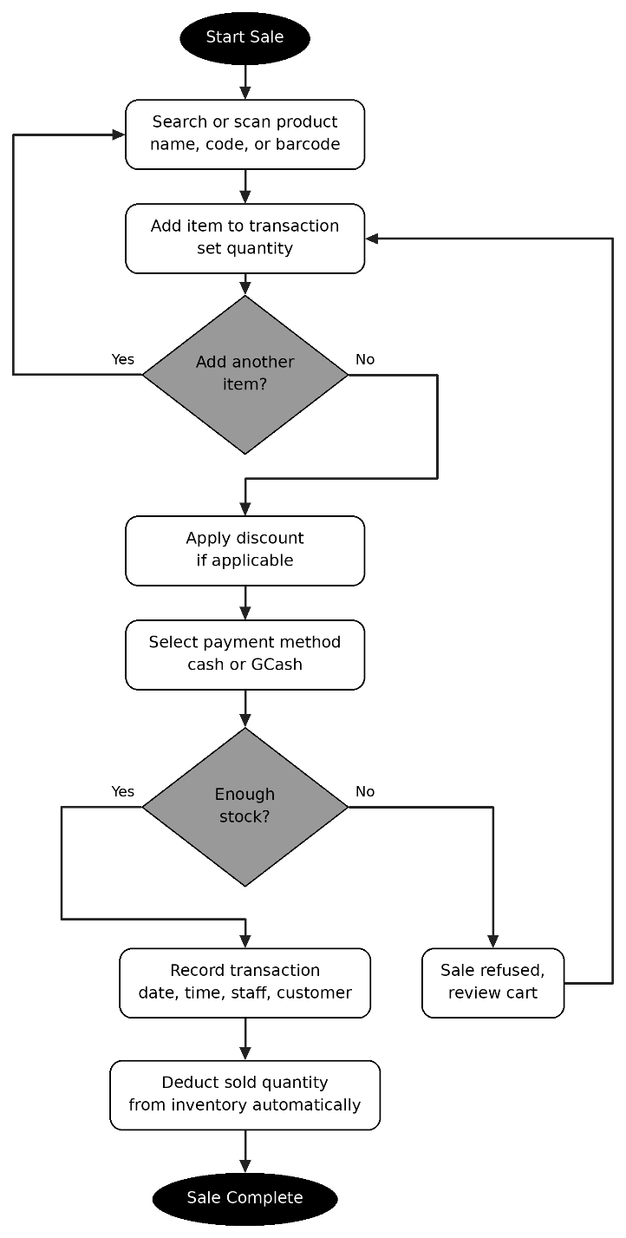
Traces a single sale from product search or barcode scan, through payment and a stock check, to the automatic deduction of stock.
Figure 1. Sales Transaction Flow
6.2.2 Inventory Update Flow
Shows how staff add, edit, or archive a product, and how the system checks stock levels and sends a low stock alert.
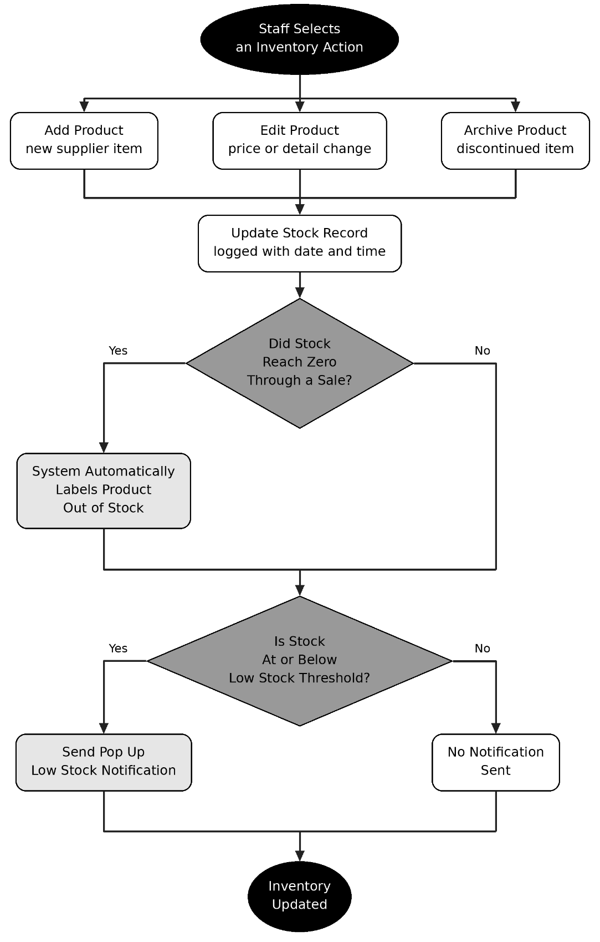
Figure 2. Inventory Update Flow
6.2.3 User Access Chart
Outlines what each role can view or edit, consistent with Sections 4.8 and 5.2.
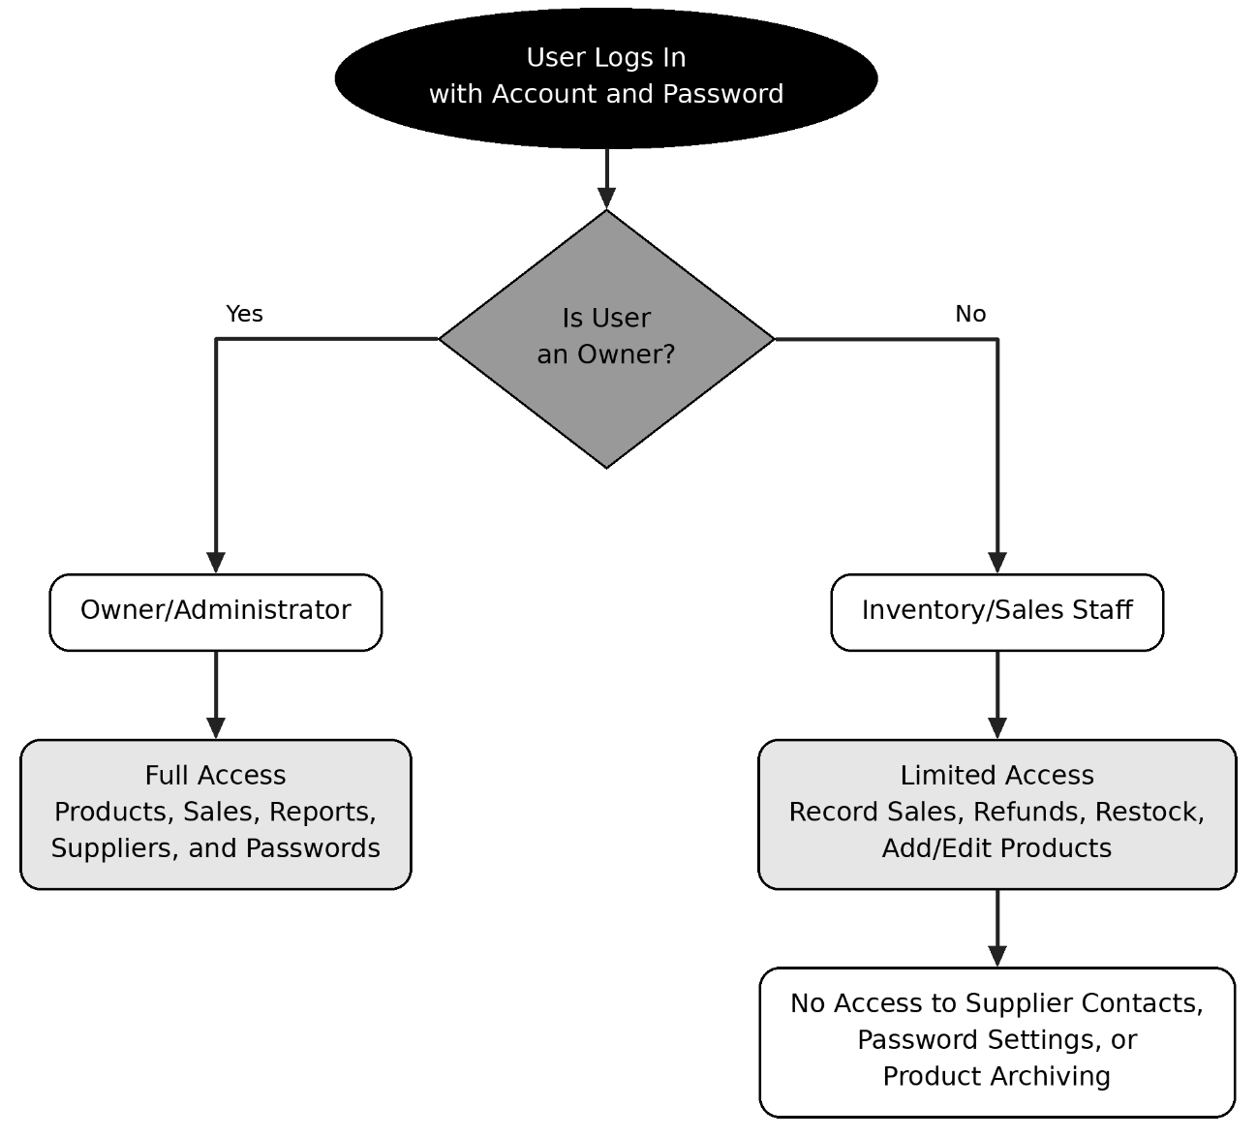
Figure 3. User Access Chart
6.2.4 Offline and Online Data Synchronization
Shows how a recorded sale or inventory update is handled depending on whether the device is online or offline.
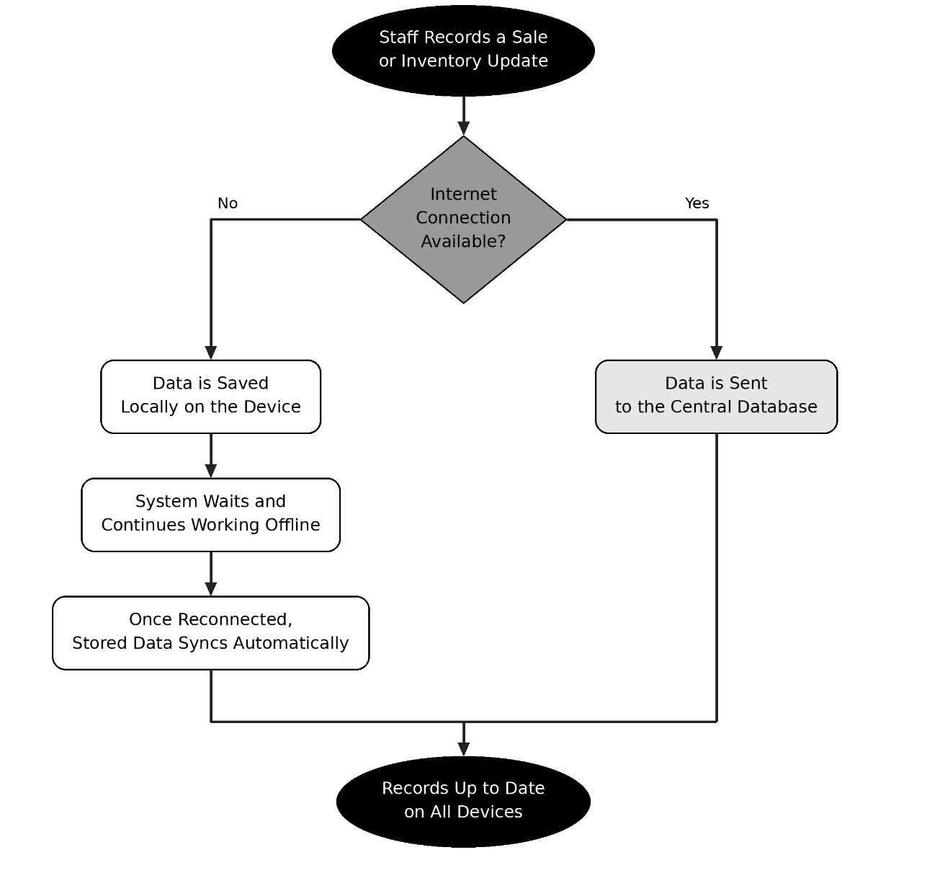
Figure 4. Offline-to-Online Data Synchronization
6.2.5 Refund and Exchange Flow
Shows how a past sale is refunded: the system checks the quantities against what was sold, works out the amount, and either returns the units to stock or keeps them out, for example if damaged. For an exchange, the refund is followed by a new sale of the replacement item (Figure 1).
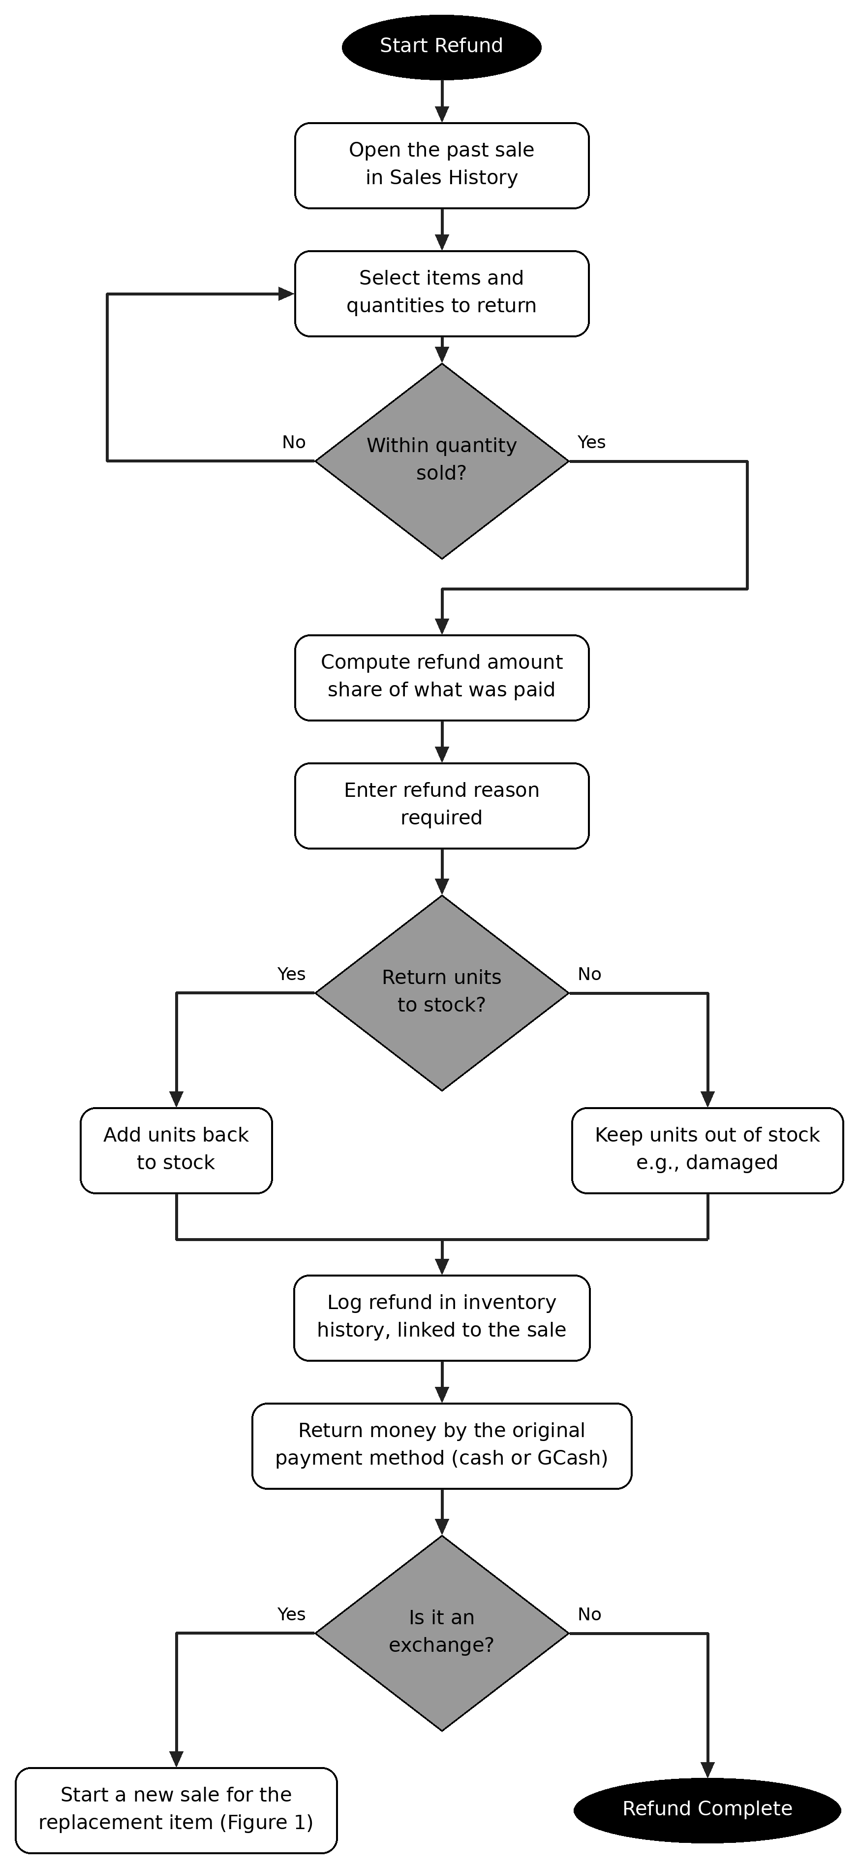
Figure 5. Refund and Exchange Flow

7. Approval and Sign-Off Matrix
The signatures below validate this Software Requirements Specification document as the official source of truth and development blueprint for the project build.
Role / Stakeholder | Name & Title | Signature / Date
Product Owner | Melanie Jabonite
Team Leader | Manuel Thomas Medina
UI Designer | Van Paulino
Frontend Developer(s) | Dawn Mabutin
Frontend Developer(s) | Chezza Mae Gonzaga
Backend Developer(s) | Michael John Felices
Backend Developer(s) | John Moises Balingasa
Backend Developer(s) | Renz Rommel Dasal
Database Administrator(s) | Pheche Prudenciado
Database Administrator(s) | Vanna Padilla

