Part 1:

1. Change into the ​csci2020u ​directory  


2. Make a new directory, called ​lab02



3. In the ​lab02 ​directory, create the directory structure used by Gradle

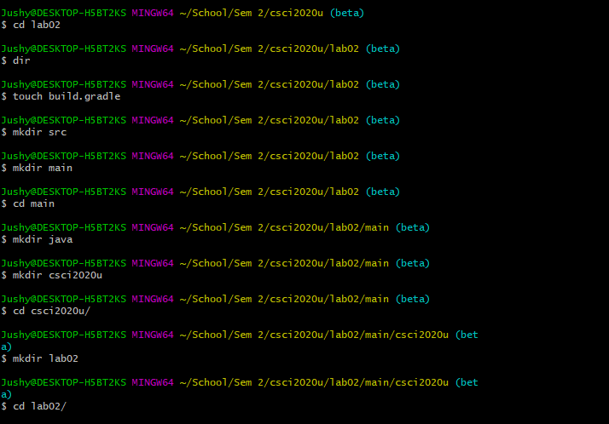





Part 2:

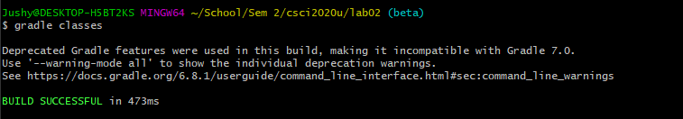

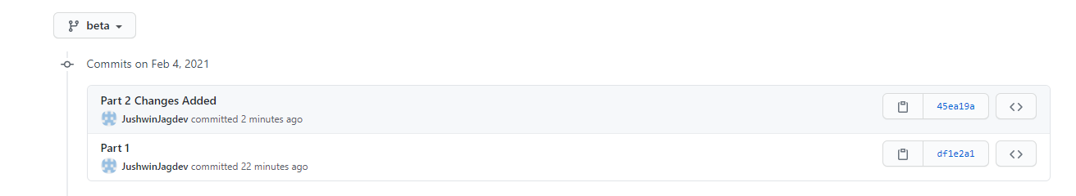

<https://github.com/JushwinJagdev/csci2020u_JushwinJagdev/tree/beta>

