A

Project Proposal

On

**Note Sharing System**

For the partial fulfillment of the requirements for the degree of Bachelor of Computer Engineering Under Pokhara University

**Submitted to**

Department of Computer Engineering

National Academy of Science and Technology

**Under the supervision of**

Mr. Sunil Bahadur Bist

Lecturer, Department of Computer Engineering

**Submitted by**

Binod Raj Pant (22070199)

BE Computer, 6th Semester

May, 2025

|  |  |
| --- | --- |
|  | **National Academy of Science and Technology**  (Affiliated to Pokhara University)  Accredited by University Grants Commission (UGC), Nepal (2022)  Uttarbehedi-4 Dhangadhi, Kailali, Nepal |

**Abstract**

The Note Sharing System is a web application that is designed to facilitate the efficient digital sharing of academic Note between multiple users. The system addresses the limitations of traditional note-sharing methods such as printed copies and fragmented digital files by providing a centralized, secure, and systematically organized collection of educational resources. The system utilizes role-based authentication to differentiate between various types of users and administrators, thus ensuring secure and controlled access.

Users can upload, search, and find Note categorized by subject or course, while administrators handle content moderation, manage user interactions, and provide system maintenance. The system supports multiple file types (e.g., PDFs, DOCX) and includes features like search functionality, categorization enhance overall ease of use.

With the advent of digital note-sharing sites, the reliance on physical resources decreased significantly, freed monotonous workloads, and made them accessible on multiple hardware. Additionally, collaborative learning is facilitated as individuals can exchange their insights, thus enriching the shared resources.

Highlighting its focus on scalability and security in its architecture, the system integrates data encryption with traditional backup measures for protecting users' content. In short, the Note Sharing System strives to improve university efficiency, facilitate knowledge sharing, and pursue an environmentally friendlier approach towards handling educational resources.

***Keywords: Note Sharing System, note-sharing site, digital Notesharing site***

1. **Introduction**

In today's fast-paced digital world, access to well-organized and reliable study materials is crucial for effective learning. Many individuals struggle to find high-quality Note on various subjects due to the lack of a centralized and structured platform. Existing solutions often rely on scattered resources, such as physical copies or informal online sharing, which can be disorganized, outdated, or difficult to retrieve. A dedicated digital system is needed to simplify the process of sharing and accessing educational content efficiently.

The Note Sharing System addresses this challenge by providing a unified platform where users can upload, search, and download Note across multiple subjects. Unlike traditional methods, this system ensures that Note are categorized systematically, making them easily accessible to anyone seeking study materials. By eliminating dependency on physical copies and unreliable sources, the platform promotes a more convenient and sustainable way of learning.

This system is designed to cater to a wide range of users, including students, self-learners, and professionals looking for structured educational content. With features like role-based access control, it maintains security while allowing seamless note-sharing. The goal is to create an inclusive, user-friendly environment that enhances knowledge dissemination without unnecessary restrictions, benefiting anyone in need of quality study resources.

1. **Problem Statement**
2. Lack of Centralized Platform
3. Difficulty in Finding Relevant Note
4. Inefficient Note Sharing
5. Convenience issues
6. **Objectives**

To develop a Note Sharing System that enables easy, reliable, and centralized exchange of academic notes with a focus on user convenience and secure access.

1. **Literature Study**

The design and implementation of the proposed Note Sharing System are informed by an analysis of existing digital learning platforms, academic resource-sharing services, and region-specific note-sharing applications. Global platforms such as Studocu, Course Hero, and Scribd demonstrate effective models for user-generated content, role-based access control, and scalable knowledge-sharing ecosystems [1]–[3]. Studocu employs a gamified reward system (StuCoins) to incentivize contributions, alongside hybrid (AI + human) moderation to ensure content quality [1]. Course Hero emphasizes copyright-aware sharing, balancing free and premium access while crowd-sourcing study materials [2]. Scribd, with its cloud-based document management and OCR-powered search, highlights the importance of cross-platform accessibility [3]. In contrast, regional platforms like E-Note, BSCCSIT Notes, and Mero Note cater to localized educational needs, particularly in Nepali academic contexts, but lack advanced features such as real-time collaboration, fine-grained access control, or version history [4]–[6]. E-Note focuses on offline note distribution for SEE/NEB curricula, while BSCCSIT Notes serves as a centralized repository for TU CSIT syllabus, limiting user-generated content [4], [5]. MeroNote prioritizes lightweight access but omits collaboration tools [6]. Synthesizing these insights, the proposed system addresses critical gaps by integrating real-time editing (inspired by global platforms), simplified role management (improving upon BSCCSIT Notes’ rigidity), and offline-first functionality (enhancing E-Note’s approach). Additionally, it adopts open-source cloud solutions to reduce costs, unlike proprietary models in [1]–[3], while incorporating transparent moderation and multilingual support for broader accessibility .

1. **System Requirements**
2. **Functional Requirements**
3. User Management
4. Notes management
5. Category management
6. Subject management
7. File management
8. Search and filtering by subject
9. **Non-Functional Requirements**
10. Scalability
11. Response time
12. Easy Ui
13. **Requirement prioritization table**

|  |  |
| --- | --- |
| **Requirements** | **Priority (High/Medium/Low)** |
| User Authentication | High |
| Upload/Download Note | High |
| Search | Medium |
| Security | Medium |
| Response Time | Medium |

1. **Methodology & System Design**

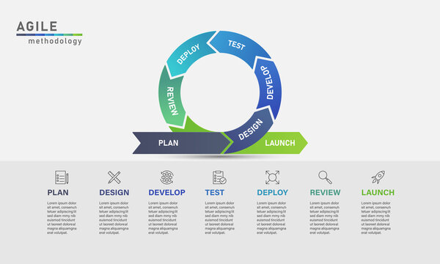**Methodology:** Agile model for development of Note Sharing System which is an iterative and incremental approach to project management that emphasizes flexibility and adaptability, particularly in software development When adopting the Agile model to develop the system, following processes were followed:

**Fig : Agile Methodology**

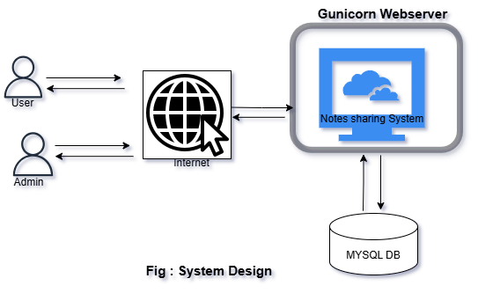**System Design:** In this phase the general concept or flow of system is Designed. We studied the stakeholder related to the Note Sharing system. The conceptual design of this system is as below:

Some of the System Designs are:

1. **Use Case Diagram**

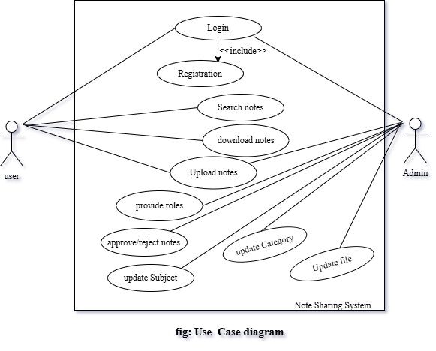

1. **Er diagram**

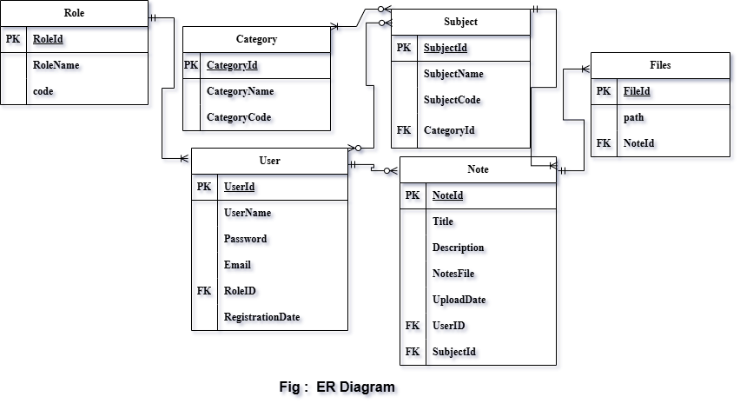

1. **Data Flow Diagram**

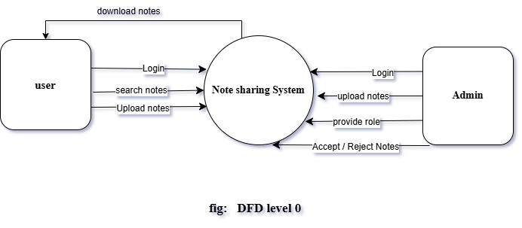

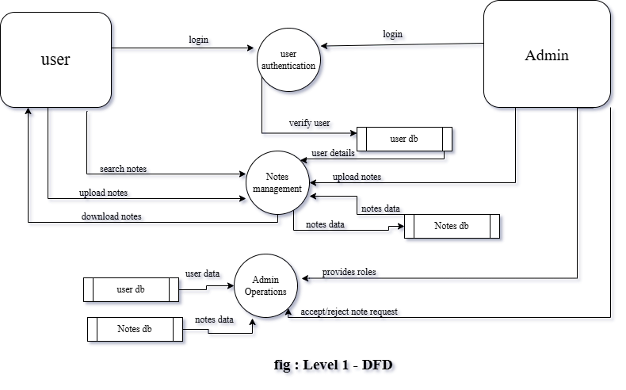

1. **Development Cost Estimation**

As this project is developed as part of an academic mini project, the overall cost has been kept minimal by utilizing available resources and open-source technologies. No commercial software or external funding was involved.

|  |  |  |  |
| --- | --- | --- | --- |
| **S. N.** | **Item** | **Details** | **Estimated Cost** |
|  | Development Tools | IDEs, Front-end, Back-end Technologies, Database | Open Source |
|  | Hardware depreciation | Laptop | 2000 |
|  | Documentation and Printing | Proposal, report and User manual | 1500-2000 |
|  | Domain and Hosting | Domain registration and hosting services | 5000-12000 |
|  | Development cost | All development related cost | 20000*3=60000 |
|  | Miscellaneous Costs | Business registration, legal consultations, electricity etc. | 15000 |
|  | Planning and Research | Feasibility study , information gathering | 5000 |

**Total Cost Estimation : 92000**

1. **Project Schedule (Task and Timeline Diagram)**

This project schedule has been designed as per the requirements and constraints involved. This project is scheduled to be completed in about 3 months. This project starts form the second week of May, 2025 and goes to fourth week of July, 2025 where there is final Defense.

|  |  |  |  |  |  |  |  |  |  |  |  |
| --- | --- | --- | --- | --- | --- | --- | --- | --- | --- | --- | --- |
| **Activities** | **May** | | | **June** | | | | **July** | | | |
| W 2 | W 3 | W 4 | W 1 | W 2 | W 3 | W 4 | W 1 | W 2 | W 3 | W 4 |
| Project analysis |  |  |  |  |  |  |  |  |  |  |  |
| Feasibility Study |  |  |  |  |  |  |  |  |  |  |  |
| Proposal Submission |  |  |  |  |  |  |  |  |  |  |  |
| Proposal defense |  |  |  |  |  |  |  |  |  |  |  |
| Designing |  |  |  |  |  |  |  |  |  |  |  |
| Coding |  |  |  |  |  |  |  |  |  |  |  |
| Mid-term defense |  |  |  |  |  |  |  |  |  |  |  |
| Testing |  |  |  |  |  |  |  |  |  |  |  |
| Final Testing |  |  |  |  |  |  |  |  |  |  |  |
| Documentation |  |  |  |  |  |  |  |  |  |  |  |
| Final Defense |  |  |  |  |  |  |  |  |  |  |  |

1. **Proposed Deliverable**
2. Project Report
3. Presentation slides
4. Note Sharing System
5. **Conclusion**

The Note Sharing System presents an efficient and scalable solution to the challenges of accessing and distributing educational Note in a digital era. By providing a structured, user-friendly platform, it eliminates the inefficiencies of scattered resources and promotes organized, secure, and instant access to study materials. The system’s role-based access ensures smooth management while maintaining flexibility for all users—students, self-learners, and professionals alike. Beyond convenience, this project highlights the importance of democratizing education through technology. By reducing dependency on physical Note and unreliable sources, it fosters a collaborative and sustainable learning environment. Future enhancements could include AI-driven recommendations, version control for Note, and broader subject coverage to further improve usability.

Ultimately, the Note Sharing System bridges the gap between knowledge seekers and providers, making education more accessible, efficient, and adaptable to modern needs. Its success lies in its simplicity, security, and universal applicability—a step forward in redefining how knowledge is shared and consumed.

1. **References**

[1] Studocu, “StuCoin rewards and content moderation,” [Online]. Available: <https://www.studocu.com> . Accessed: May, 10, 2025.

[2] Course Hero, “Copyright and crowdsourced materials,” [Online]. Available: <https://www.coursehero.com> . Accessed: May, 10, 2025.

[3] Scribd, “Document storage and retrieval systems,” [Online]. Available: <https://www.scribd.com> . Accessed: May, 10, 2025.

[4] E-Note, “Nepali educational notes repository,” [Online]. Available: <https://www.enote.com.np> . Accessed: May, 10, 2025.

[5] BSCCSIT Notes, “TU CSIT syllabus-based resources,” [Online]. Available: <https://www.bsccsit.notes.edu.np> . Accessed: May, 10, 2025.

[6] Mero Note, “Minimalist note-sharing platform,” [Online]. Available: <https://www.meronote.com.np> . Accessed: May, 10, 2025.