**A, LIKELY UNDERSERVED, DEFENSE OF THE PUBLIC SECTOR IN A RANDOM UNFORGIVING WORLD**

**INTRODUCTION**

I find farming sims relaxing. You know, those games where you pretend to be a farmer living in a small community. Everything’s cute and fun.



Delightful!

A common minigame in these is the fishing minigame. It is a game of precision where you have to use your mouse or console to pull and release. If you click too much, you will break the pole. If you click too infrequently, your fish will escape.



Miserable[1]!

In even bringing up the farming sims, I’m procrastinating writing this article. I’ve been doing that for the last month. In a lot of ways, talking about the private sector, any private sector, can feel as precarious and fruitless as trying to catch an imaginary fish. If you’re too anti-government, you look like one of those libertarians who joined the movement in protest of age of consent laws. But you certainly don’t want to be too pro-government. You look like a fresh baby that’s never read Animal Farm.



You either die a hero or live long enough to be the horse from animal farm

If you’re *really* poor with your words, you look like both at the same time. And, you know what, that is a risk I am willing to take with this article about the plans governments make and the non-incompetence based reasons why they don’t always work.

**DEVELOPMENT STRATEGY**

Say you’re from a financially challenged country.

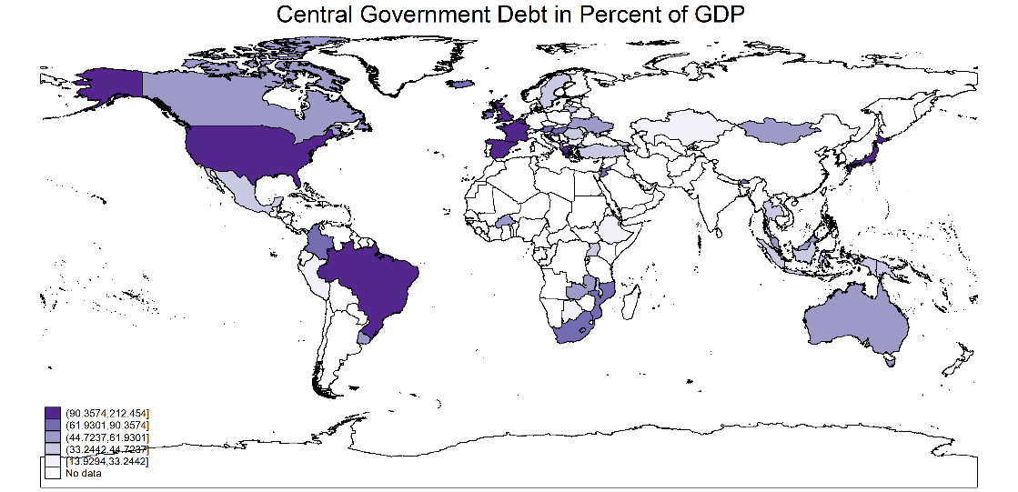

Hypothetically, of course

Let us assume that the majority of the people working for your government are doing at least a third of their jobs. Money is scarce and flows unpredictably. Your governments have to create plans on how they will allocate this scarce and unpredictable resource. Your governments also need to communicate these plans in ways that limit social unrest and convince the rest of the world that they know what they’re doing. These are called national development strategies. You can usually find them on their websites.



Which is a moot point if you don’t read them

Now, if governments always managed to do what they promised, this article would be irrelevant. Now, it is tempting to always attribute these failures to central government circus behavior because you are probably right. However, there are other reasons for these accidents. I want to illustrate the economy and vacation ruining power of macroeconomic shocks.

**VARIABILITY IN ECONOMIC DEVELOPMENT**

Did you know that most of the traditional industrialized countries have an average growth rate of less than 4 percent? I looked it up for you. I’m cool like that.

Growth Rates in Traditional Industrialized States

|  |  |  |
| --- | --- | --- |
| **Country Name** | **Mean Annual Growth Rate (%)** | **Annual Growth Standard Deviation (%)** |
| **Australia** | 3.368 | 1.749 |
| **Belgium** | 2.582 | 2.239 |
| **France** | 2.649 | 2.443 |
| **Japan** | 3.375 | 3.886 |
| **United Kingdom** | 2.282 | 2.716 |
| **United States** | 2.998 | 2.101 |

Source: World Bank World Development Indicators

Check the appendix for calculations

The implication of this is that your country would only need to maintain a growth rate of less than 4 percent per annum, *consistently*, to eventually industrialize. It has been done before. Now, let us look at some more countries.

Growth Rates for Low and Middle Income Countries With High Growth Rates

|  |  |  |
| --- | --- | --- |
| **Country Name** | **Mean Annual Growth Rate (%)** | **Mean Annual Growth Rate (%)** |
| **Botswana** | 7.576 | 6.664 |
| **Myanmar** | 5.247 | 5.947 |
| **Oman** | 7.899 | 14.463 |
| **Nigeria** | 3.662 | 5.947 |
| **Thailand** | 5.551 | 3.884 |

Source: World Bank World Development Indicators

Check the appendix for calculations

These are all countries that many people would like to visit but they’re not exactly known for being economic powerhouses despite their growth rates being much higher than that of the more traditionally healthy countries. However, these countries have higher GDPs, human development indicator factors and levels of infrastructural growth partially because of the variability of these growth rates. See, the variability in the growth rate implies incredible highs and lows which cancel out to arguably mid GDP per annum growth rates. Thus is the power of the things you cannot control; shocks like currency devaluations, commodity price fluctuations and insurgencies. Let’s use Malawi as an example because that’s where I’m from.

**MALAWI 2063**

The Malawi 2063 is divided into 10 year bite sized implementation plans. The first (MIP-1) is a roadmap that Malawi would use to become at least a lower-middle income country by 2030. A lower middle income country, according to the World Bank, is a country with a gross national income (GNI) per capita ranging from 1,146 to 4,515 USD[2]. These are countries like Haiti, Pakistan and Zimbabwe (World Bank n.d.). Surely, it was not an exhibition of hubris to plan for Malawi to reach the same level of economic development as Pakistan, Zimbabwe and Haiti by 2030 (World Bank n.d.).

**(LETS MATHEMATICALLY EXAMINE WHY) THIS WAS NOT AN EXHIBITION OF HUBRIS BECAUSE IN THE SOCIAL SCIENCES YOU HAVE TO PROVE EVERYTHING**

To achieve this level of growth, the people who wrote the Malawi 2063 calculated that, from 2019 moving forward, the country would need a consistent GDP growth rate of at least 6 percent to become a lower middle income country by 2030. In my generosity, I calculated 5.75 percent. Because I love you. Check the appendix for the formula I used. While this is a bit ambitious, it was not inconceivable, at the time, because:

1. **Growth rate in prior years**

Growth Rates

|  |  |  |  |  |  |
| --- | --- | --- | --- | --- | --- |
|  | **2015** | **2016** | **2017** | **2018** | **2019** |
| **Actual** | 2.8% | 2.5% | 4.0% | 4.4% | 5.5% |
| **Necessary** | 4.3% | 4.6% | 4.9% | 5.2% | 5.4% |
| **Sub-Saharan Africa** | 2.9% | 1.2% | 2.5% | 2.8% | 2.7% |

The growth rate in 2019 was approximately 5 percent and had been trending upwards for several years. This could have been evidence of a peak in a business cycle. However, this could also be evidence of improving economic prospects due to factors like ideal weather conditions, investments in agribusiness and the growing mining sector. Lastly, this growth rate was higher than that of the regional average on a continent gaining a reputation for rapid economic development.

1. **Unlocking resources in the country**

There were some viable suggestions for areas of improvement. In the case of Malawi it could be taking advantage of growth in the financial and information technology sectors. Perhaps, revitalizing the agricultural sector through modernization, mechanization, crop diversification, value addition or plantation style commercial farming. Perhaps expanding the tourism sector by taking advantage of some of the country’s comparative advantages like the lake or the cave paintings or the forest hikes.

1. **Belief in you**

Macroeconomists are starting to categorize the value of intangible assets like trust (Chami, Espinoza and Montiel 2020) and innovation (Hospers 2005). Its visible if you know where to look. Trust, for example, manifests in international variations in public sector revenue collection, tax evasion and perceptions of corruption (even among countries at the same economic level). You also cannot measure how much politicians and public servants believe in their country. But, you can sense it with some leaders and policymakers.

**WHY THIS ULTIMATELY DID NOT WORK OUT**

If you look at the growth rate we actually got, it was grossly inadequate.

Malawi Growth Rate from 2020 to 2024

|  |  |  |  |
| --- | --- | --- | --- |
| **Year** | **2020** | **2021** | **2022** |
| Growth Rate | 0.80 % | 2.75 % | 0.92 % |

There are a lot of reasons why they don’t always fully work out. A lot of it was corruption. While rent seeking does play an unprecedented role in obstructing national progress, the real chicanery is in the variables that no one could predict. In 2020 we had a growth rate of 0.8 percent. That’s almost nothing. Why did this happen? The covid-19 Pandemic, among other disasters. Behold:

The Abbreviated Table of Unexpected Public Sector Shocks

|  |  |  |
| --- | --- | --- |
| **Year** | **Calamity** | **Yikes Magnitude[3]** |
| **2020** | Covid-19 | !!! |
| **2021** | Too much rain for the tobacco | !! |
| Kapichira power station being absolutely wrecked by the rain | !!!!! |
| **2022** | Tropical Storm Ana | !!!!! |
| Russia-Ukraine War | !! |
| 25 Percent Devaluation | !!!!! |
| **2023** | Cyclone Freddy | !!!!!! |
| 44 Percent Currency Devaluation | !!!! |

**WELL, WHATS THE POINT THEN?**

I like a good commie trash joke just as much as the next person and I am acutely aware of how governments incompe-dance away your tax dollars.



For many of us (you too), this is the national anthem.

So why have development strategies if you we live in uncertainty and at any minute something you cannot predict will disturb all your plans? What’s the point if you don’t really believe in your government? What’s the point of doing anything? Why train for a marathon if your roommate might hit you with their car and paralyze you? Everything we do is shadowed by uncertainty and risk. You can at least hedge your bets if you have some sort of plan. Even if it doesn’t work, it gave you a direction to start from and a place to question yourself if the progress doesn’t happen. It is also important to consider that there are steps responsible governments can take to hedge their bets. Steps like investments in clean technology and getting support from organizations like MIGA and the IMF.

**WHAT ABOUT 2063?**

I almost forgot about that. I’m sure you did too because 2063 is so far into the future that unless Malawi has a years-long civil war, it should at least be a lower middle income country by then. To be a lower middle income country by 2063, it would need an annual growth rate of 1.7 percent until 2063. It is unlikely that the growth rate will remain that low. There’s even hope for the country to become an upper middle income country by then. According to the generous version of my calculation, Malawi would need a steady annual growth rate of approximately 5 percent to be an upper middle income country by 2063.

**BIBLIOGRAPHY**

Chami, Ralph, Raphael Espinoza, and Peter Montiel. 2020. "Macroeconomic Policy in Fragile States ." In *The Role of Trust in Rebuilding Failed and Fragile States* , by Daouda Sembene, 111-128. Oxford: Oxford Univesity Press.

Government, Malawi. 2023. *Annual Economic Report 2023.* Lilongwe: Malawi Government .

Hospers, Gert-Jan. 2005. "Joseph Schumpeter and His Legacy in Innovation Studies ." *Knowledge, Technology & Policy* 20-37.

Malawi Government. 2022. *Annual Economic Report 2022.* Lilongwe: Ministry of Economic Planning, Development and Public Sector Reforms .

National Planning Commission. 2021. *Malawi 2063.* Lilongwe: National Planning Commission.

Planning, Ministry of Economic. 2020. *Annual Economic Report 2020.* Lilongwe: Ministry of Economoic Planning.

The Ministy of Economic Planning. 2021. *Annual Economic Report 2021.* Lilongwe: Ministry of Economic Planning, Development and Public Sector Reforms .

World Bank. n.d. *World Bank Country and Lending Groups.* Accessed 06 14, 2024. https://datahelpdesk.worldbank.org/knowledgebase/articles/906519-world-bank-country-and-lending-groups.

—. n.d. *World Bank Country and Lending Groups.* Accessed June 2024. https://datahelpdesk.worldbank.org/knowledgebase/articles/906519-world-bank-country-and-lending-groups.

**APPENDIX**

1. **Where did I get my data?**

I used data from the World Development Indicators (WDI) from the World Bank. The GDP estimates in the world development indicators are slightly different from those recorded in the Malawi Annual Economic Report and the IMF World Economic Outlook. This is because these and the Malawi government are all different institutions using separate parameters for their estimates. Fortunately, the numbers are all very similar. I like the use the WDI because they’re easily accessible.

1. **How does this equation work?**

I borrowed a compounding equation from the accountants and finance folks and used it to reverse engineer the growth rate Malawi would consistently need, based on a year, to become a lower middle income country.

I used the GNI growth rate as a proxy for the GDP growth rate. I explain why below.

1. **Why did I use GDP as a proxy for GNI?**

Both of these variables are indicators of an economy’s productivity but with slight differences. The gross domestic product (GDP) measures all that is produced within an economy. The gross national income (GNI) measures all that is produced by residents of Malawi (even those outside of Malawi) minus what is produced by non-residents within Malawi). In Malawi’s case, the GDP and GNI are quite similar with the GNI consistently being slightly higher

|  |  |  |  |  |  |  |  |  |
| --- | --- | --- | --- | --- | --- | --- | --- | --- |
| **Year** | **2015** | **2016** | **2017** | **2018** | **2019** | **2020** | **2021** | **2022** |
| **GNI** | 550.56 | 549.24 | 556.18 | 565.46 | 580.73 | 570.04 | 570.29 | 560.67 |
| **GDP** | 544.28 | 542.93 | 549.63 | 558.56 | 573.40 | 562.78 | 563.36 | 554.20 |

Because of this, I am assuming the growth rate we found for the GNI is the same one we would need for the GDP to facilitate the economic growth we are looking for.

1. I am being hyperbolic. I actually like the fishing minigames. They’re hard, though
2. This is according to the financial year 2024/25 classification
3. Based on my personal perceptions