

School of Engineering
Diploma in AI & Data Engineering

EGDT305
Big Data Processing Platforms & Applications

Big Data Analytics & Comparison Report
AY2026S1

- Perform data cleaning on PySpark
Summary: 1,000,000 to 991,997 rows (0.8% removed): 104 duplicate jobIds, 4 fabricated 'SCAMMER' rows, nulls dropped/imputed (median/'UNKNOWN'), distanceFromCBD outliers to 500,000km removed via IQR, salaryInThousands outliers removed via IQR (bounds $11K-$219K; one row read $10,000,000). Full justification and before/after counts are in the submitted notebook, Section 3.
- Exploratory Data Analysis.
- What is the highest paying job role for the web industry?
Answer: CEO is the highest-paying role in the WEB industry, averaging $148K. Reason: executive roles carry the largest pay premium in every industry, and WEB is itself the 3rd highest-paying industry overall, so its top role clears $140K.
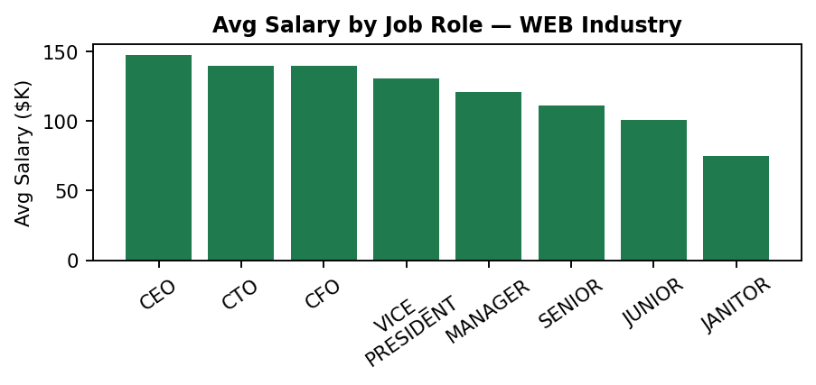
- Rank the top 10 jobs roles with the highest salary for all the industry?
Answer: Only 9 distinct job roles exist in the cleaned dataset (no 10th): 1. CEO $143K, 2. CTO $134K, 3. CFO $134K, 4. VICE_PRESIDENT $125K, 5. MANAGER $115K, 6. SENIOR $105K, 7. JUNIOR $95K, 8. PRESIDENT $81K (n=1, statistically negligible), 9. JANITOR $71K. Reason: the ranking mirrors organisational hierarchy almost exactly.
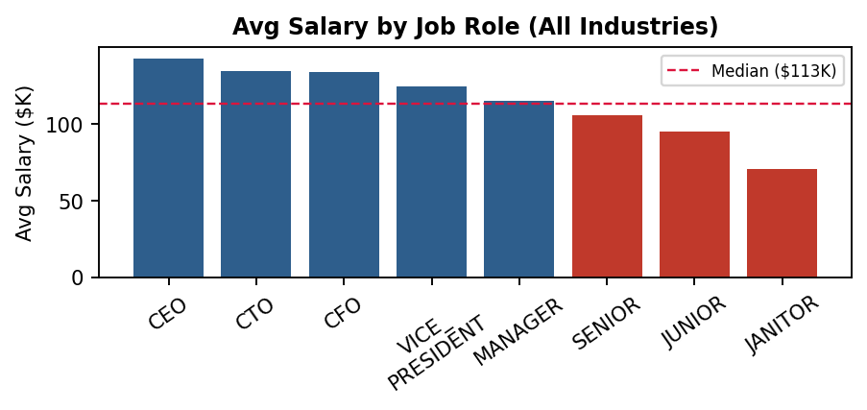
- Which of the industries has the highest salary?
Answer: OIL has the highest average salary at $129K, marginally ahead of FINANCE ($129K). Reason: both are capital-intensive industries with high revenue per employee, which supports higher compensation.
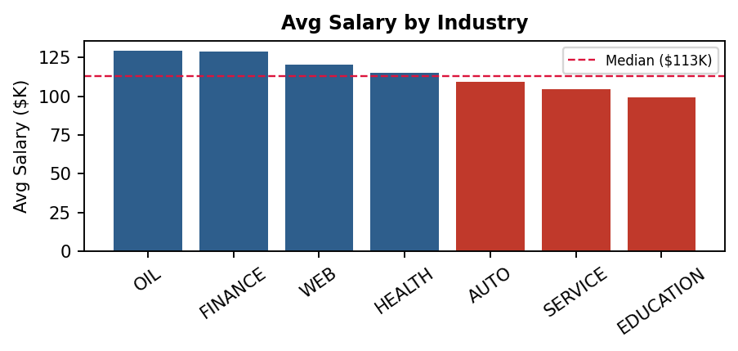
- Which job has the lowest pay?
Answer: JANITOR has the lowest average salary at $71K. Reason: it is a non-specialised role with lower skill requirements and a larger available labour pool.

- Which industries have the lowest pay?
Answer: GOVERNMENT is technically lowest ($81K), but that is a single record in the cleaned dataset and is not a reliable finding. Among industries with adequate sample size, EDUCATION ($99K) and SERVICE ($104K) are the genuinely lowest-paying sectors.
Reason: both are service driven, often publicly funded sectors rather than revenue/capital-intensive ones, which structurally caps salary budgets.

- Median salary per year
Answer: The computed median salary is $113,000/year.

- Which industry has the highest percentage of people who are below the median salary?
Answer: Technically GOVERNMENT (100%), but this is a single-record category and not a meaningful finding. Among industries with adequate sample size, EDUCATION has the highest share below the $113K median at 66.0%, followed by SERVICE (60.7%) and AUTO (55.5%). Reason: EDUCATION and SERVICE are lower revenue-intensity, often publicly-funded sectors, which structurally caps pay below the market median.
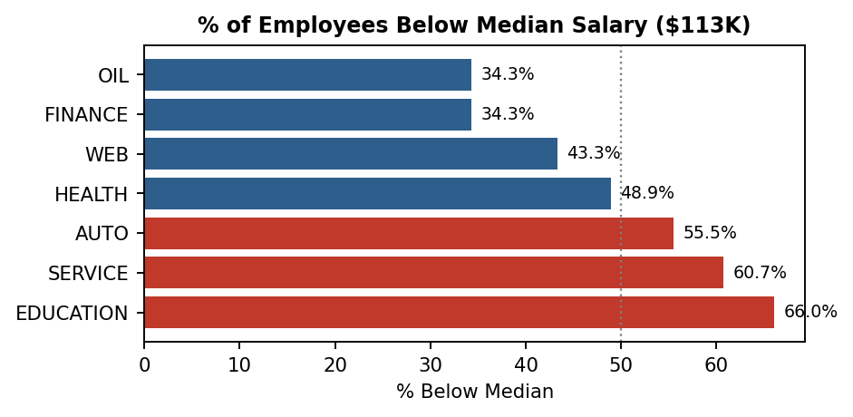

- What are the job roles that are below the median salary?
Answer: SENIOR ($105K), JUNIOR ($95K), and JANITOR ($71K) fall below the $113K median. PRESIDENT ($81K) is also technically below it but is a single-record role and not representative.

Reason: these sit in the lower rungs of the seniority ladder, where lower responsibility and a larger available labour supply keep pay below the market median (red bars in the job-role chart above).

- Determine if there is a relationship between years of experience and salary.
Answer: Yes, a positive but moderate relationship: Pearson correlation r = 0.36. Average salary rises steadily from $92K at 0 years to $137K at 24 years, but the wide spread of salaries within each experience level shows job role and industry are stronger predictors than tenure alone. (As a side comparison, distanceFromCBD correlates at r = -0.29 -- salary tends to be higher closer to the CBD.)
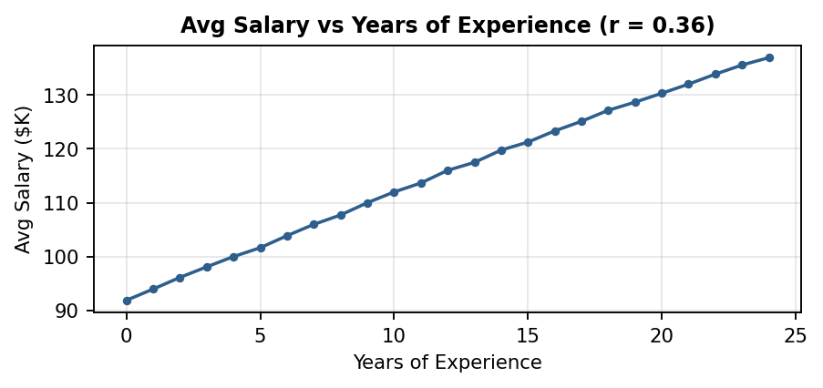

- Is there a relationship between education and salary?
Answer: Yes: DOCTORAL $134K > MASTERS $129K > BACHELORS $125K > HIGH_SCHOOL $102K > NONE $98K -- a clear, monotonic ordering. However the premium is modest (~$9K from Bachelor's to Doctoral), so education is a contributing factor but not the dominant salary driver.
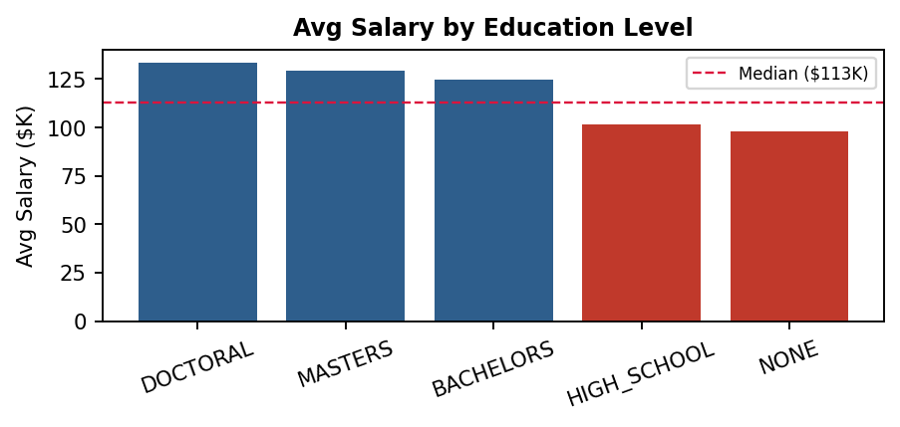

- Did the major they studied affect the salary?
Answer: Yes, but the effect is small. ENGINEERING ($136K) and BUSINESS ($134K) pay the most, LITERATURE ($124K) the least -- a spread of only ~$12K, versus a ~$72K spread across job roles. Major matters far less than role or industry. Overall conclusion across (i)-(k): job role and industry are the dominant salary predictors; education, experience, and major are secondary contributing factors.
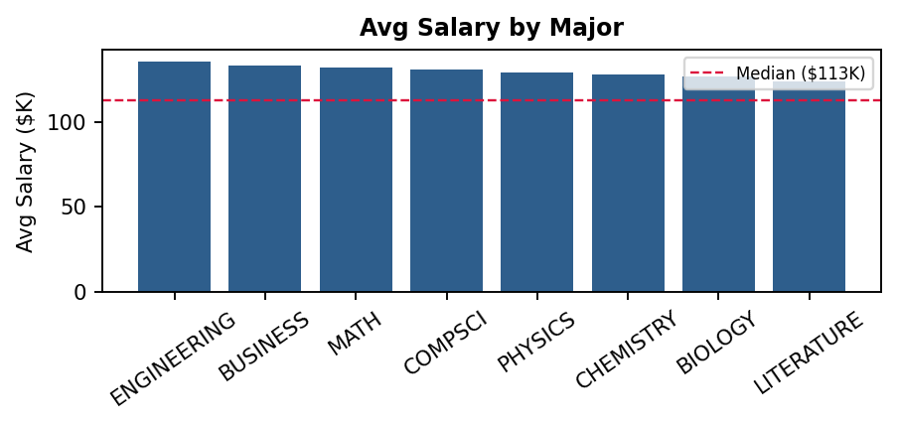

- ML Model Development using PySpark
Feature Engineering & Training Setup
- Categorical features (jobRole, education, major, industry) encoded via StringIndexer -> OneHotEncoder; numeric features (yearsExperience, distanceFromCBD) used as-is; all assembled into a 35-dimension feature vector.
- 80/20 train-test split (seed=42): 793,858 training rows, 198,139 test rows.
- Three regressors trained and compared: Linear Regression (regParam=0.1, elasticNetParam=0.8), Random Forest (100 trees, maxDepth=10), and Gradient Boosted Trees (100 iterations, maxDepth=5), each evaluated on the held-out test set with RMSE, R² and MAE.
Model Comparison (held-out test set)
Model | RMSE | R² | MAE
Linear Regression | 19.12 | 0.7385 | 15.53
Random Forest | 20.52 | 0.6990 | 16.50
GBT Regressor (selected) | 18.54 | 0.7543 | 15.14

Model selected: GBT Regressor -- lowest RMSE ($18.54K), highest R² (0.754), lowest MAE ($15.14K). Reason: salary depends on interactions between categorical features (a CEO in OIL != a CEO in WEB premium). GBT's sequential error-correction -- each tree targets the previous ensemble's residuals -- captures these interactions, which a single linear equation cannot.
Why the other two were not selected: Random Forest scored below Linear Regression on every metric: with only 6 raw features, its random feature subsampling per split is too aggressive to consistently learn jobRole/industry/education interactions. Linear Regression was competitive (R² = 0.74, salary is mostly linear in experience) but can't model non-linear salary banding between roles, and has the highest MAE of the three.
Hyperparameter Tuning: GBT tuned via 3-fold cross-validation over maxDepth [4,5] x maxIter [50,100] (12 fits). Best: maxDepth=5, maxIter=100 -- RMSE=18.54, R²=0.754, MAE=15.14, confirming the original hyperparameters were already near-optimal, now with cross-validated evidence.

- Recommend strategies for how a person can chart their career
The profile of the person is:
- Years of experience in the following:
  - Software, AI & Data: 6
  - Backend Services: 14
- Interest: Board games, fixing things, Trading card games
- Yearly salary: $100,000
- Married with three cats, one toddler, six chickens and one whole room of trading card games and blind boxes.
- Owns a house with a monthly mortgage of $2,50
- Monthly household expenditure: $6,000

Financial Baseline
Monthly mortgage ($2,500) + monthly household expenditure ($6,000) = $8,500/month = $102,000/year in committed expenses, against a current salary of $100,000. That is already a $2,000/year shortfall before accounting for the toddler's future costs, so salary growth is not optional, but it is financially necessary.

1. Which industry should this person move into?
Answer: FINANCE (fintech). It is the 2nd highest-paying industry in this dataset ($129K average, vs. $100K current), and it is the most natural landing spot for a 20-year Backend Services + Software/AI/Data profile.

2. Why that industry?
- High, sustained demand for real-time data pipelines and ML models in fraud detection, algorithmic trading and risk analytics, where backend + data/AI skills intersect.
- 14 years of backend services experience transfers directly to building the scalable, reliable systems banks and fintechs run on.
- Singapore's financial sector is short on experienced engineers who also understand regulatory/data-integrity requirements (MAS, Basel) a 20-year veteran is a rare, valuable combination rather than a generic hire.
- Singapore's ICT sector has an IMDA-identified gap of ~19,000 professionals; software engineers, data scientists and finance professionals are the most in-demand roles into 2026 (Jobs in Demand in Singapore 2026, finalroundai.com).

3. What skillsets are needed?
- Cloud architecture (AWS/GCP): Singapore cloud engineers earn a median ~S$110K, mid-level S$105-145K, seniors S$150-200K (skillup.sg, 2026) - certification is a direct lever on pay.
- MLOps / data-engineering tooling (Spark, Kafka, Airflow, MLflow, model serving): AI/ML engineers in Singapore earn S$105K-130K, roughly 10-15% above equivalent data scientists, with MLOps/infrastructure depth cited as the main driver of the gap at senior level (skillup.sg AI/ML Engineer Salary Guide, 2026).
- How to obtain it: SkillsFuture Credit + IMDA's TeSA programme subsidise this training for Singaporeans/PRs, lowering the cost of the AWS/GCP/Kubernetes route (skillup.sg, 2026).
- Practical route: 1) one cloud associate certification (~2-3 months part-time), 2) a hands-on MLOps project for interviews, 3) target fintech/bank data-platform teams directly.

4. Financial feasibility check
Employees with 18-22 years' experience in this dataset average $130K (range $30K-$219K, n=196,345). Narrowing to Finance/Web industry, senior-to-VP-level roles specifically, the average is $141K - a +$41K improvement over the current $100K, comfortably clearing the $102K annual-expense baseline. Even the more conservative FINANCE industry-wide average ($129K) provides a $27K surplus.

5. Leveraging personal interests
Board games and trading card games reflect analytical, probabilistic thinking - directly relevant to risk analytics and algorithmic trading in finance.

