深 圳 大 学 实 验 报 告

课程名称： 数字图像处理

实验项目名称：Exp2 Image Intensity Transformations and
Spatial Filtering

学院： 电子与信息工程学院

专业： 电子信息工程

指导教师： 李斌

报告人： 学号： 班级： 文华班

实验时间： 2024年 4月2日、9日、16日

实验报告提交时间： 2024 年 4 月 18 日

教务部制
实验目的（Aim of Experiment）：
- Learn the method of contrast adjustment and histogram equalization.
- Learn how to display histograms of images.
- Learn how to perform spatial filtering.

实验内容与要求（Experiment Steps and Requirements）：
- Perform Contrast Adjustment. (a) Load the image 'beans.png'. (b) Stretch its graysacle to the range of [0,1]. (Tips: skimage.exposure.rescale_intensity). (c) Shrink its grayscale to the range of [0.2,0.8]. (Tips: skimage.exposure.rescale_intensity). (d) Obtain the negative image. (Tips: skimage.exposure.rescale_intensity). (e) Perform log transformation. (Tips: skimage.exposure.adjust_log). (f) Perform Gamma transformation with 𝛾=0.5 and 𝛾=1.5, respectively. (Tips: skimage.exposure.adjust_gamma). Display the images with suitable titles.
- Compute and Display Image Histogram. (a) Compute the histogram of the original image and the histograms of the adjusted images above. (Tips:Matplotlib.pyplot.histor skimage.exposure.histogram(image, nbins=256)). (b) Display the histogram of the original image and the histograms of the adjusted images above. Use a suitlabe title for each figure.
- Image Histogram Equalization. (a) Load the image 'beans.png'. (b) Perform histogram equalization of the image. (Tips: skimage.exposure.equalize_hist). (c) Display the original image, the equalized image, the histogram of the original image, and the equalized image. (d) Answer the question: What are their differences?
- Smoothing Linear Filtering. (a) Load the image 'mandrill.jpg'. (b) Add salt&Pepper noise with different intensities (at least 3 kinds). (Tips: skimage.util.random_noise). (c) Perform smoothing linear filtering to smooth these noised images respectively. (Tips: ImageFilter.BLUR). (d) Display the images in the same figure with sub-figures. Add the corresponding title to each sub-figure.
- Gaussian Smoothing Filtering. (a) Load the image 'mandrill.jpg'. (b) Add Gaussian noise to image. (Tips: skimage.util.random_noise). (c) Perform Gaussian Smoothing Filtering to smooth the noised image. Select kernels with different radius values (at least 3 kinds). (Tips: ImageFilter. GaussianBlur). (d) Display the images in the same figure with sub-figures. Add the corresponding title to each sub-figure.
- Median Filtering. (a) Load the image 'mandrill.jpg'. (b) Add salt&Pepper noise with different intensities (at least 3 kinds). (Tips: skimage.util.random_noise). (c) Perform median filtering to smooth these noised images respectively. Select kernels with different radius parameter values (at least 3 kinds). (Tips: ImageFilter.MedianFilter). (d) Display the images in the same figure with sub-figures. Add the corresponding title to the sub-figure.
- Sharpening Filtering. (a) Load the image 'lena.jpg', convert it to grayscale. (b) Perform sharpening spatial filtering to enhance the image with different parameters (at least 3 kinds). (Tips: skimage.filters.laplace). (c) Display the images in the same figure with sub-figures. Add the corresponding title to the sub-figure.
- Face Detection and Processing with OpenCV. (Bonus Practice) (a) Load the image 'exp2_7.jpg'. (b) The face region is detected and marked with a green rectangle. (Tips: You may usecv2.CascadeClassifier, or cv2.dnn.readNetFromCaffe, or MTCNN). (c) Perform Gaussian smoothing filtering for the background region. Some examples of the generated results are shown in the figure below.
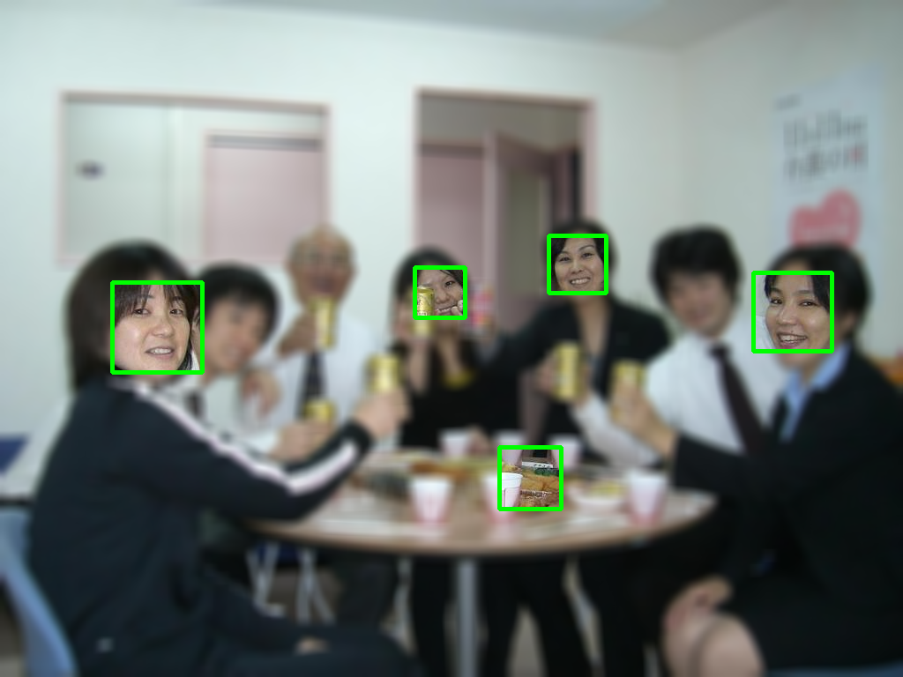
Figure 1. The result of cv2.CascadeClassifier
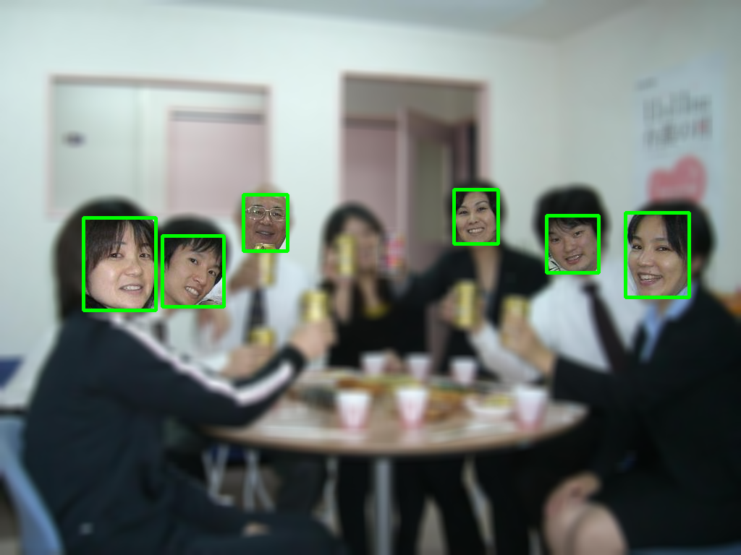
Figure 2. The result of cv2.dnn.readNetFromCaffe
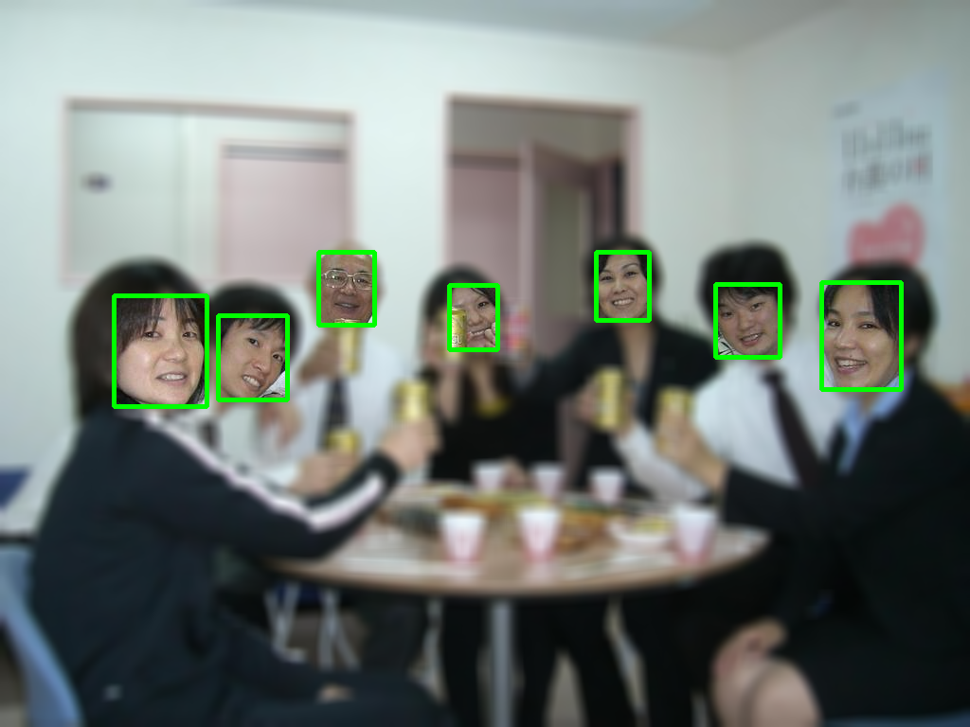
Figure 3. The result of MTCNN
- Face Detection with Laptop Camera. (Bonus Practice). (a) Load video stream from the laptop camera. (b) Use a face detection model to detect images captured by the camera. (c) Mark the face region with a green rectangle to achieve real-time detection as good as possible. (d) Perform Gaussian smoothing filtering for the background region.

实验代码及数据结果（Experiment Codes and Results）：

深圳大学学生实验报告用纸
实验分析与结论（Analysis and Conclusion）：

指导教师批阅意见：

成绩评定：

实验态度  10分 | 实验步骤及代码  40分 | 实验数据与结果  40分 | 实验分析与结论  10分

指导教师签字：李斌
2024 年 4 月 20 日
备注：

