ASSIGNMENT 1

1. Create another html file that contains a heading and a couple of paragraphs. You could name this new file another_page.html and you should place it into the same folder where you are first html is. After you have created a new html page, add a link to the first page so that the browser will load another_page. html when you click the test Go to the other page in the first page. You need to use the <a> and </a> tags in this exercise. Inside the tag <a> you need to use href attribute that specifies which page will be loaded when the link is clicked.

first.html

<!DOCTYPE html>

<html lang="en">

  <head>

    <meta charset="UTF-8" />

    <meta name="viewport" content="width=device-width, initial-scale=1.0" />

    <title>First Page</title>

  </head>

  <body>

    <p> What is HTML5? </p>

    <p>

      To know the anwser <a href="another_page.html"> Go to the other page. </a>

    </p>

  </body>

</html>

OUTPUT

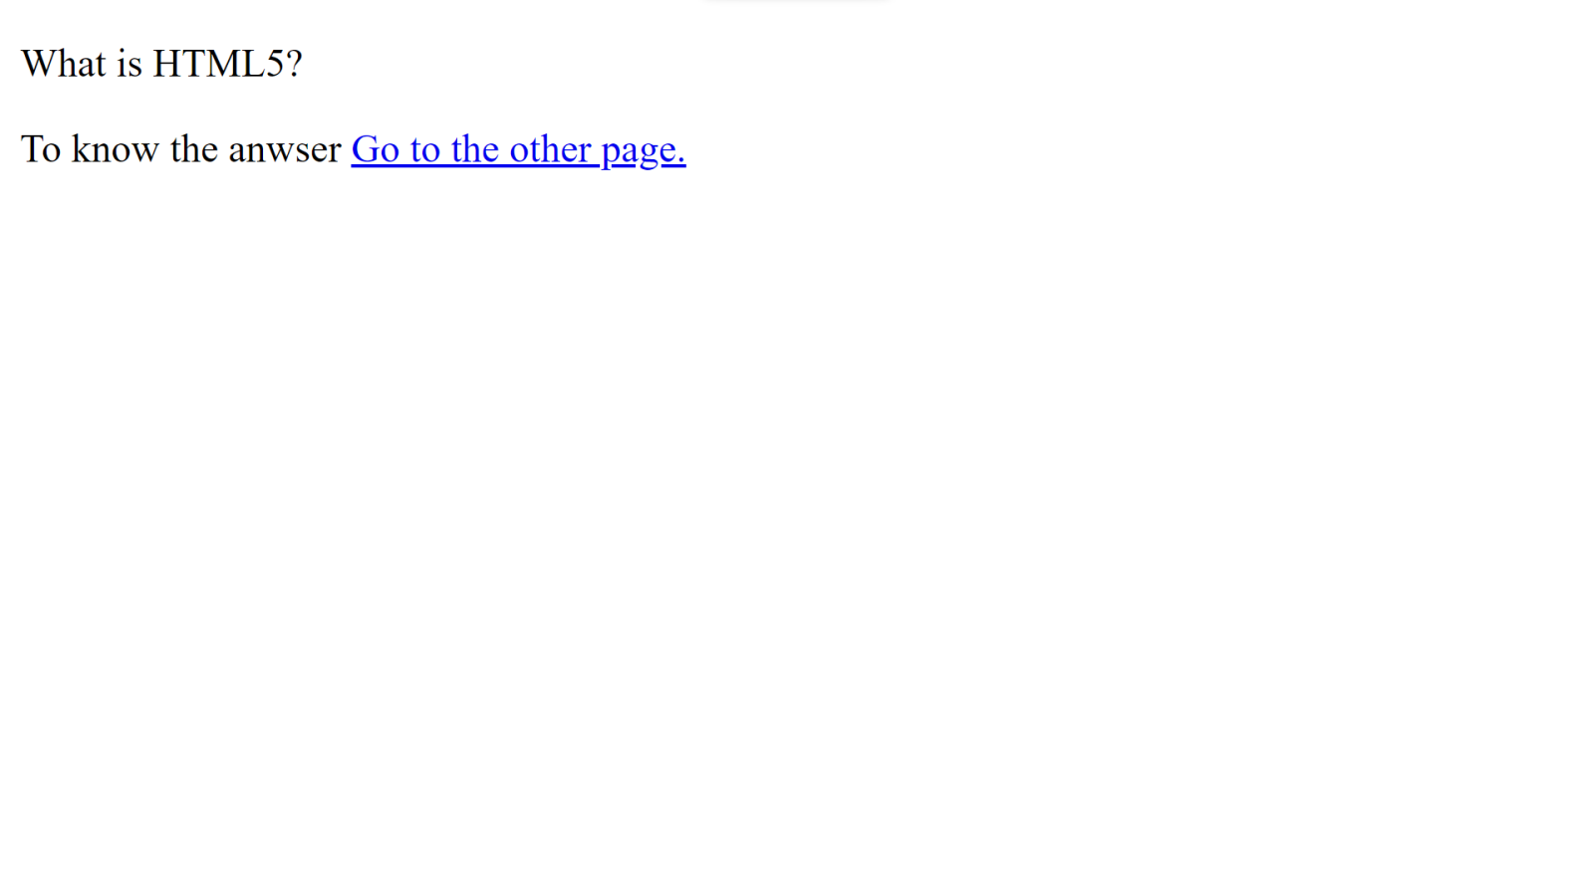

another_page.html

<!DOCTYPE html>

<html lang="en">

  <head>

    <meta charset="UTF-8" />

    <meta name="viewport" content="width=device-width, initial-scale=1.0" />

    <title>Another Page</title>

  </head>

  <body>

    <h1> What is HTML5? </h1>

    <p>

      HTML5 is the fifth version of HTML. This version was released in 2014.

      HTML5 comes with new and advanced features. It allows developers to build

      animations and simple to complex applications that run on the browser.

    </p>

    <p>

      HTML5 can help developers build web apps, which are developed for

      Entertainment, Online streaming, Video players, Audio players, etc.

    </p>

    <p>

      In the previous versions, for video playback and drag-and-drop features,

      users had to depend on third-party browser plug-ins, like Adobe Flash.

      However, HTML5 offers all these features to the users along with many

      other new features and HTML attributes for building attractive websites.

      Almost all web browsers, including Google Chrome, Safari, Mozilla Firefox

      Microsoft Edge, and mobile browsers, such as Android and iOS support most

      of the HTML5 features.

    </p>

  </body>

</html>

OUTPUT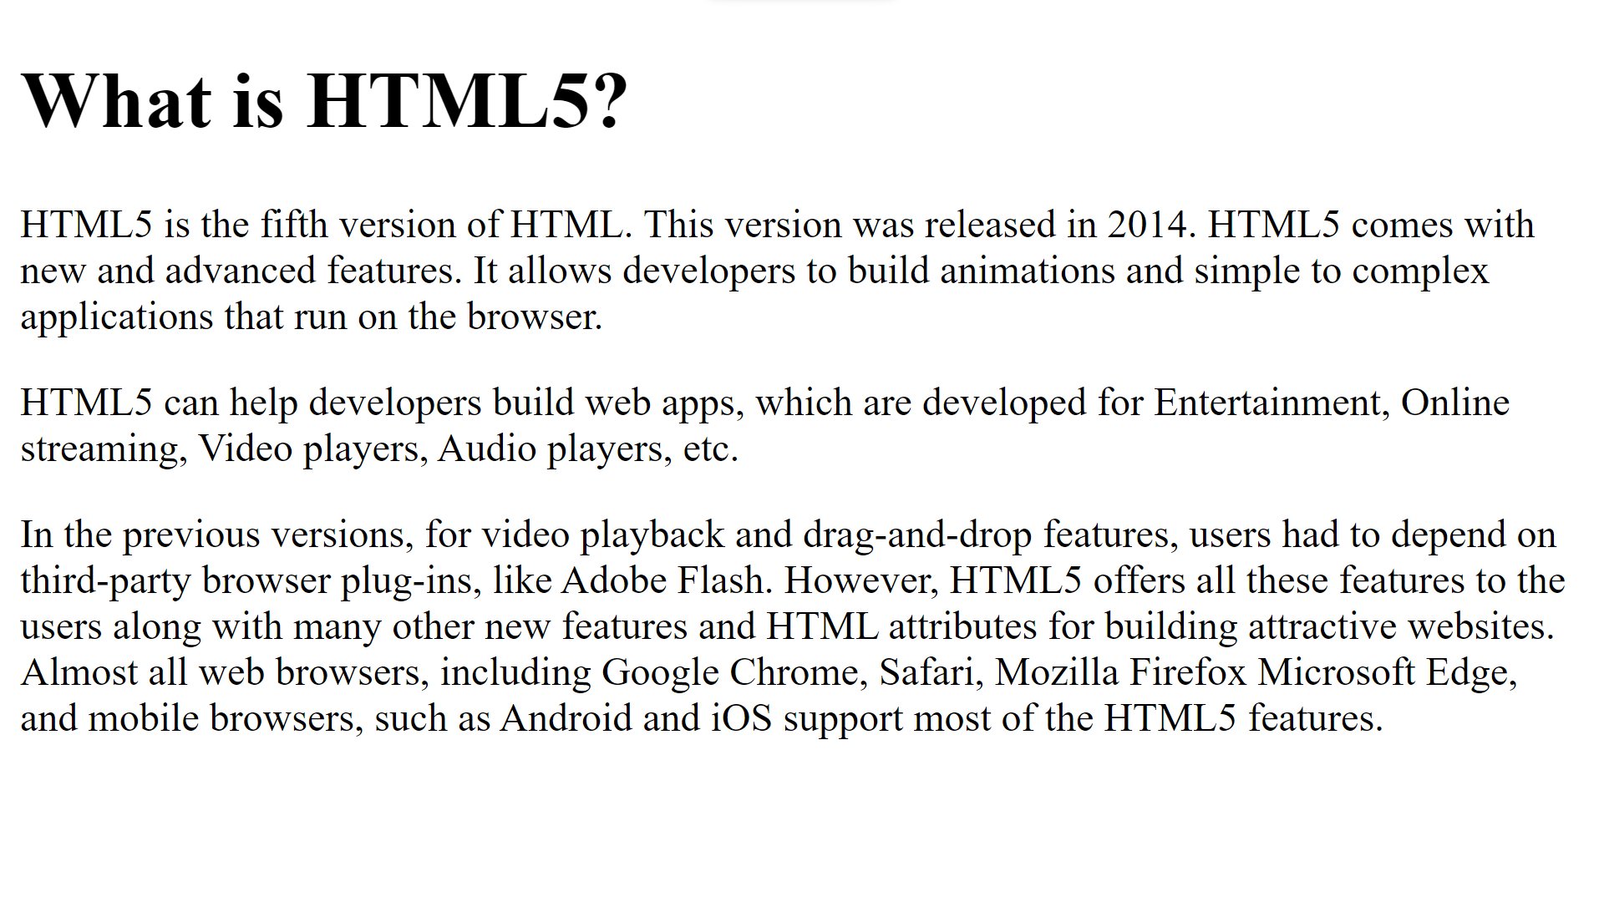

1. Create a Resume using HTML tags.

resume.html

<!DOCTYPE html>

<html lang="en">

  <head>

    <meta charset="UTF-8" />

    <meta name="viewport" content="width=device-width, initial-scale=1.0" />

    <title>RESUME</title>

  </head>

  <body>

    <!-- Personal Information -->

    <div>

      <hr color="black" />

      <h1>Mohit Singh</h1>

      <h2>MERN Stack Developer</h2>

      <div>

        <hr />

        <table>

          <tr>

            <th>

              <img src="https://img.icons8.com/gmail" alt="Email" />

            </th>

            <td> mohitsinghatwork@gmail.com </td>

            <th>

              <img src="https://img.icons8.com/phone" alt="Phone" />

            </th>

            <td> +91 7988373879 </td>

            <th>

              <img src="https://img.icons8.com/address" alt="Address" />

            </th>

            <td> Hisar, Haryana, India </td>

            <th>

              <img src="https://img.icons8.com/linkedin" alt="linkedin" />

            </th>

            <td> linkedin.com/in/mohit-singh-40b098222 </td>

          </tr>

        </table>

      </div>

      <hr color="black" />

    </div>

    <!-- Languages -->

    <div>

      <h2>LANGUAGES</h2>

      <a href="https://www.w3.org/html/"  >

        <button>HTML</button>

      </a>

      <a href="https://www.w3.org/Style/CSS/">

        <button>CSS</button>

      </a>

      <a href="https://getbootstrap.com/">

        <button>Bootstrap</button>

      </a>

      <a href="https://devdocs.io/javascript/">

        <button>JavaScript</button>

      </a>

      <a href="https://react.dev/">

        <button>React Js</button>

      </a>

      <a href="https://nodejs.org/en">

        <button>Node Js</button>

      </a>

      <a href="https://expressjs.com/">

        <button>Express Js</button>

      </a>

      <a href="https://www.python.org/">

        <button>Python</button>

      </a>

      <a href="https://www.java.com/en/">

        <button>Java</button>

      </a>

      <a href="https://www.mysql.com/">

        <button>MySql</button>

      </a>

      <a href="https://www.mongodb.com/">

        <button>MongoDB</button>

      </a>

      <a

        href="https://docs.oracle.com/en/database/oracle/oracle-database/23/sqpug/starting-SQL-Plus.html">

        <button>SQL Plus</button>

      </a>

      <a href="https://en.cppreference.com/w/c">

        <button>C</button>

      </a>

    </div>

    <!-- Qualification -->

    <div>

      <h2> QUALIFICATION </h2>

      <table border="0">

        <tr>

          <td>

            <h3>MCA</h3>

          </td>

          <td>

            <h4>Aug/2022-till date</h4>

          </td>

        </tr>

        <tr>

          <td colspan="2"

            >Guru Jambheswar University Science & Technology, Hisar</td

          >

        </tr>

        <tr>

          <td>

            <h3> BCA </h3>

          </td>

          <td>

            <h4> Aug/2018-Aug/2021 </h4>

          </td>

        </tr>

        <tr>

          <td colspan="2">

            Guru Jambheswar University Science & Technology, Hisar

          </td>

        </tr>

        <tr>

          <td>

            <h3> Higher Secondary </h3>

          </td>

          <td>

            <h4> Aug/2018 </h4>

          </td>

        </tr>

        <tr>

          <td colspan="2"> Army Public School, Hisar Cantt </td>

        </tr>

      </table>

    </div>

  </body>

</html>

OUTPUT

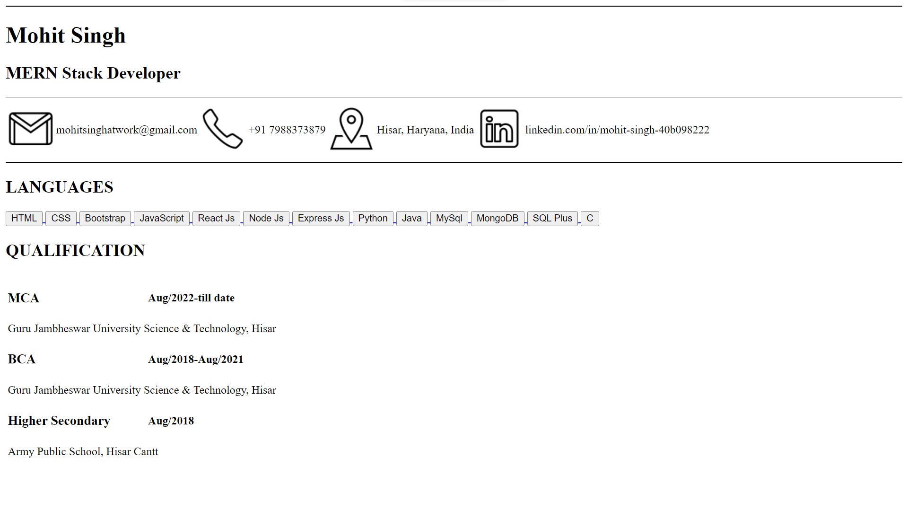

1. List Assignment:
2. Introduction to Programming
3. Variable and Data Types
4. Control Structures
5. Functions
6. Data Structures and Algorithms
7. Arrays and Lists
8. Stacks and Queues
9. Trees and Graphs
10. Database Management Systems
    * + 1. Relational Database Concepts
        2. SQL Queries
        3. Normalization

list.html

<!DOCTYPE html>

<html lang="en">

  <head>

    <meta charset="UTF-8" />

    <meta name="viewport" content="width=device-width, initial-scale=1.0" />

    <title>List</title>

  </head>

  <body>

    <ol type="1">

      <li>Intoduction to Programming

        <ol type="1">

          <li>Variables and Data Types</li>

          <li>Control Structure</li>

          <li>Function</li>

        </ol>

      </li>

      <li>Data Structure and Algorithms

        <ol type="1">

          <li>Arrays and List</li>

          <li>Stacks and Queue</li>

          <li>Trees and Graphs</li>

        </ol>

      </li>

      <li>Database Management Systems

        <ol type="1">

          <li>Relational Database Concepts</li>

          <li>SQL Queries</li>

          <li>Normalization</li>

        </ol>

      </li>

    </ol>

  </body>

</html>

OUTPUT

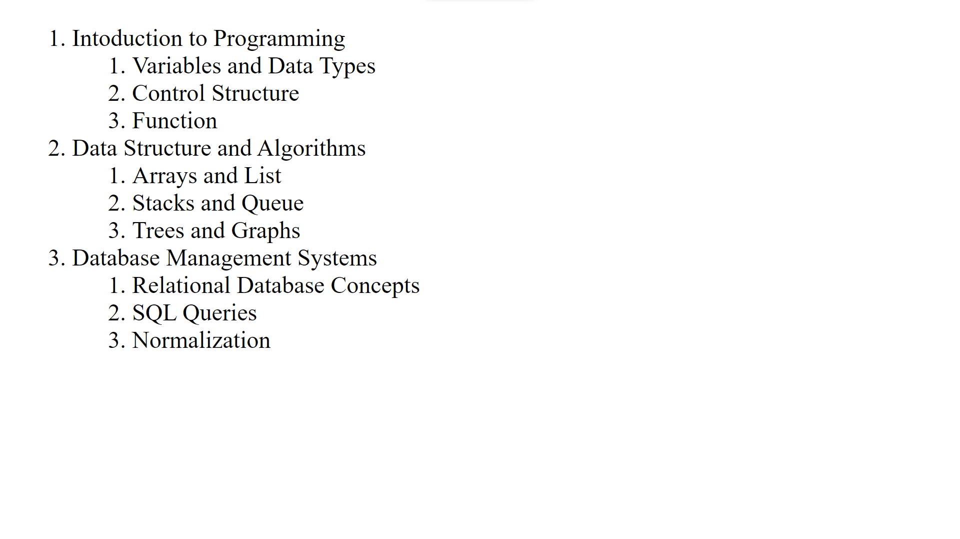

1. Table Assignment:

|  |  |  |  |  |
| --- | --- | --- | --- | --- |
| **Heading** | **Students** | **Details** | | |
| **Id** | **Name** | **Department** | **Roll Number** |
| Student List | 1 | Victor | Computer Science | 12345 |
| 2 | Williams | Electronics | 23456 |
| 3 | Harry | Electrical | 34567 |
| 4 | Ricks | Civil | 45678 |

table.html

<!DOCTYPE html>

<html lang="en">

  <head>

    <meta charset="UTF-8" />

    <meta name="viewport" content="width=device-width, initial-scale=1.0" />

    <title>Table</title>

  </head>

  <body>

    <table border="1">

      <col />

      <col />

      <colgroup span="3"> </colgroup>

      <thead>

        <tr>

          <th scope="rowgroup" rowspan="2"> Heading </th>

          <th scope="col">Students</th>

          <th scope="colgroup" colspan="3">Details</th>

        </tr>

        <tr>

          <th scope="col">ID</th>

          <th scope="col">Name</th>

          <th scope="col">Department</th>

          <th scope="col">Roll Number</th>

        </tr>

      </thead>

      <tbody>

        <tr>

          <td rowspan="4">Student List</td>

          <td>1</td>

          <td>Victor</td>

          <td>Computer Science</td>

          <td>12345</td>

        </tr>

        <tr>

          <td>2</td>

          <td>Williams</td>

          <td>Electronics</td>

          <td>23455</td>

        </tr>

        <tr>

          <td>3</td>

          <td>Harry</td>

          <td>Electrical</td>

          <td>34567</td>

        </tr>

        <tr>

          <td>4</td>

          <td>Ricks</td>

          <td>Civil</td>

          <td>45678</td>

        </tr>

      </tbody>

    </table>

  </body>

</html>

OUTPUT

