3.)
After logged in
A10 Server-side Request Forgery>Cross Site request Forgery>3
On the top right, I just clicked on the webwolf symbol, it redirected me to another page where I just logged in with the same credentials and uploaded fakepage.html in that page
After that, I just came back to WebGoat page and made some changes in the web developer tools.
Went back to WebWolf and clicked on the link at the end os file uploaded and then submitted it.
After that, I just clicked on the submit button in the WebGoat, which just redirected to where the flag, success and messages values are displayed.
I just copied and pasted in the confirm flag value and then submitted.
Note: whenever it asked me log in I logged in with the same credentials.

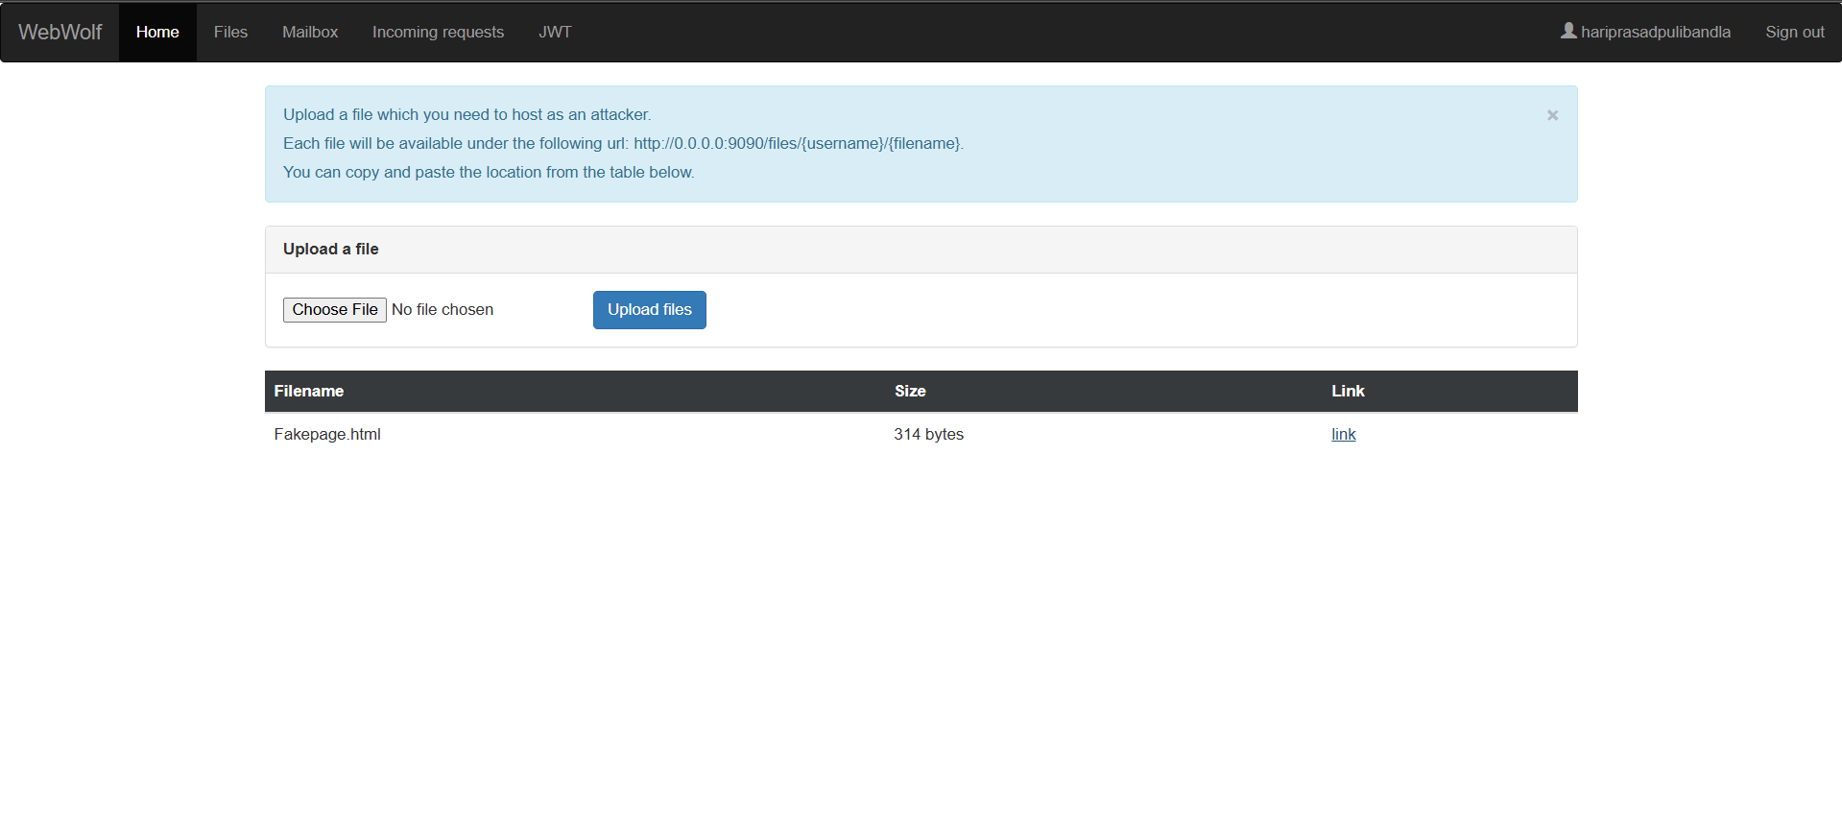
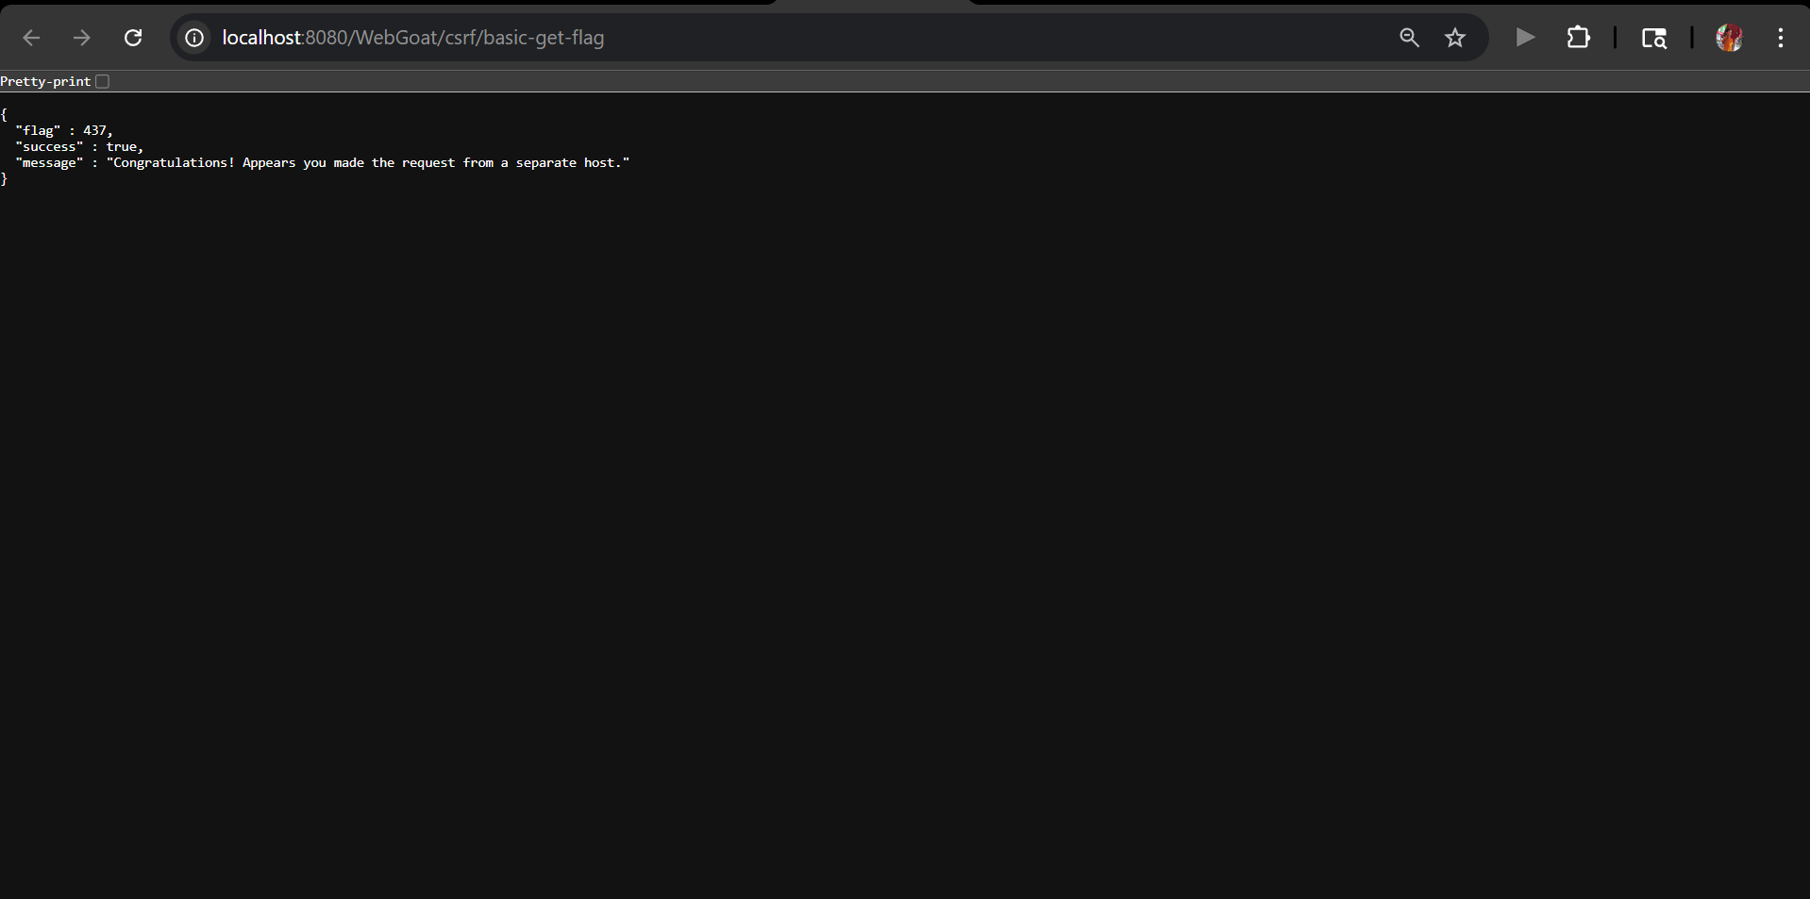

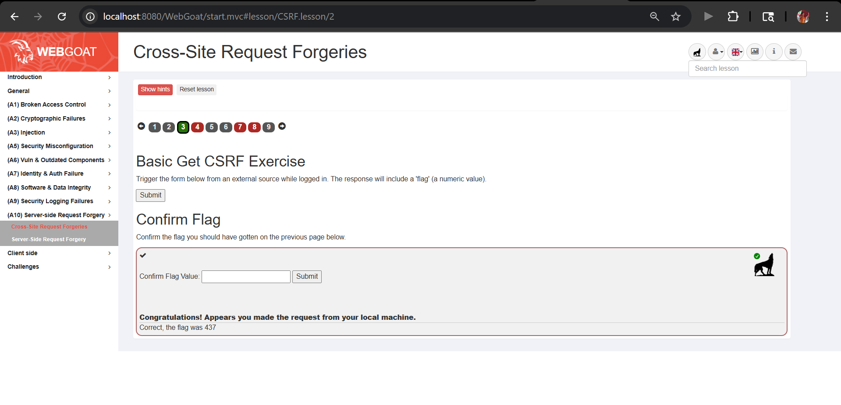
4.)
Opened the 4th question and tried submit feedback, but it threw an error, which is captured in the developer tools and for some other details which are used for earlier purposes
With the use of details that we found from there, we have developed an HTML file named comment.html and uploaded it to the WebWolf website, clicked on the link at the end, and then reviewed
Relogged in to the WebGoat and then into WebWolf > clicked the link at the file review.html>review>then the feedback,lessoncomplted etc details are displayed.

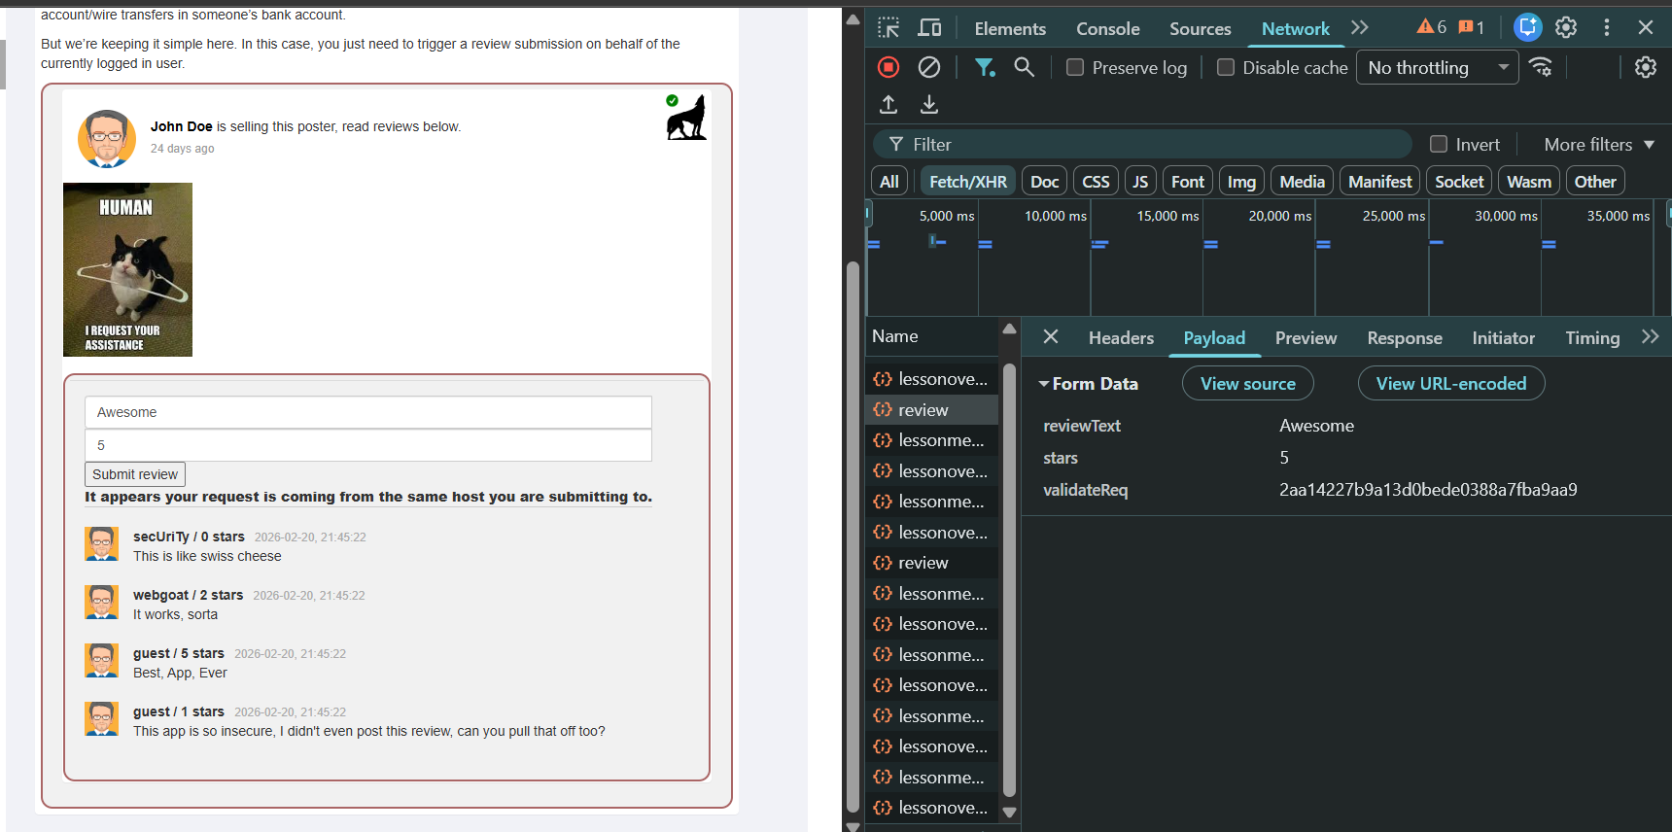

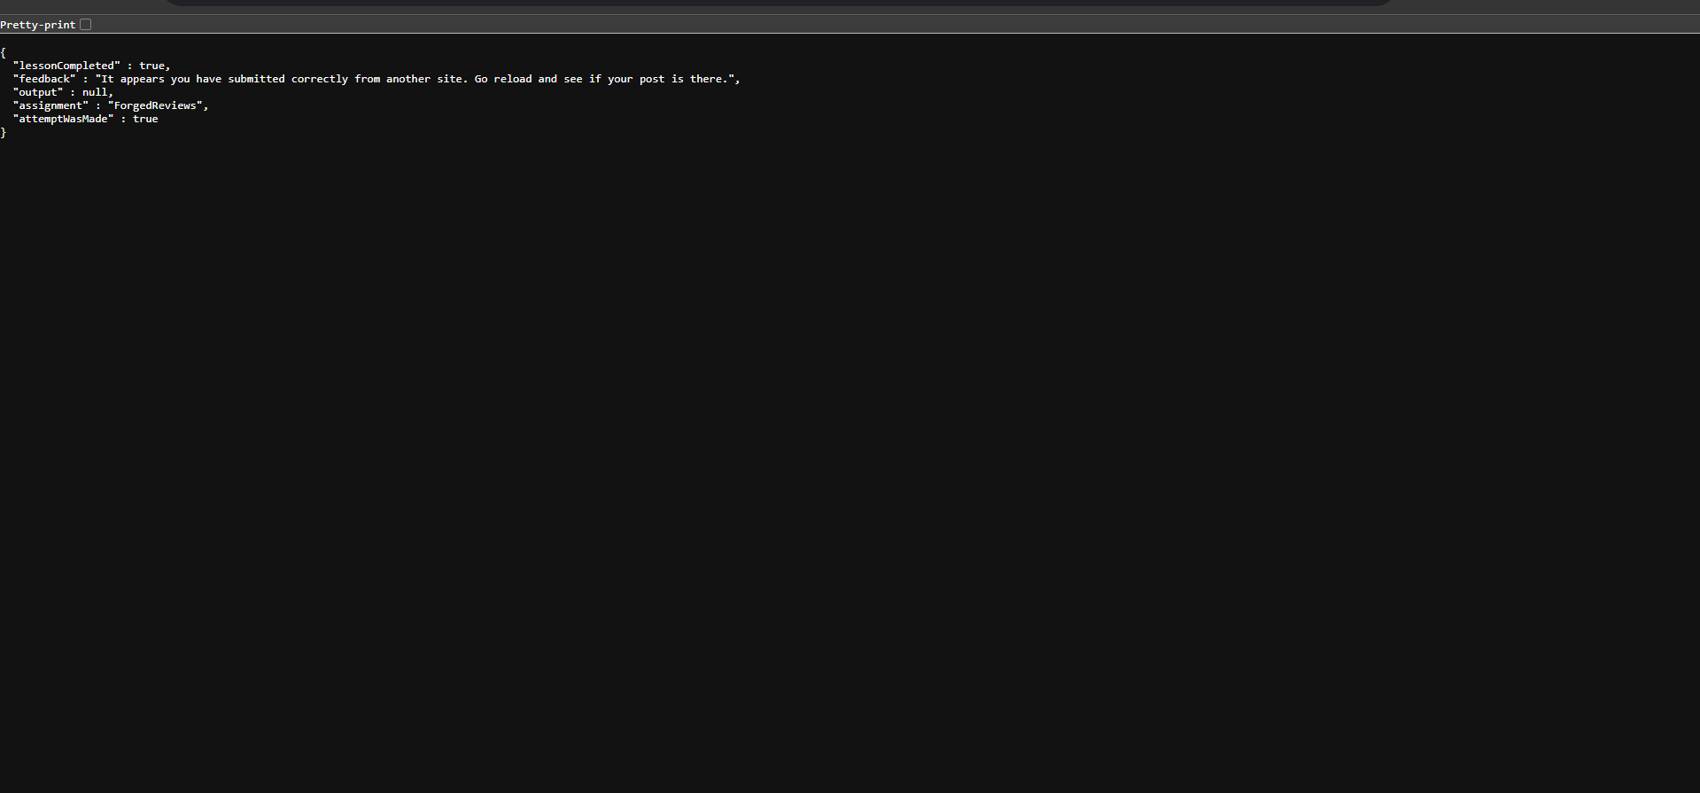

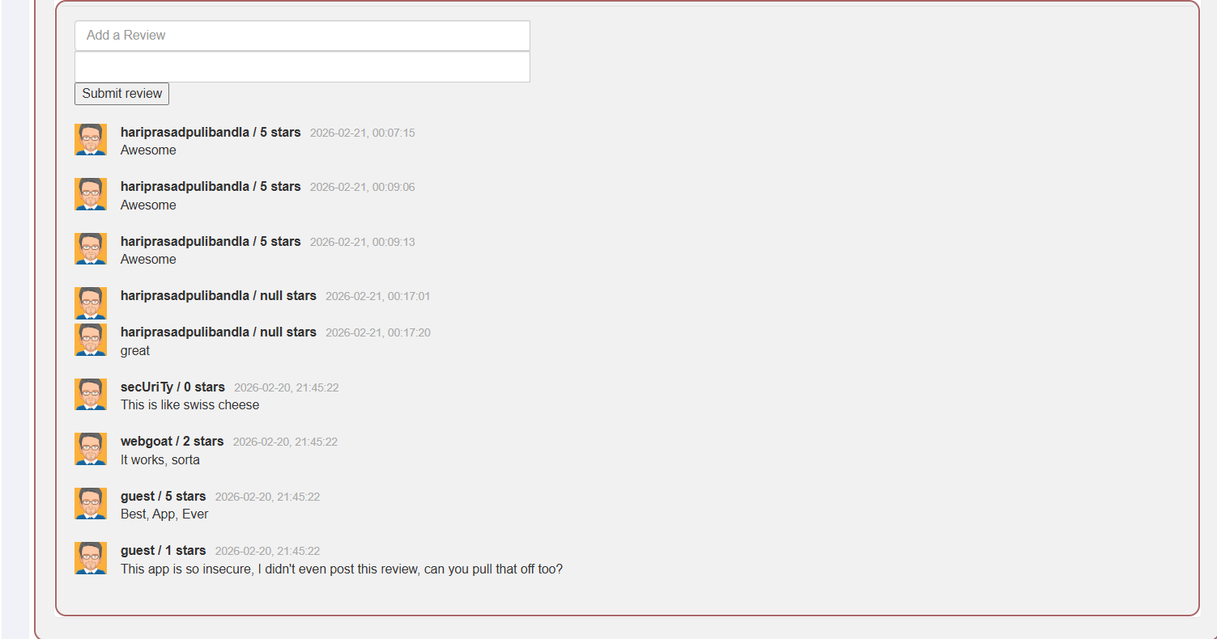

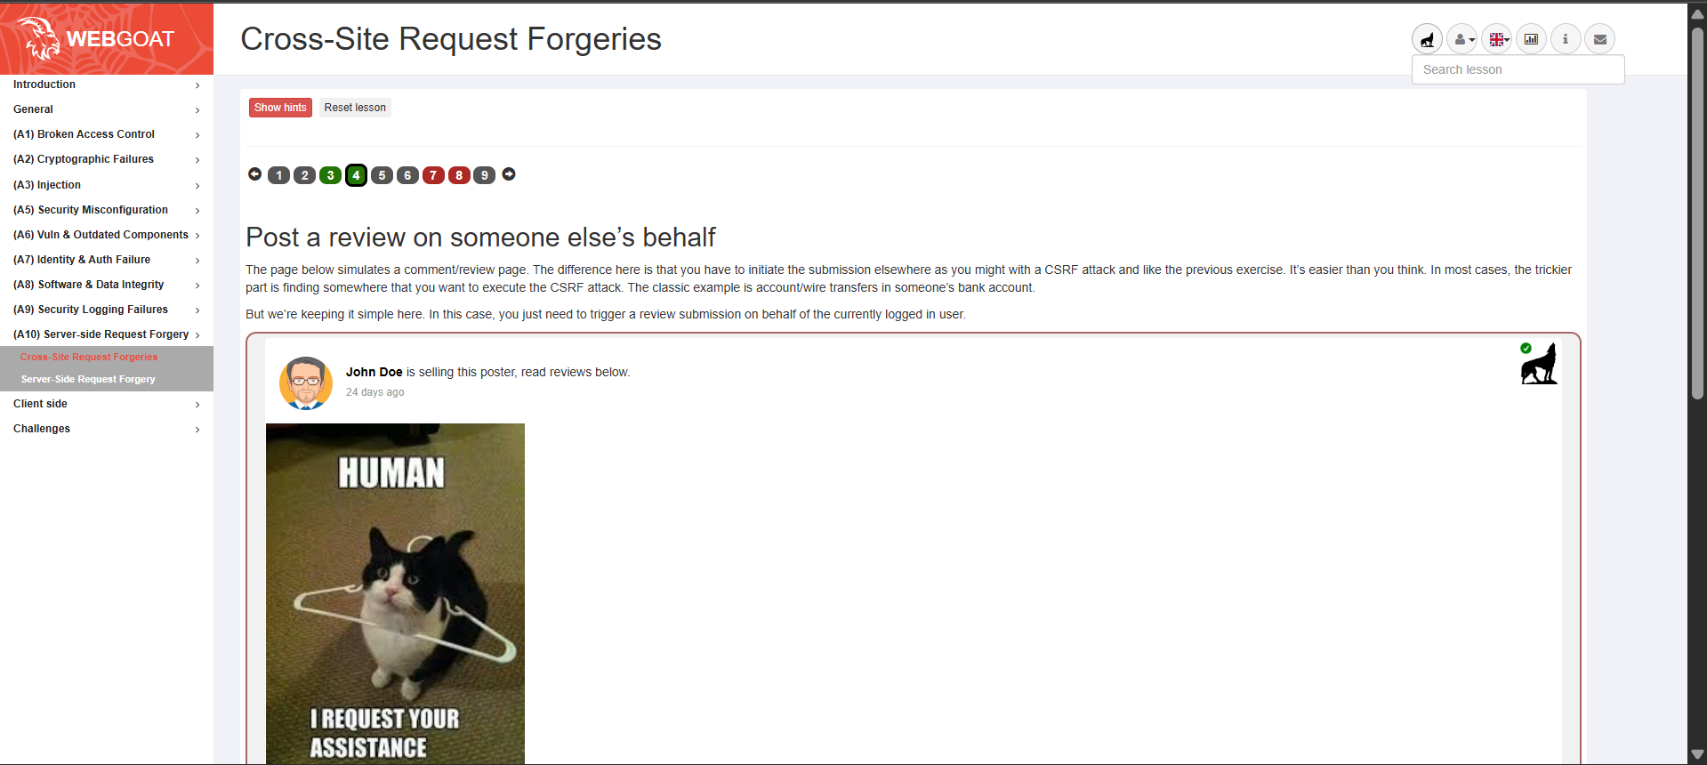

7.)
Opened the 7th question and tried to submit content by filling some details, but it threw an error, which is captured in the developer tools and for some other details which are used for earlier purposes
With the use of details that we found from there, we have developed an HTML file named content.html and uploaded it to the WebWolf website, clicked on the link at the end, and then submitted.
Relogged in to the WebGoat and then into WebWolf > clicked the link at the file content.html>submit>then the feedback,lessoncomplted etc details are displayed.
From the above details I also got the flag value I just copied and pasted it in the WebGoat and then submitted it to complete the assignment

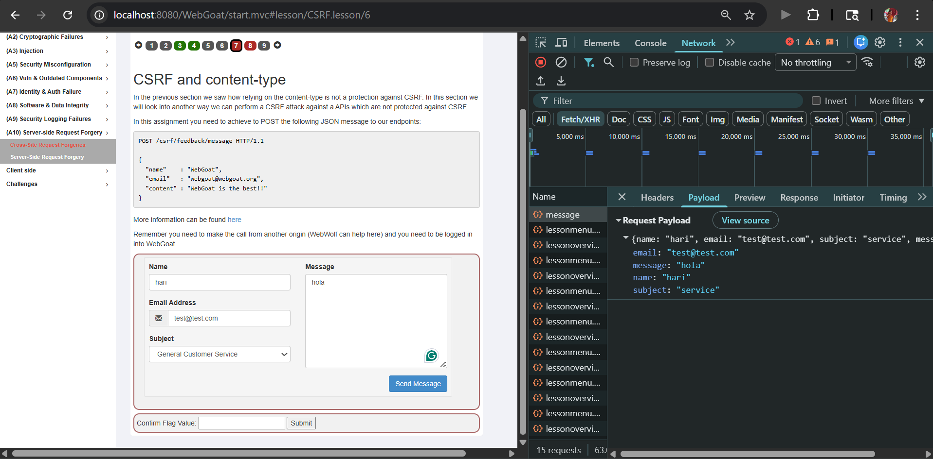

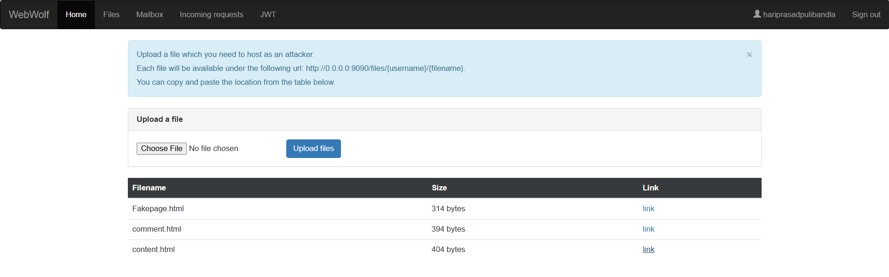

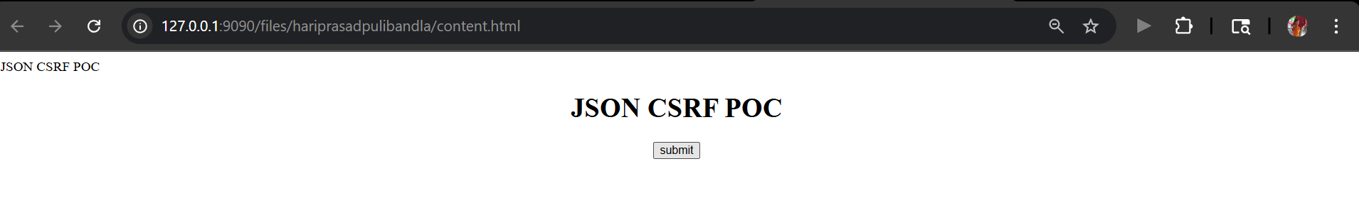

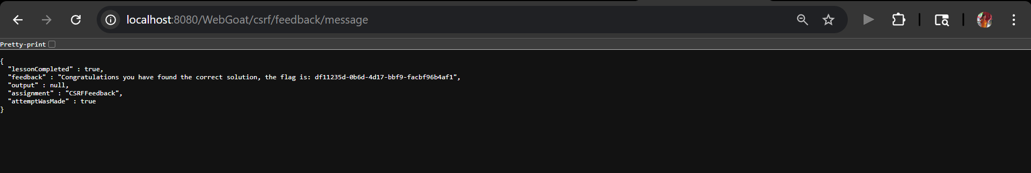
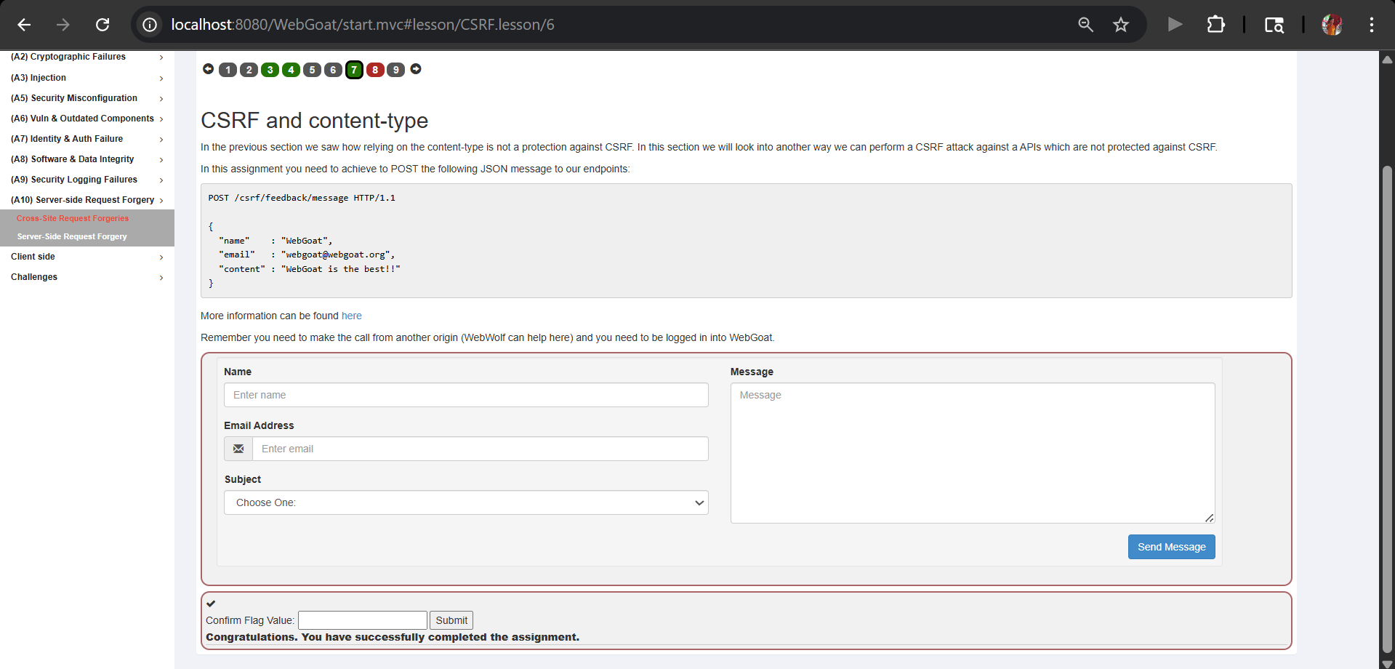

8.)
Created a new user with username as csrf-{username} and password same as my main account and kept it logged in
Open the user.html file in another tab of the same browser>submit>then it displayed lessoncompleted, feedback etc details.
After logging in to my main account by logged out of the new account made my assignment solved
