**DATA534 Project Proposal**

(Justin Chan, Kenny Tong, Vimaljeet Singh)

**Group information**

* Government of Canada Drug Product Database Wrapper API (GC DPD)
* Source API : https://hc-sc.api.canada.ca/en/detail?api=dpd

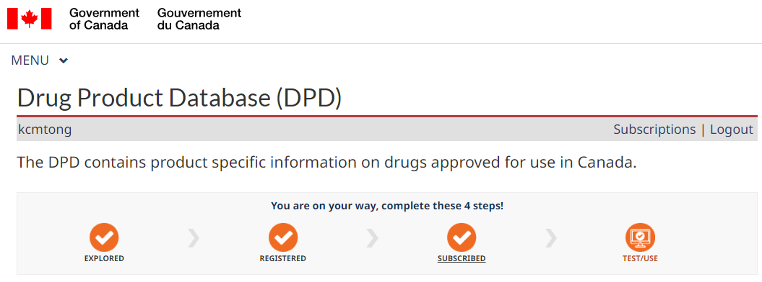



Description and Motivation of the API

**Motivation to work on the API:**

The current GC API provided useful information (e.g. Drug Information, ingredients, pharmaceutical companies, etc) but the current APIs are generic and primitive :

* The calling interface and parameters are mostly done via internal ID.  The current APIs are not very user-friendly with restraining input parameters,  and results are also not readily usable.
* Currently, different drug details are stored and disseminated via several different individual APIs, which require tedious and routine operation to have a consolidated and integrated view of the drug information.
* The current API returns results in json format which will need further parsing, reorganizing and manipulation before they can be used in the respective programming languages.

Therefore, we have decided to provide user-friendly wrapper functions on a few most frequently used scenarios.  The wrapper target to achieve :

* Our wrapper would greatly simplify the API calling procedure and enhance usability by providing user-friendly api interfaces.  Instead of using original “Internal IDs” (which most users should not be familiar with) as the search parameters, our wrapper adopts drug/ingredient names as the input variables, increasing usage convenience.
* Our wrapper would be implemented in Python, the Python user community could be benefited in terms of efficiency and usability by retrieving the relevant data in a direct python-native and cleaned format for their further analysis.
* The wrapper will also try to provide a consolidated view which integrates different data sources, saving users’ efforts from performing unnecessary data wrangling and joining.



**Description of the API:**

Function 1: Drug_Consumption:

* Input : Drug Name (Exact Match)
* Output : Drug Form (Pill, Lozenge, etc) & Route of Administration (Oral, Topical, etc)
* Underlying API calls : /route, /drugproduct, /form

Function 2: Drug_ingredient :

* Input : drug name (Exact Match)
* Output : the ingredient of the input drug name
* Underlying API call : /drugproduct, /activeingredient

Function 3: Ingredient_VeterinarySpecies:

* Input : Ingredient Name (Exact Match)
* Output : list of vet_species_name that were linked to the given ingredient_name
* Underlying API call : /activeingredient, /veterinaryspecies

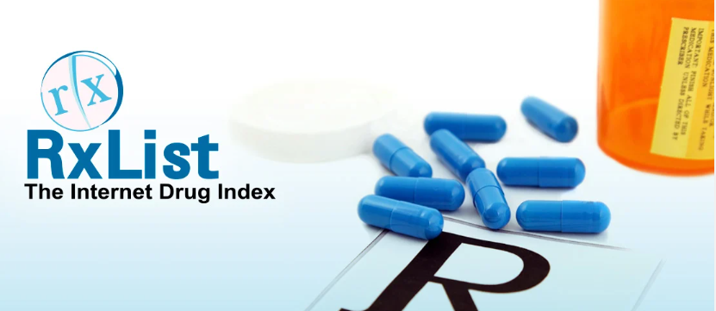

**Intended users and outcome:**

* **Description of the intended users**: Pharmacists and Doctors.

* **Description of the outcome**: Since different patients have different symptoms, allergic ingredients and preferences, Pharmacists and Doctors can use this API wrapper to quickly search through the database and determine the most suitable drugs that could be prescribed to their patients. Due to the original API suffering from being too generic and primitive, having an API wrapper that could search drug ingredients and intended users by product name instead of product id could result in a faster searching time and reduced error rate.

# About DPD

* The DPD contains product specific information on drugs approved for use in Canada.
* Managed by Health Canada
* It contains approximately 47,000 products that are currently approved, marketed, dormant or cancelled.

# The wrapper functions

**Drug Consumption**:

* Input : Drug Name (Exact Match)
* Output : Drug Form (Pill, Tablet, Powder, Syrup etc) & Route of Administration (Oral, Topical, etc)

Underlying API calls : /route, /drugproduct, /form

Example:

Input: ACETAMINOPHEN 325MG

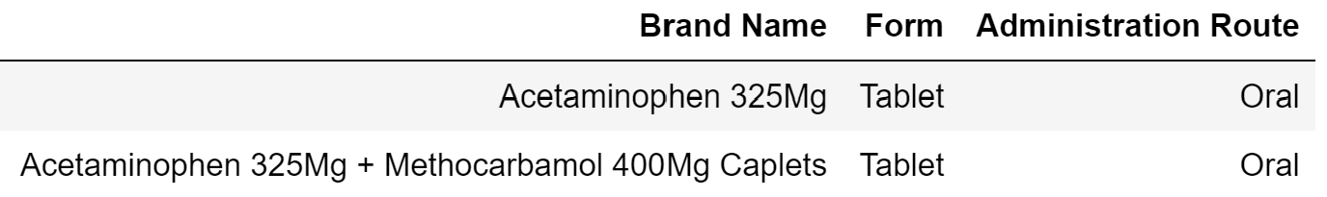

# Target Audience & Potential Use & Advantages

* Can be used by Pharmacists and Doctors to search drugs through the database of the appropriate form and route of administration according to the patient’s preference.
* Faster search results as the search is not generic and does not use drug id for search input as drug ids are not well-known.

# Future Work

* Create a wrapper function that gives users the option to pick a format to provide input i.e. name of the drug or drug code by showing a table of drug names and drug ids and still implement the wrapper functions that we have shown.
* Create a wrapper function that takes as input the name of the ingredient to which the patient is allergic and show drugs that are free from that ingredient
* Create a wrapper function to find the form and route of administration of the drug depending on the schedule of the drug i.e. is it a prescription drug, OTC, or Narcotic etc.

# Distinguishing Feature

Currently you cannot input a drug name and find the **form and route of administration of the** **active** **drugs in one API call**. The wrapper function helps do just that.

# Technical Challenge